Additional file

Figure S1. Nesting locations of different tagging cohorts on Svalbard and Novaya Zemlya. On Svalbard, Pink-footed geese that were GPS-tagged during wing moult in Svalbard nested in the area where they were tagged, while geese tagged in Finland were spread out over the center and north, and geese tagged in Norway concentrated more on the center and south. On Novaya Zemlya, only one goose from the first cohort nested, while 16 geese from the second cohort nested over a wider area. Geese that did not nest are not depicted. Number of nests is given as sample size per group.

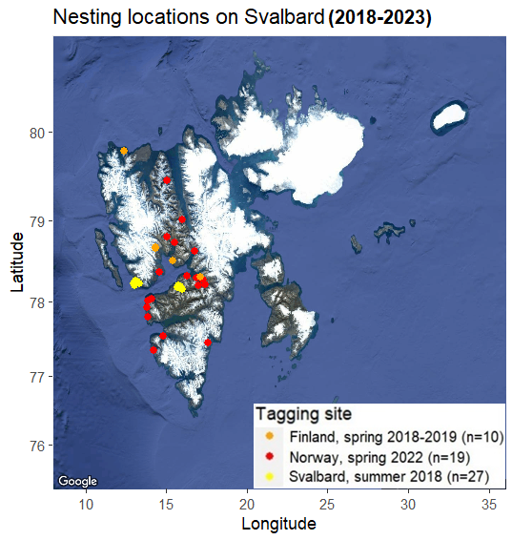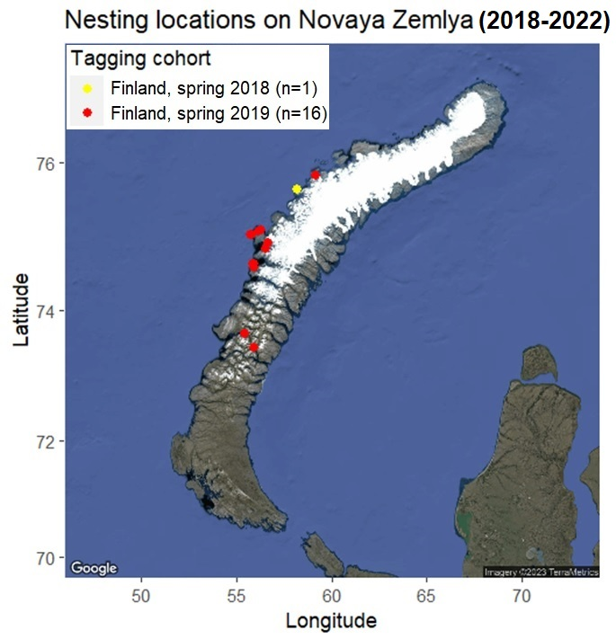

Figure S2. Schematic representation of changes in body condition after capture on different stopovers. The time that it takes captured geese to catch up in body condition with uncaptured geese is expected to be longer when geese are fattening up on the stopover (B), than when they are not fattening up (A), assuming constant values of body stores lost due to capture and constant fattening speed of tagged geese.
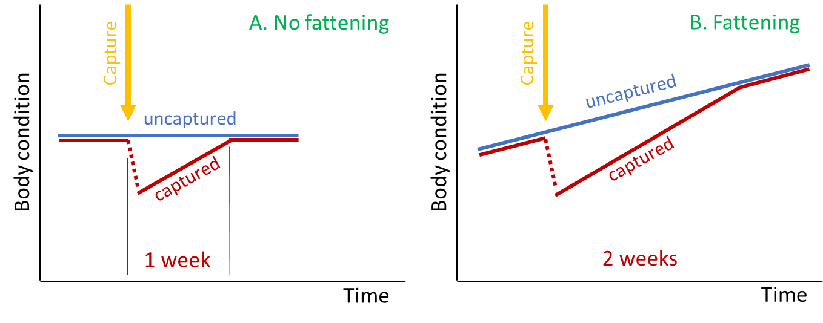

Table S1. Sample sizes for cross-sectional analyses. For each stage (departure, arrival, breeding propensity, laying date, hatching success) the number of GPS-tagged geese is given, for the quasi-control and experimental groups, and per flyway (as specified by the stopover and breeding area).

Year | Stopover | Breeding area | Quasi-control / Experimental
Year | Stopover | Breeding area | Departure date | Arrival date | Breeding propensity | Laying date | Nesting success
2019 | Oulu | Svalbard | 1 / 3 | 1 / 2 | 1 / 2 | 0 / 1 | 0 / 1
2019 | Oulu | Novaya Zemlya | 2 / 8 | 2 / 7 | 2 / 7 | 0 / 3 | 0 / 3
2022 | Trøndelag | Svalbard | 7 / 46 | 7 / 43 | 8 / 42 | 8 / 19 | 8 / 19
Total |  |  | 10 / 57 | 10 / 52 | 11 / 51 | 8 / 23 | 8 / 23

Table S2. Sample sizes for longitudinal analyses. For each year, the number of GPS-tagged geese is given, for departure from stopover and arrival in breeding area (separated by a “/” in each cell). Underlined numbers indicate experimental group (i.e. tagged recently), not underlined numbers the quasi-control group (i.e. tagged longer ago).
Cohort | Breeding area | Departure stopover / arrival breeding area
Cohort | Breeding area | 2018 | 2019 | 2020 | 2021 | 2022 | 2023
2018 (spring, Oulu) | Svalbard | 3 / 3 | 1 / 1 | 1 / 1 | 1 / 1 | 1 / 1 | 1 / 1
2018 (spring, Oulu) | Novaya Zemlya | 2 / 2 | 2 / 2 | 1 / 1 | 1 / 1 | 1 / 1 | 0 / 0
2018 (spring, Oulu) | Unknown | 1 / 1 | 0 / 0 | 0 / 0 | 0 / 0 | 0 / 0 | 0 / 0
2019 (spring, Oulu) | Svalbard | - | 3 / 2 | 0 / 0 | 0 / 0 | 0 / 0 | 0 / 0
2019 (spring, Oulu) | Novaya Zemlya | - | 8 / 7 | 6 / 6 | 5 / 4 | 4 / 4 | 1 / 1
2022 (spring, Trøndelag) | Svalbard | - | - | - | - | 46 / 43 | 35 / 27
2018 (summer, Svalbard) | Svalbard | - | 25 / 25 | 18 / 18 | 13 / 13 | 6 / 6 | 5 / 5

Table S3. Brood size distribution as observed in Adventdalen, Longyearbyen, Svalbard.
Year | Group | 0 | 1 | 2 | 3 | 4 | 5 | 6 | 7 | 8 | Total
2019 | Unringed | 90 | 2 | 2 | 2 | 4 | 2 | 0 | 1 | 1 | 136
2019 | GPS-tagged | 6 | 1 | 1 | 0 | 0 | 0 | 0 | 0 | 0 | 8
2022 | Unringed | 35 | 5 | 5 | 4 | 3 | 2 | 1 | 0 | 0 | 55
2022 | GPS-tagged | 0 | 1 | 4 | 0 | 0 | 0 | 0 | 1 | 0 | 6

Table S4. Geese that died shortly after capture in Trøndelag, Norway, spring 2022. The moment of death was based on GPS and accelerometry: when dying on water, the Y-axis of the accelerometer (in dimension from body towards head) turned gradually negative, indicating a hanging instead of upright neck. Time is UTC+2. One GPS-tag (code 5Z) was retrieved and deployed on a different individual in a following catch.
Goose (tag ID) | Age, sex | Captured | Died | Time interval | Location, distance | Found | Circumstances
5Z (1st deploy) | Adult female | 26-04-2022 (11:10) | 28-04-2022 (03:29) | 1.7 d | Eidsbotn,  2.6 km NE | 28-04-2022 | Died and found on water.
XC | Adult female | 27-04-2022 (18:50) | 29-04-2022 (05:19) | 1.4 d | Eidsbotn,  1.4 km NE | 29-04-2022 | Died on water, found on coast.
5Z (2nd deploy-ment) | Adult female | 29-04-2022 (12:30) | 02-05-2022 (05:24) | 2.7 d | Høsholmen, 12.8 km N | 03-05-2022 | Died near coast, only tag found in forest nearby (predated?)

