Supplemental information for:
The variability of muscle-blubber interface temperature with activity level in a captive Risso’s dolphin (Grampus griseus)

Kino Sakai^{1*}, Daisuke Fukui², Hiroshi Shirouzu³, Yurie Watanabe³, Daiki Inamori³, Noriko Funasaka⁴, Kagari Aoki^{1,5}, Kentaro Q. Sakamoto¹

- Atmosphere and Ocean Research Institute, The University of Tokyo, Chiba 277-8564, Japan
- Ise Kizuna Animal Hospital, Mie 516-0066, Japan
- Taiji Whale Museum and Aquarium, Wakayama 649-5171, Japan
- Cetacean Research Center, Graduate School of Bioresources, Mie University, Mie 514-8507, Japan
- Faculty of Life and Environmental Sciences, Teikyo University of Science, Yamanashi 409-0193, Japan

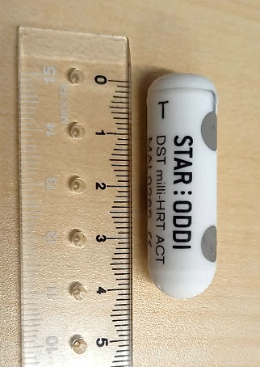
Fig. S1. A DST milli-HRT ACT tag used in this experiment. The tag weighs 12g in air, with a diameter of 13 mm and a length of 39.5 mm (Star-Oddi Co., Iceland). Electrocardiograms were detected by two electrodes at the tag surface.

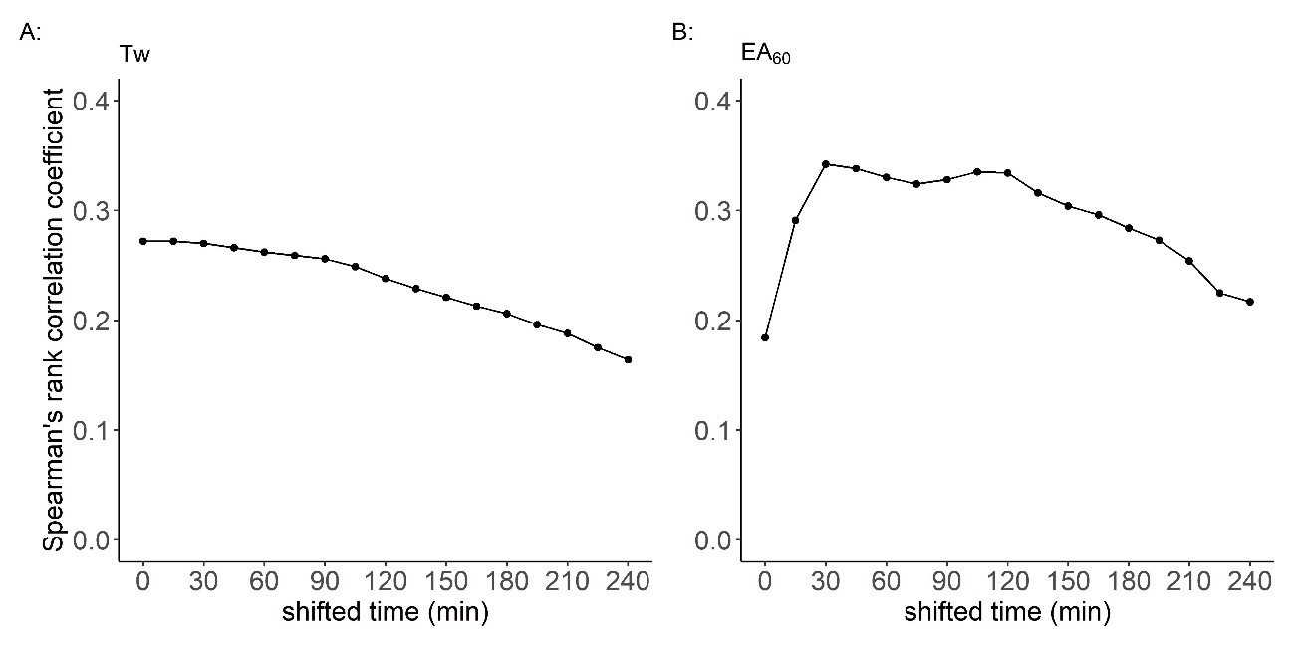
Fig. S2. Spearman’s rank correlation coefficient between (A) the temperature of the muscle-blubber interface (Tmbi) vs the water temperature (Tw) and (B) Tmbi vs External Acceleration averaged over 60 s (EA₆₀). Tw or EA₆₀ was shifted backward every 15 min with respect to Tmbi for 4 h. The maximum coefficient was 0.27 at 0 or 15 min shifted for Tw and 0.34 at 30 min shifted for EA₆₀, respectively.

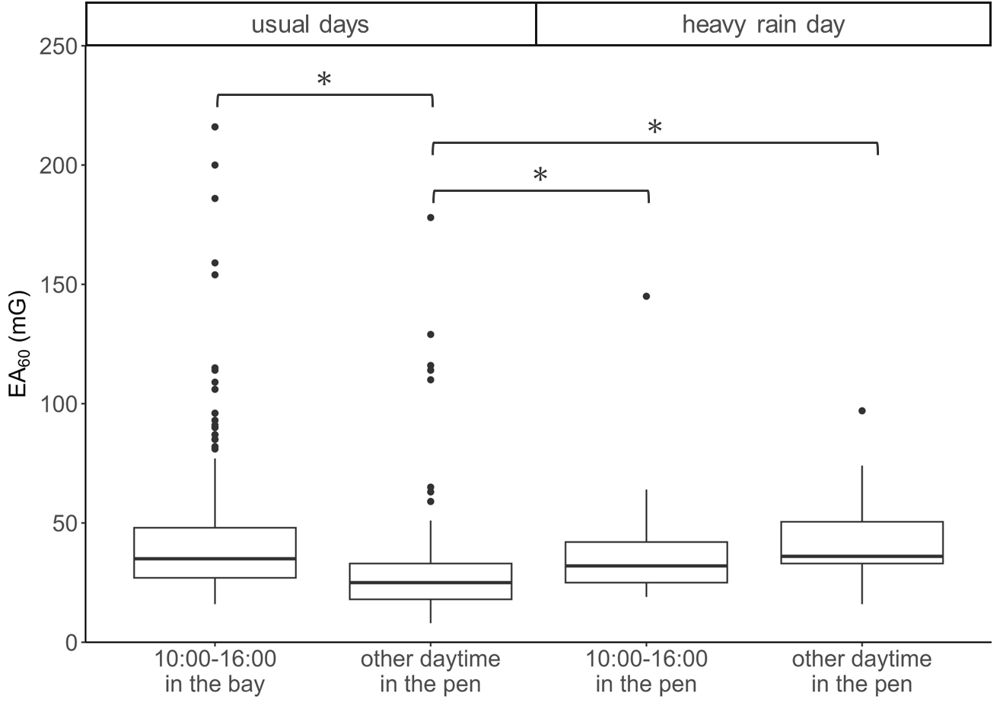
Fig. S3. External Acceleration averaged over 60 s (EA₆₀) under different weather conditions and times. The animal was swimming freely in the bay at approximately 10:00–16:00 and spent the other time in the net pen except for the 3rd day with the heavy rain and strong winds. On a heavy rain day, the animal spent the entire day in the net pen. * P < 0.05.

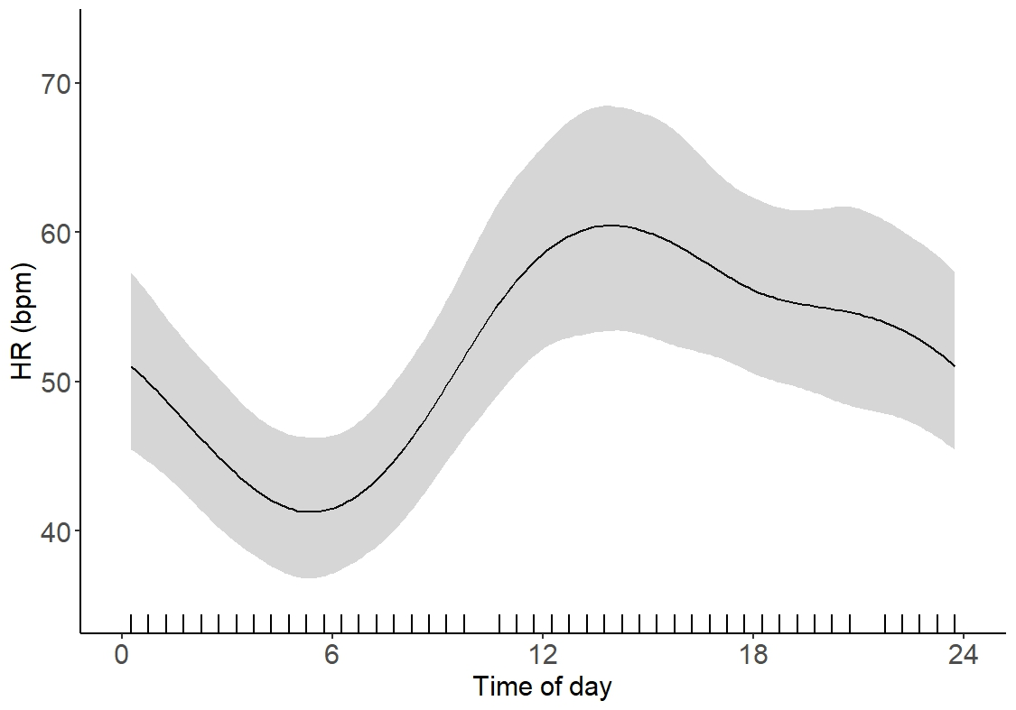
Fig. S4. Partial effect of the time of day on the heart rate (HR). The variation of HR was significantly explained by the time of day according to the best-fit model of generalized additive models (GAMs). The tick symbols on the x-axis are the data points observed in this study. The shaded areas indicate the 95% confidence intervals.

