Classification of African ground pangolin behaviour based on accelerometer readouts: validation of bio-logging methods

Supplementary materials 2: Tables and Figures
Jessica Harvey-Carroll^{1, 2, 3, *}, Daire Carroll^{2,3,!}, Cara-Marie Trivella¹, and Ellen Connolly¹
1. Tikki Hywood Foundation, Harare, Zimbabwe.
2. Department of Biological and Environmental Sciences, University of Gothenburg, Gothenburg, Sweden.
3. Gothenburg Global Biodiversity Centre, Gothenburg, Sweden.
* Jessica.harveycarroll@gmail.com
! daire.carroll@bioenv.gu.se

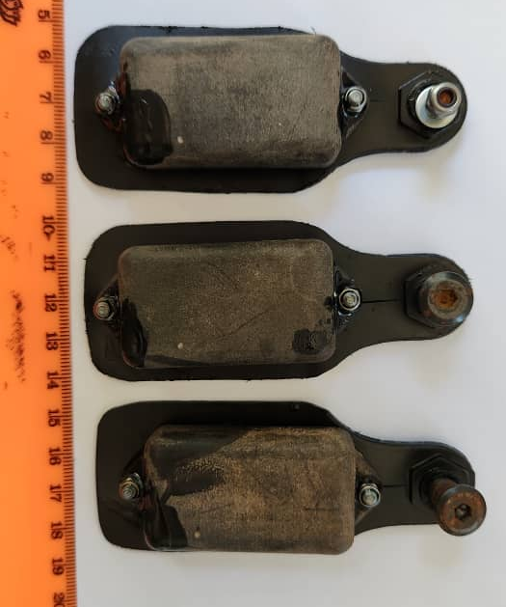
Figure S1. Accelerometers were mounted on flexible ear tags and secured at a single point using a 6 mm bolt with a sleeve threaded through the ventral side and secured with a nut on the dorsal side of the first central dorsal scale caudally from the pelvis. Tags seen here are the black type deployed on free ranging pangolins.

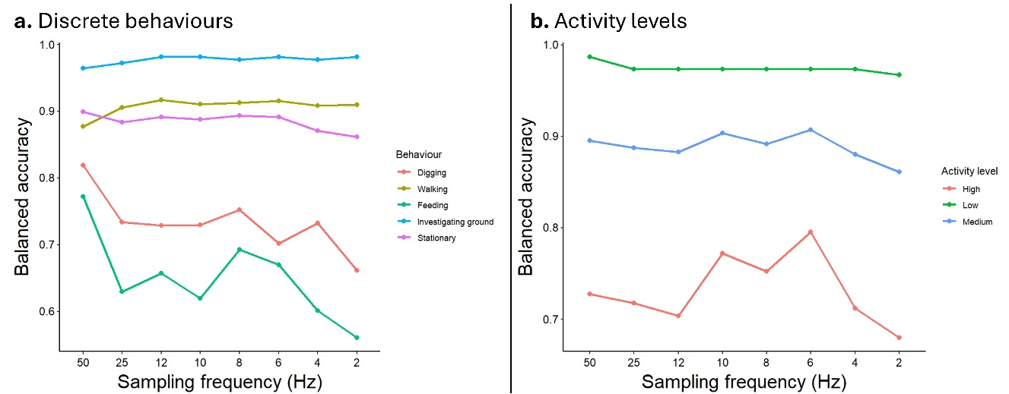
Figure S2. The balanced accuracy of Random Forest (RF) models for classifying a. discrete behaviours and b. activity levels across sampling frequency for the sampling window with the highest overall model accuracy (50 Hz discrete behaviours and 10 Hz for activity levels).

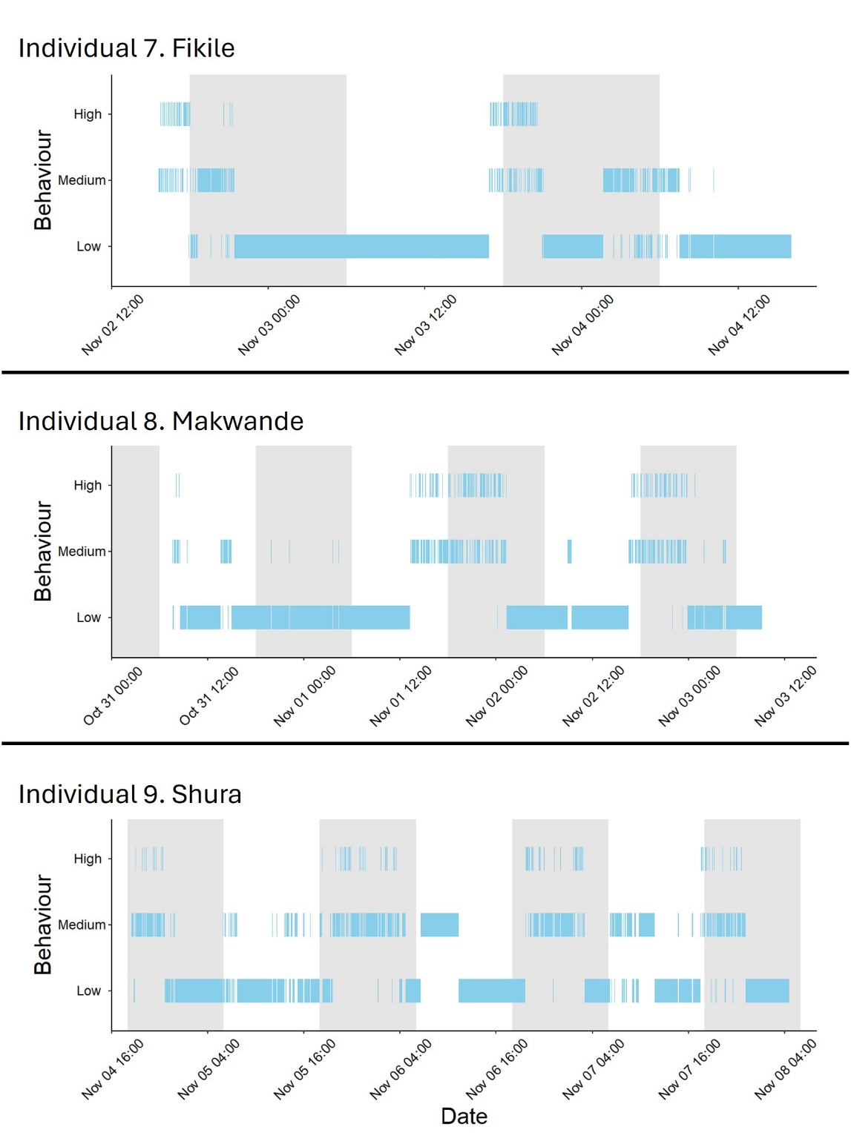
Figure S3. The classification of free ranging pangolin behaviour into activity levels based on accelerometer readouts (sampling frequency = 10 Hz, smoothing window = 7 seconds). These pangolins were not under observation outside of device attachment and retrieval. Grey shaded areas represent night. White areas representing day.

Table S1. The summary metrics calculated from accelerometer readouts. SD = Standard Deviation. Min. = minimum. Max. = maximum.
Summary metric | Description
Overall Dynamic Body Acceleration (ODBA, g) | Summation of absolute values of acceleration on each axis, after accounting for static g force.
Vectorial Dynamic Body Acceleration (VeDBA, g) | Vectorial sum of values of acceleration on each axis, after accounting for static g force.
Surge (Mean, SD, Min., Max.) | Linear acceleration along the longitudinal axis (tail to head)
Sway (Mean, SD, Min., Max.) | Linear acceleration along the lateral axis (shoulder to shoulder)
Heave (Mean, SD, Min., Max.) | Linear acceleration along the vertical axis (feet to back)
Pitch (Mean and SD) | Rotational acceleration about the lateral axis (shoulder to shoulder)
Roll (Mean and SD) | Rotational acceleration about the longitudinal axis (tail to head)

Table S2. Number of seconds of behaviour performed by individual pangolins used in random forest model.
ID | Behaviour | Seconds performed
Chaminuka | Digging | 87.34
Chaminuka | Feeding | 295.4
Chaminuka | Investigating ground | 82.46
Chaminuka | Stationary | 19.06
Chaminuka | Walking | 1240.54
Sindisiwe | Digging | 666.16
Sindisiwe | Feeding | 803.9
Sindisiwe | Investigating ground | 203.66
Sindisiwe | Stationary | 54.24
Sindisiwe | Walking | 636.24
Dakarai | Digging | 149.54
Dakarai | Feeding | 161.26
Dakarai | Investigating ground | 402.8
Dakarai | Stationary | 488.06
Dakarai | Walking | 571.88
Impi | Digging | 59.24
Impi | Feeding | 519.64
Impi | Investigating ground | 147.82
Impi | Stationary | 811.34
Impi | Walking | 775.4
Shura | Digging | 1.02
Shura | Feeding | 41.04
Shura | Investigating ground | 30.14
Shura | Stationary | 11.08
Shura | Walking | 738.02
Yakachena | Digging | 176.62
Yakachena | Feeding | 536.72
Yakachena | Investigating ground | 82.46
Yakachena | Stationary | 516.06
Yakachena | Walking | 375.66

Table S3. Confusion matrix for testing dataset of behavioural data using a five second smoothing window.
Frequency |  | Digging | Feeding | Investigating ground | Static | Walking
50Hz | Digging | 37 | 5 | 6 | 0 | 7
50Hz | Feeding | 1 | 99 | 2 | 4 | 4
50Hz | Investigating ground | 0 | 9 | 23 | 1 | 6
50Hz | Static | 0 | 1 | 0 | 103 | 2
50Hz | Walking | 17 | 13 | 9 | 2 | 224
25Hz | Digging | 27 | 1 | 6 | 0 | 5
25Hz | Feeding | 4 | 109 | 5 | 5 | 7
25Hz | Investigating ground | 9 | 3 | 12 | 0 | 10
25Hz | Static | 0 | 0 | 0 | 104 | 0
25Hz | Walking | 15 | 14 | 17 | 1 | 221
12Hz | Digging | 27 | 2 | 8 | 0 | 7
12Hz | Feeding | 1 | 108 | 1 | 3 | 2
12Hz | Investigating ground | 6 | 5 | 14 | 1 | 7
12Hz | Static | 0 | 0 | 0 | 106 | 0
12Hz | Walking | 21 | 12 | 17 | 0 | 227
10Hz | Digging | 27 | 4 | 7 | 0 | 5
10Hz | Feeding | 2 | 106 | 1 | 2 | 1
10Hz | Investigating ground | 4 | 5 | 11 | 2 | 8
10Hz | Static | 0 | 0 | 0 | 106 | 0
10Hz | Walking | 22 | 12 | 21 | 0 | 229
8Hz | Digging | 30 | 5 | 9 | 1 | 6
8Hz | Feeding | 1 | 106 | 1 | 1 | 1
8Hz | Investigating ground | 3 | 6 | 17 | 1 | 11
8Hz | Static | 0 | 0 | 0 | 105 | 0
8Hz | Walking | 21 | 10 | 13 | 2 | 225
6Hz | Digging | 24 | 1 | 9 | 0 | 7
6Hz | Feeding | 1 | 107 | 0 | 2 | 2
6Hz | Investigating ground | 6 | 6 | 15 | 2 | 5
6Hz | Static | 0 | 0 | 0 | 106 | 0
6Hz | Walking | 24 | 13 | 16 | 0 | 229
4Hz | Digging | 29 | 5 | 11 | 0 | 16
4Hz | Feeding | 2 | 106 | 3 | 2 | 1
4Hz | Investigating ground | 2 | 3 | 9 | 1 | 6
4Hz | Static | 0 | 0 | 0 | 105 | 0
4Hz | Walking | 22 | 13 | 17 | 2 | 220
2Hz | Digging | 20 | 0 | 11 | 0 | 10
2Hz | Feeding | 2 | 107 | 4 | 1 | 3
2Hz | Investigating ground | 2 | 5 | 6 | 2 | 6
2Hz | Static | 0 | 0 | 0 | 106 | 0
2Hz | Walking | 31 | 15 | 19 | 1 | 224

Table S4. Confusion matrix for activity levels testing dataset of behavioural data using a seven second smoothing window.
Frequency |  | High | Medium | Low
50Hz | High | 17 | 6 | 0
50Hz | Medium | 19 | 270 | 2
50Hz | Low | 0 | 0 | 74
25Hz | High | 16 | 3 | 0
25Hz | Medium | 20 | 273 | 4
25Hz | Low | 0 | 0 | 72
12Hz | High | 15 | 3 | 0
12Hz | Medium | 21 | 273 | 4
12Hz | Low | 0 | 0 | 72
10Hz | High | 20 | 4 | 0
10Hz | Medium | 16 | 272 | 4
10Hz | Low | 0 | 0 | 72
8Hz | High | 19 | 8 | 0
8Hz | Medium | 17 | 268 | 4
8Hz | Low | 0 | 0 | 72
6Hz | High | 22 | 7 | 0
6Hz | Medium | 14 | 269 | 4
6Hz | Low | 0 | 0 | 72
4Hz | High | 16 | 7 | 0
4Hz | Medium | 20 | 269 | 4
4Hz | Low | 0 | 0 | 72
2Hz | High | 14 | 10 | 0
2Hz | Medium | 22 | 266 | 5
2Hz | Low | 0 | 0 | 71

