Supplementary Materials
Gone with the wind : Local environmental variation influences detection efficiency in a coastal acoustic array
Edwards, J.E., Buijse, A.D., Winter, H.V., Bijleveld, A.I.

- Attachment designs for fixed acoustic receiver deployments
For each of the two classes of floating buoys used in this study, specialized attachment designs were used. For the larger buoys (Fig. 2a), a harness was constructed using a 6 m length of stainless steel chain wrapped in plastic tubing to prevent abrasion, and was suspended from the exposed portion of the float. The harness and equipment were weighed down by approximately 10 kg of steel chain links at a depth of approximately 4.5 m below the surface. Acoustic receivers were attached to each harness at a depth of ~3 m below the surface via hose clamps or zip ties. A PVC-coated steel safety cable was used as an extra precaution to secure the receivers by looping one end of the cable around a metal loop at the top of the buoy and running the opposite end of the cable through the lower portion of the receiver housing.
For smaller spar-type buoys, a rope-and-pulley system was constructed to facilitate the retrieval and deployment of receivers from the surface (Fig. 2b). A halved length of Dyneema rope was fixed at both ends to the top of the spar and was fed at its midpoint through a pulley which was anchored at the submerged base of the spar by a horizontal steel rod. Receivers were attached by running one length of the rope through the base of the receiver which was then attached lengthwise to the same rope using zip ties.
For stations deployed either on metal poles or on the jetty (exclusively in the small array), telemetry equipment were attached using a weighted harness system composed of nylon rope which was tied to the pole or jetty above the water line and suspended vertically in the water column (Fig. 2c). To prevent wearing or abrasion, the nylon rope was fed through a length of rubber garden hose. The submerged end of the rope was then anchored to the seabed using a cement block. Acoustic receivers were attached to the vertical section of rope at height of 1 m above the seabed and test tags were placed 10 cm below the upward-facing receiver (15 cm below at R6). Receivers and test tags were secured to the nylon rope using hose clamps or zip ties and gangion line. Using a similar method, test tags used in the small array were also secured to the deployment harnesses using a zip tie and a small piece of gangion line situated 50 cm above the downward-facing receiver.

- Environmental data
For the small-scale study, these included hourly wind speed (m/sec), wind direction (°) and precipitation amount (mm) recorded by a Dutch national weather station located approximately 7.5 km south of the array (station 235 De Kooy; KMNI: https://daggegevens.knmi.nl/klimatologie/uurgegevens). To calculate tidal range, water level measurements (m NAP – a standard reference altitude used in the Netherlands) were obtained from the Dutch Department of Waterways and Public Works (Rijkswaterstaat: https://waterinfo.rws.nl/#/publiek/waterhoogte) and included records from the Den Helder measurement station. Water temperature and salinity measurements were recorded at 10-minute intervals throughout the study period by the NIOZ jetty located in the northeastern corner of the array (21,22). These records were summarized into hourly mean values for comparison with the response variable. Bathymetric measurements (m NAP) were obtained for the location of each station via Rijkswaterstaat (https://www.rijkswaterstaat.nl/), which is the executive organization of the Ministry of Infrastructure and Water Management.
At the larger array scale, hourly wind speed and direction were also obtained via three of the Dutch national weather stations located in the vicinity of the array (stations 235 De Kooy, 242 Vlieland, and 251 Hoorn Terschelling; KMNI: https://daggegevens.knmi.nl/klimatologie/uurgegevens) with measurements from the nearest weather station assigned to each receiver station (Fig. 1c, main article). Bathymetric data for each station were obtained via Rijkswaterstaat (https://www.rijkswaterstaat.nl/). Hourly water levels for each receiver station were derived from interpolated sea surface height fields using the Rappoldt method (three-point interpolation) (23) combined with Rijkswaterstaat depth data (Water info: https://waterinfo.rws.nl/#/nav/bulkdownload). The Rappoldt method was applied over the entire Dutch Wadden Sea area, using sea surface height observations from Rijkswaterstaat (Netherlands) and the Federal Waterways and Shipping Administration (Eems-Dollard region, Germany). To calculate tidal range while accounting for variation in water column depth at each receiver station, water level measurements were centered around each station’s mean. Hourly water temperature, receiver tilt (used as a proxy for tidal current strength), and average ambient noise levels used in these analyses were recorded by internal sensors incorporated in the VR2Tx receivers.

Supplementary Tables and Figures
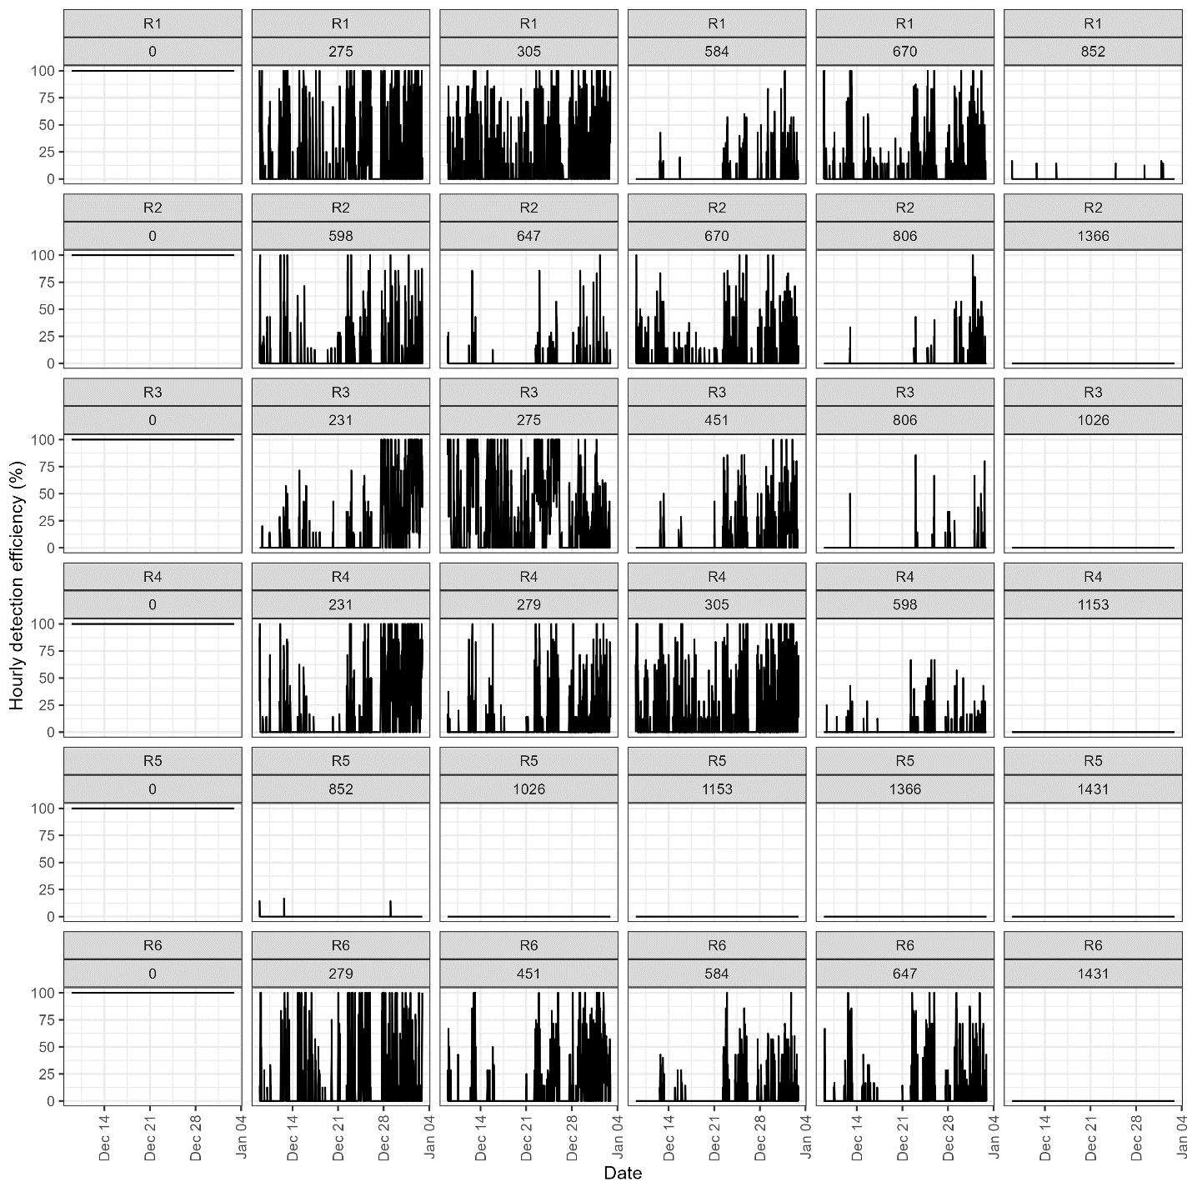
Figure S1 | Hourly detection efficiency for six static acoustic receiver stations (R1-R6) over a one-month study period and at a range of fixed distances from the acoustic transmitters (0-1431 m).
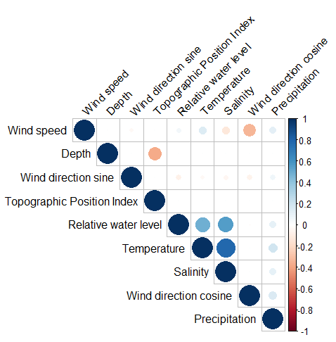
Figure S2 | Correlation matrix for potential factors influencing variation in detection efficiency in a small-scale range test (N=5 receiver stations). Units of measurement for the displayed factors are as follows: wind speed (m/s), bottom depth (m), relative water level (m), temperature (°C), salinity (PSU), precipitation (mm).
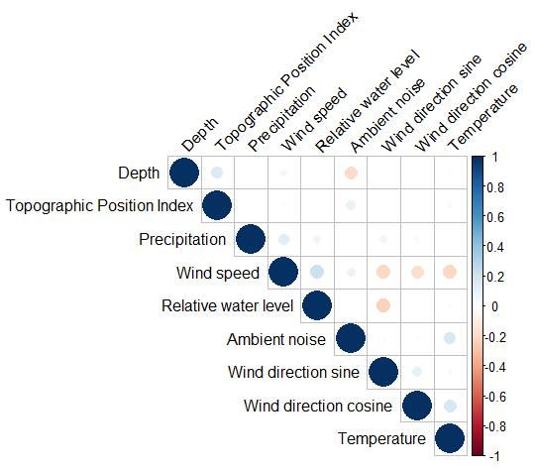
Figure S3 | Correlation matrix for potential factors influencing variation in detection efficiency in a large-scale range test (N=22 receiver stations). Units of measurement for the displayed factors are as follows: bottom depth (m), precipitation (mm), wind speed (m/s), relative water level (m), ambient noise (mV), and temperature (°C).

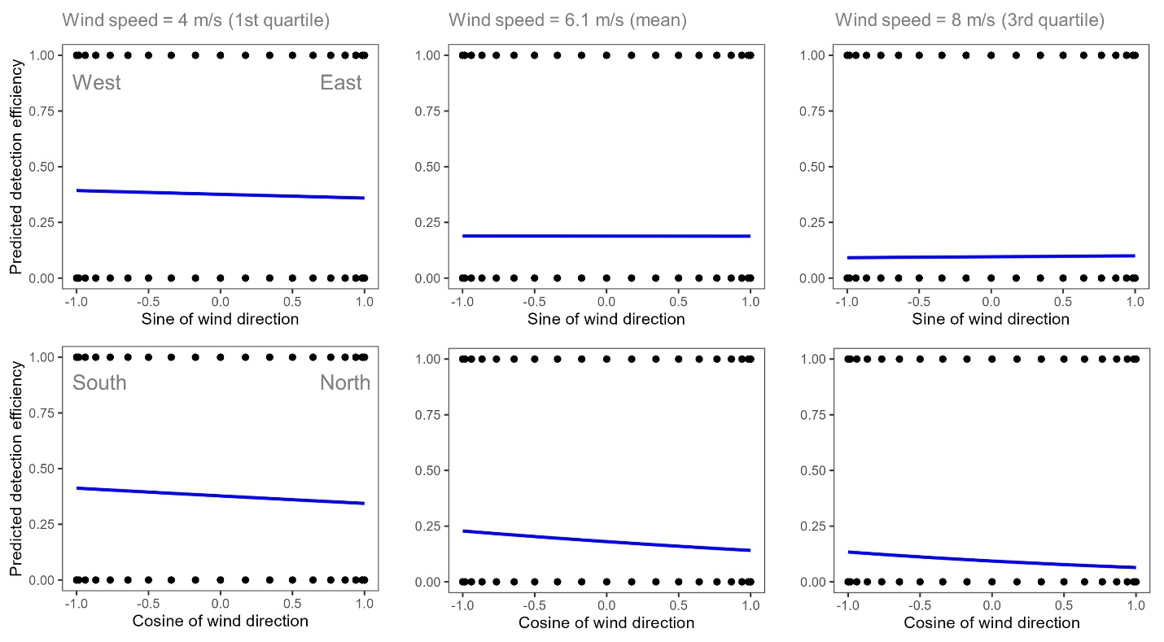
Figure S4 | Predicted detection efficiency relative to distance from tag recorded in a large-scale range test array (N=22 receiver stations). Panels depict changes in predicted detection efficiency with variation in the sine and cosine of wind direction and all other variables held constant at their respective mean values. The effect of wind speed is shown by predicting detection efficiency at three wind speeds: the first quartile value (4 m/s), the mean value (6.1 m/s), and the 3rd quartile value (8 m/s).

Table S1 | Results of a likelihood ratio test to compare a null model and two versions of the logistic regression model with and without and interaction between wind speed and the combined effects of sine of wind direction and cosine of wind direction.
 | Model | Resid. Df | Resid. Dev | Df | Deviance | Pr(>Chi) | Signif.
1 | better ~ 1 | 10655 | 12052.1
2 | better ~ wind_speed + wind_dir_sine + wind_dir_cosine + mean_t + precip_mm + daynight + depth_m + water_level | 10647 | 9695.6 | 8 | 2356.5 | <0.001 | ***
3 | better ~ wind_speed * (wind_dir_sine + wind_dir_cosine) + mean_t + precip_mm + daynight + depth_m + water_level | 10645 | 9604.1 | 2 | 91.5 | <0.001 | ***

