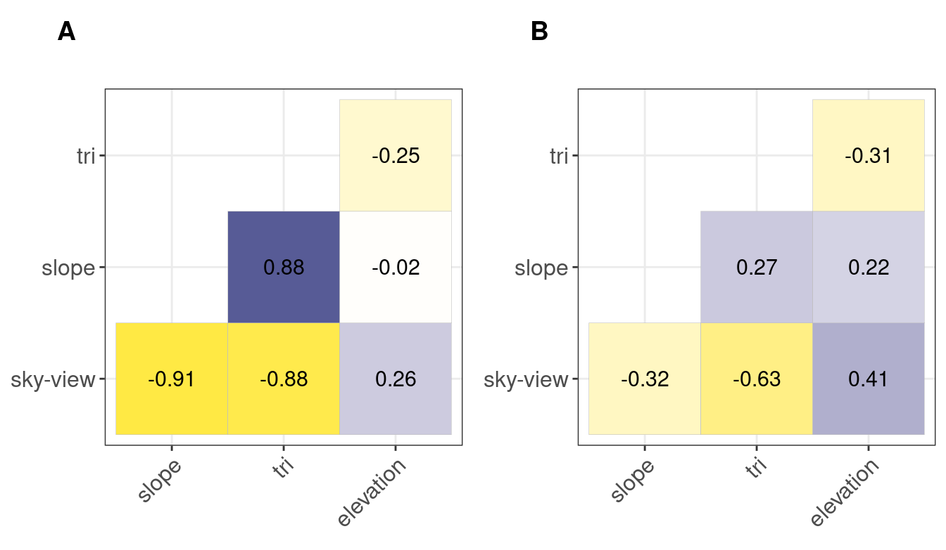
Figure S1: Correlinearity plots for A) the correlations between the explanatory variables for the static tests (n = 8466), and B) the correlations between the explanatory variables of the mobile tests (n = 92). TRI stands for terrain ruggedness index.
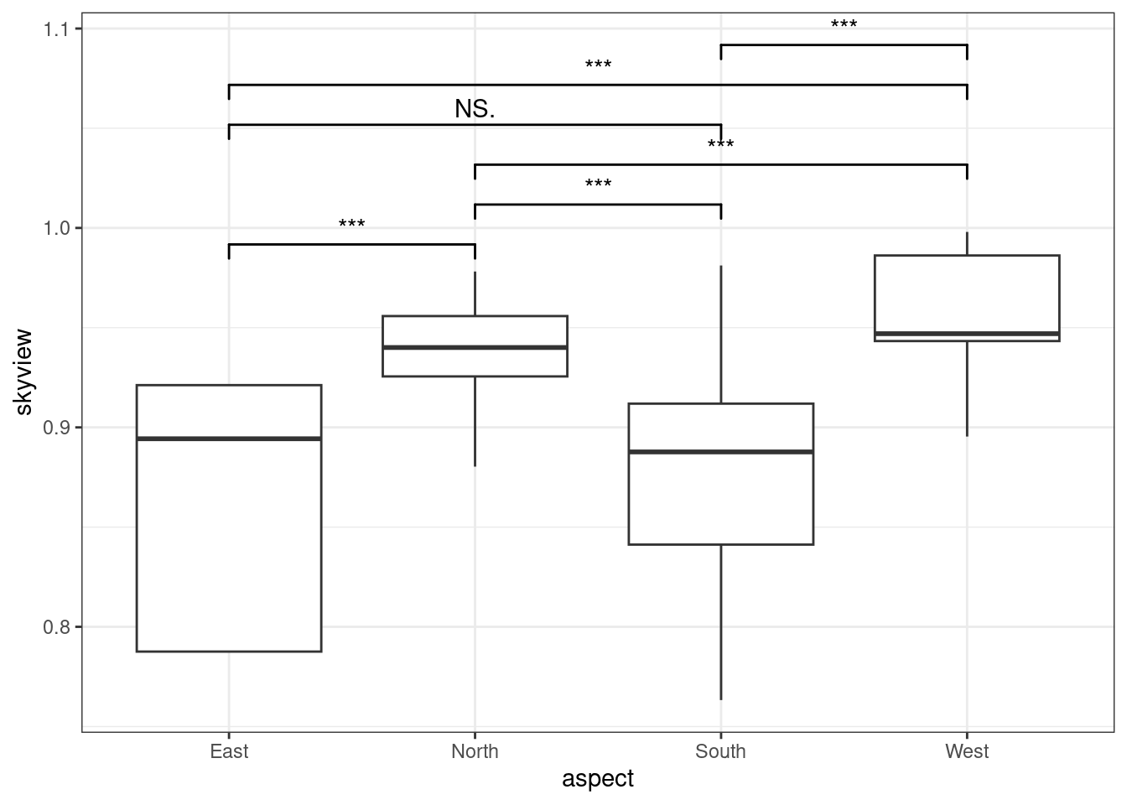
Figure S2: Boxplot of the relation between sky-view and the cardinal directions (N, E, S, W). Analysis of variance (Anovo test) with TukeyHSD post-hoc test. The abrogated stars indicate the strength of evidence.

