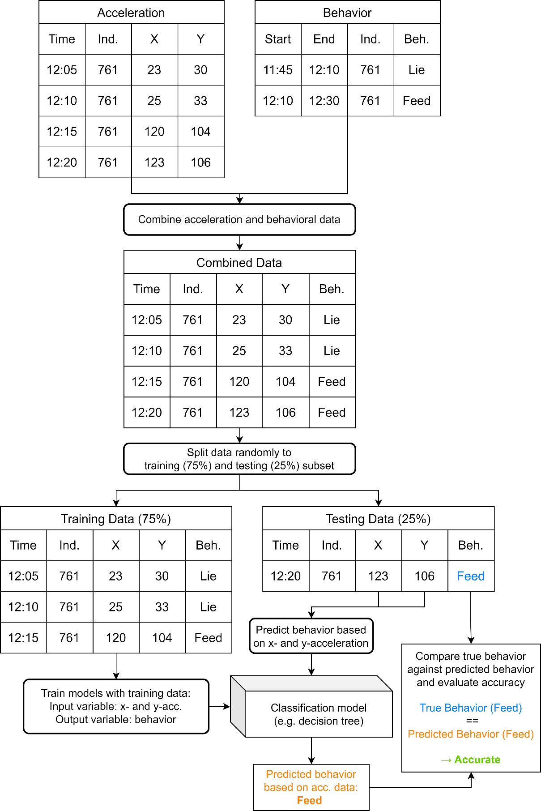
Figure S1: Simplified visualization of the data analysis process to train and test behavioral classification models based on data collected by accelerometers included in GPS-collars.

