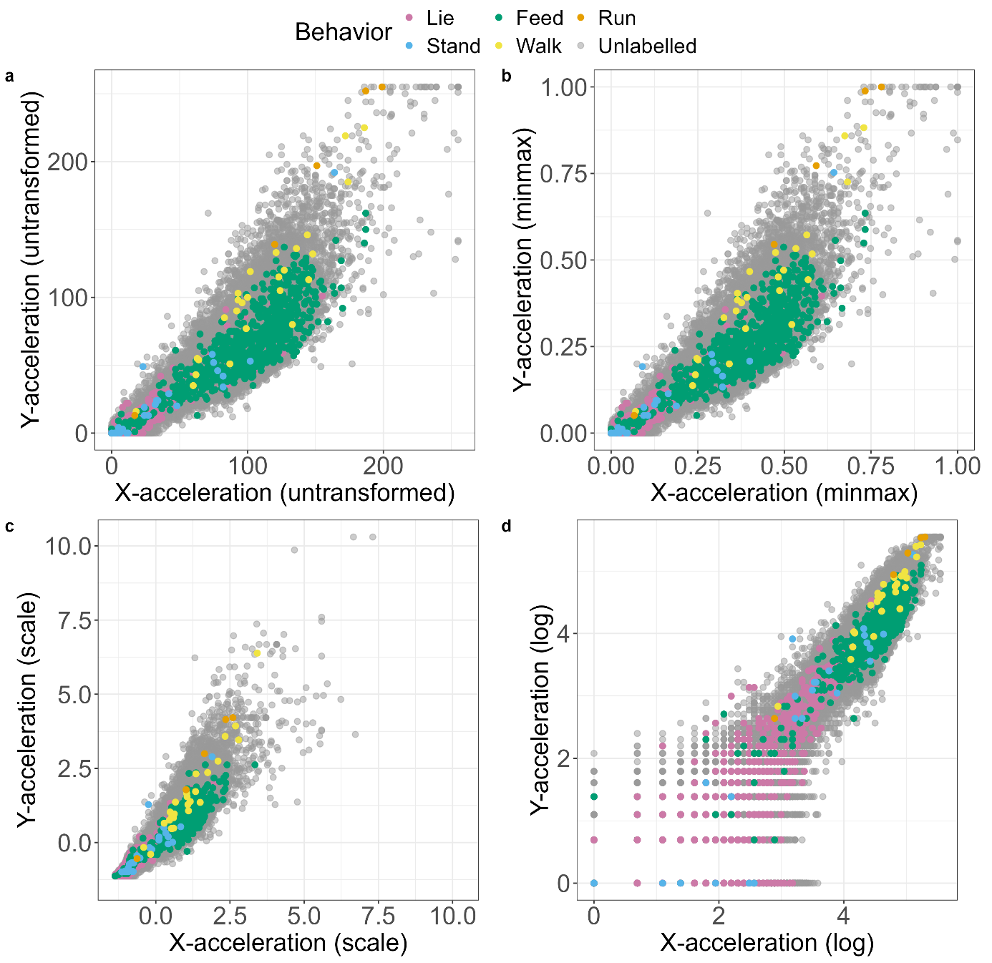
Figure S2: Each point signifies the x- and y-acceleration value of a single 5-min acceleration interval. The plots display the untransformed (a), minmax- (b), scale- (c) and log-normalized (d) acceleration data. Notice how minmax-normalization (b) retains the original distribution of the untransformed acceleration data (a).

