Additional file 1
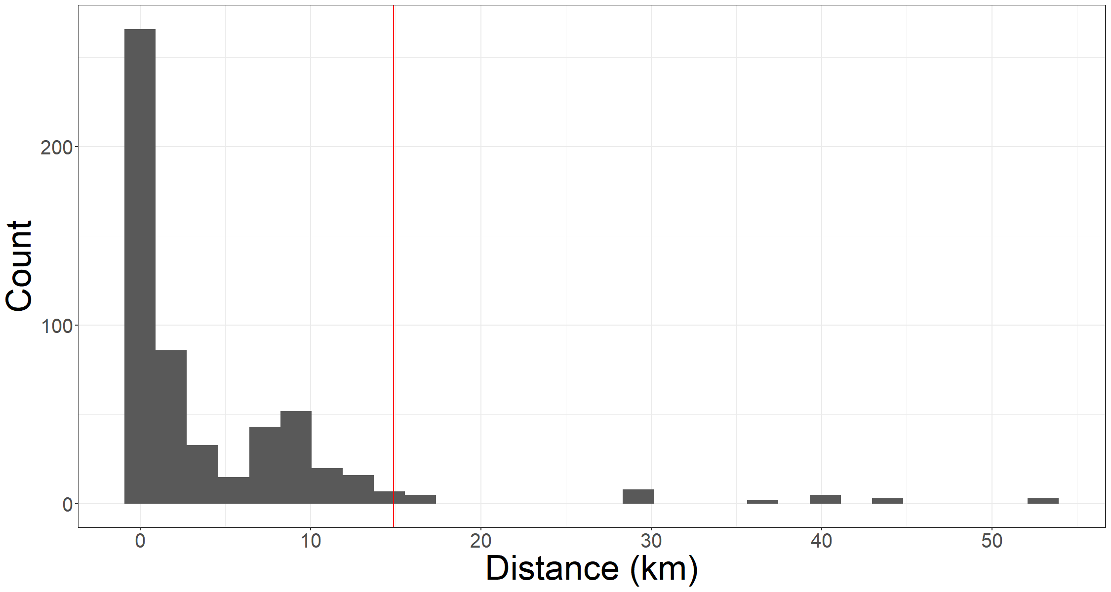
Fig. S1: Histogram of the distances between the tags and the goniometer when the antenna was positioned on top of the research vessel mast (h = 18.7 m a.s.l.). These data were used to fit the LMM. The red vertical line indicates the 95th percentile (15 km).
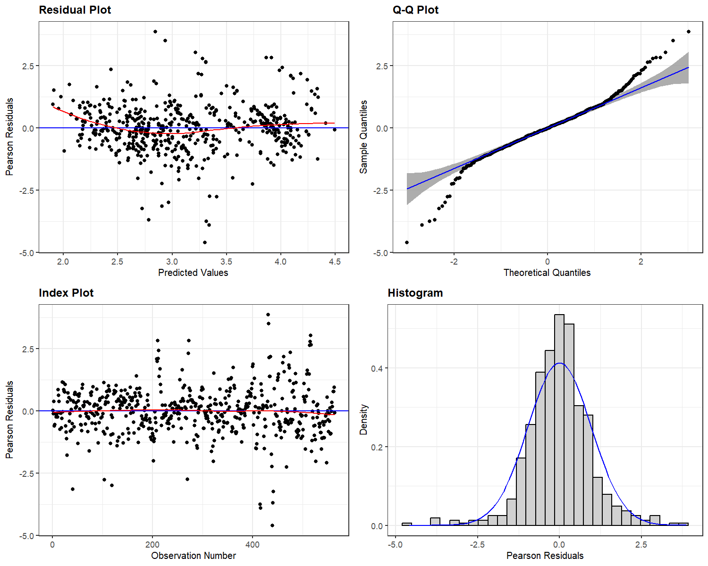
Fig. S2: Residual diagnostics for the linear mixed-effects model predicting log₁₀(distance) from dBm signal strength. Plots show acceptable normality, constant variance, and no evidence of temporal autocorrelation or major model misspecification.

