Supplementary Material 3: additional results

Daily distance results
Table S1: This table shows the statistical results obtained when assessing whether there are differences between daily distances travelled in the three subspecies.

Subspecies | Estimate | Std Error | t value | p value
Wolf | 2.33 | 0.47 | 4.97 | 6.86E-07
Dingo | -0.04 | 0.73 | -0.06 | 0.95
Dog | -2.03 | 0.56 | -3.64 | 2.73E-04

Table S2: This table shows the statistical results obtained when assessing whether there are differences between daily distances travelled in the three subspecies, taking into account only adult individuals.

Subspecies | Estimate | Std Error | t value | p value
Wolf | 2.33 | 0.47 | 5.00 | 5.67E-07
Dingo | -0.02 | 0.62 | -0.04 | 0.97
Dog | -2.47 | 0.56 | -4.39 | 1.15E-05

Table S3: This table shows the statistical results obtained when assessing whether intrinsic variables influence the daily distances travelled in wolves and dogs.
Wolf
Variable | Category | Estimate | Std Error | t value | C.I. 2.5% | C.I 97.5%
Sex | Female | 7.87 | 1.84 | 4.29 | 4.07 | 11.55
Sex | Male | 0.36 | 1.31 | 0.28 | -2.06 | 3.92
Age | Adult | 7.87 | 1.84 | 4.29 | 4.07 | 11.55
Age | Subadult | 4.42 | 1.75 | 2.53 | 0.85 | 7.69
Dog
Variable | Category | Estimate | Std Error | t value | p value
Sex | Female | 0.03 | 0.75 | 0.05 | 0.96
Sex | Male | 0.15 | 0.09 | 1.60 | 0.11

Home range
Table S4: This table shows the methodology adopted for home range estimation in the revision papers.
Subspecies | Method | Frequency
Wolf | Minimum Convex Polygon | 21 papers
Wolf | Fixed kernel density estimation | 7 papers
Wolf | Autocorrelated Kernel density estimation | 3 papers
Wolf | Brownian Bridge Movement Model | 2 papers
Wolf | Adaptive Kernel density estimation | 2 paper
Wolf | Kernel Brownian Bridge | 1 paper
Dingo | Adaptive Kernel density estimation | 1 paper
Dingo | Minimum Convex Polygon | 3 papers
Dingo | Fixed Kernel density estimation | 2 paper
Dog | Minimum Convex Polygon | 11 papers
Dog | Biased Random Bridge | 5 papers
Dog | Connection of the outlying sightings | 5 papers
Dog | Autocorrelated Kernel density estimation | 2 papers
Dog | Fixed Kernel density estimation | 1 paper
Dog | Characteristic Hull Polygon | 1 paper
Dog | Time-Localized Convex Hull | 1 paper

Daily home range results from Kernel method
Table S5: This table shows the statistical results obtained when assessing whether there are differences between daily home range in the three subspecies, with Kernel method.
Variable | Subspecies | Method | Estimate | Std Error | t value | p value
Extended area | Wolf | 95%Kernel | 3.32 | 0.87 | 3.83 | 2.57E-04
Extended area | Dog | 90-95% Kernel | -6.02 | 0.29 | -20.61 | <2e-16
Core area | Wolf | 50%Kernel | 2.33 | 1.33 | 1.76 | 0.08
Core area | Dog | 50%Kernel | -5.87 | 0.45 | -13.16 | <2e-16

Table S6: This table shows the statistical results obtained when assessing whether intrinsic variables influence the daily home range in the three subspecies, with Kernel method.
Extended area
Wolf
Variable | Category | Estimate | Std Error | t value | p value
Sex | Female | 141.00 | 16.15 | 8.73 | 2.40E-09
Sex | Male | -23.55 | 19.64 | -1.20 | 0.24
Age | Adult | 141.00 | 16.15 | 8.73 | 2.40E-09
Age | Subadult | 20.34 | 21.76 | 0.94 | 0.36
Dog
Sex | Female | -1.81 | 0.25 | -7.10 | 1.22E-12
Sex | Male | 0.34 | 0.21 | 1.66 | 0.10
Core area
Wolf
Sex | Female | 31.05 | 3.95 | 7.86 | 1.88E-08
Sex | Male | -6.03 | 4.80 | -1.26 | 0.22
Age | Adult | 31.05 | 3.95 | 7.86 | 1.88E-08
Age | Subadult | 6.42 | 5.32 | 1.21 | 0.24
Dog
Sex | Female | -5.83 | 2.01 | -2.91 | 0.01
Sex | Male | 0.89 | 0.48 | 1.85 | 0.07

Daily home range results from MCP method
Table S7: This table shows the statistical results obtained when assessing whether there are differences between daily home range in the three subspecies, with MCP method.
Variable | Subspecies | Method | Estimate | Std Error | t value | Pr(>|t|)
Extended area | Wolf | 95%Kernel | 2.58 | 1.61 | 1.60 | 0.12
Extended area | Dog | 95% Kernel | -4.20 | 0.53 | -7.86 | 5.64E-11
Core area | Wolf | 50%Kernel | 1.72 | 2.17 | 0.79 | 0.43
Core area | Dog | 50%Kernel | -4.29 | 0.72 | -5.96 | 1.18E-07

Table S8: This table shows the statistical results obtained when assessing whether intrinsic variables influence the daily home range in the three subspecies, with MCP method.
Extended area
Wolf
Variable | Category | Estimate | Std Error | t value | Pr(>|t|)
Sex | Female | 7.56 | 1.82 | 4.15 | 2.97E-04
Sex | Male | -2.11 | 2.22 | -0.95 | 0.35
Age | Adult | 7.56 | 1.82 | 4.15 | 2.97E-04
Age | Subadult | 8.93 | 2.45 | 3.64 | 1.14E-03
Dog
Sex | Female | -4.75 | 3.11 | -1.53 | 0.14
Sex | Male | 0.25 | 0.72 | 0.35 | 0.73
Core area
Wolf
Sex | Female | -2.04 | 0.66 | -3.11 | 4.42E-03
Sex | Male | -0.72 | 0.80 | -0.90 | 0.38
Age | Adult | -2.04 | 0.66 | -3.11 | 4.42E-03
Age | Subadult | 3.07 | 0.89 | 3.47 | 1.78E-03
Dog
Sex | Female | -5.67 | 4.20 | -1.35 | 0.19
Sex | Male | 0.04 | 0.97 | 0.04 | 0.97

Seasonal home range results from Kernel method
Table S9: This table shows the statistical results obtained when assessing whether there are differences between seasonal home range in the three subspecies, with Kernel method.
COLD SEASON
Variable | Subspecies | Method | Estimate | Std Error | t value | Pr (>|t|)
Extended area | Wolf | 95% Kernel | 7.51 | 1.09 | 6.86 | 1.43E-09
Extended area | Dingo | 90 – 95% Kernel | -3.14 | 0.55 | -5.74 | 1.75E-07
Extended area | Dog | 95% Kernel | -7.55 | 0.46 | -16.44 | < 2e-16
Core area | Wolf | 50% Kernel | 5.89 | 1.53 | 3.85 | 2.63E-04
Core area | Dingo | 50% Kernel | -3.50 | 1.13 | -3.09 | 2.90E-03
Core area | Dog | 50% Kernel | -7.31 | 0.67 | -10.88 | < 2e-16
WARM SEASON
Variable | Subspecies | Method | Estimate | Std Error | t value | p value
Extended area | Wolf | 95% Kernel | 6.30 | 1.39 | 4.53 | 0.00E+00
Extended area | Dingo | 85 – 95% Kernel | -5.04 | 0.68 | -7.40 | 0.00E+00
Extended area | Dog | 95% Kernel | -7.71 | 0.52 | -14.81 | 0.00E+00
Variable | Subspecies | Method | Estimate | Std Error | t value | Pr (>|t|)
Core area | Wolf | 50% Kernel | 4.90 | 1.27 | 3.85 | 3.00E-04
Core area | Dog | 50% Kernel | -6.88 | 1.23 | -5.60 | 6.08E-07

Table S10: This table shows the statistical results obtained when assessing whether there are differences between seasonal home range in the three subspecies using the Kernel method, taking into account only adult individuals.
COLD SEASON
Variable | Subspecies | Method | Estimate | Std Error | t value | Pr (>|t|)
Extended area | Wolf | 95% Kernel | 5.50 | 0.83 | 6.61 | 0.000
Extended area | Dingo | 90 – 95% Kernel | -2.71 | 0.39 | -6.96 | 0.000
Extended area | Dog | 95% Kernel | -7.59 | 0.34 | -22.61 | 0.000
WARM SEASON
Variable | Subspecies | Method | Estimate | Std Error | t value | p value
Extended area | Wolf | 95% Kernel | 6.34 | 2.03 | 3.13 | 0.0028
Extended area | Dingo | 85 – 95% Kernel | -5.54 | 1.12 | -4.96 | 0.000
Extended area | Dog | 95% Kernel | -7.73 | 0.77 | -10.09 | 0.000

Table S11: This table shows the statistical results obtained when assessing whether intrinsic variables influence the seasonal home range in the three subspecies, with Kernel method.
COLD SEASON
Extended area
Wolf
Variable | Category | Estimate | Std Error | t value | C.I. 2.5% | C.I 97.5%
Sex | Female | 5.23 | 1.24 | 4.21 | 2.62 | 7.57
Sex | Male | -0.13 | 0.31 | -0.40 | -0.75 | 0.47
Age | Adult | 5.23 | 1.24 | 4.21 | 2.62 | 7.57
Age | Subadult | -0.22 | 0.41 | -0.54 | -1.07 | 0.54
Dingo
Variable | Category | Estimate | Std Error | t value | C.I. 2.5% | C.I 97.5%
Sex | Female | 3.58 | 0.84 | 4.24 | 2.05 | 5.09
Sex | Male | -0.01 | 0.32 | -0.03 | -0.63 | 0.61
Age | Adult | 3.58 | 0.84 | 4.24 | 2.05 | 5.09
Age | Subadult | 0.23 | 0.44 | -0.30 | -0.58 | 1.21
Dog
Variable | Category | Estimate | Std Error | t value | Pr(>|t|)
Sex | Female | 1.09 | 2.05 | 0.53 | 0.60
Sex | Male | 0.61 | 0.40 | 1.55 | 0.13
Core area
Wolf
Variable | Category | Estimate | Std Error | t value | C.I. 2.5% | C.I 97.5%
Sex | Female | 3.58 | 0.84 | 4.24 | 2.05 | 5.09
Sex | Male | -0.01 | 0.32 | -0.03 | -0.63 | 0.61
Age | Adult | 3.58 | 0.84 | 4.24 | 2.05 | 5.09
Age | Subadult | 0.23 | 0.44 | -0.30 | -0.58 | 1.21
Dog
Variable | Category | Estimate | Std Error | t value | p value
Sex | Female | -7.06 | 2.84 | -2.48 | 0.02
Sex | Male | 1.57 | 0.61 | 2.59 | 0.01
WARM SEASON
Extended area
Wolf
Variable | Category | Estimate | Std Error | t value | Pr(>|z|)
Sex | Female | 7.44 | 2.14 | 3.48 | 5.05E-04
Sex | Male | 0.01 | 0.36 | 0.01 | 0.99
Age | Adult | 7.44 | 2.14 | 3.48 | 5.05E-04
Age | Subadult | 0.26 | 0.57 | 0.47 | 0.64
Dingo
Variable | Category | Estimate | Std Error | t value | p value
Sex | Female | 17.24 | 6.34 | 2.72 | 0.03
Sex | Male | -13.66 | 4.87 | -2.81 | 0.02
Age | Adult | 17.24 | 6.34 | 2.72 | 0.03
Age | Subadult | -4.28 | 4.84 | -0.88 | 0.40
Dog
Variable | Category | Estimate | Std Error | t value | Pr(>|t|)
Sex | Female | -4.42 | 0.36 | -12.17 | 1.07E-12
Sex | Male | -0.43 | 0.48 | -0.90 | 0.38
Core area
Wolf
Variable | Category | Estimate | Std Error | t value | Pr(>|t|)
Sex | Female | -0.64 | 0.24 | -2.69 | 0.01
Sex | Male | -0.04 | 0.31 | -0.11 | 0.91
Age | Adult | -0.64 | 0.24 | -2.69 | 0.01
Age | Subadult | 0.78 | 0.35 | 2.24 | 0.03
Dog
Variable | Category | Estimate | Std Error | t value | p value
Sex | Female | -7.14 | 0.50 | -14.29 | 0.00
Sex | Male | -0.10 | 0.66 | -0.16 | 0.88

Seasonal home range results from MCP method
Table S12: This table shows the statistical results obtained when assessing whether there are differences between seasonal home range in the three subspecies, with MCP method.
COLD SEASON
Variable | Subspecies | Method | Estimate | Std Error | t value | Pr(>|z|)
Extended area | Wolf | 95-100% MCP | 5.91 | 0.01 | 1090.77 | < 2e-16
Extended area | Dingo | 95-100% MCP | -2.32 | 0.01 | -427.97 | < 2e-16
Extended area | Dog | 95-100% MCP | -6.75 | 1.03 | -6.56 | 5.39E-11
Variable | Subspecies | Method | Estimate | Std Error | t value | p value
Core area | Wolf | 50% MCP | 3.07 | 0.66 | 4.62 | 0.00E+00
Core area | Dog | 50% MCP | -8.34 | 0.37 | -22.72 | 0.00E+00
WARM SEASON
Variable | Subspecies | Method | Estimate | Std Error | t value | Pr(>|z|)
Extended area | Wolf | 95-100% MCP | 4.97 | 3.35E-03 | 1485.70 | < 2e-16
Extended area | Dingo | 95-100% MCP | -1.84 | 0.85 | -2.16 | 0.03
Extended area | Dog | 95% MCP | -6.52 | 1.41 | -4.62 | 3.90E-06
Variable | Subspecies | Method | Estimate | Std Error | t value | Pr (>|t|)
Core area | Wolf | 50% MCP | 4.73 | 1.22 | 3.86 | 3.01E-04
Core area | Dog | 50% MCP | -6.79 | 1.22 | -5.54 | 9.07E-07

Table S13: This table shows the statistical results obtained when assessing whether intrinsic variables influence the seasonal home range in the three subspecies, with MCP method.
COLD SEASON
Extended area
Wolf
Variable | Category | Estimate | Std Error | t value | Pr(>|t|)
Sex | Female | 4.97 | 0.52 | 9.49 | 0.00
Sex | Male | 0.01 | 0.31 | 0.03 | 0.98
Age | Adult | 4.97 | 0.52 | 9.49 | 0.00
Age | Subadult | -0.22 | 0.35 | -0.64 | 0.53
Dog
Variable | Category | Estimate | Std Error | t value | Pr(>|t|)
Sex | Female |  | 0.84 | 0.39 | 0.41
Sex | Male |  | 0.39 | 2.04 | 0.05
Core area
Wolf
Variable | Category | Estimate | Std Error | t value | C.I. 2.5% | C.I 97.5%
Sex | Female | 3.04 | 0.85 | 3.59 | 1.46 | 4.67
Sex | Male | -0.26 | 0.46 | -0.58 | -1.22 | 0.55
Age | Adult | 3.04 | 0.85 | 3.59 | 1.46 | 4.67
Age | Subadult | -0.08 | 0.56 | -0.58 | -1.03 | 1.11
Dog
Variable | Category | Estimate | Std Error | t value | Pr(>|t|)
Sex | Female | -8.21 | 2.70 | -3.04 | 4.70E-03
Sex | Male | 1.53 | 0.50 | 3.08 | 4.20E-03
WARM SEASON
Extended area
Wolf
Variable | Category | Estimate | Std Error | t value | C.I. 2.5% | C.I 97.5%
Sex | Female | 5.74 | 1.22 | 4.71 | 3.38 | 8.10
Sex | Male | -0.01 | 0.20 | -0.07 | -0.39 | 0.39
Age | Adult | 5.74 | 1.22 | 4.71 | 3.38 | 8.10
Age | Subadult | 0.29 | 0.20 | -0.09 | -0.25 | 0.84
Dog
Variable | Category | Estimate | Std Error | t value | Pr(>|t|)
Sex | Female | -2.27 | 1.66 | -1.37 | 0.18
Sex | Male | 0.24 | 0.43 | 0.56 | 0.58
Core area
Wolf
Variable | Category | Estimate | Std Error | t value | Pr(>|t|)
Sex | Female | 0.07 | 0.27 | 0.25 | 0.81
Sex | Male | 0.18 | 0.36 | 0.52 | 0.61
Age | Adult | 0.07 | 0.27 | 0.25 | 0.81
Age | Subadult | 0.75 | 0.40 | 1.86 | 0.07
Dog
Variable | Category | Estimate | Std Error | t value | p value
Sex | Female | -10.49 | 4.75 | -2.21 | 0.04
Sex | Male | 0.83 | 0.72 | 1.16 | 0.26

Daily activity patterns
Figure 1: Daily activity patterns of wolves (top panel, 30 individuals from 2 studies), and dogs (bottom panel, 37 individuals from 1 study) from from processed raw GPS data on activity patterns of Canis lupus spp. The lines represent the mean speed (km/h) and the error bars indicate the standard deviation for adults (orange) and subadults (green).
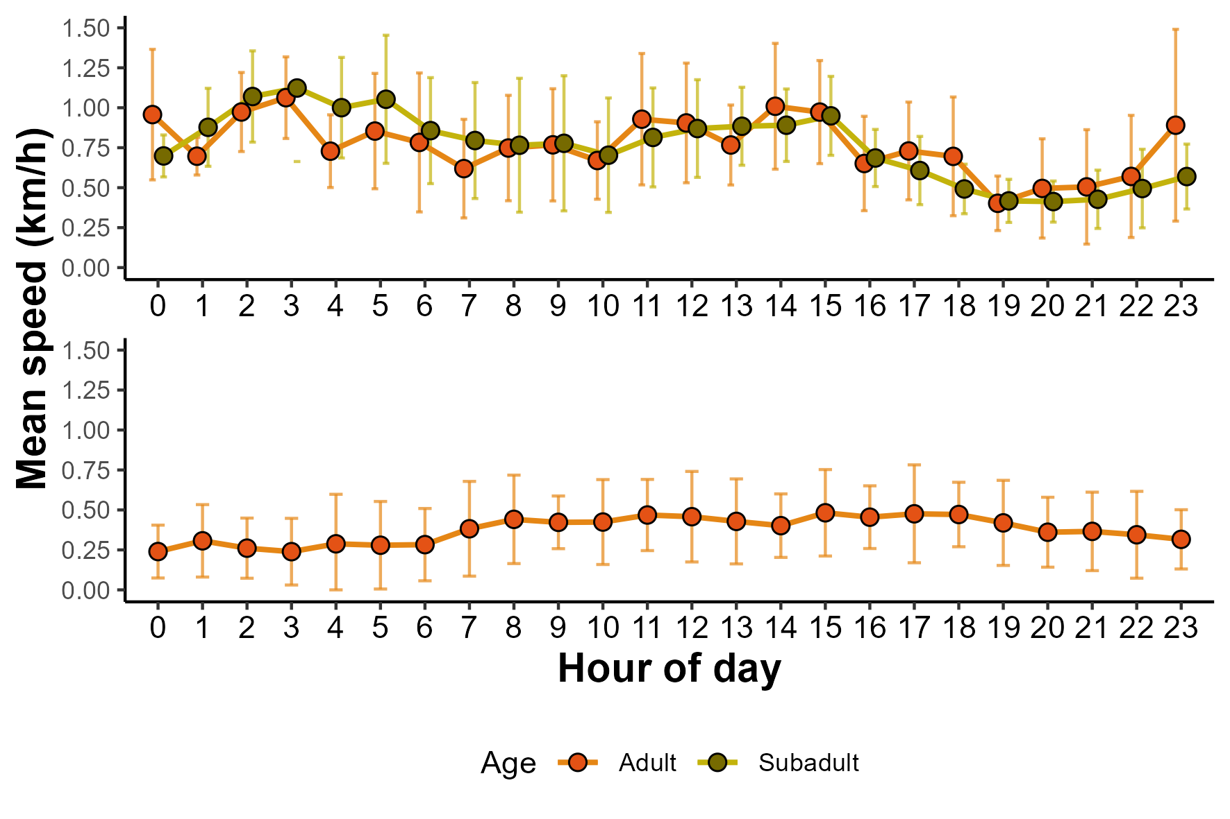
Figure 2: Daily activity patterns of wolves (top panel, 30 individuals from 2 studies), and dogs (bottom panel, 37 individuals from 1 study) from from processed raw GPS data on activity patterns of Canis lupus spp. The lines represent the mean speed (km/h) and the error bars indicate the standard deviation for females (purple) and males (green).
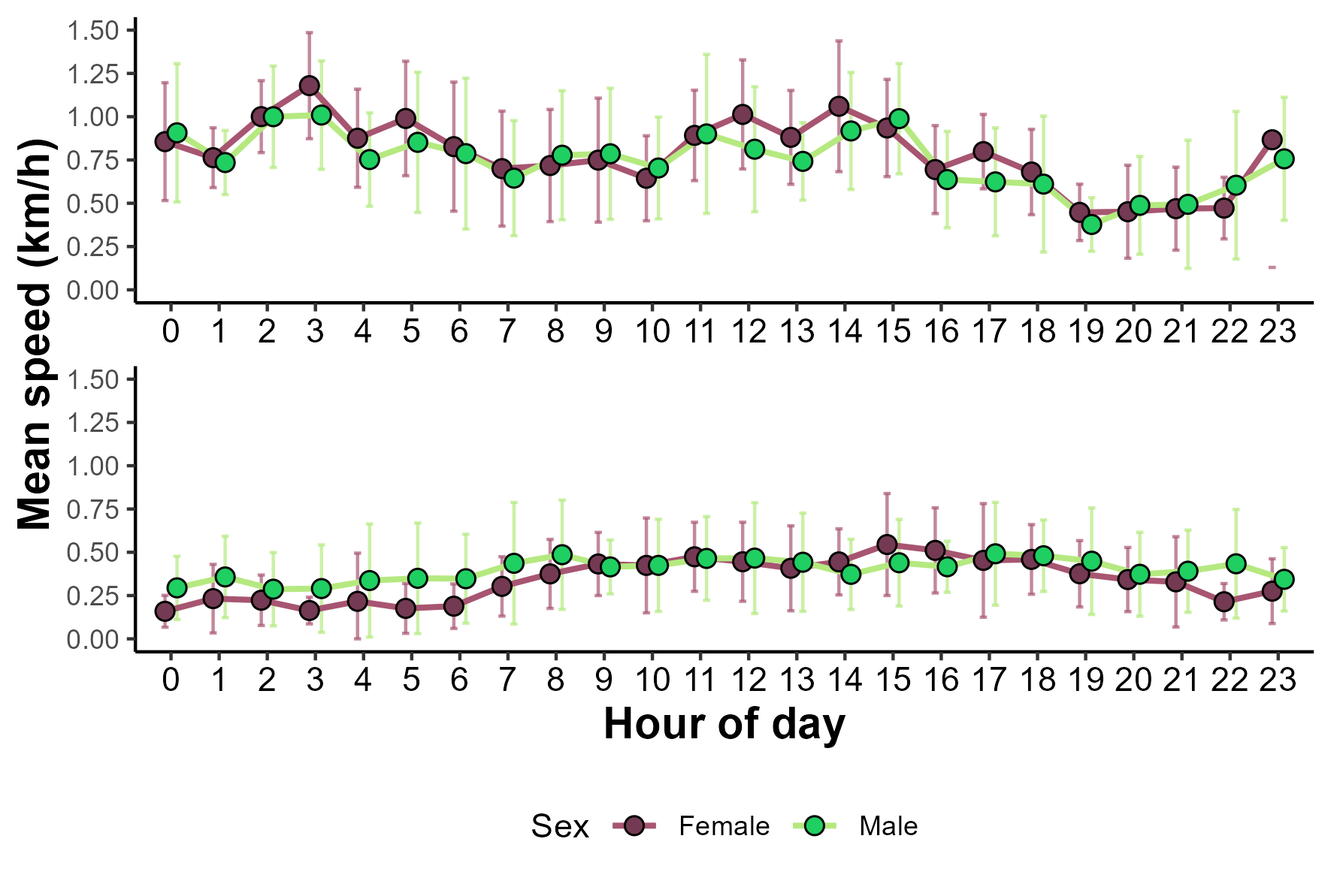

Table S14: This table shows the statistical results obtained when assessing whether there are differences between daily activity patterns in two subspecies, wolves and dogs.
Diurnal
Subspecies | Beta | Odds Ratio | C.I. 2.5% | C.I 97.5% | p value
Wolf | -0.547 | 0.579 | 0.276 | 1.217 | 0.149
Dog | 1.407 | 4.083 | 1.466 | 11.366 | 0.007
Nocturnal
Wolf | -0.547 | 0.579 | 0.276 | 1.217 | 0.149
Dog | -1.564 | 0.209 | 0.058 | 0.75 | 0.016
Crepuscular
Wolf | -1.386 | 0.25 | 0.102 | 0.612 | -1.386
Dog | -0.256 | 0.774 | 0.222 | 2.704 | -0.256
Cathemeral
Wolf | -0.847 | 0.429 | 0.196 | 0.936 | -0.847
Dog | -1.009 | 0.365 | 0.107 | 1.24 | -1.009

