Supplementary Material
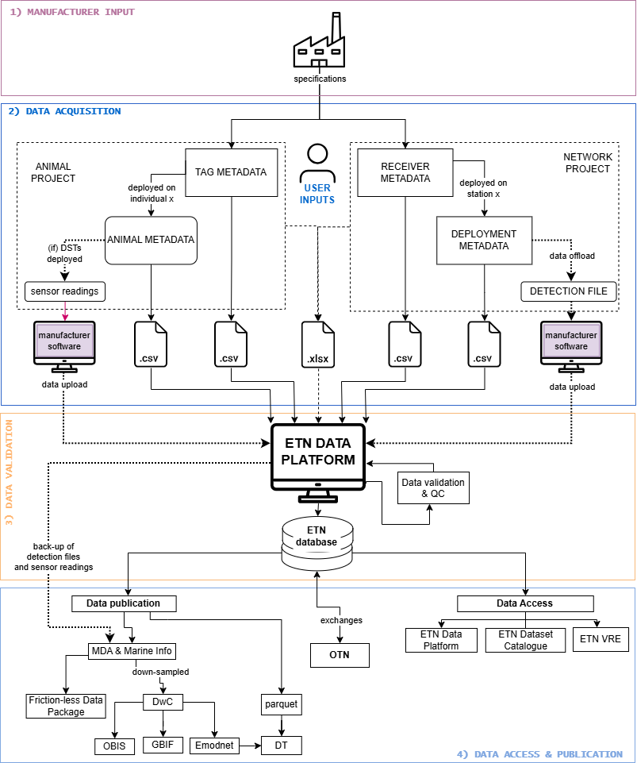
Figure 1 Supplementary material. Dataflow Schema for ETN. ETN users upload information on their purchased tags and receivers based on information provided by manufacturers, and animals and deployments based on information they collect on the field. These metadata is quality controlled during the import process. ETN users then offload receiver detections when servicing their equipment and upload those raw files to the ETN Data Platform. The ETN system subsequently matches tags to detections. ETN data can be accessed via the ETN Data Platform, the ETN Dataset Catalogue and downloaded via the ETN VRE (includes the etn R package). Raw data is automatically archived in the Marine Data Archive (MDA). Public data is further published in full-resolution as Friction-less Data Package and parquet, and downsampled as DwC.

