Supplementary material 1 - Visual validation and exclusion of incorrectly classified inactivity periods using HMM
Visual validation of the HMM classifications based on daily mean activity values led us to exclude 28 observations for which the start date of the inactivity period, the end date, or both did not appear to be correctly identified. These cases were generally characterized by one of the following patterns:
- daily mean activity values at the beginning and/or end of the inactivity period classified as inactive, despite being substantially higher than activity levels observed during the rest of the winter (Figure S1.1 A and D);
- daily mean activity values immediately before and/or after the inactivity period classified as transitional, despite being similar to, or only marginally higher than, activity levels during the rest of the winter (Figure S1.1 B);
- elevated daily mean activity during gestation incorrectly classified as belonging to the transitional state (one case among the 28 excluded observations, Figure S1.1 C).
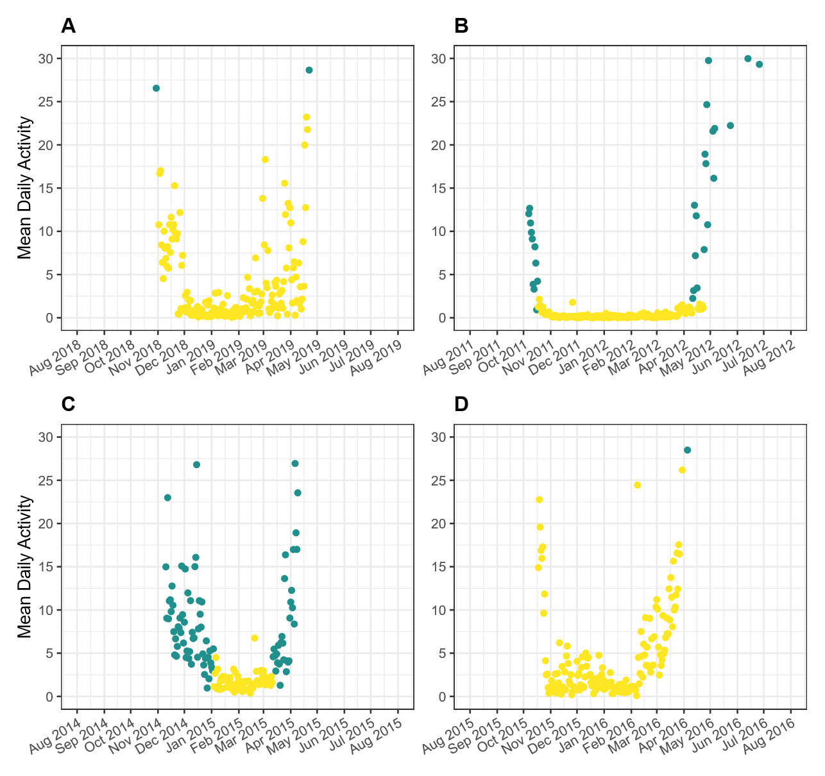
Figure S1.1 - Examples of mean daily activity over time for different individuals between August and July that were excluded following visual validation of the HMM outputs. The y-axis was truncated at 30 to improve visual interpretation of transitions between the inactive (yellow) and transitional (green) activity states assigned by the Hidden Markov Model.

