Supplementary material 2 - Comparison of denning dates estimated from daily mean vs. variance activity using HMM
We applied the same methodology using Hidden Markov Model (HMM) but based on daily variance activity instead of daily mean activity (See step 3 of the methodology). We studied the correlation between den entry and exit dates obtained by HMM using daily mean activity and daily variance activity with Pearson linear correlation coefficient with its 95% confidence. The strict concordance between mean and variance was 62% for den entry and 66% for den exit, with 77% of entry dates and 79% of exit dates falling within a ±2-day agreement window. (Figure S2.1).
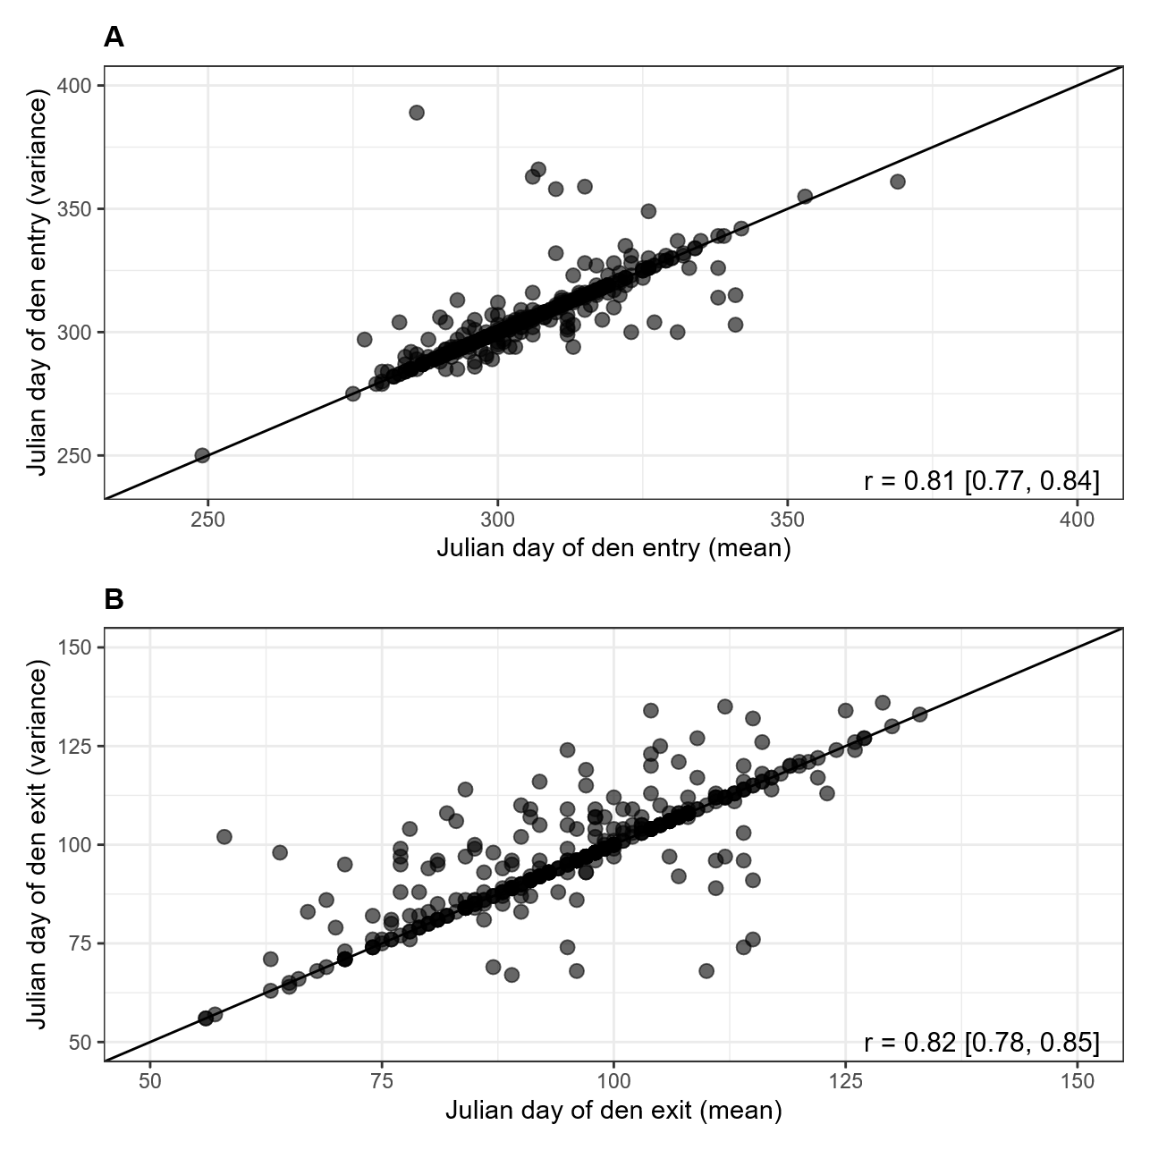
Figure S2.1 - Correlation of den entry (A) and exit (B) dates obtained using Hidden Markov Model based on daily mean activity and daily variance activity.

