Supplementary material 3 - Linear mixed-effects models of denning phenology across demographic groups
To assess whether denning phenology differed among demographic groups, we used linear mixed-effects models fitted. Separate models were built for den entry and den exit dates (expressed as Julian day). In each model, demographic group and year were included as fixed effects, while individual identity was included as random intercept to account for repeated measures of the same individuals across years. Estimated marginal means (LS-means) were computed for each demographic group. Pairwise contrasts between reproductive status categories were then performed using Tukey’s post hoc tests to control for Type I error inflation associated with multiple comparisons (Tables S3.1 and S3.2; Figure S3.1).
Table S3.1 - Pairwise comparisons of adjusted means (EMMeans) for date of den entry across Scandinavian brown bear demographic groups, with Tukey’s adjustment for multiple testing.
Comparison | Estimate | SE | df | lower.CL | upper.CL | t.ratio | p.value
AM – F COY | 3.200 | 2.902 | 234.0 | -5.430 | 11.830 | 1.103 | 0.9268
AM – F Y | 1.294 | 3.576 | 317.4 | -9.316 | 11.904 | 0.362 | 0.9998
AM – PF | 13.143 | 2.558 | 176.1 | 5.514 | 20.772 | 5.138 | < 0.0001
AM – AF | 6.247 | 3.173 | 271.0 | -3.178 | 15.672 | 1.969 | 0.4370
AM – SF | -4.043 | 2.783 | 220.7 | -12.325 | 4.240 | -1.452 | 0.7724
AM – SM | -3.043 | 3.590 | 288.3 | -13.703 | 7.617 | -0.848 | 0.9796
F COY – F Y | -1.906 | 2.976 | 252.0 | -10.751 | 6.938 | -0.641 | 0.9954
F COY – PF | 9.943 | 1.776 | 258.2 | 4.665 | 15.220 | 5.599 | < 0.0001
F COY – AF | 3.047 | 2.644 | 317.1 | -4.800 | 10.893 | 1.152 | 0.9111
F COY – SF | -7.243 | 2.223 | 340.3 | -13.836 | -0.650 | -3.258 | 0.0209
F COY – SM | -6.243 | 3.454 | 283.6 | -16.500 | 4.014 | -1.807 | 0.5441
F Y – PF | 11.849 | 2.748 | 262.3 | 3.683 | 20.015 | 4.311 | 0.0005
F Y – AF | 4.953 | 3.394 | 301.7 | -5.123 | 15.028 | 1.459 | 0.7687
F Y – SF | -5.336 | 3.089 | 315.9 | -14.502 | 3.829 | -1.728 | 0.5979
F Y – SM | -4.337 | 4.035 | 329.0 | -16.307 | 7.633 | -1.075 | 0.9351
PF – AF | -6.896 | 2.330 | 325.1 | -13.808 | 0.016 | -2.960 | 0.0510
PF – SF | -17.185 | 1.817 | 341.0 | -22.575 | -11.796 | -9.458 | < 0.0001
PF – SM | -16.186 | 3.166 | 253.7 | -25.596 | -6.775 | -5.112 | < 0.0001
AF – SF | -10.289 | 2.562 | 325.0 | -17.891 | -2.687 | -4.016 | 0.0014
AF – SM | -9.289 | 3.681 | 305.0 | -20.216 | 1.637 | -2.523 | 0.1546
SF – SM | 1.000 | 3.353 | 279.0 | -8.959 | 10.959 | 0.298 | 0.9999
PF = Pregnant female; F COY = Female with cubs-of-the-year; F Y = Female with yearlings; AF = Solitary adult female; AM = Adult male; SF = Solitary subadult female; SM = Solitary subadult male.

Table S3.2 - Pairwise comparisons of adjusted means (EMMeans) for date of den exit across Scandinavian brown bear demographic groups, with Tukey’s adjustment for multiple testing.
Comparison | Estimate | SE | df | lower.CL | upper.CL | t.ratio | p.value
AM – FGB CL | -2.752 | 3.663 | 282.1 | -5.430 | 11.830 | -0.751 | 0.9980
AM – FGB CU | -14.134 | 3.190 | 238.2 | -9.316 | 11.904 | -4.431 | 0.0005
AM – FGB COY | -21.535 | 2.591 | 183.6 | 5.514 | 20.772 | -8.312 | < 0.0001
AM – F TYO | -10.316 | 3.586 | 291.8 | -3.178 | 15.672 | -2.877 | 0.0987
AM – F Y | -16.588 | 2.884 | 225.9 | -12.325 | 4.240 | -5.753 | < 0.0001
AM – AF | -9.680 | 3.152 | 253.6 | -13.703 | 7.617 | -3.071 | 0.0589
AM – SF | -7.048 | 2.947 | 238.8 | -10.751 | 6.938 | -2.392 | 0.2933
AM – SM | -8.825 | 3.772 | 286.9 | 4.665 | 15.220 | -2.340 | 0.3221
FGB CL – FGB CU | -11.383 | 3.677 | 311.6 | -4.800 | 10.893 | -3.096 | 0.0542
FGB CL – FGB COY | -18.783 | 3.096 | 309.0 | -13.836 | -0.650 | -6.066 | < 0.0001
FGB CL – F TYO | -7.564 | 3.903 | 291.4 | -16.500 | 4.014 | -1.938 | 0.5877
FGB CL – F Y | -13.836 | 3.251 | 306.6 | 3.683 | 20.015 | -4.256 | 0.0009
FGB CL – AF | -6.929 | 3.546 | 305.9 | -5.123 | 15.028 | -1.954 | 0.5767
FGB CL – SF | -4.296 | 3.313 | 302.7 | -14.502 | 3.829 | -1.297 | 0.9317
FGB CL – SM | -6.074 | 4.324 | 299.9 | -16.307 | 7.633 | -1.405 | 0.8955
FGB CU – FGB COY | -7.400 | 2.564 | 309.6 | -13.808 | 0.016 | -2.886 | 0.0961
FGB CU – F TYO | 3.818 | 3.582 | 307.9 | -22.575 | -11.796 | 1.066 | 0.9786
FGB CU – F Y | -2.453 | 2.899 | 312.0 | -25.596 | -6.775 | -0.846 | 0.9953
FGB CU – AF | 4.454 | 3.145 | 311.8 | -17.891 | -2.687 | 1.416 | 0.8909
FGB CU – SF | 7.086 | 2.940 | 311.6 | -20.216 | 1.637 | 2.410 | 0.2822
FGB CU – SM | 5.309 | 3.920 | 282.7 | -8.959 | 10.959 | 1.354 | 0.9136
FGB COY – F TYO | 11.218 | 2.897 | 258.5 | lower.CL | upper.CL | 3.872 | 0.0043
FGB COY – F Y | 4.947 | 1.939 | 244.3 | -5.430 | 11.830 | 2.552 | 0.2130
FGB COY - AF | 11.854 | 2.489 | 311.0 | -9.316 | 11.904 | 4.764 | 0.0001
FGB COY - SF | 14.486 | 2.273 | 309.3 | 5.514 | 20.772 | 6.373 | < 0.0001
FGB COY - SM | 12.709 | 3.456 | 266.2 | -3.178 | 15.672 | 3.678 | 0.0086
F TYO – F Y | -6.272 | 3.101 | 253.6 | -12.325 | 4.240 | -2.022 | 0.5292
F TYO – AF | 0.636 | 3.492 | 296.9 | -13.703 | 7.617 | 0.182 | 1.0000
F TYO – SF | 3.268 | 3.350 | 304.4 | -10.751 | 6.938 | 0.976 | 0.9878
F TYO – SM | 1.491 | 4.255 | 304.7 | 4.665 | 15.220 | 0.350 | 1.0000
F Y – AF | 6.907 | 2.731 | 307.3 | -4.800 | 10.893 | 2.529 | 0.2223
F Y – SF | 9.540 | 2.527 | 311.1 | -13.836 | -0.650 | 3.776 | 0.0059
F Y – SM | 7.762 | 3.689 | 280.4 | -16.500 | 4.014 | 2.104 | 0.4724
AF – SF | 2.632 | 2.844 | 309.3 | 3.683 | 20.015 | 0.925 | 0.9914
AF – SM | 0.855 | 3.895 | 291.1 | -5.123 | 15.028 | 0.220 | 1.0000
SF – SM | -1.777 | 3.735 | 286.8 | -14.502 | 3.829 | -0.476 | 0.9999
FGB COY = Female who gave birth during the winter and with cubs-of-the-year; FGB CL = Female who gave birth during the winter but lost her cubs; FGB CU = Female who gave birth during the winter but whose cubs’fate is unknow; F Y = Female with yearlings; F TYO = Female with two years old offsprings; AF = Solitary adult female; AM = Adult male; SF = Solitary subadult female; SM = Solitary subadult male

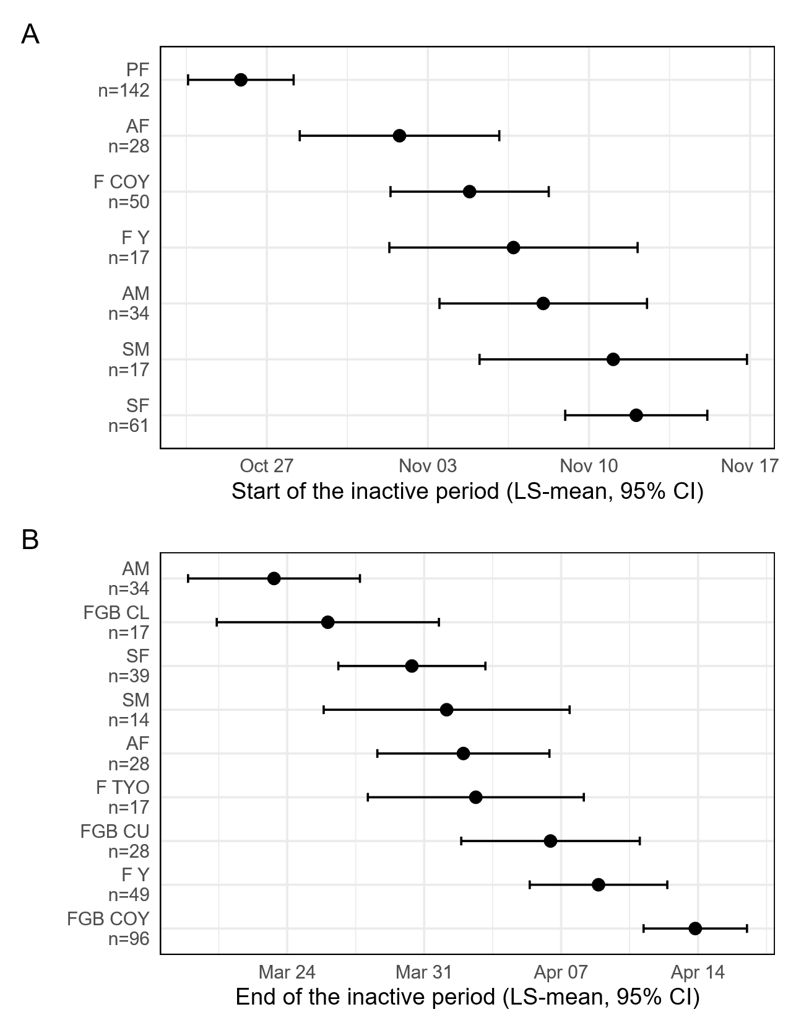
Figure S3.1 - Plot of start (A) and end (B) LS-mean dates of the inactivity period by demographic group for Scandinavian brown bears in south-central Sweden between 2003 and 2024. PF = Pregnant female; F COY = Female with cubs-of-the-year; F Y = Female with yearlings; F TYO = Female with two years old offsprings; AF = Solitary adult female; AM = Adult male; SF = Solitary subadult female; SM = Solitary subadult male; FGB COY = Female who gave birth during the winter and with cubs of-the-year; FGB CL = Female who gave birth during the winter but lost her cubs; FGB CU = Female who gave birth during the winter but whose the fate of the cubs is unknow.

