Supplemental Materials

Supplemental Figure 1. Map of the Mid-Atlantic Bight (MAB; indicated by the red box), including shipping lanes (striped areas), seasonal management areas (SMAs; gray shaded areas with the dashed outline), and offshore wind (OSW) lease areas (dotted areas), as well as the two subregions: New York Bight (orange) and coastal waters of Virginia (blue).
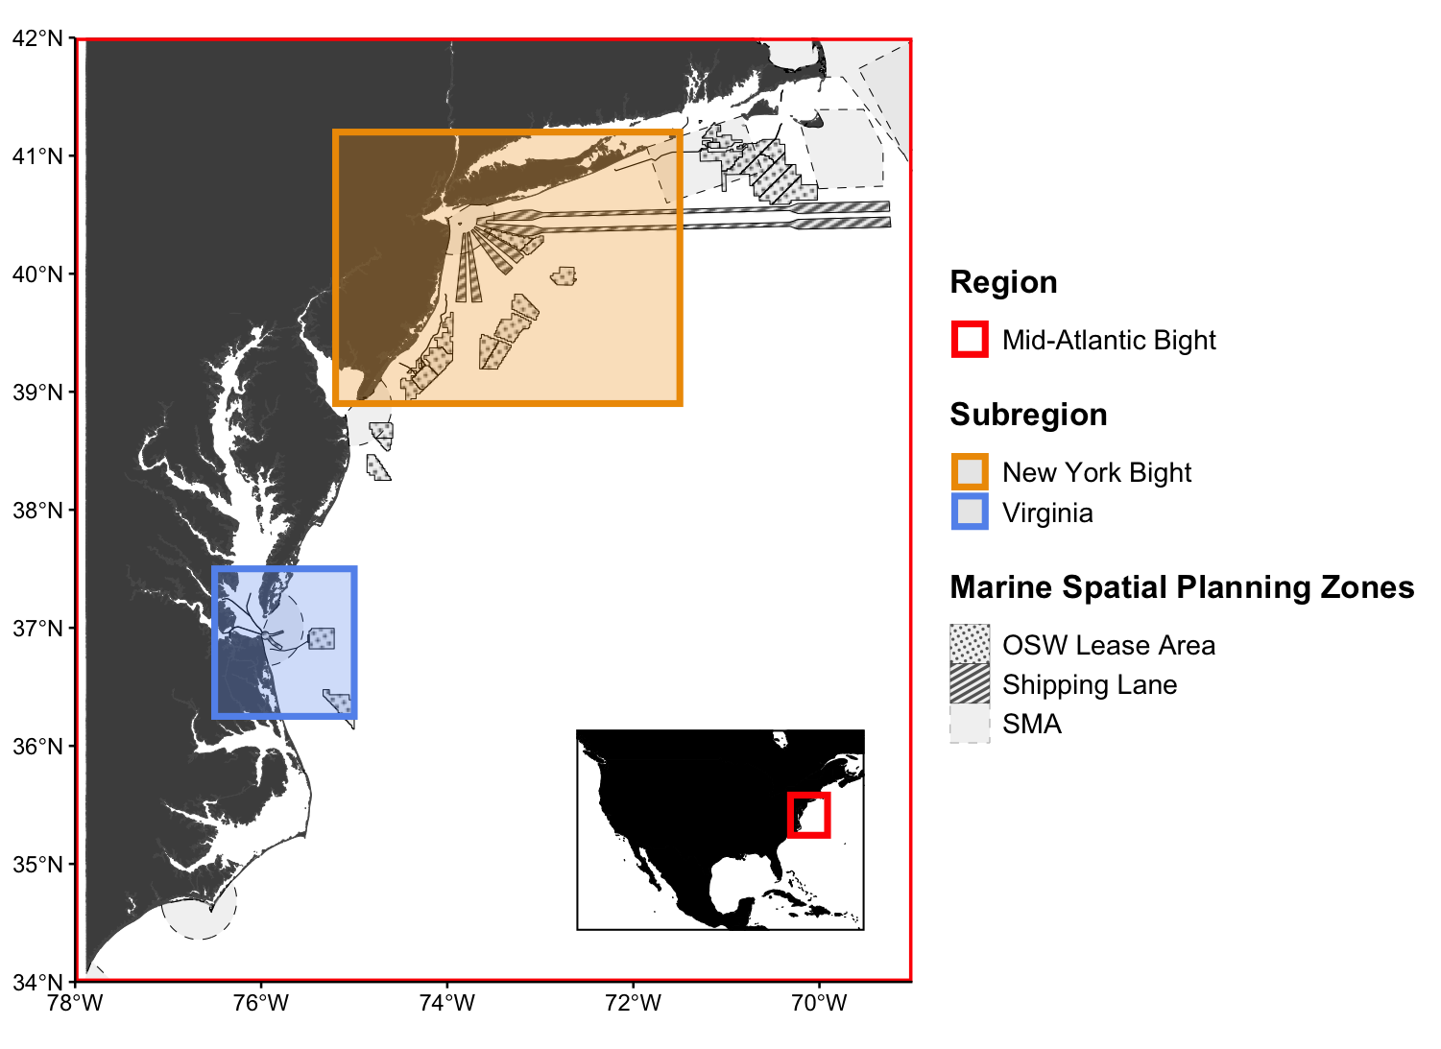

Supplemental Figure 2. Mean (and standard deviation) number of transmissions per hour of the day for each of the three satellite-tagged minke whales.
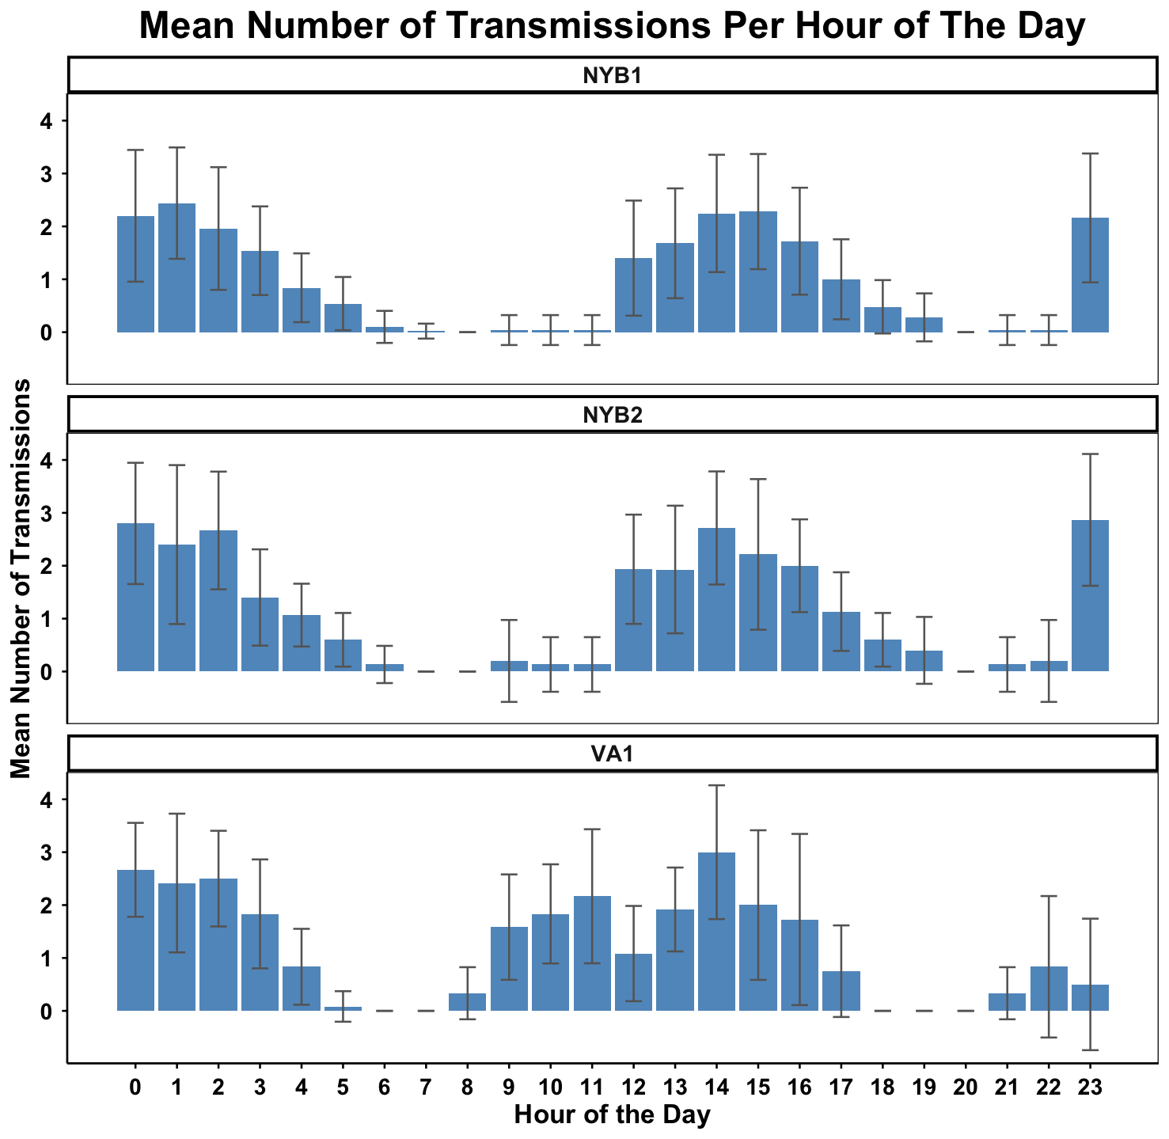

Supplemental Figure 3. Dive depths (black line) with depth range (red error bars) for the first hour of NYB1 time series data. Error bars get larger at deeper dive depths.

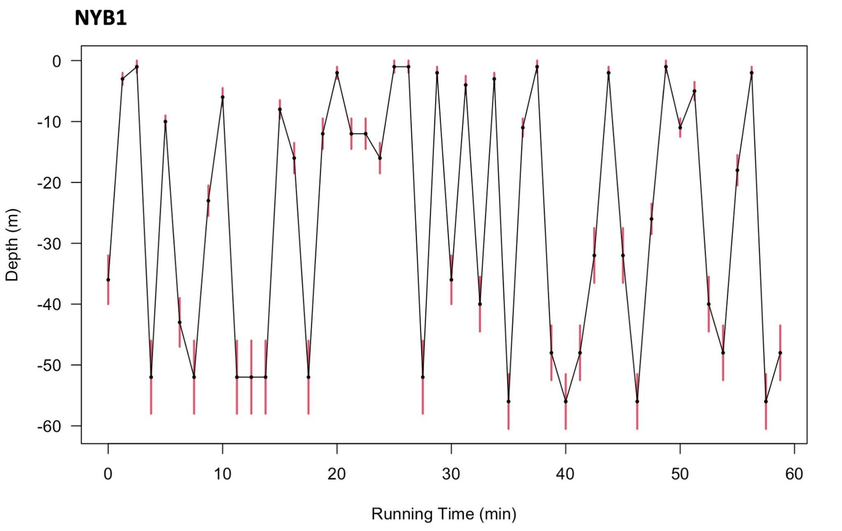

Supplemental Figure 4. Estimated depth ranges for each dive depth based on the time series data for the NYB-tagged whales.
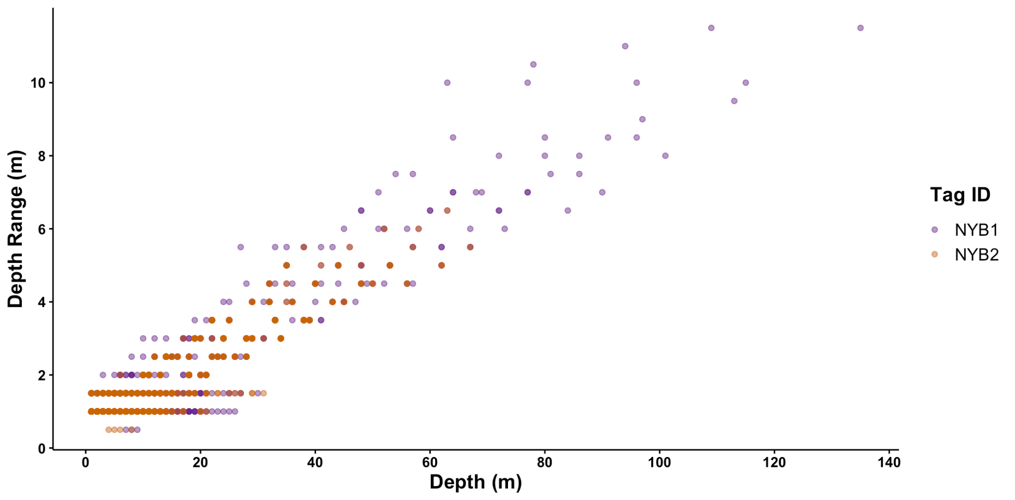

Supplemental Figure 5. Dive segmentation schematic. The blue line represents the time series depth data, with each node in the line representing a dive depth data point collected on a 75-second interval. The black lines at 2 m depth and 15 m depth are the qualifying dive depth threshold and the segmentation threshold, respectively. The dive segments (i.e., different dives) are indicated by the alternating shaded regions. The blue stars indicate the maximum depth for each dive.
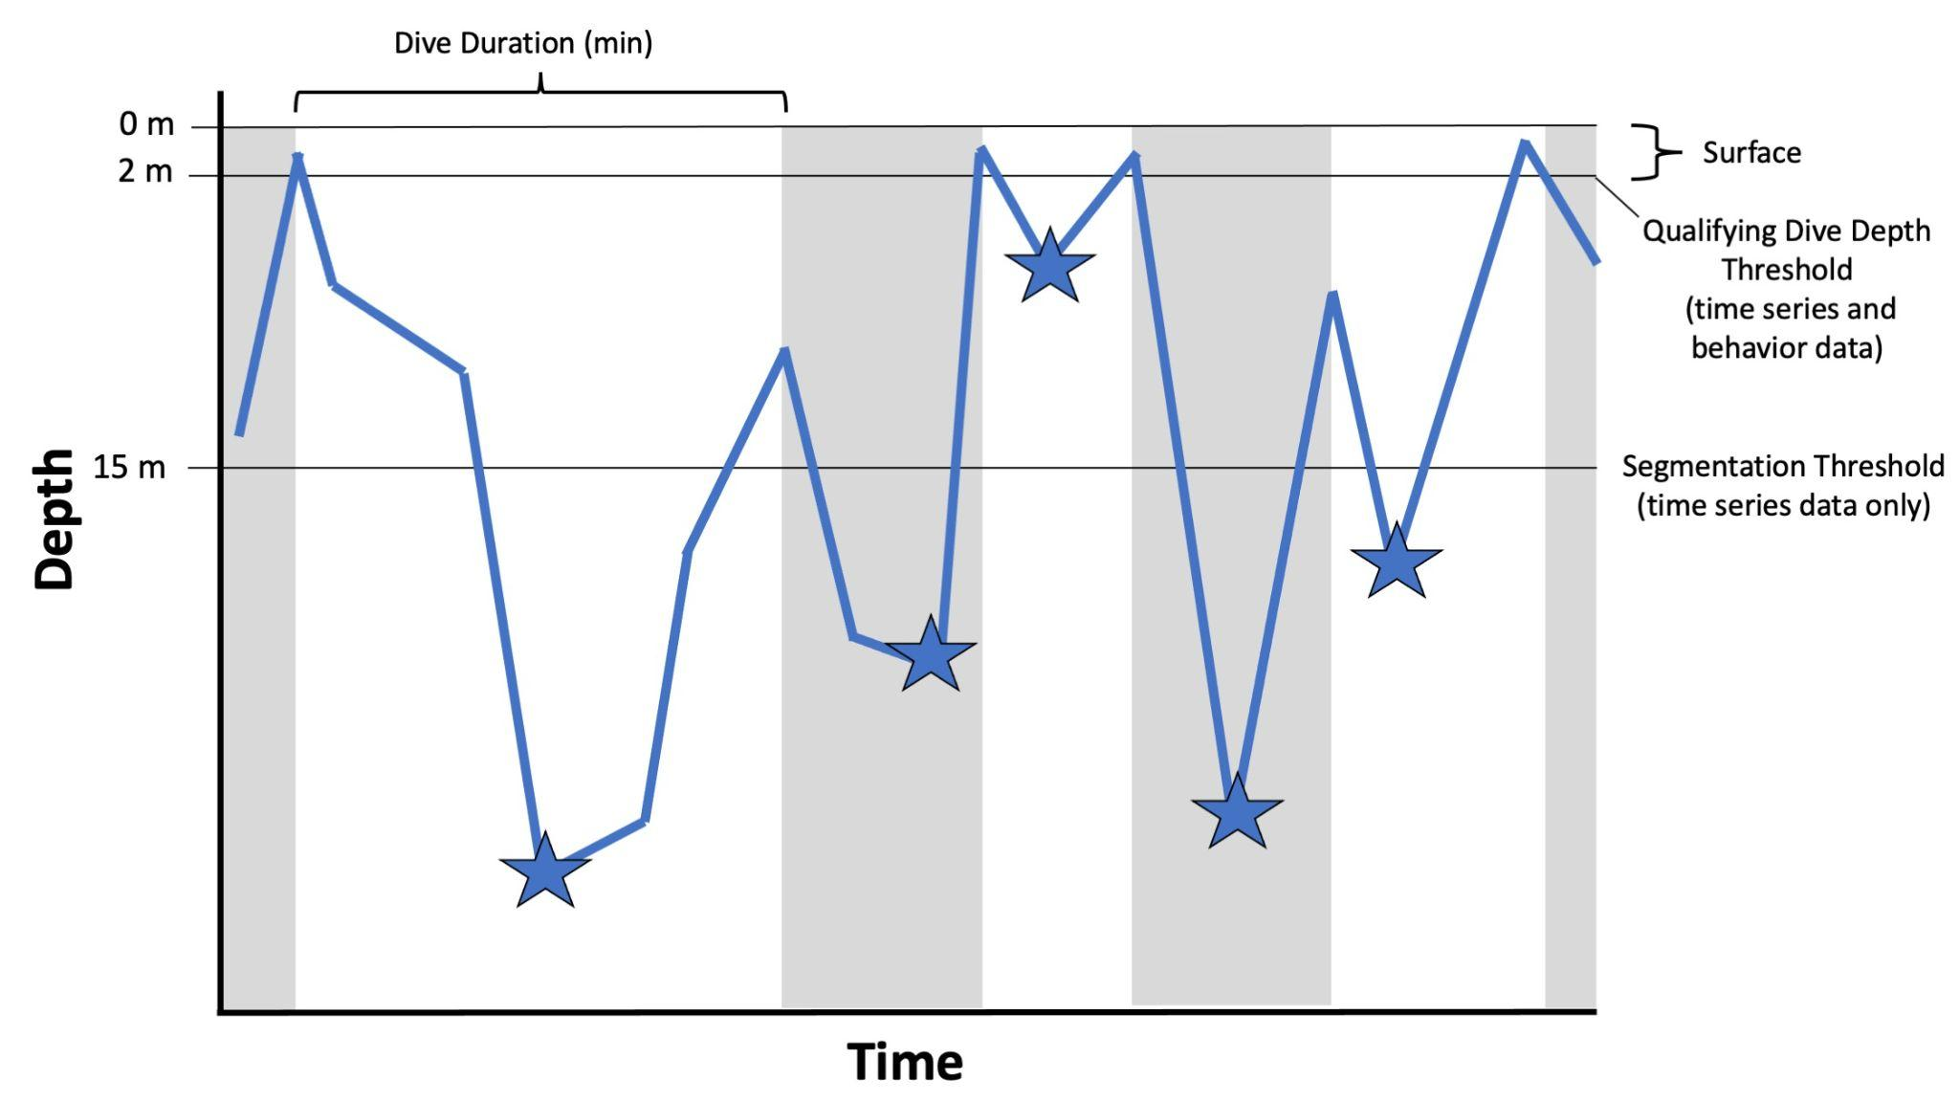

Supplemental Figure 6. Depths (m) for all dives for the NYB-tagged whales based on the 75 second sample rate for the time series data. Shaded regions indicate nighttime and light regions indicate daytime. Gaps in data are shown by the black bars along the top of the graphs.

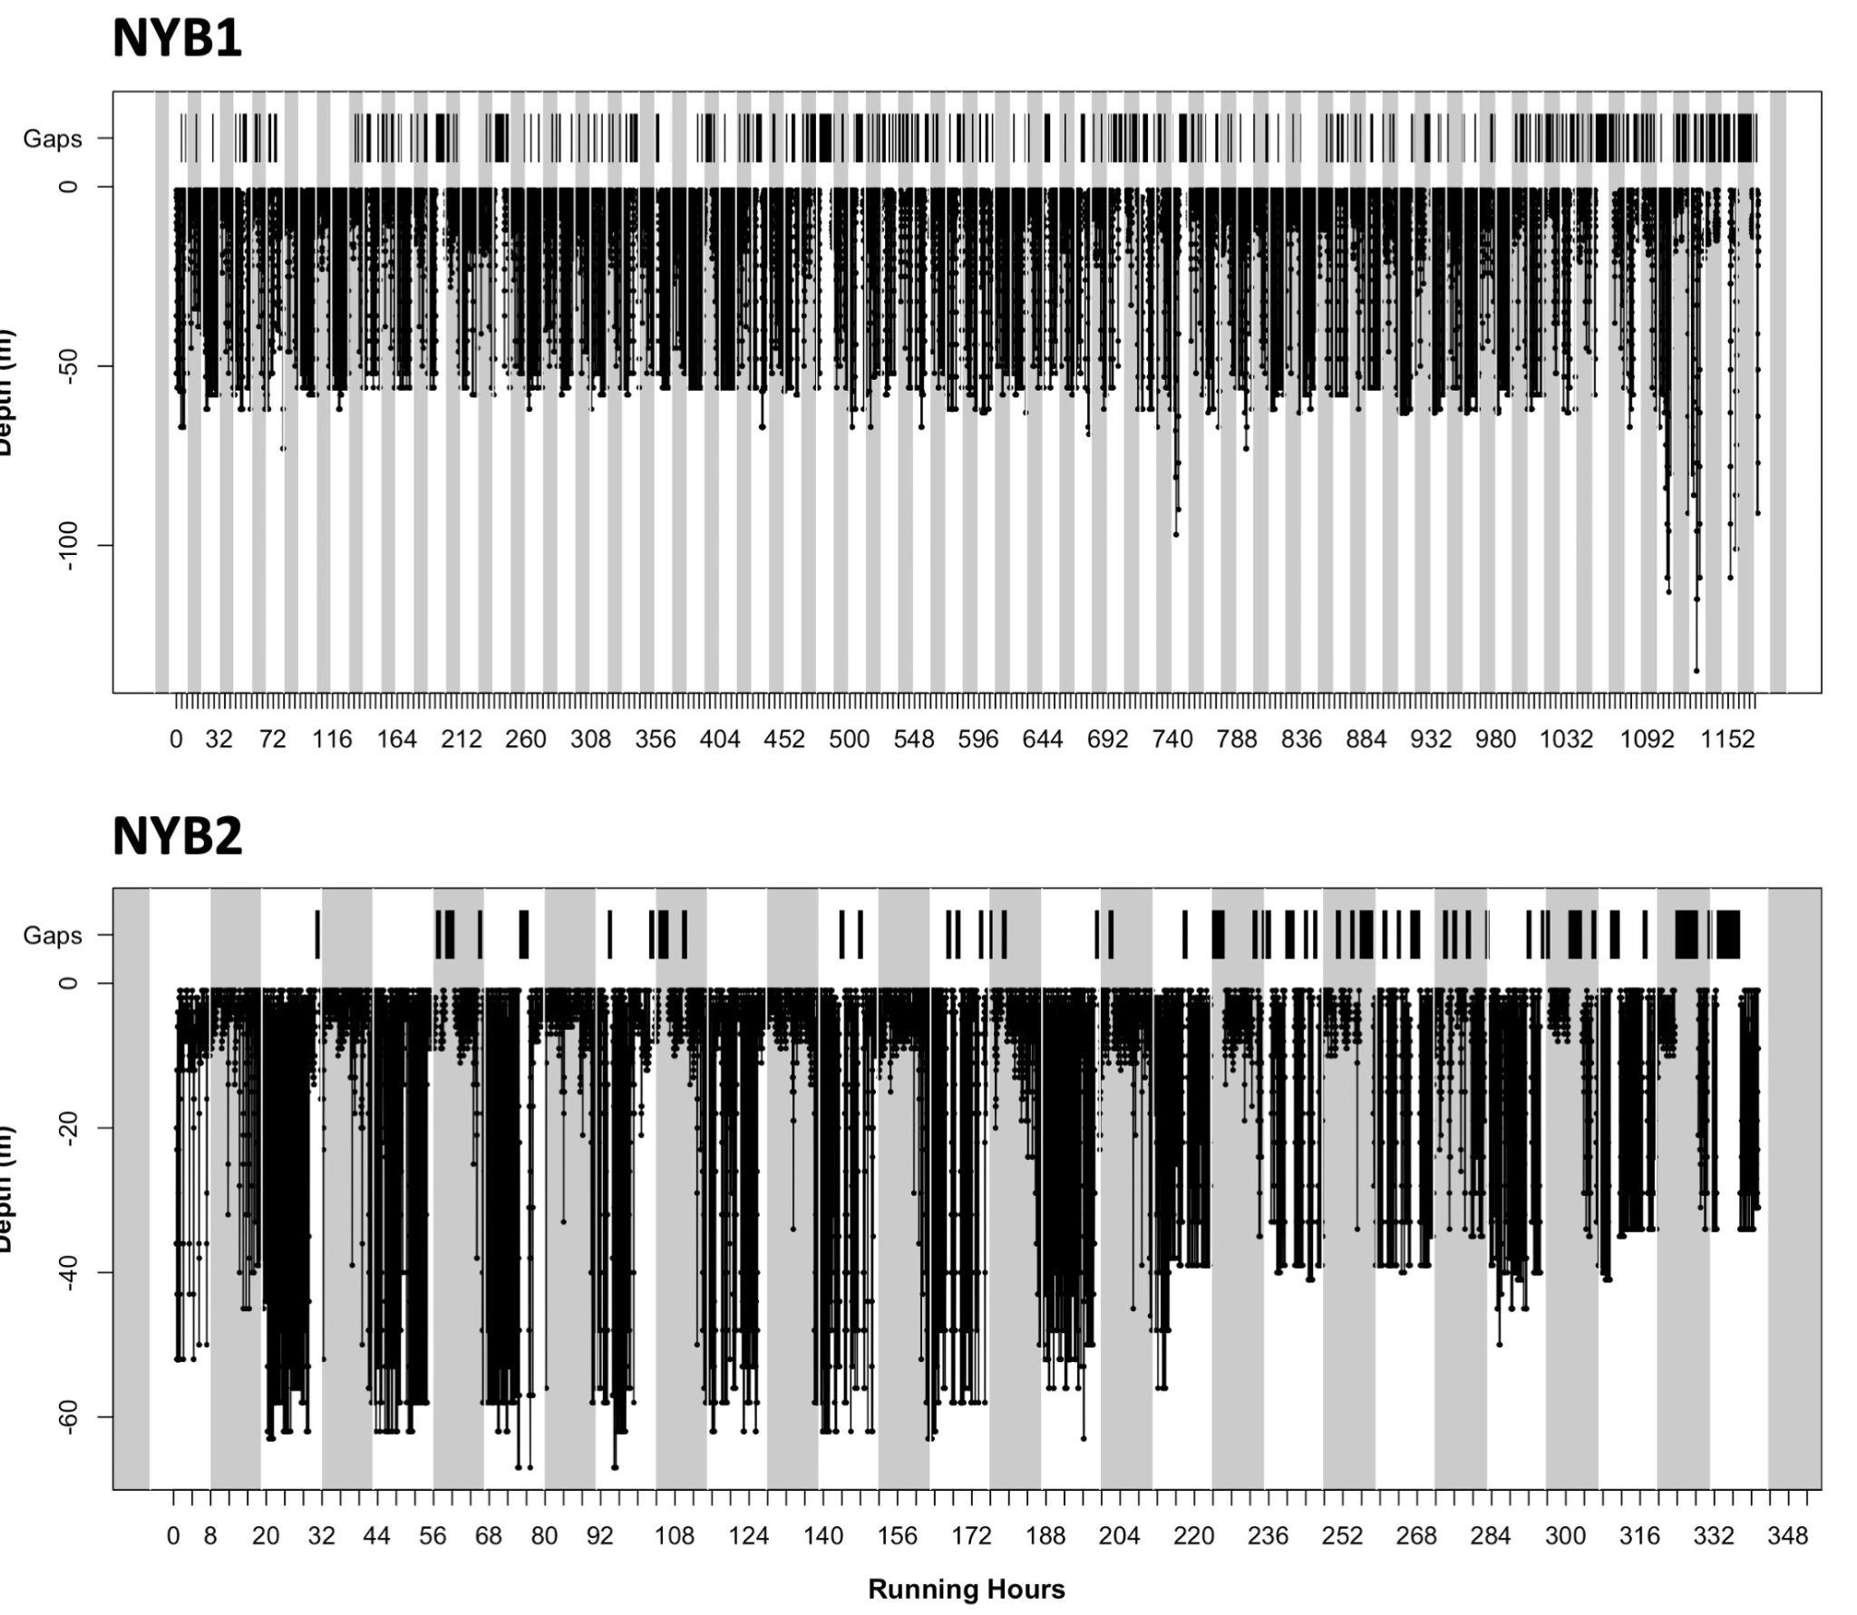

Supplemental Figure 7. The mean straightness index for all hours in which the minke whales were occupying areas with different sediment classes.
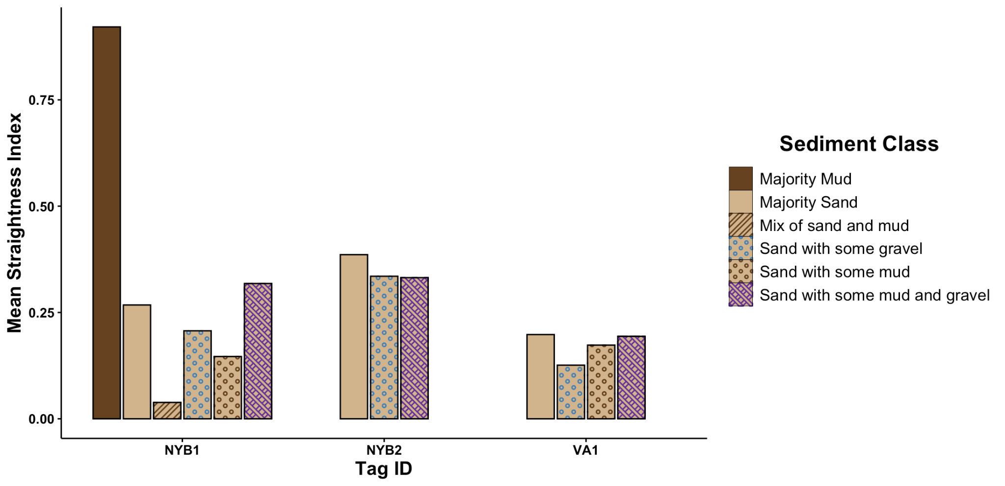

Supplemental Figure 8. Map of the distribution of the most likely minke whale prey species in the two subregions of the Mid-Atlantic Bight based on habitat suitability indices (calculated using preferred prey habitat based on depth, distance to shore, and sediment type) for each prey species of interest (sand lance, pollock, Atlantic herring, and Atlantic menhaden). The black points are all locations of the NYB-tagged minke whales (A) and the VA-tagged minke whale (B) where the behavior was classified as area-restricted search (ARS).
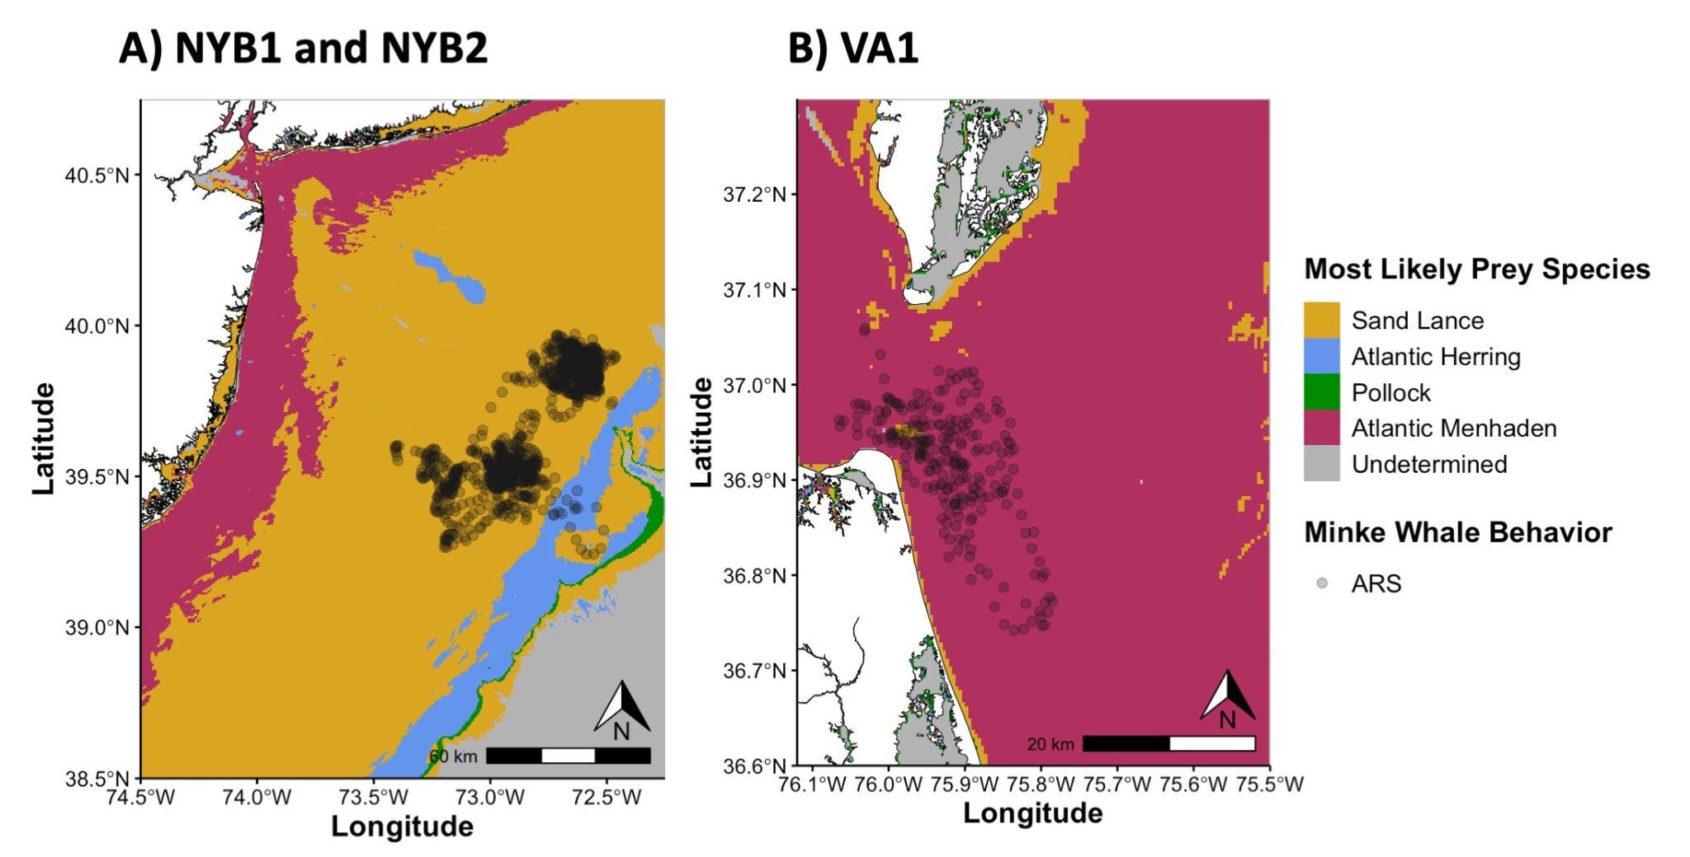

Supplemental Table 1. Number of transmissions with each location quality class per tagged whale.
Location Quality Class | Number of Transmissions  BaTag01 | Number of Transmissions  BaTag02 | Number of Transmissions  BaTag03
3 | 18 | 6 | 39
2 | 24 | 12 | 62
1 | 65 | 40 | 49
0 | 179 | 65 | 21
A | 224 | 93 | 56
B | 629 | 190 | 104

Supplemental Table 2. Summarized dive metrics.
Dive Metric | NYB1 | NYB2 | VA1
Number of Qualifying Dives | 9457 | 3600 | 670
Mean (IQR) Number of Qualifying Dives per Day | 202 (158 – 246) | 266 (209 – 318) | 59 (49 – 78)
Number (percentage) of Each Dive Shape | Square: 5064 (54%)  U: 3944 (42%)  V: 449 (5%) | Square: 1956 (54%)  U: 1538 (43%)  V: 106 (3%) | Square: 637 (95%)  U: 26 (4%)  V: 7 (1%)

Supplemental Methods

Satellite Tag Settings
For NYB1 and NYB2, the transmitter had the capacity to make 700 transmissions per day with no carryover. It transmitted between 23:00 – 7:00 and 12:00 – 19:00 local time. These transmitters had repetition periods of 15 seconds and were equipped with a conductivity switch that prevented transmissions when the tag was underwater. For the time series data, the sampling rate was set to 75 seconds. The minimum dive depth threshold for a qualifying dive was 2 m, and there was no threshold set for the duration of a qualifying dive. For VA1, the transmitter had the capacity to make 1100 transmissions per day with no carryover and had a repetition period of 15 seconds. It transmitted between 21:00 – 4:00 and 8:00 – 17:00 local time. The minimum dive depth and duration thresholds for a qualifying dive were set to 2 m and 2 min, respectively.

State Space Model Parameters and Model Fit
Depending on their behavior, minke whales are documented to swim at speeds up to 8.3 m/s when being pursued by predators (Ford et al. 2005). Therefore, we set the maximum travel rate to 10 m/s to exclude implausible locations. The data were then fitted using a correlated random walk SSM in the aniMotum package to filter locations and provide estimates of “true” locations (Jonsen et al. 2023). The model fit was assessed with the AICc score, visually assessing the fitted plot, and by examining the one-step-ahead prediction residuals in time-series plots, Q-Q plots, and autocorrelation functions using the osar function. Overall, the best model fit used a 1-hr interpolation. While there are gaps in the data during certain hours of the day (Supplemental Figure 2), gaps were predominantly due to the timing of satellite passes. The mean gap time between transmissions was 1.04 hrs for NYB1, 0.87 hrs for NYB2, and 0.85 for VA1. Moreover, the hourly interpolation of locations matched up well with features of the environment (e.g., maximum dive depths mapped really closely to the bathymetric depths at the estimated hourly locations compared to data interpolated at larger timesteps). Using an hourly interpolation also provided more data points for downstream analyses (thus increasing statistical power). Lastly, we ran the full analysis (including calculating the mean, standard deviation, and range of environmental variables, movement characteristics, and time spent in OSW lease areas, shipping lanes and active seasonal management areas throughout the tagged animal tracks based on the estimated interpolated locations) for both a 1-hr timestep and a 4-hr timestep (the second best model fit) and found that there was a negligible difference between the two model outputs. For example, the mean (and range) in chl-a for NYB1 was 0.33 mg m³ (0.11 – 0.41 mg m³) for the 1-hr timestep and 0.33 mg m³ (0.10 – 0.42 mg m³) for the 4-hr timestep. Therefore, the SSM interpolation frequency was set to one location per hour.

Calculating Track Straightness
We used the Github version of the MSSI package (github.com/pennekampster/MSSI) following methods outlined in Lee et al. 2017, wherein behavioral states were inferred for Antarctic minke whales. To ensure that it was working well with our dataset, we compared the output of several modelling approaches: 1) building a correlated random walk state space model with 1-hr interpolation and then calculating straightness using MSSI; 2) building a correlated random walk state space model with 1-hr interpolation and then calculating straightness using a move persistence model in aniMotum; and 3) building a correlated random walk state space model with 4-hr interpolation and then calculating straightness using a move persistence model in aniMotum. Based on the AICc scores, reviewing diagnostic plots, and considering the ecological context, we found that Approach 1 and 3 best captured movement characteristics and gave very similar results, but Approach 1 was also able to maintain hourly interpolation of estimated locations, which provides more data points (and thus, statistical power) for downstream analyses. Therefore, we calculated the track straightness using this modelling approach.

Dive Segmentation Scheme for Time Series Data
Due to the 75 seconds repetition period for the time series data, the dive data risked being aliased for NYB1 and NYB2. For example, if a sample was taken at a depth of 14 m, the minke whale returned to the surface and then dove back down to a similar depth (where the next sample was taken in the time series) within the 75 second sampling period, it would be included within the same dive even though it was actually two separate dives. To try to mitigate this aliasing, the dive depth was segmented using a dive segmentation threshold of 15 m based on a vertical ascent rate of 0.2 m per second during the 75 second sampling period (i.e., 15 m could be traversed over the course of 75 seconds). If a minke whale surpassed this segmentation threshold during a vertical ascent, subsequent sampled points were considered part of a new dive (Supplemental Figure 4). It is possible that dives may be incorrectly segmented using this segmentation scheme (i.e., one minke whale dive that includes movements across the 15 m segmentation threshold is incorrectly marked as multiple dives), however these criteria provided the most realistic balance between concatenating and splitting dives.
Dive shapes were categorized depending on how long the animal spent at the bottom of the dive (e.g., if the animal was below 80% of the maximum dive depth for a given dive for >50%, 20-50%, or less than 20% of the dive duration, they were classified as square, U-shaped dives, and V-shaped dives, respectively (Cioffi et al. 2021).

Environmental and Anthropogenic Variables
Shapefiles for Offshore Wind (OSW) Lease Areas, seasonal management areas (SMAs), and shipping lanes for the New York Bight were downloaded from the Northeast Ocean Data Portal. Shipping lanes off the coast of Virginia had boundaries that included the Traffic Separation Scheme, Coastal Maintained Channels in U. S. Waters (U.S. Army Corps of Engineers), and Shipping Fairways, Lanes, and Zones for U.S. Waters (National Oceanic and Atmospheric Administration) following the methods outlined by Aschettino et al. 2020.
For each hourly position, distance to shore was calculated using the dist2land function in the ggOceanMaps package (Vihtakari 2024) and the bathymetric depth was determined using the getNOAA.bathy function from the marmap package (Pante and Simon-Bouhe 2013). The bathymetric depth dataset has a spatial resolution of 1 arc-minute (~1.5km). The seabed soft sediment was determined for each hourly position using the extract function from the terra package (Hijmans 2025). Sediment data had a 500m spatial resolution and was obtained using the soft sediments data layer in the Mid-Atlantic Ocean Data Portal, which interpolated data from the United States Geological Survey (USGS) Sediment Texture Database, the USGS SEABED Database, and data from recent National Ocean Service (NOS) surveys. Soft sediment classes were based on the relative proportions of sand, mud, and gravel. A soft sediment was considered a majority if it constituted >75% of the sample and absent if it constituted <25% of the sample. When multiple soft sediments were present in 25 – 75% of the sample, all soft sediments within that range would be included in the classification. For example, a sample was classified as “majority sand” if it had >75% sand and <25% mud, “sand with some mud” if the sample contained 25 – 75% of both sand and mud, but sand was dominant, “mix of sand and mud” if the sample contained 25 – 75% of both sand and mud and they were roughly equal, “mud with some sand” if the sample contained 25 – 75% of both sand and mud, but mud was dominant, and “majority mud” if the sample contained >75% mud and <25% sand. The number and percentage of tag deployment hours corresponding with each soft seabed sediment was calculated based on the estimated hourly locations. Locations for which soft seabed sediment data was unavailable were excluded.
SST, chl-a, and SSS data had a daily resolution and gridded spatial resolutions of 0.01°, 0.02°, and 0.25°, respectively. Therefore, the daily mean position was calculated and the daily values for these variables were determined from Environmental Research Division Data Access Program (ERDDAP) repositories using the rxtracto function in the rerddapXtracto package (Mendelssohn, 2024). Chl-a, SSS and SST were extracted using a 0.02° (~2km) radius around the daily mean position. For each position, SST was determined using the Group for High Resolution Sea Surface Temperature (GHRSST) Multiscale Ultrahigh Resolution (MUR) SST analysis fv0.41 from the National Aeronautics and Space Administration (NASA) Jet Propulsion Laboratory via the University of South Florida ERDDAP (https://erddap.marine.usf.edu/erddap). Chl-a data was determined using the gap-free multi-sensor Level-1 to Level-2 (MSL12) Ocean Color dataset from the National Oceanographic and Atmospheric Administration (NOAA) via the NOAA CoastWatch Central Operations ERDDAP (https://coastwatch.noaa.gov/erddap). SSS values were determined using the soil moisture – ocean salinity (SMOS) mission’s microwave imaging radiometer with aperture synthesis (MIRAS) satellite observations from the European Space Agency (ESA) via the NOAA CoastWatch Central Operations ERDDAP (https://coastwatch.noaa.gov/erddap). SSS had days for which no data were available, and these gaps were filled using the na.approx function in the zoo package. Subsequently, the mean and range of all environmental variables were calculated. Night and day were determined using the suncalc package (Thieurmel & Elmarhraoui 2023), wherein the time between sunrise and sunset was considered day and time between sunset and sunrise was considered night.

Minke Whale Prey Habitat
Each potential minke whale prey species has distinct habitat preferences. Sand lance show a strong association with water depths < 100 m and have a dependence on sandy substrates for burrowing (Staudinger et al. 2020). Pre-spawning Atlantic herring are most abundant at depths of 100 – 150 m (Maravelias et al. 2000), while spawning herring prefer gravel beds < 50 km from the coast (Blaxter 1990). Pollock show no strong preferences for sediment type (Scott 1982), and tend to inhabit deeper waters (100 – 125 m and 130 – 150 m for adults and juveniles, respectively; Steele 1963; Hardy 1978). Spawning Atlantic menhaden are found at depths of 20 – 60 m (Checkley Jr. et al. 1999) and adult menhaden tend to be < 5 km from the coast in depths < 50m (Whitehead 1985). Adult menhaden inhabit areas with bottom compositions of sand and/or mud, and sometimes gravel as well (ASMFC 2011).

Supplemental Materials References

Atlantic States Marine Fisheries Commission [ASMFC]. (2011). Atlantic Menhaden stock assessment and review panel reports. SAR No. 10-02. 325p.

Blaxter JHS (1990) The herring. Biologist 37:27–3.

Checkley, Jr, , Ortner, , Werner, , Settle, and Cummings, (1999), Spawning habitat of the Atlantic menhaden in Onslow Bay, North Carolina. Fisheries Oceanography, 8: 22-36. https://doi.org/10.1046/j.1365-2419.1999.00019.x

Ford J. K. B., Ellis G. M., Matkin D. R., Balcomb K. C., Briggs D., Morton A. B. (2005). Killer whale attacks on minke whales: prey capture and antipredator tactics. Mar. Mamm. Sci. 21, 603–618. doi: 10.1111/j.1748-7692.2005.tb01254.x

Hardy, J.D., Jr. 1978. Development of fishes of the MidAtlantic Bight: An atlas of egg, larval and juvenile stages. Vol. 2 Anguillidae through Syngnathidae. U.S. Fish Wildl. Serv. Biol. Serv. Prog. FWS/OBS78/12. 458 p

Hijmans R (2025). terra: Spatial Data Analysis. R package version 1.8-9, github.com/rspatial/terra.

Lee JF, Friedlaender AS, Oliver MJ, et al. Behavior of satellite-tracked Antarctic minke whales (Balaenoptera bonaerensis) in relation to environmental factors around the western Antarctic Peninsula. Anim Biotelemetry. 2017;5:23. doi:10.1186/s40317-017-0138-7

Maravelias CD, Reid DG, Swartzman G (2000) Seabed substrate, water depth and zooplankton as determinants of the prespawning spatial aggregation of North Atlantic herring. Mar Ecol Prog Ser 195:249–259

Mendelssohn R. rerdappXtraco: Extracts Environmental Data from ‘ERDAPPTM’ Web Services. R package version 1.2.1. Available from: https://CRAN.R-project.org/package=rerddapXtracto.

Pante E, Simon-Bouhet B (2013) marmap: A Package for Importing, Plotting and Analyzing Bathymetric and Topographic Data in R. PLoS ONE 8(9): e73051. doi.org/10.1371/journal.pone.0073051

Scott, J.S. 1982. Selection of bottom type by groundfishes of the Scotian Shelf. Can. J. Fish. Aquat. Sci. 39: 943-947.
Steele, D.H. 1963. Pollock (Pollachius virens (L.)) in the Page 7 Bay of Fundy. J. Fish. Res. Board Can. 20: 1267-1314.
Thieurmel B, Elmarhraoui A (2023). suncalc: Compute Sun Position, Sunlight Phases, Moon Position and Lunar Phase. R package version 0.5.2, https://github.com/datastorm-open/suncalc.
Vihtakari M (2024). ggOceanMaps: Plot Data on Oceanographic Maps using 'ggplot2'. R package version 2.2.0, https://mikkovihtakari.github.io/ggOceanMaps/.

