Seasonal migration and habitat shifts of the cyprinid fish Schizothorax eurycephalus in a Central Asian mountain river
Otabek Omonov^{1,2,*}, Pieterjan Verhelst³, Johan Coeck³, Robrecht Dockx³, Peter Goethals¹, Bakhtiyor Karimov², Erkin Karimov⁴, Damiano Oldoni³, Martin Schletterer^{5,6,*}, Daniel S. Hayes⁶

¹Department of Animal Sciences and Aquatic Ecology, Ghent University, Ghent, Belgium
²“Tashkent Institute of Irrigation and Agricultural Mechanization Engineers” National Research University (“TIIAME” NRU), Qori Niyoziy 39, 100000 Tashkent, Uzbekistan
³Research Institute for Nature and Forest (INBO), Havenlaan 88, bus 73, 1000 Brussels, Belgium
⁴Tashkent State Agrarian University, University street 2, 100000 Tashkent, Uzbekistan
⁵Chair of Hydraulic Engineering, TUM School of Engineering and Design, Technical University of Munich, Arcisstraße 21, 80333 Munich, Germany
⁶BOKU University, Institute of Hydrobiology and Aquatic Ecosystem Management, Department of Ecosystem Management, Climate and Biodiversity, Gregor-Mendel-Straße 33, 1180 Vienna, Austria

* Correspondence: Martin Schletterer: martin.schetterer@tum.de; Otabek Omonov: omonovo268@gmail.com

Supplemental information containing figures S1 – S4 and table S1 – S5.

Figures

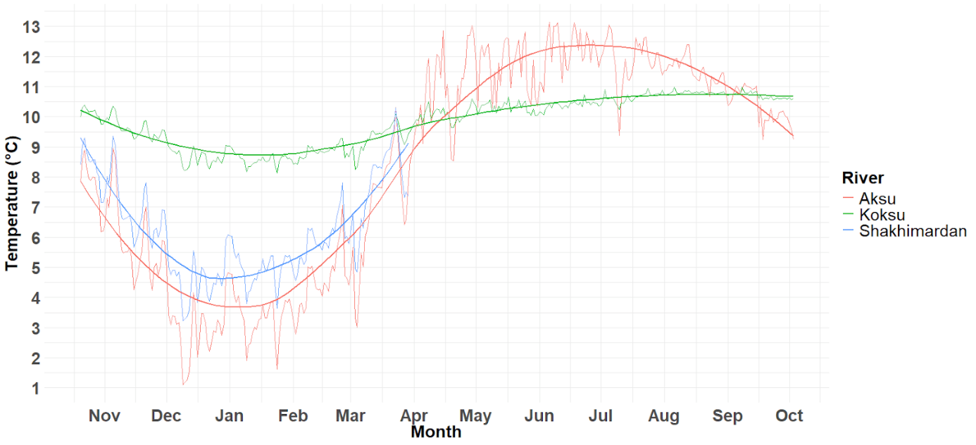

Figure S1. The water temperature of the rivers Aksu (red), Koksu (green) and Shakhimardan (blue) obtained from HOBO temperature data loggers. Note that the data logger in the River Shakhimardan got lost in March, resulting into a limited dataset. However, the water temperature of the River Shakhimardan strongly follows the pattern of the River Aksu, its main tributary. This is clearly visible from the overlapping data records in the figure.
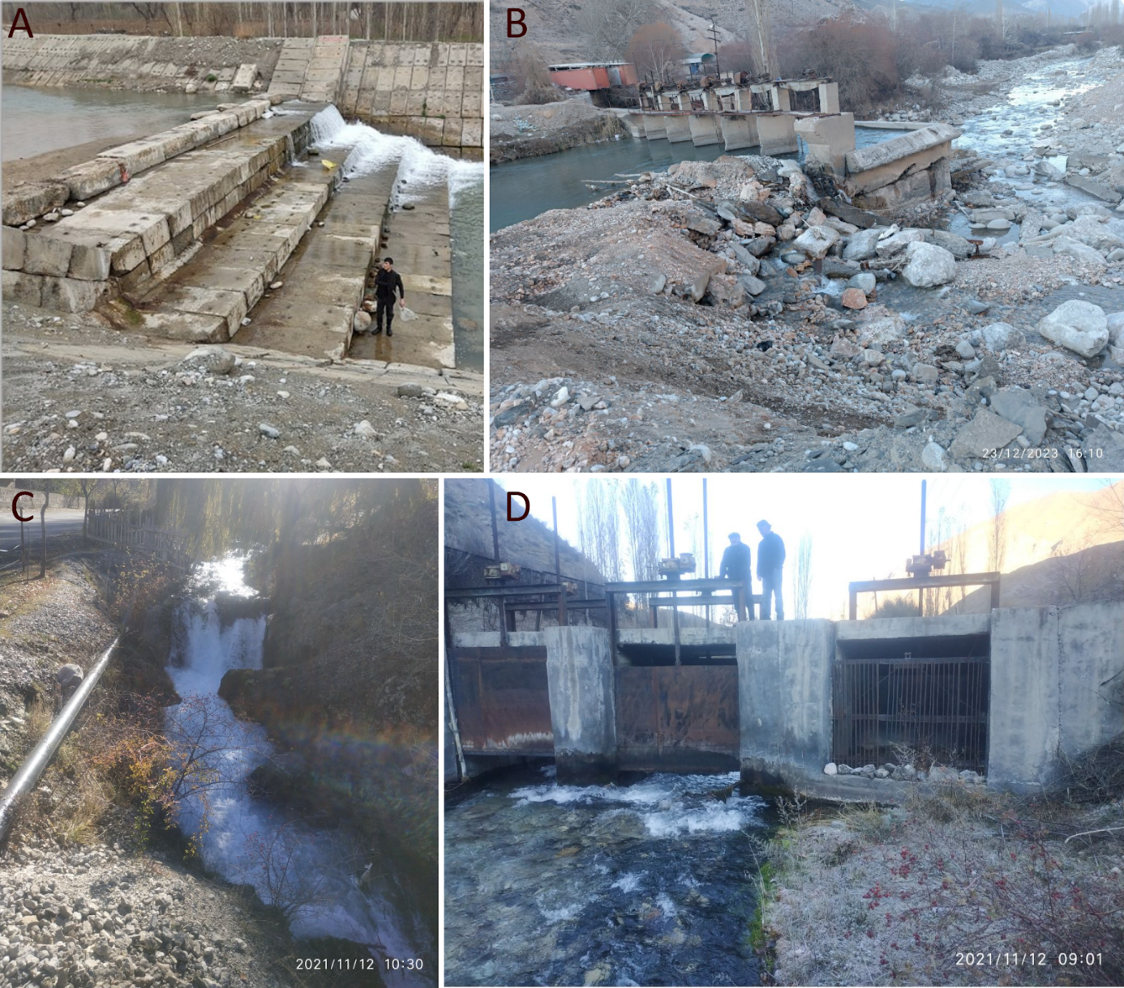
Figure S2. The artificial fish migration barriers in the catchment. (A) In the mainland Uzbekistan the Shakhimardan River features 19 artificial cascades, some exceeding 4 m in height, and (B) in Jiydelik (Kyrgyzstan) a hydropower plant is operational. (C) Upstream of the Koksu River there is an artificial waterfall established due to road constructions and (D) an old intake for a hydropower plant that was never built (but now reconstructed as part of a hydropower plant development within the EU Horizon project “Hydro4U”).

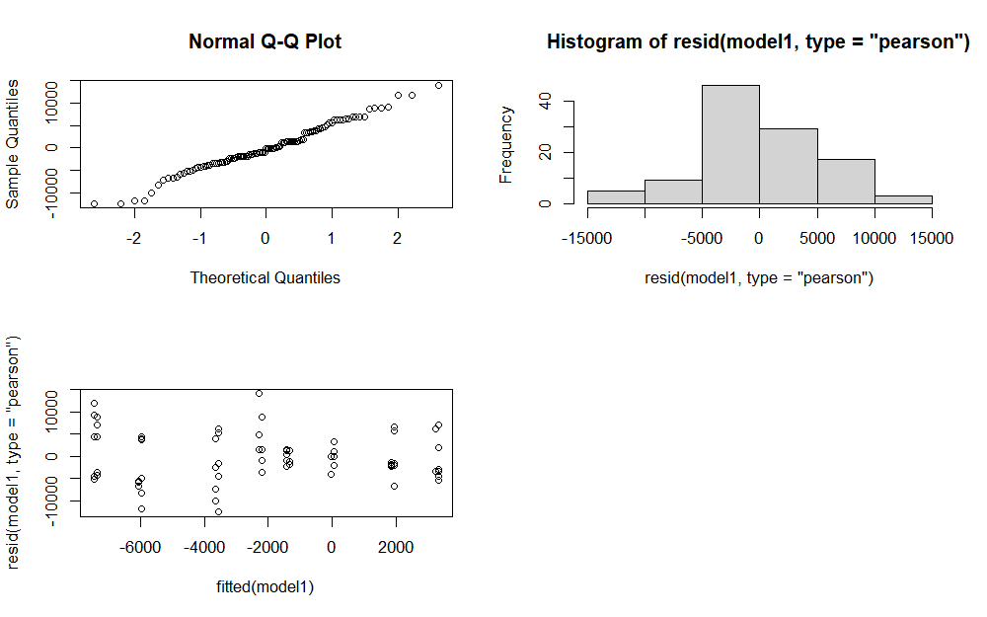
Figure S3. Output of the LMM validation for the analysis on the seasonal displacements by the tagged snow trout.

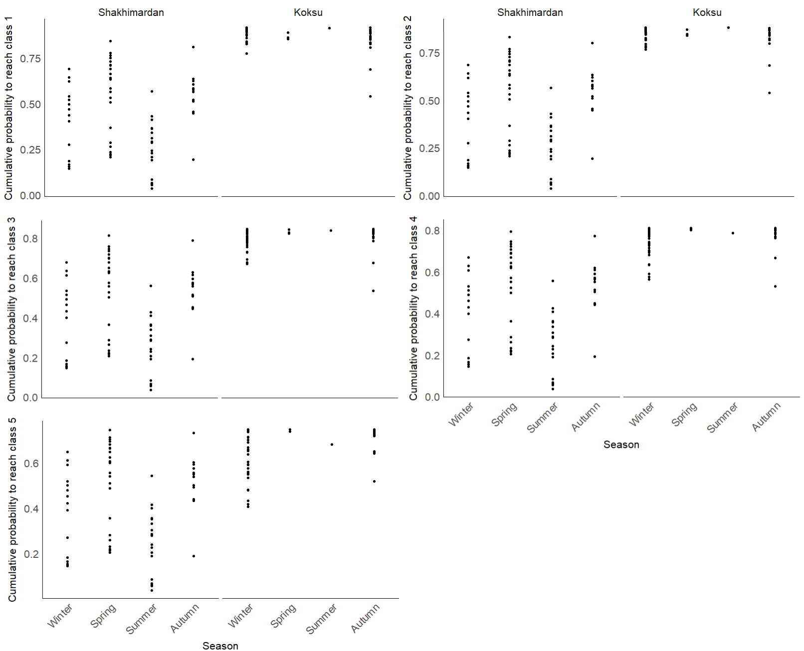
Figure S4. The cumulative probabilities of the snow trout to reside in substrate classes higher than one (fine sediment; top left), two (sand; top right), three (fine gravel; middle left), four (gravel, middle right) and five (cobbles, bottom left) over the four different seasons.

Tables

Table S1. The catch and release date and location, total length (mm), weight (g) and sex of the 27 tagged snow trout. For each fish the tag ID is given and whether the transmitter had an external antenna or a coiled, internal antenna. The tag weight – fish weight body ratio was calculated (given in %). We also provide the total time that a fish was tracked and their net displacement during the study period (i.e. the distance between the most upstream and most downstream detection). We classified the fate of the fish in three categories: ‘0’ indicates a fish that was alive and contained the transmitter during the tracking period (23 October 2022 and 9 July 2024); ‘1’ indicates a fish that died or lost its tag briefly after release (hence these fish were omitted from the analysis) and ‘2’ indicates a fish that potentially died or lost its tag after more than six months of tracking. For snow trout of class ‘2’, we added the date after which the fish was considered dead or lost its tag.
Tag ID | Catch and release date | Transmitter antenna | Catch and release location | Total length (mm) | Weight (g) | Sex | The tag weight - fish body weight ratio [%] | Total tracking time (days) | Net displacement (m) | Fate
40020 | 24/10/2022 | coiled | Koksu | 237 | 144 | F | 2.50 | 624 | 14845 | 0
40060 | 24/10/2022 | coiled | Koksu | 282 | 246 | F | 1.46 | 192 | 5400 | 0
40080 | 23/10/2022 | coiled | Shakhimardan | 243 | 162 | M | 2.22 | 544 | 11827 | 0
40100 | 23/10/2022 | coiled | Aksu | 230 | 150 | M | 2.40 | 9 | 2447 | 1
40110 | 22/10/2022 | coiled | Shakhimardan | 240 | 167 | F | 2.16 | 252 | 624 | 1
40150 | 25/10/2022 | coiled | Koksu | 305 | 314 | F | 1.15 | 191 | 12863 | 0
40600 | 24/10/2022 | coiled | Koksu | 250 | 166 | M | 2.17 | 624 | 14071 | 0
40610 | 25/10/2022 | coiled | Koksu | 328 | 389 | F | 0.93 | 472 | 6661 | 0
40620 | 24/10/2022 | coiled | Shakhimardan | 325 | 420 | F | 0.86 | 624 | 15651 | 0
40630 | 23/10/2022 | coiled | Koksu | 320 | 381 | F | 0.94 | 544 | 9981 | 0
40640 | 25/10/2022 | coiled | Koksu | 308 | 349 | F | 1.03 | 25 | 3516 | 1
40650 | 25/10/2022 | coiled | Koksu | 262 | 193 | M | 1.87 | 623 | 15852 | 0
40660 | 24/10/2022 | coiled | Shakhimardan | 245 | 148 | M | 2.43 | 622 | 2950 | 2 (18/11/2023)
40670 | 25/10/2022 | coiled | Koksu | 244 | 169 | M | 2.13 | 623 | 11786 | 0
40690 | 25/10/2022 | external | Koksu | 326 | 347 | M | 1.33 | 629 | 745 | 1
40770 | 25/10/2022 | external | Koksu | 245 | 197 | M | 2.34 | 621 | 14212 | 0
40781 | 25/10/2022 | external | Koksu | 245 | 154 | M | 2.99 | 344 | 15319 | 0
40791 | 25/10/2022 | external | Koksu | 320 | 356 | F | 1.29 | 286 | 17416 | 0
40800 | 25/10/2022 | external | Koksu | 267 | 219 | M | 2.10 | 424 | 17686 | 2 (26/07/2023)
40810 | 27/10/2022 | external | Koksu | 356 | 572 | F | 0.80 | 619 | 312 | 1
40820 | 25/10/2022 | external | Koksu | 239 | 136 | M | 3.38 | 622 | 17657 | 2 (05/05/2023)
40831 | 25/10/2022 | external | Koksu | 316 | 315 | F | 1.46 | 542 | 17798 | 2 (04/10/2023)
40841 | 27/10/2022 | external | Koksu | 311 | 294 | M | 1.56 | 279 | 15069 | 0
41960 | 25/10/2022 | external | Koksu | 312 | 281 | F | 1.64 | 623 | 15051 | 2 (03/08/2023)
41969 | 24/10/2022 | external | Shakhimardan | 201 | 115 | M | 4 | 204 | 716 | 1
41980 | 25/10/2022 | external | Koksu | 254 | 153 | F | 3.01 | 621 | 1976 | 1
41990 | 25/10/2022 | external | Koksu | 237 | 151 | F | 3.05 | 621 | 1761 | 1

Table S2. Classification of mesohabitat characteristics.

Habitat Characteristics | Class Code Description
Habitat Characteristics | 0 | 1 | 2 | 3 | 4 | 5 | 6 | 7 | 8 | 9
Substrate Type | Organic material (e.g., decomposed plant matter) | Fine sediment: clay, silt, loam | Sand (granular particles) | Fine gravel (2–6 mm) | Gravel (6–20 mm) | Cobbles (20–60 mm) | Pebbles (60–120 mm) | Large stones (120–200 mm) | Boulders (>200 mm) | Bedrock (solid rock formations)
Water Flow Velocity | Very slow (<0.1 m/s) | Slow (0.1–0.4 m/s) | Moderate (0.4–1.0 m/s) | Fast (1.0–1.5 m/s) | Very fast (>1.5 m/s)
Water Depth | <0.2 m; very shallow | 0.2-0.5 m; shallow | 0.5-0.7 m; medium | 0.7-0.9 m; deep | >0.9 m; very deep

Table S3. The output of the LMM on seasonal movement showing the estimates, standard errors (SE), degrees of freedom (DF), t-value and p-value for the different explanatory variables according to reference levels, being ‘Winter’ for season, ‘Female’ sex and the internal coiled antenna type. Significant p-values (< 0.05) are indicated in bold.
Fixed effect | Estimate | SE | DF | t-value | p-value
Intercept | 39.78 | 1085.60 | 103 | 0.04 | 0.97
Spring | -5445.56 | 1378.28 | 103 | -3.95 | < 0.01
Summer | -2959.54 | 1452.53 | 103 | -2.04 | 0.13
Autumn | 3292.09 | 1333.97 | 103 | 2.47 | 0.02
Sex M | -1372.29 | 1022.48 | 103 | -1.34 | 0.18
Tag type - external antenna | -80.95 | 1051.48 | 103 | -0.08 | 0.94

Table S4. The output of the ordinal logistic regression mixed model on seasonal depth use showing the estimates, standard errors (SE), z-value and p-value for the different rivers and seasons according to reference level ‘Shakhimardan’ and ‘winter’ respectively. Significant p-values (< 0.05) are indicated in bold.
Fixed effect | Estimate | SE | z-value | p-value
Spring | 0.31 | 0.33 | 0.96 | 0.34
Summer | 1.31 | 0.41 | 3.21 | 0.001
Autumn | -1.96 | 0.39 | -5.03 | < 0.001
Koksu | -2.84 | 0.32 | -8.75 | < 0.001
Spring : Koksu | -0.11 | 0.54 | -0.21 | 0.83
Summer : Koksu | -3.25 | 2.87 | -1.13 | 0.26
Autumn : Koksu | 0.97 | 0.45 | 2.17 | 0.03

Table S5. The output of the ordinal logistic regression mixed model on seasonal water flow velocity use showing the estimates, standard errors (SE), z-value and p-value for the different rivers and seasons according to reference level ‘Shakhimardan’ and ‘winter’ respectively. Significant p-values (< 0.05) are indicated in bold.
Fixed effect | Estimate | SE | z-value | p-value
Spring | -1.63 | 0.35 | -4.68 | < 0.001
Summer | -0.33 | 0.42 | -0.79 | 0.43
Autumn | 0.33 | 0.40 | 0.83 | 0.41
Koksu | -2.51 | 0.34 | -7.27 | < 0.001
Spring : Koksu | 1.94 | 0.53 | 3.63 | < 0.001
Summer : Koksu | -2.68 | 2.87 | -0.93 | 0.35
Autumn : Koksu | 2.95 | 0.47 | 6.34 | < 0.001

Table S6. The output of the ordinal logistic regression mixed model on seasonal use of substrate types showing the estimates, standard errors (SE), z-value and p-value for the different rivers and seasons according to reference level ‘Shakhimardan’ and ‘winter’ respectively. Significant p-values (< 0.05) are indicated in bold.
Fixed effect | Estimate | SE | z-value | p-value
Spring | -0.42 | 0.35 | -1.21 | 0.23
Summer | 1.05 | 0.47 | 2.22 | 0.03
Autumn | -0.17 | 0.39 | -0.44 | 0.66
Koksu | -3.38 | 0.35 | -9.72 | < 0.001
Spring : Koksu | 2.02 | 0.50 | 4.05 | < 0.001
Summer : Koksu | -0.04 | 1.69 | -0.02 | 0.98
Autumn : Koksu | 1.27 | 0.43 | 2.94 | < 0.01

