ADDITIONAL FILES

Additional File 1 Estimated resource requirements of 4-h interval manual scans. Assumptions: 9 km distance between base and colony; two snowmobiles per outing; round-trip distance of 18 km per snowmobile; fuel efficiency of 10 km/L; fuel cost of $10 per liter.
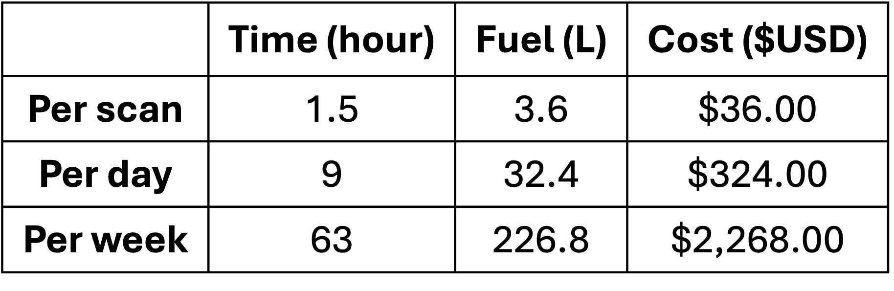

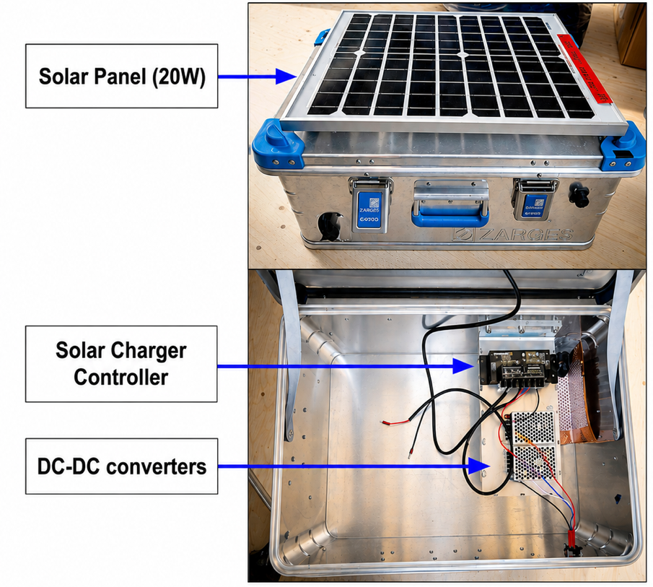
Additional File 2 Power box. The power enclosure houses a solar charge controller that regulates power generated by the mounted solar panels, along with two DC-DC converters (12 V to 5 V and 24 V to 24 V, the latter not used in this deployment). When deployed in the field, the box is filled with batteries to provide energy storage.

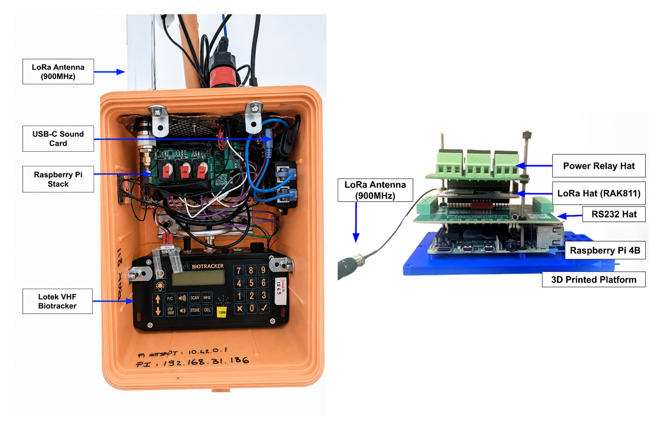Additional File 3 Internal layout of the processing box. Lotek VHF biotracker, Raspberry Pi stack, USB sound card, and LoRa antenna (left). Detailed view of the Raspberry Pi stack (right).

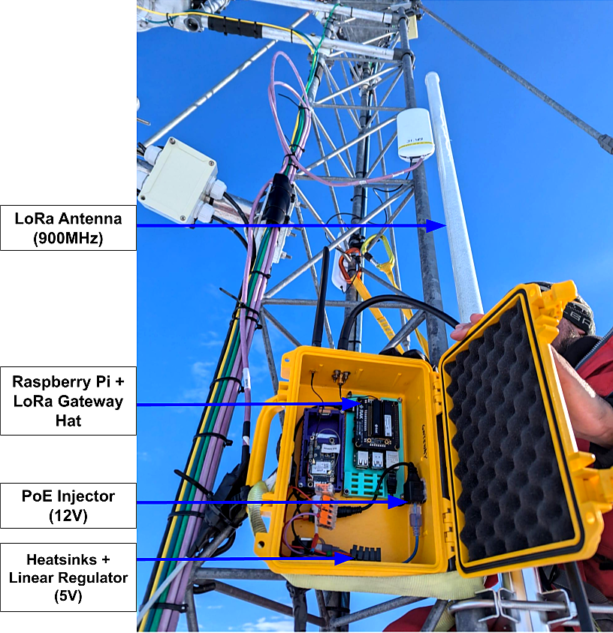
Additional File 4 Field deployed LoRaWAN gateway. The gateway was mounted 6 m above ground level on the mast of the SPOT Penguin Observatory. The gateway is housed in a yellow, weather-resistant enclosure and is equipped with an external 1m-long LoRa antenna operating at 915 MHz.

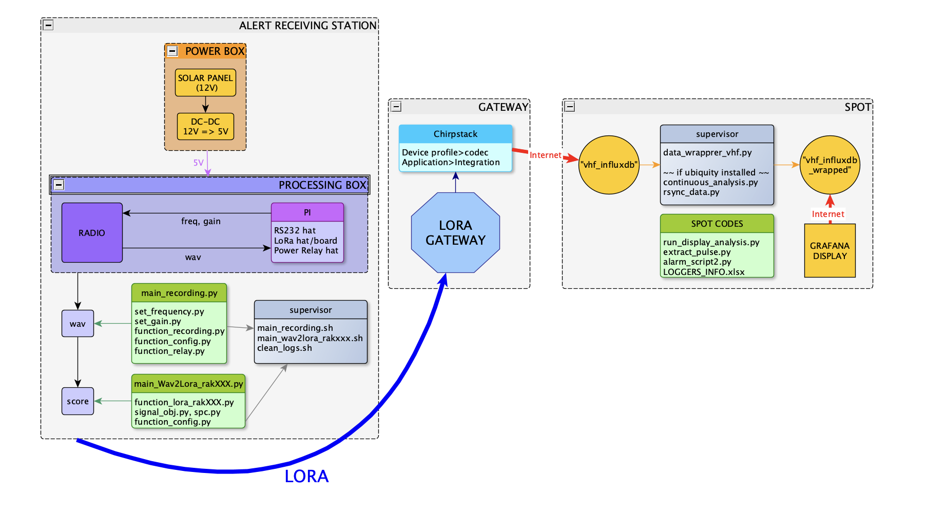
Additional File 5 Detailed ALERT Information and Script Flow. Each ALERT receiving station consists of a power box (solar panels, batteries, and DC–DC converters) and a processing box housing a Raspberry Pi stack that controls a VHF receiver, performs onboard data analysis, and manages LoRa transmissions. The processed data (i.e. detection scores) are transmitted via LoRaWAN to a gateway running ChirpStack v4. The gateway stores base64-encoded packets in a local InfluxDB database, where they are decoded and formatted for efficient querying by a linked Grafana interface that provides real-time visualization.

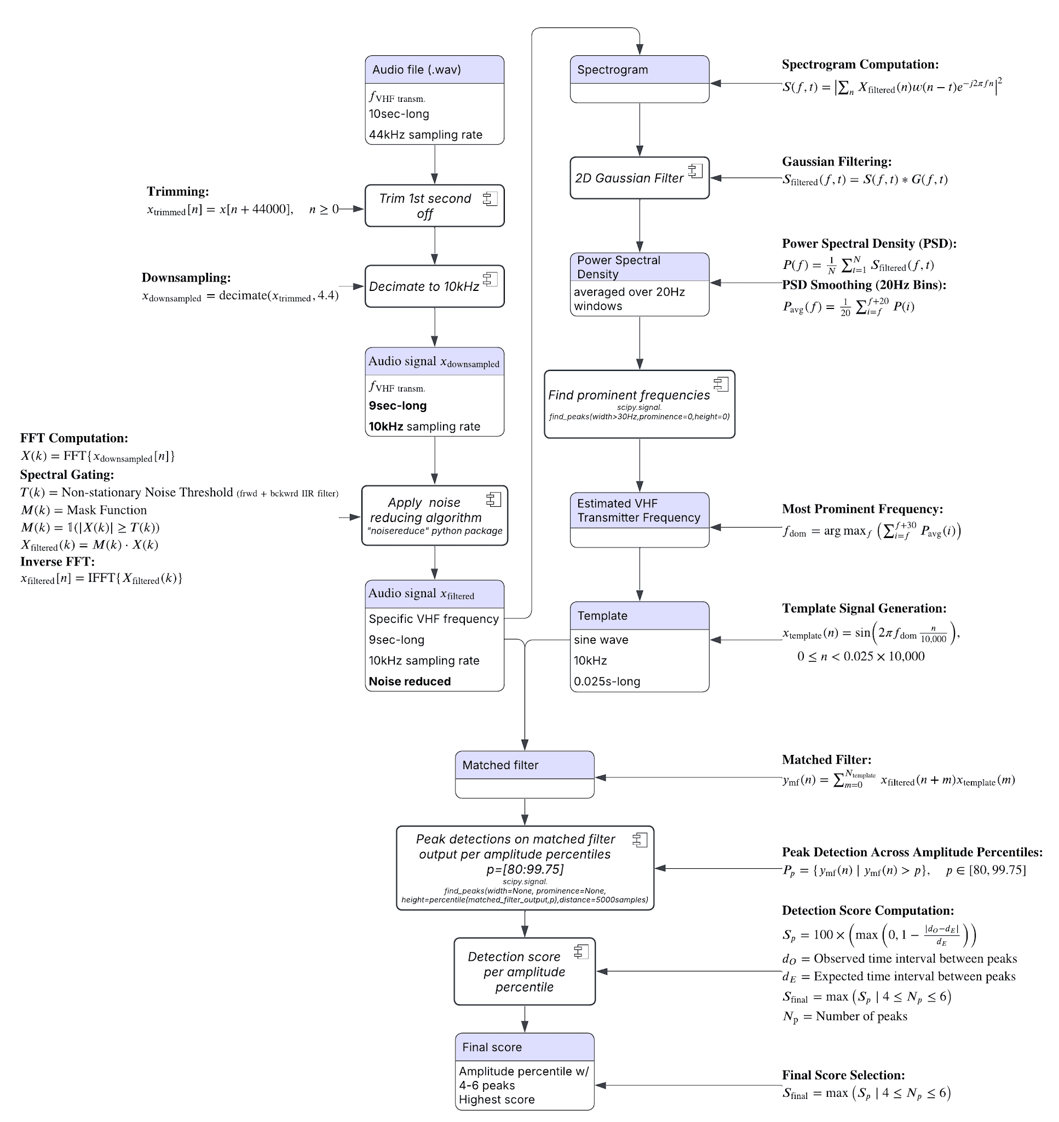
Additional File 6 Detection algorithm flowchart. The flowchart illustrates the processing steps applied to a raw audio file, including trimming, downsampling, noise reduction, and template signal extraction and match filtering, which are used to evaluate the presence of a detection signal by assigning a detection score.

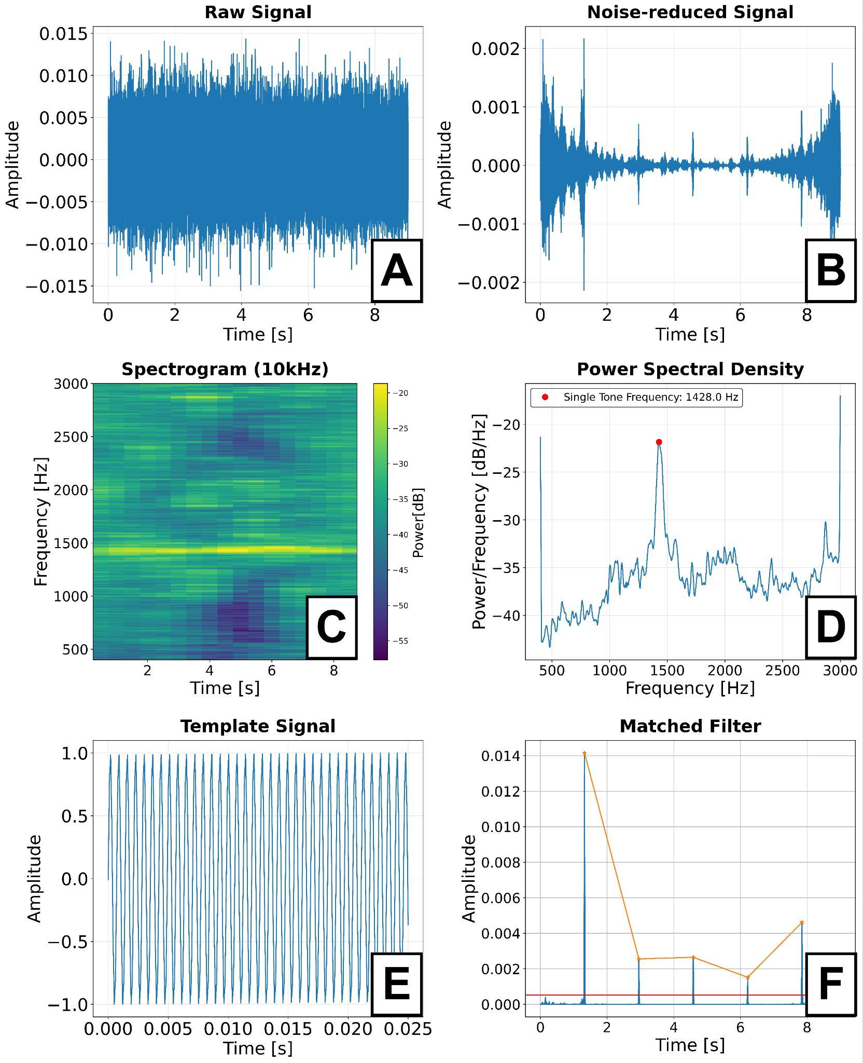
Additional File 7 Analyzed audio file example. Example output of the detection algorithm for a single audio file, resulting in a detection score of 97. The analysis begins with the raw audio signal (A), which is subsequently noise-reduced (B). A spectrogram of the noise-reduced signal, downsampled to 10 kHz, is then computed (C). From the corresponding power spectral density (PSD; D), the dominant signal frequency is identified and used to generate a 25 ms sine-wave template, which is finally applied to the noise-reduced signal using matched filtering to enhance repetitive pulse-like features (F). Detection scores are then derived from peak detection on the matched-filter output based on peak count and temporal spacing.

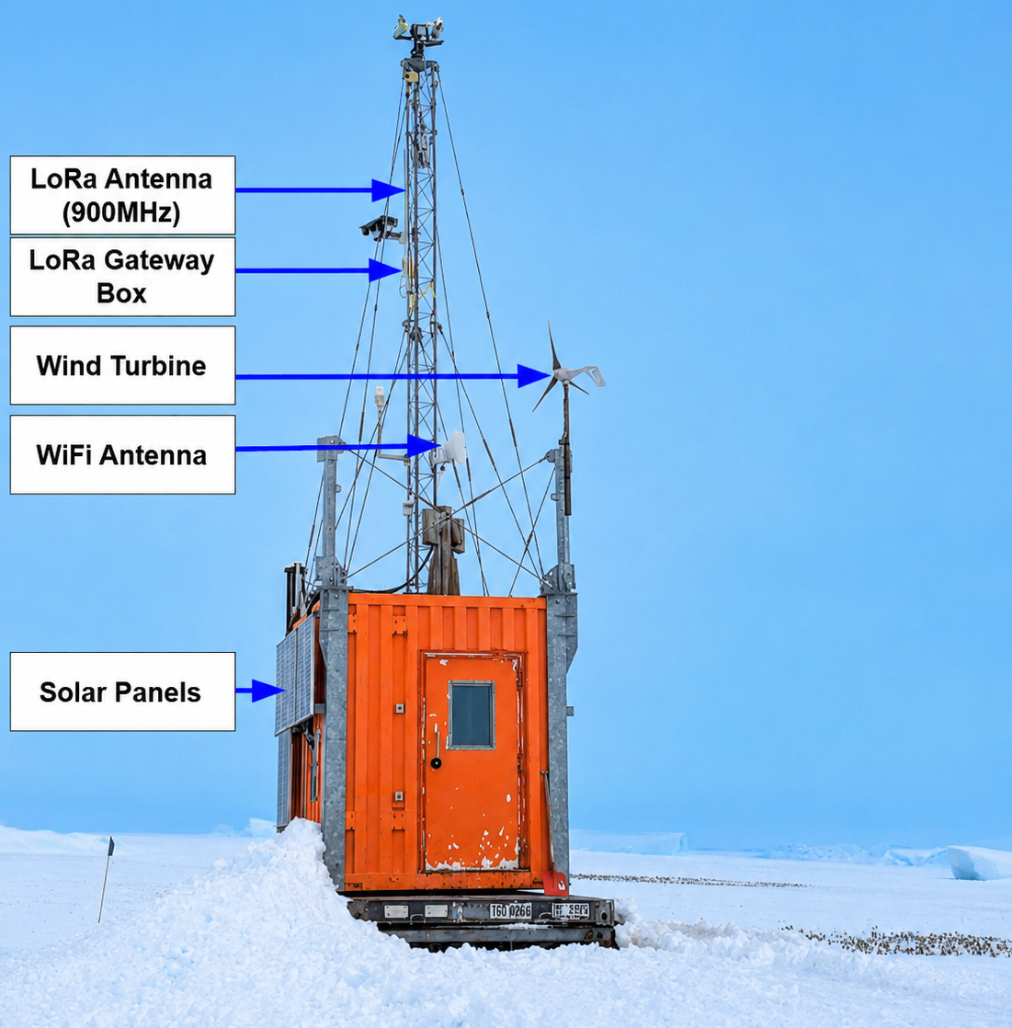
Additional File 8 SPOT: Single Penguin ObservaTory. Located at Akta Bay, Antarctica, the self-powered observatory hosted a LoRaWAN gateway and antenna. SPOT is energetically self-sufficient using solar generators and wind turbines, and is connected to the internet through a Wi-Fi link to the research base Neumayer Station III.

Additional File 9 Summary of biologger deployments on emperor penguins.
AusOMS and LittleLeo refer to micro acoustic recorders from AquaSound Inc. (Kobe, Japan) and video loggers from Little Leonardo Corporation (Tokyo, Japan), respectively. CatsCams are high-resolution cameras from Customized Animal Tracking Solutions Pty. Ltd. (Queensland, Australia), AxyTrek are GPS loggers from Technosmart (Rome, Italy), and GPS-LoRa tags are custom-built GPS devices with LoRa transmission capability. Return dates to the colony were identified using ALERT detections and, when available, verified with GPS data. Some VHF transmitters deployed early in the season were later redeployed on different adults, resulting in occasional repetition of tag names and frequencies.
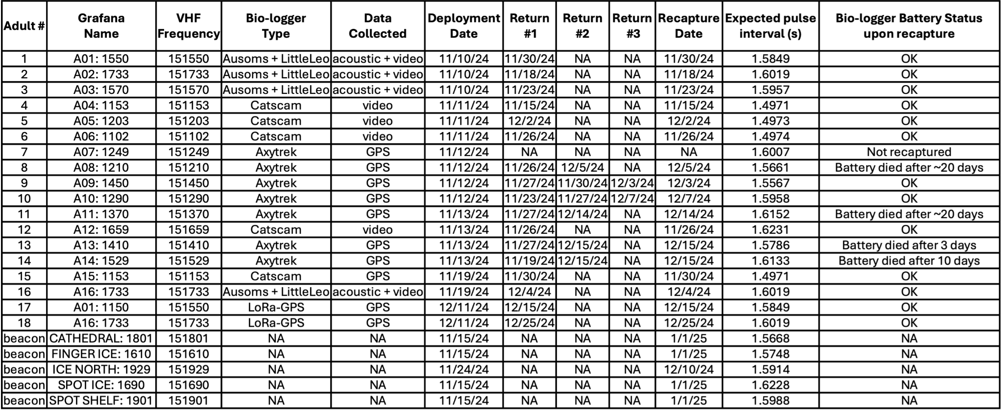

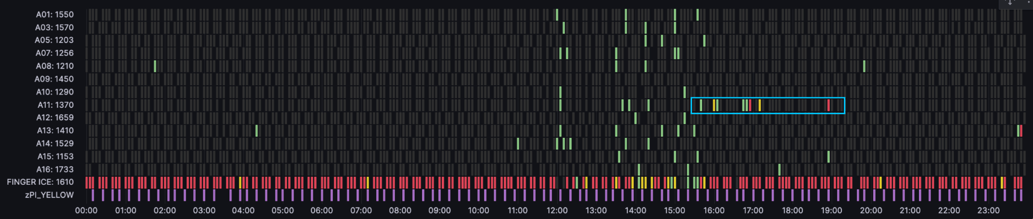
Additional File 10 Grafana display of detection scores recorded on 12-14-2024 by the yellow receiving station. Between 12:00 and 16:00, external interference appears as a cluster of elevated detection scores (65–80, green) across all monitored frequencies (rows), indicative of noise rather than genuine tag signals. Shortly after, penguin A11 generated two moderate scores (81–89, yellow) and one high-confidence score of 99 (red), spaced apart in time as highlighted in the cyan box. This sparse and subtle detection pattern could have easily been mistaken for noise. However, the high score of 99 prompted a manual check, confirming the penguin’s return to the colony and enabling successful recapture and tag retrieval.

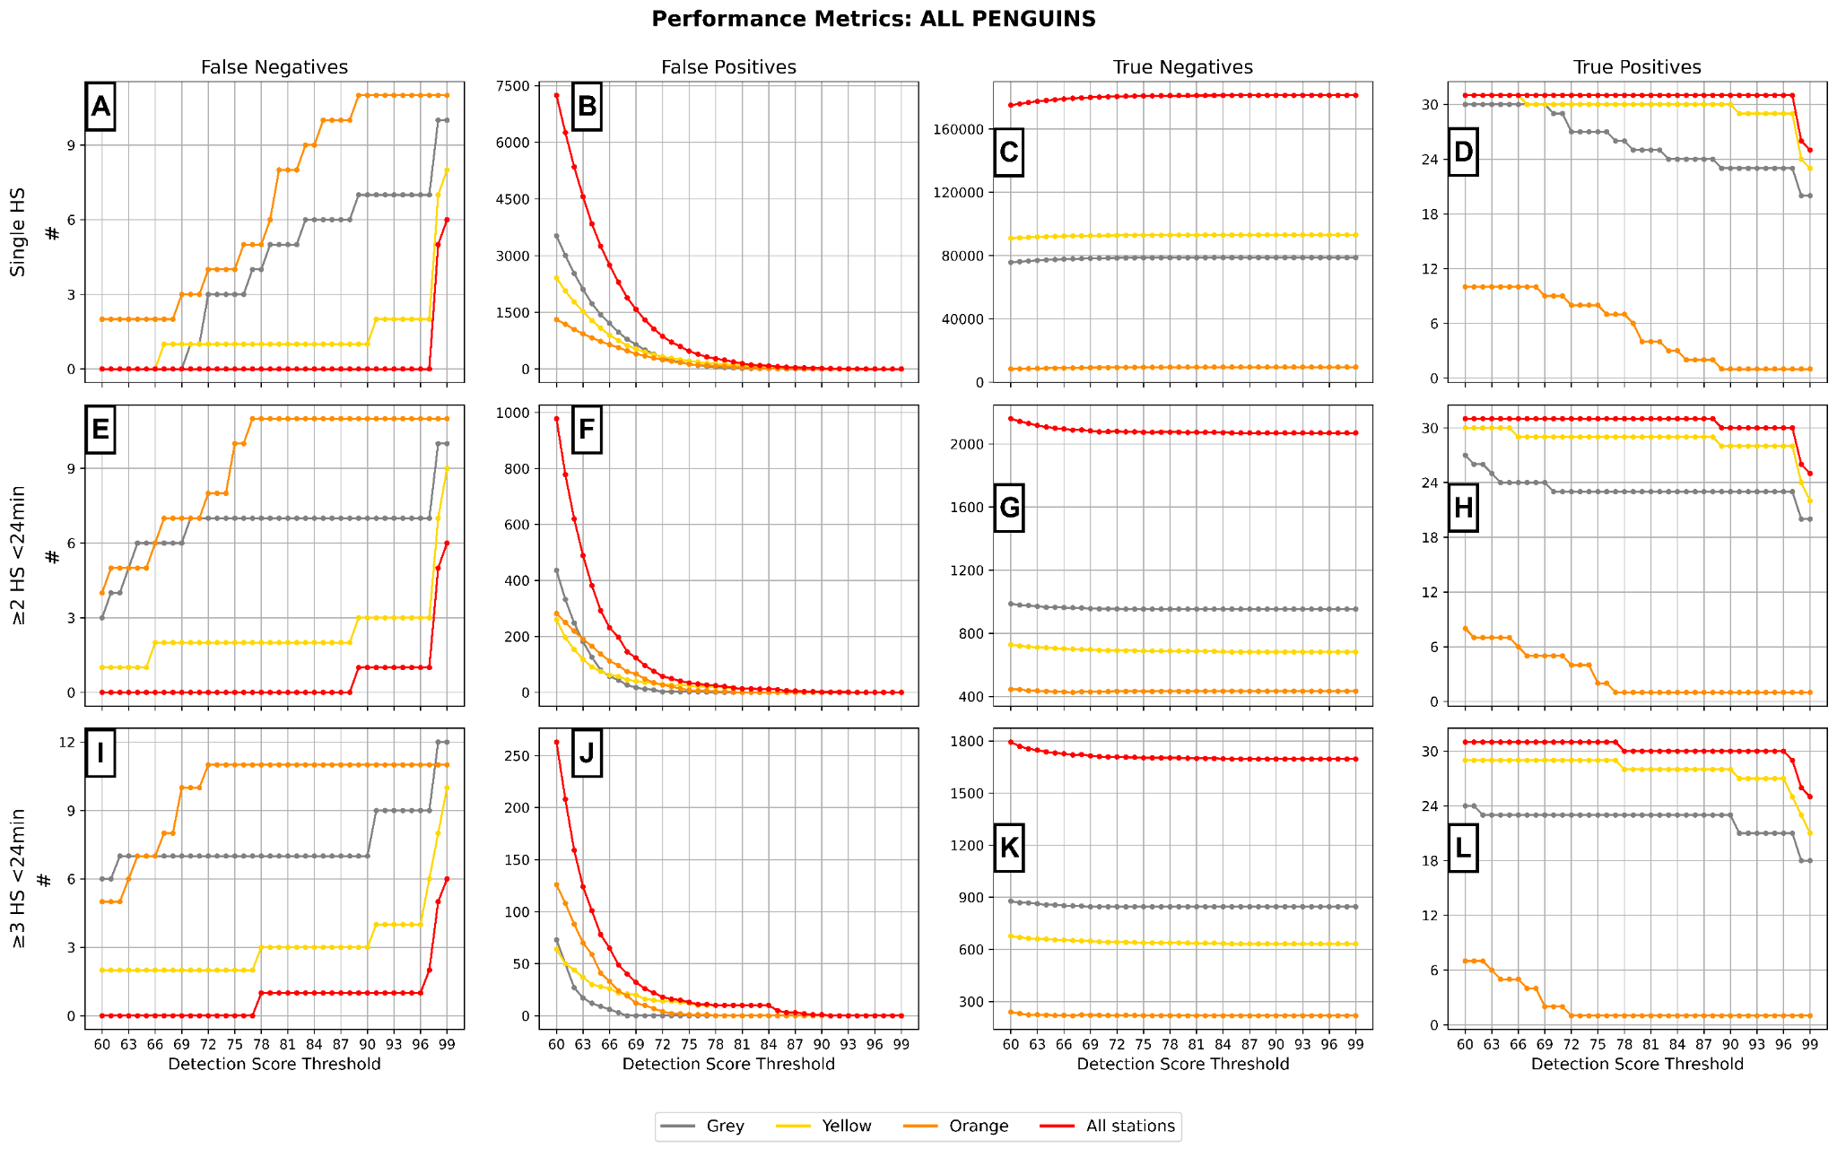
Additional File 11 Full performance metrics per ALERT station (full dataset). (FN, FP, TN, TP) for each ALERT receiving station evaluated across the full tagged penguin dataset. Metrics are shown for three detection criteria: single high score (HS), ≥2 HS within 24 minutes, and ≥3 HS within 24 minutes. True presence was inferred using VHF-based presence. Detection score thresholds range from 60 to 99. Although
25 returns were recorded, the maximum number of true positives (31) includes additional detections shortly after tag deployment, which represent true presence at the colony but not returns.

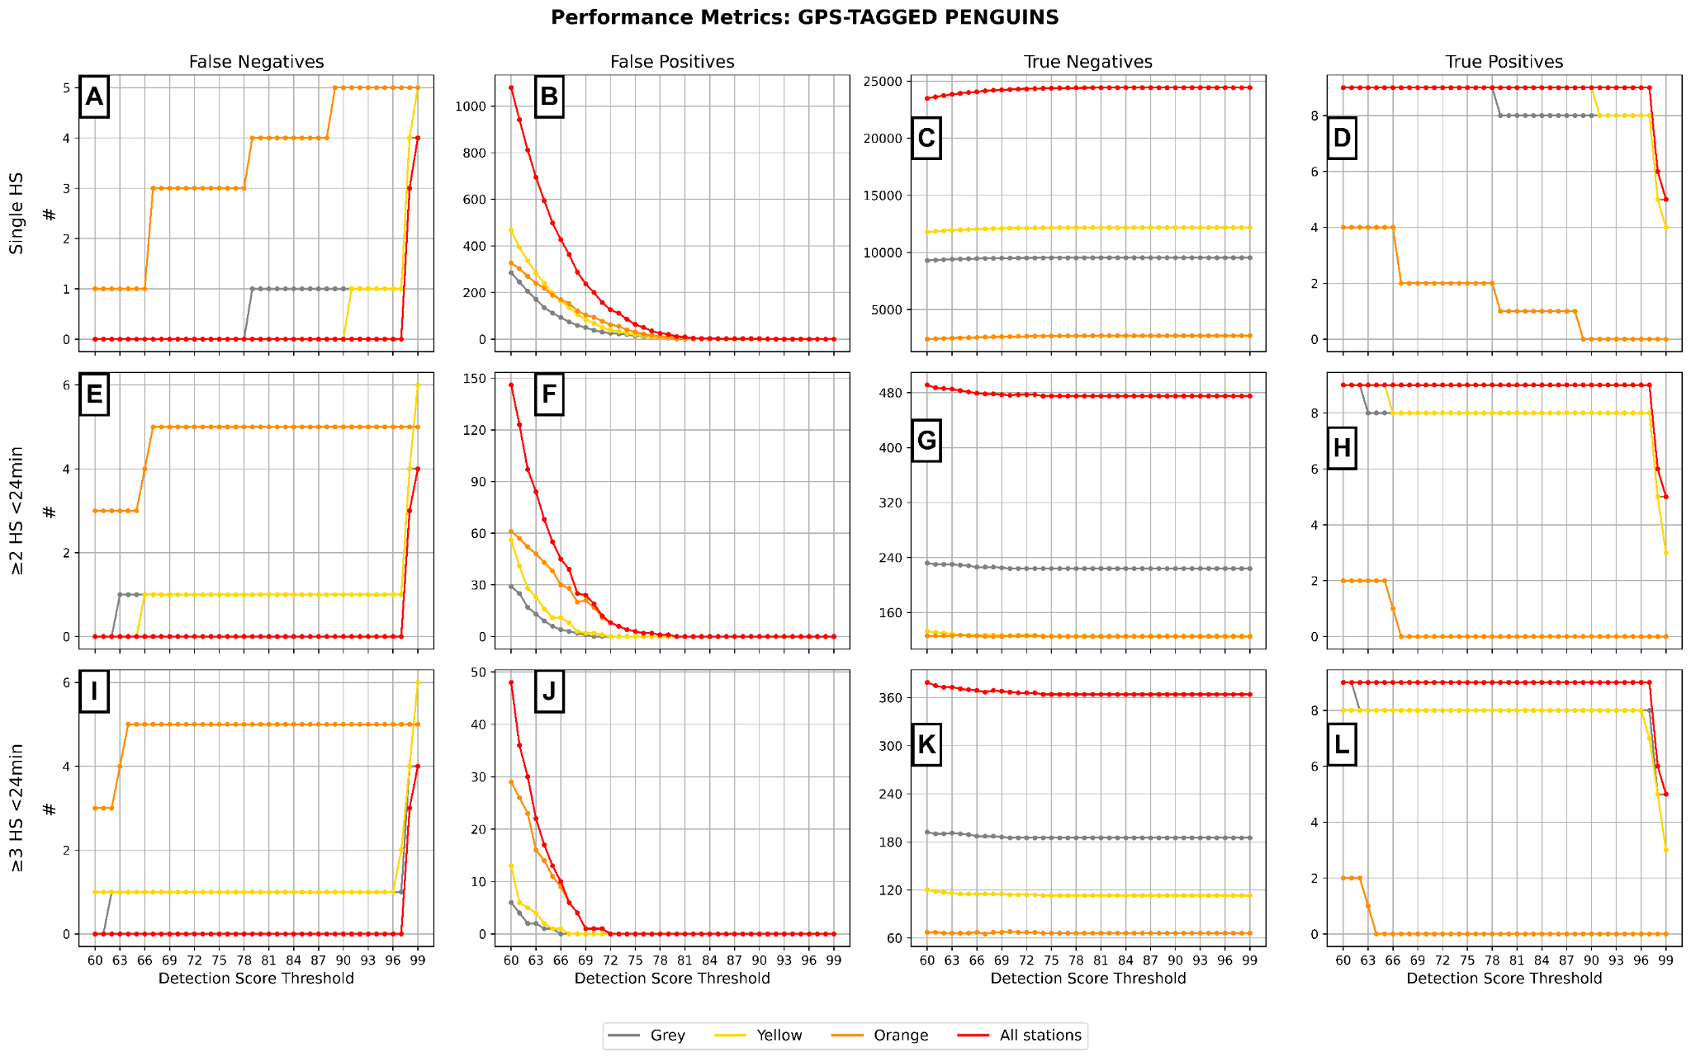Additional File 12 Full performance metrics per ALERT station (GPS-tagged only dataset). Performance metrics (FN, FP, TN, TP) for each ALERT receiving station evaluated across all GPS-tagged penguins only. Metrics are shown for three detection criteria: single high score (HS), ≥2 HS within 24 minutes, and ≥3 HS within 24 minutes. True presence was inferred using GPS-based presence. Detection score thresholds range from 60 to 99.

Additional File 13 LoRa Transmission Metrics by ALERT Component. Start and end dates reflect each component's deployment period. The Average TX Interval (s), in seconds, refers to the average time between successful LoRa transmissions. The total number of LoRa transmissions from all sources (i.e. beacons pings, Raspberry Pi heartbeats, detection scores) is reported (# LoRa TX (All Sources)), along with tag-related transmissions only (i.e detection scores; # LoRa TX (Tags Only)). The number and percentage of tag-related transmissions with detection scores >90% are also shown. Failed transmissions (# and %) are defined as transmission intervals exceeding the median plus 1.5 times the interquartile range, following the outlier detection approach proposed by Tukey (1977) for non-normal distributions. The frequency of failed LoRa transmissions during periods of system uptime is reported as failures per hour (# Failed LoRa TX/h). Differences in reported uptime reflect variation in deployment duration and intermittent power interruptions across components 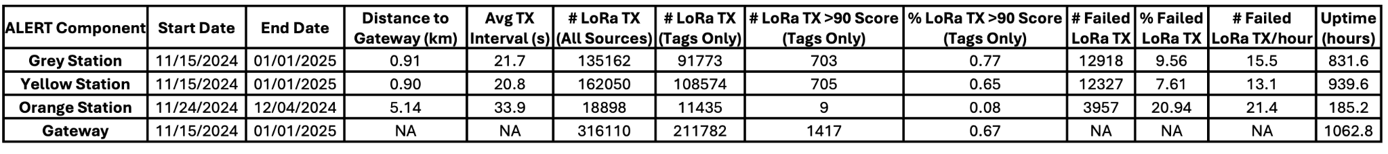
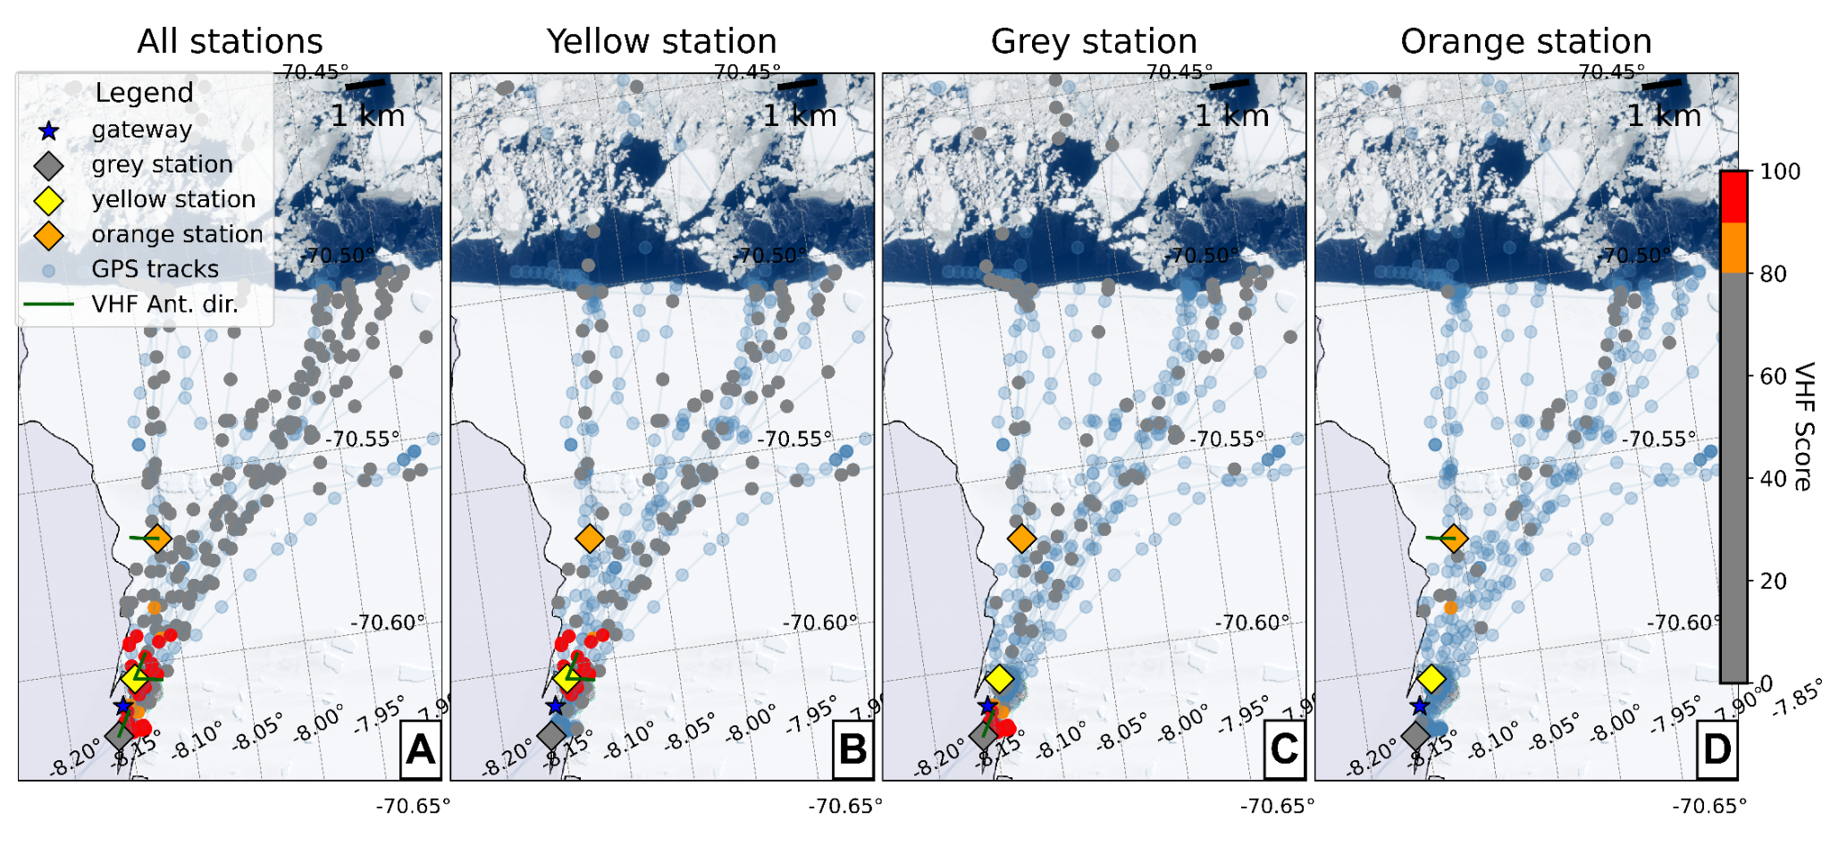
Additional File 14 Four maps of the study site (Atka Bay, Antarctica). Each map shows penguin GPS tracks and their highest VHF detection scores matched within ±15 minutes of each GPS timestamp at the considered station. This window was chosen to ensure that each VHF detection could be matched to, at most, one GPS fix, as the GPS were programmed to record a position every 30 minutes. Dot colours indicate detection score: grey (0-80), orange (81-90), and red (91-100). Blue dots represent GPS locations that could not be matched to a VHF detection, likely due to the receiving station(s) being offline.

