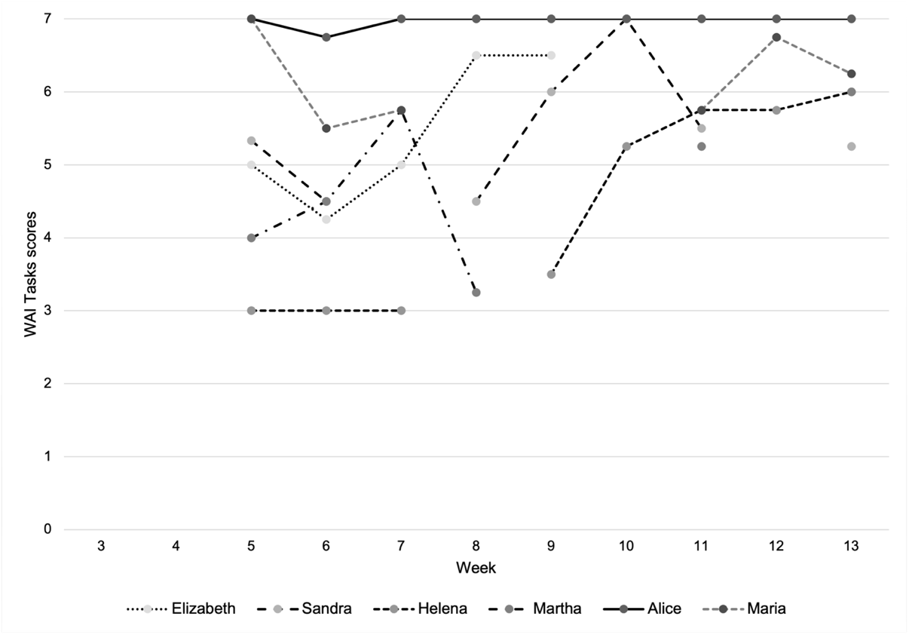

Supplemental figure 1. Individual WAI Tasks subscale scores during treatment.

