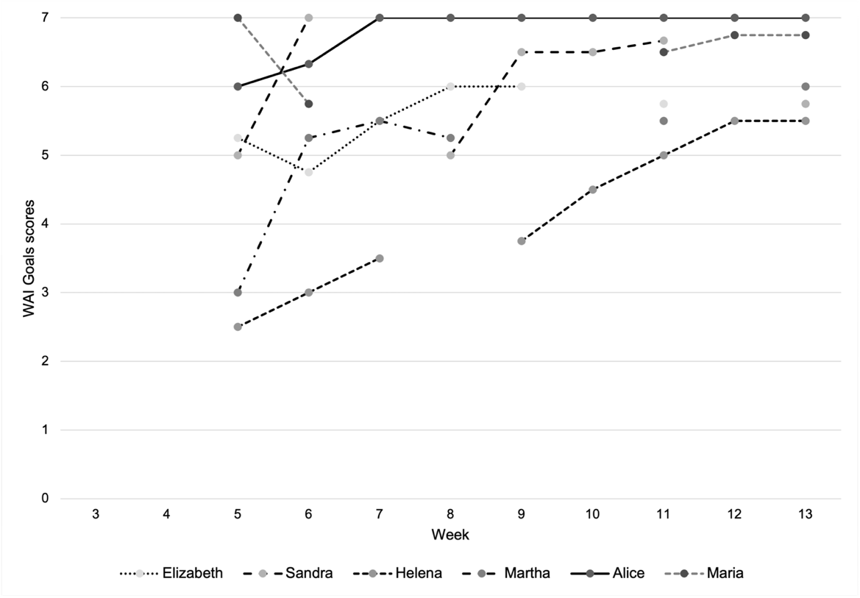

Supplemental figure 2. Individual WAI Goals subscale scores during treatment

