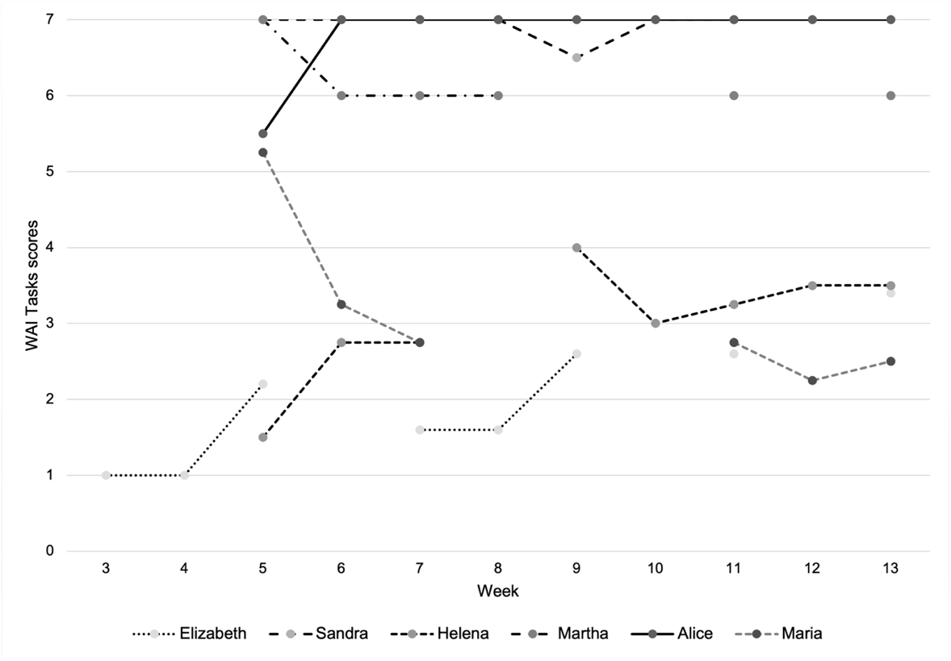
Supplemental figure 3. Individual WAI Emotional Bond subscale scores during treatment

