Appendices
Appendix A: Informed Consent
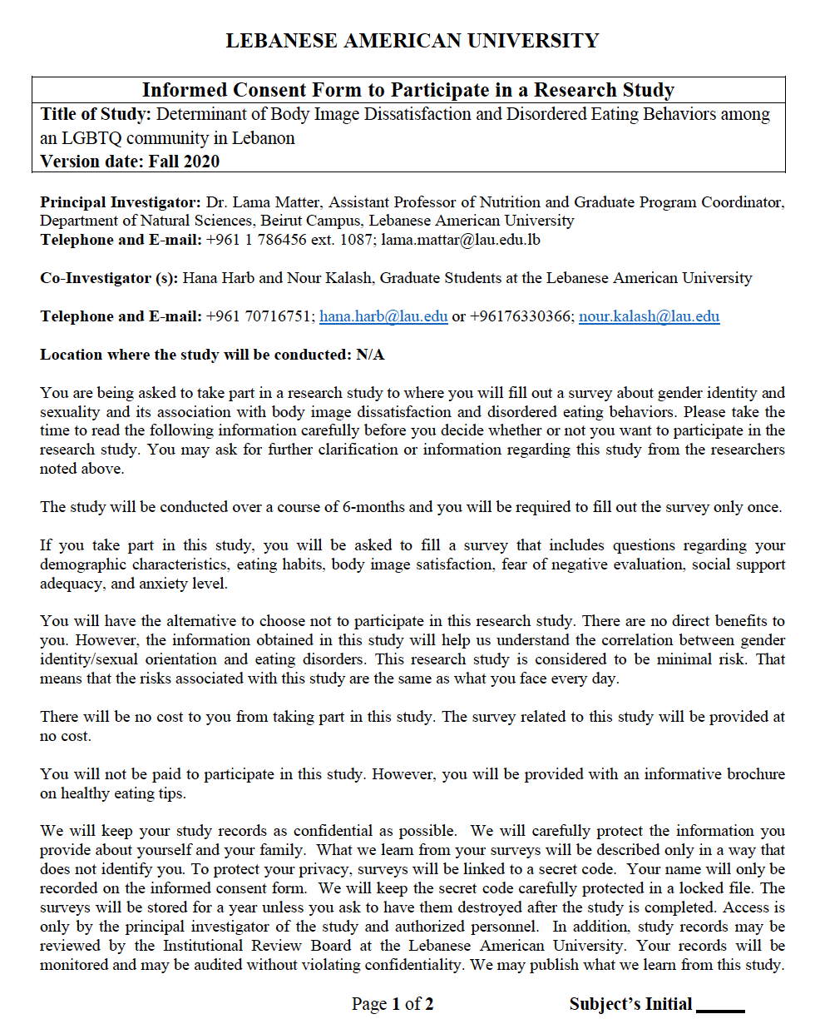

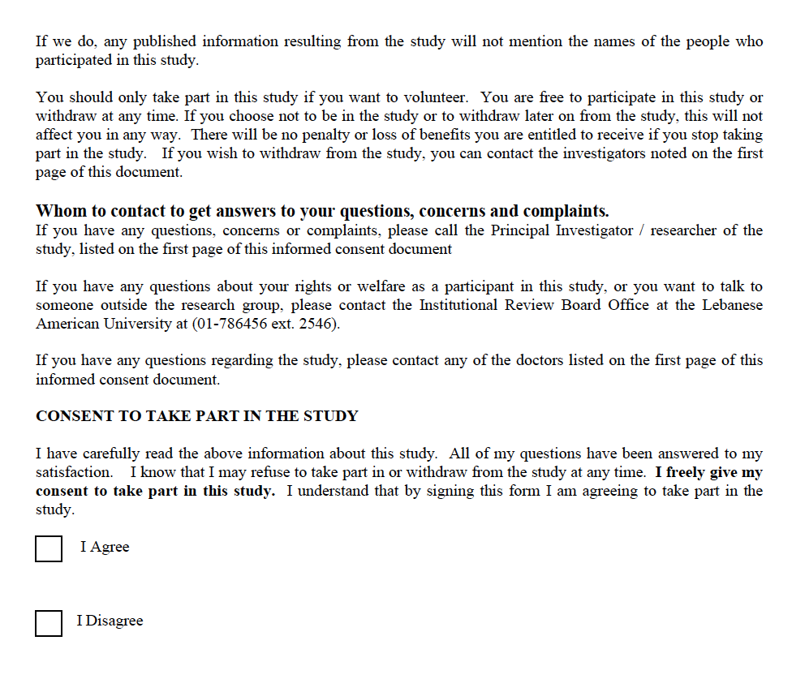

Appendix B: Sociodemographic, General Health, and Alcohol Intake Questionnaires
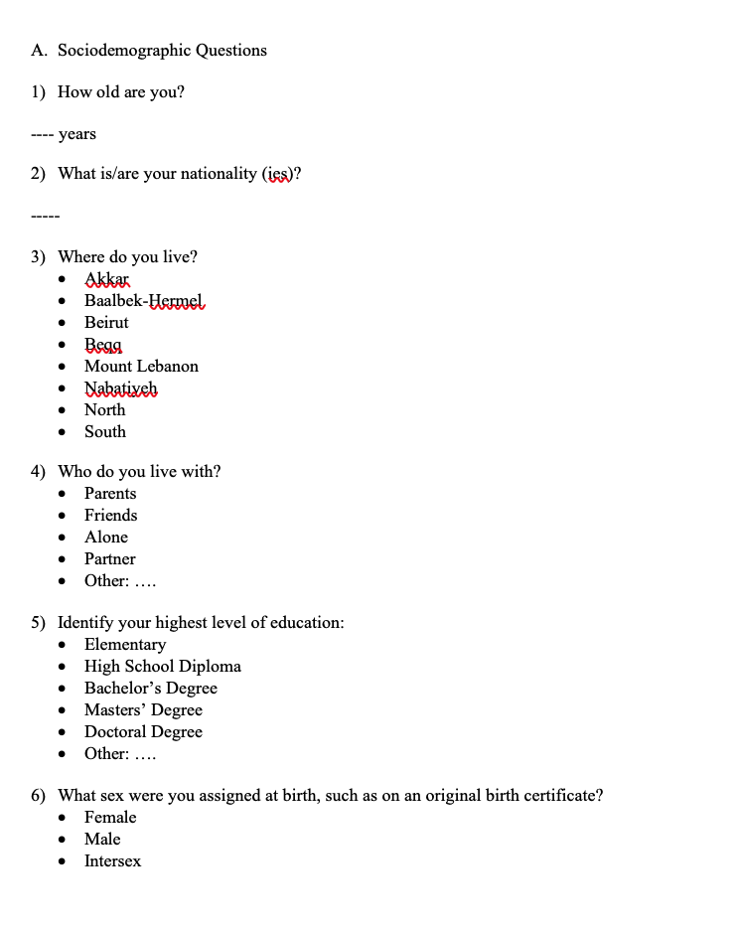
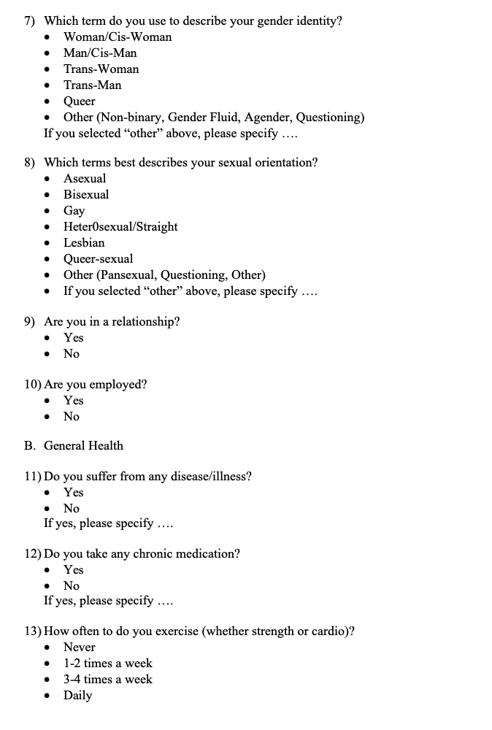

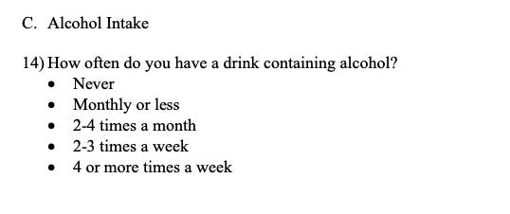
Appendix C: Eating Disorder examination questionnaire (EDE-Q 6.0)
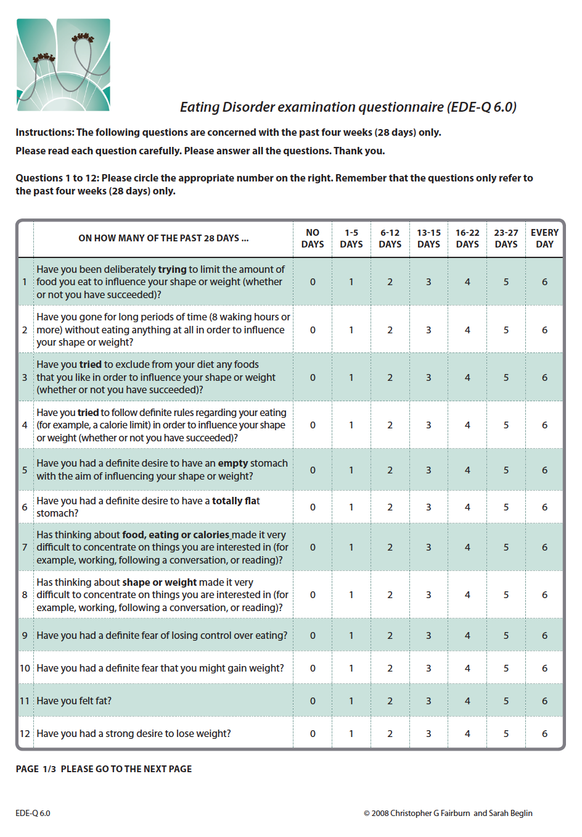
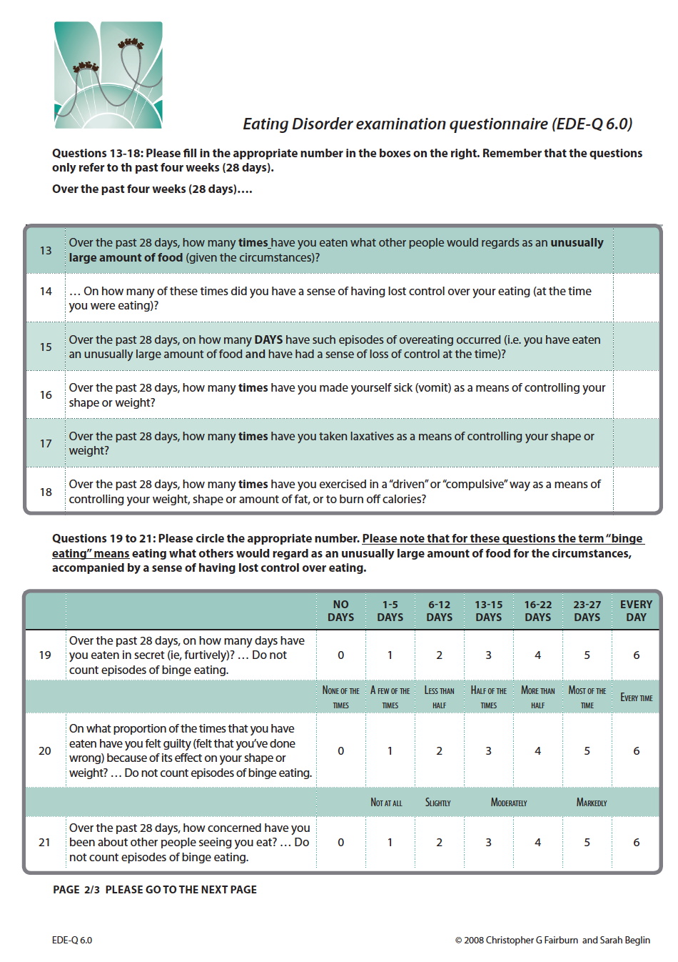
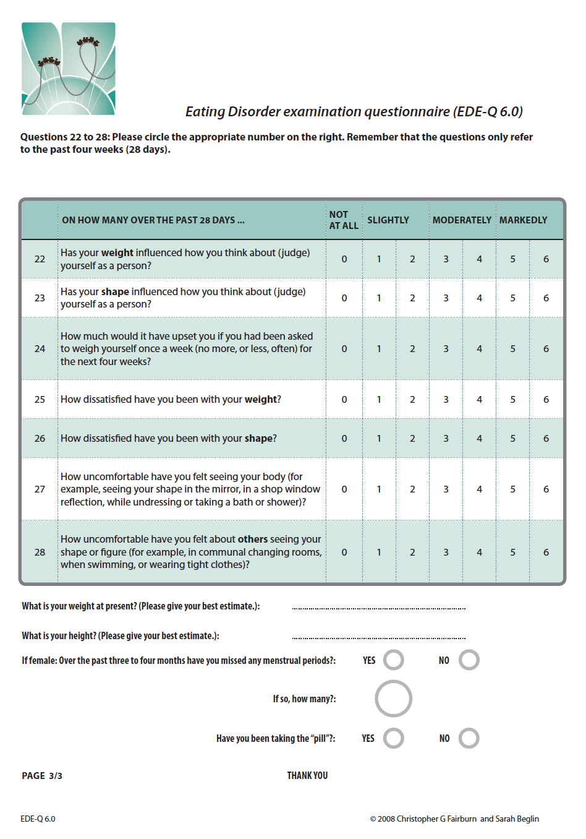
Appendix D: Body Appreciation Scale (BAS-2)
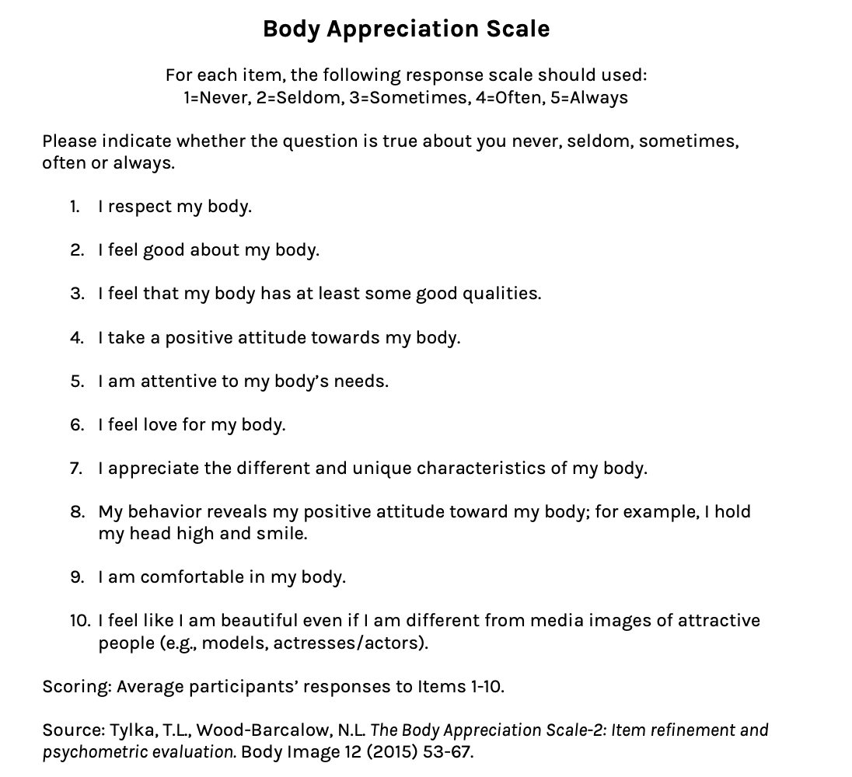

Appendix E: Generalized Anxiety Disorder (GAD-2)
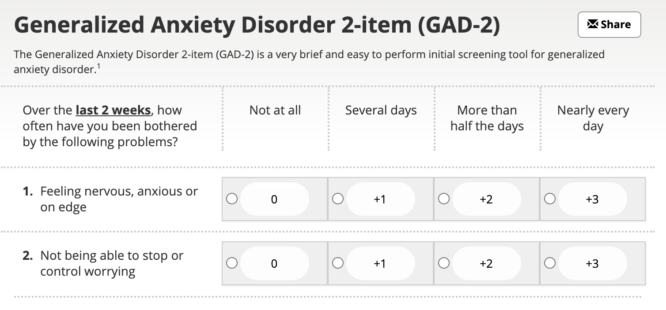
From: Kroenke K, Spitzer RL, Williams JB, Monahan PO, Löwe B. Anxiety disorders in primary care: prevalence, impairment, comorbidity, and detection. Ann Intern Med. 2007;146:317-25.

Appendix F: Brief Fear of Negative Evaluation (BFNE)

Appendix G: Heterosexist, Harassment, Rejection, and Discrimination Scale (HHRDS)
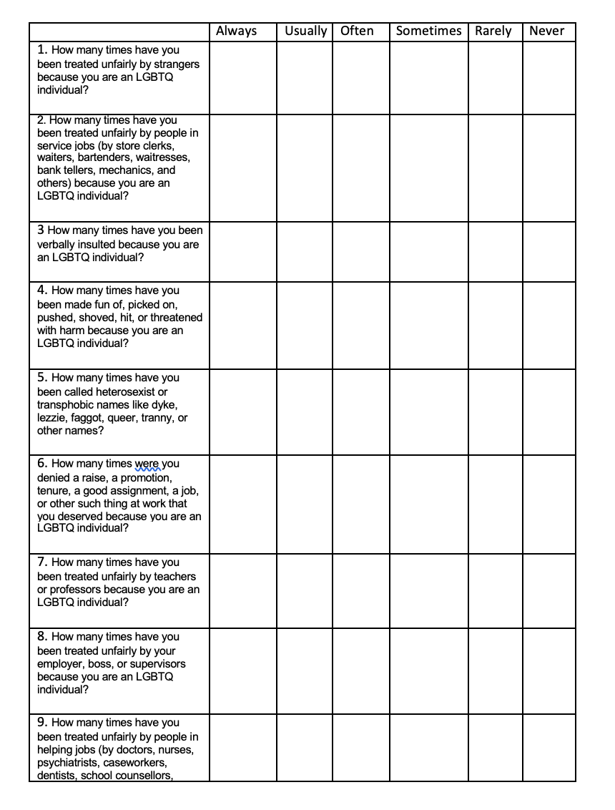

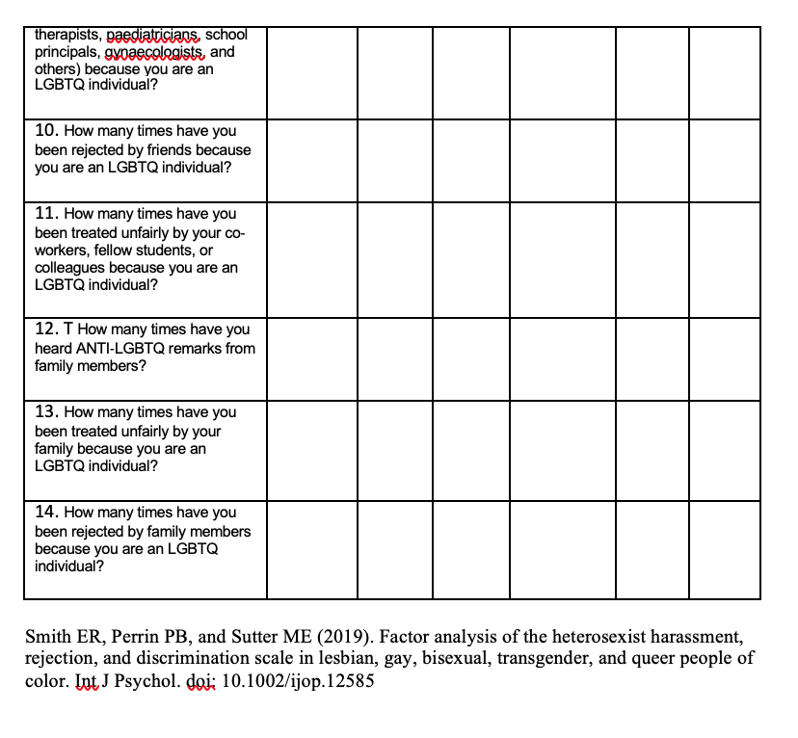

Appendix H: Multidimensional Scale of Perceived Social Support (MSPSS)
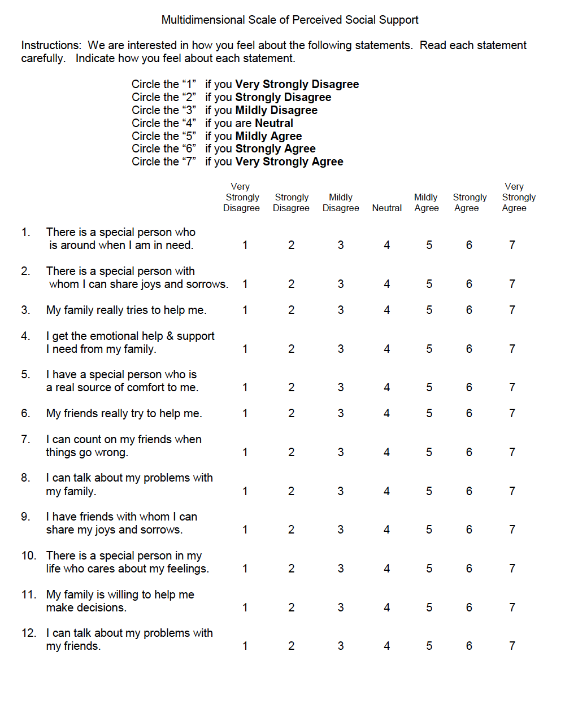From: Zimet GD, Dahlem NW, Zimet SG, Farley GK. The Multidimensional Scale of Perceived Social Support. Journal of Personality Assessment 1988;52:30-41.

Appendix I: Your Guide to a Healthy Eating and Wellbeing

