Additional file 1
S1. Misclassification for ROC analysis
Figure S1.1 shows the same data as Figure 1f in the main text, but with individual patient trajectories broken out rather than shown as an average. This gives a better sense of the variation in trajectories and %EBW at admission for patients in each group, as well as how close some patients are to reaching 95% EBW at week 20.

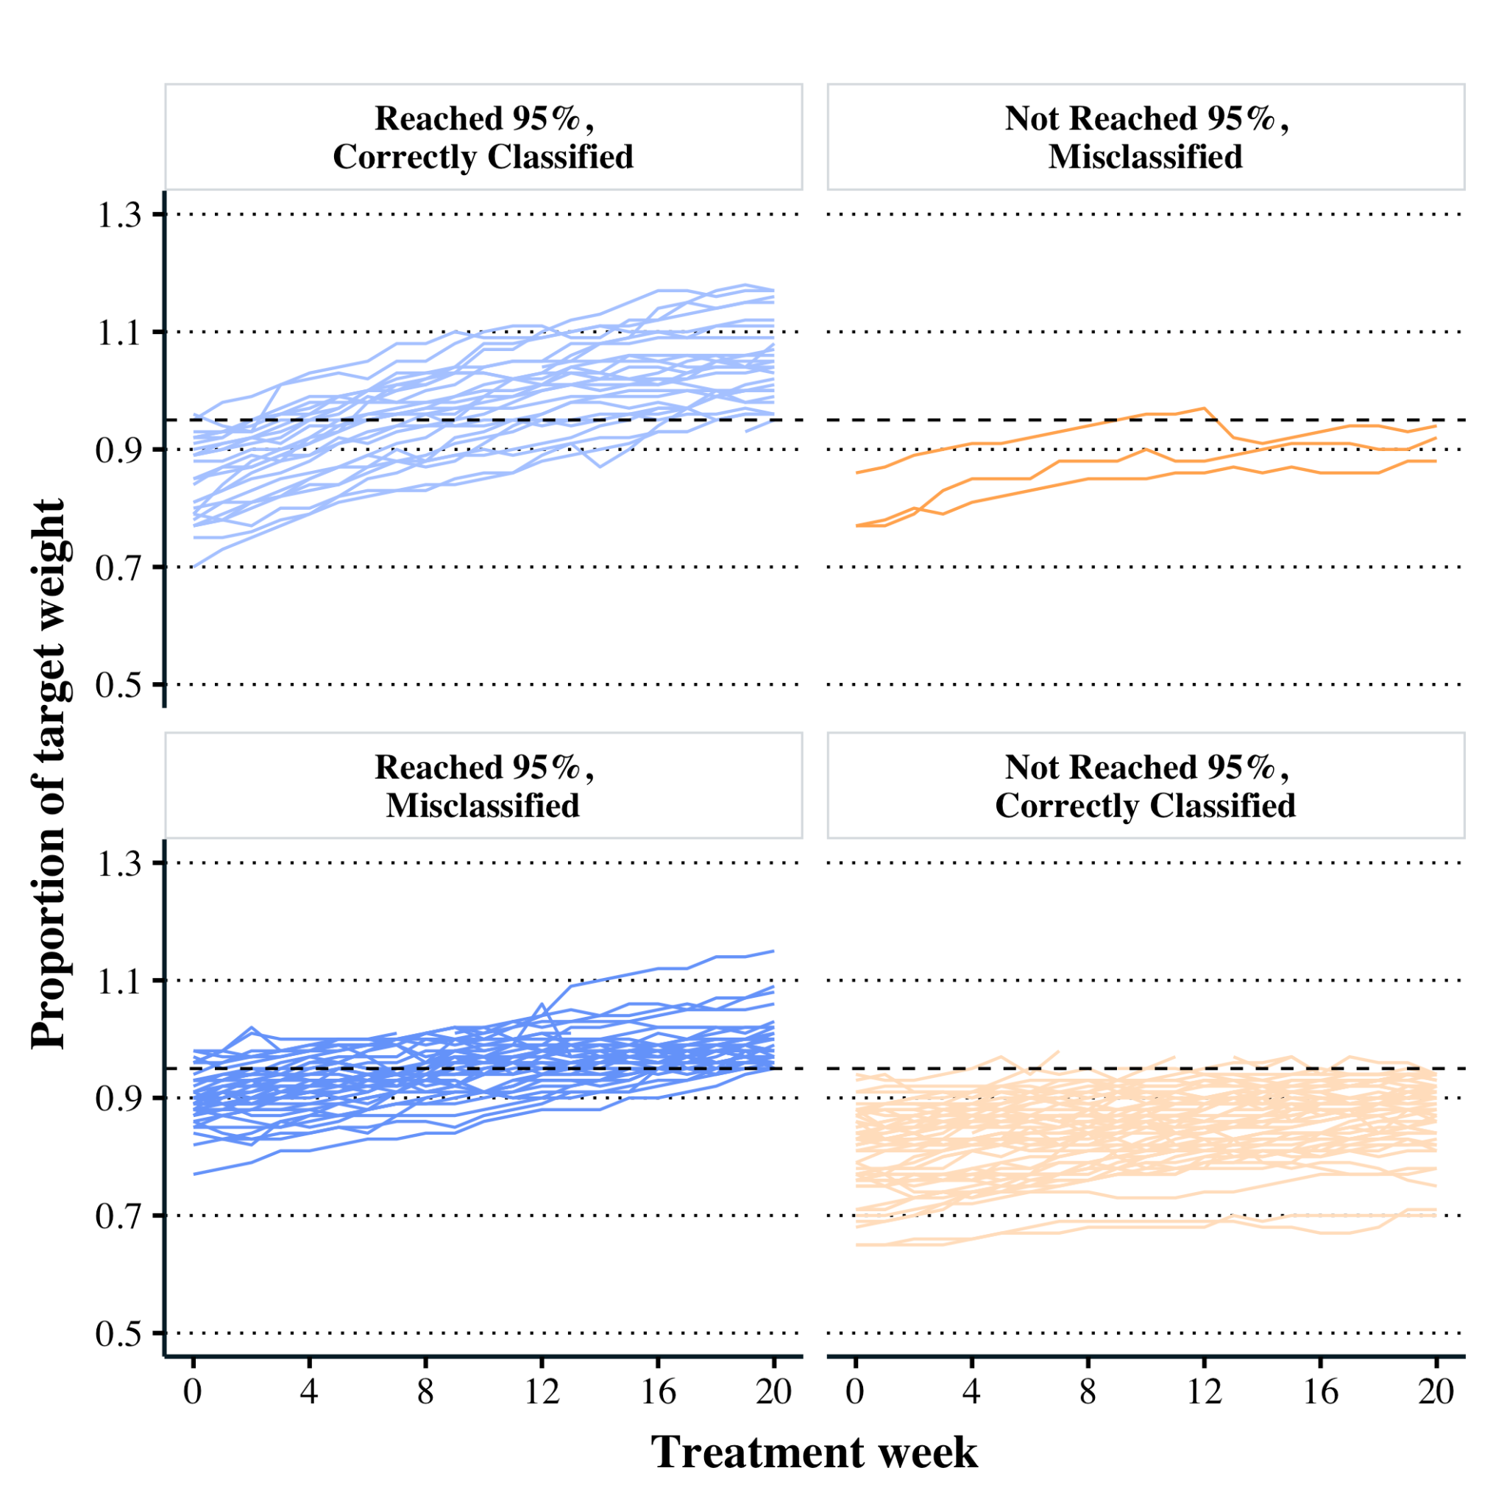
Figure S1.1. ROC misclassification individual patient trajectories. Individual trajectories of patients based on whether the ROC analysis correctly or incorrectly classified them at week 5. The horizontal dashed line gives 95% of EBW. This is the same plot as Figure 1f in the main text, but with the individual patients plotted separately as opposed to plotting the average.

S2. Additional results for models that include the starting % EBW
Table S2.1 gives the estimated probability that a patient will achieve 95% EBW based on both their weight gain (columns) and their starting %EBW (columns). As described in the main text, a series of logistic regression models were run for each week of treatment (weeks 1 - 19), which took the following form
$$log\frac{p_{i}}{1-p_{i}}=β_{0}+β_{1}\%EBW_{i,0}+β_{2}Gain_{i,n}+β_{3}(\%EBW_{i,0}×Gain_{i,n})$$
Where $log\frac{p_{i}}{1-p_{i}}$ is the log odds that patient i will achieve 95% EBW by week 20, %EBW_{i,0} is the patient’s starting %EBW, and Gain_{i,n} is the weight gained by the patient i by week n. The estimated probabilities are formed by transforming the log odds into a probability
$$P = \frac{e^{β_{0}+β_{1}\%EBW_{i,0}+β_{2}Gain_{i,n}+β_{3}(\%EBW_{i,0}×Gain_{i,n})}}{1 + e^{β_{0}+β_{1}\%EBW_{i,0}+β_{2}Gain_{i,n}+β_{3}(\%EBW_{i,0}×Gain_{i,n})}}$$
The coefficients we found for week 5 were 𝛽₀=-37.5 (8.7), 𝛽₁=42.1 (9.9), 𝛽₂=3.2 (1.4), and 𝛽₃=-3.2 (1.7). The worst of these series of models (week 1 AUC = 0.83 [0.76, 0.90]) still outperformed the best ROC model (week 5, AUC = 0.72 [0.63, 0.81]).

Table S2.1: Logistic Regression Model – Probability of Reaching 95% EBW in week 20 (P (SE))
Weight Gained by Week | % EBW at Admission | 3 pounds | 4 pounds | 5 pounds | 6 pounds | 7 pounds
3 | 75% | 0.152 (0.07) | 0.314 (0.11) | 0.539 (0.16) | 0.749 (0.16) | 0.884 (0.11)
3 | 80% | 0.353 (0.08) | 0.535 (0.09) | 0.708 (0.09) | 0.836 (0.08) | 0.915 (0.06)
3 | 85% | 0.624 (0.07) | 0.743 (0.07) | 0.834 (0.06) | 0.897 (0.05) | 0.938 (0.04)
3 | 90% | 0.835 (0.05) | 0.879 (0.05) | 0.912 (0.05) | 0.937 (0.05) | 0.955 (0.04)
4 | 75% | 0.064 (0.04) | 0.125 (0.06) | 0.229 (0.09) | 0.383 (0.13) | 0.564 (0.16)
4 | 80% | 0.206 (0.07) | 0.32 (0.08) | 0.46 (0.09) | 0.607 (0.09) | 0.737 (0.09)
4 | 85% | 0.496 (0.07) | 0.608 (0.07) | 0.71 (0.07) | 0.794 (0.07) | 0.859 (0.06)
4 | 90% | 0.789 (0.06) | 0.837 (0.06) | 0.875 (0.06) | 0.906 (0.05) | 0.93 (0.05)
5 | 75% | 0.025 (0.02) | 0.054 (0.03) | 0.112 (0.06) | 0.218 (0.1) | 0.379 (0.15)
5 | 80% | 0.117 (0.05) | 0.199 (0.07) | 0.318 (0.08) | 0.466 (0.1) | 0.62 (0.1)
5 | 85% | 0.402 (0.07) | 0.518 (0.07) | 0.631 (0.07) | 0.732 (0.07) | 0.814 (0.07)
5 | 90% | 0.773 (0.06) | 0.823 (0.06) | 0.863 (0.05) | 0.896 (0.05) | 0.921 (0.05)
6 | 75% | 0.015 (0.01) | 0.028 (0.02) | 0.054 (0.03) | 0.102 (0.05) | 0.183 (0.08)
6 | 80% | 0.08 (0.04) | 0.131 (0.06) | 0.208 (0.07) | 0.314 (0.08) | 0.444 (0.09)
6 | 85% | 0.339 (0.07) | 0.44 (0.07) | 0.547 (0.08) | 0.65 (0.08) | 0.74 (0.08)
6 | 90% | 0.751 (0.06) | 0.803 (0.06) | 0.847 (0.06) | 0.882 (0.05) | 0.91 (0.05)

