S1. The images and the pleasant and unpleasant words in the Implicit Association Test (IAT).
High-calorie food images | Low-calorie food images | Pleasant words | Unpleasant words
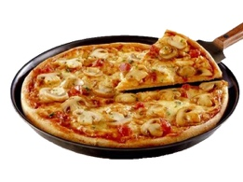 | 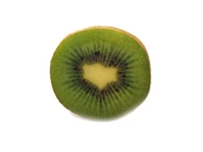 | Love | Crime
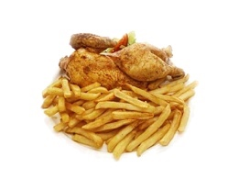 | 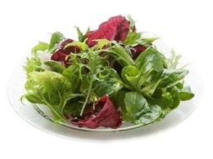 | Smile | Hate
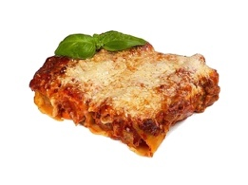 | 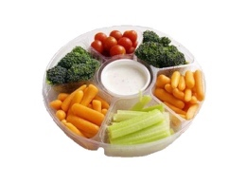 | Kiss | Torture
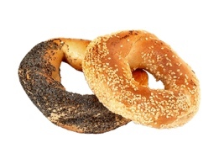 | 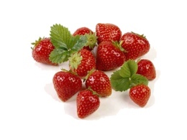 | Friendship | War
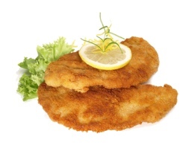 | 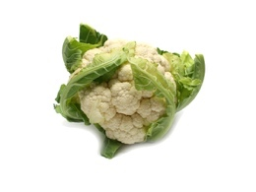 | Holiday | Murder
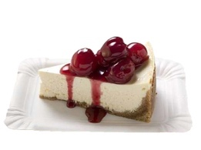 | 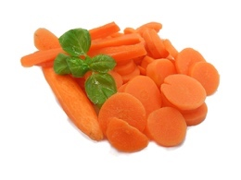 | Peace | Accident
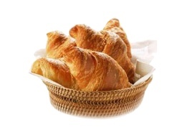 | 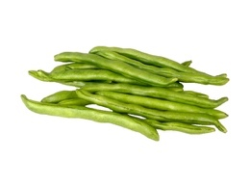 | Wonderful | Failure
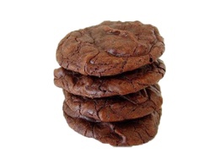 | 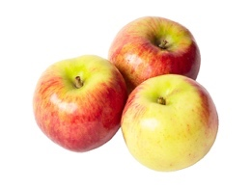 | Joy | Laziness
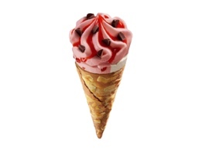 | 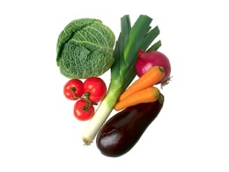 | Beauty | Disgust
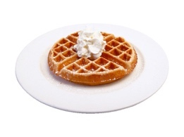 | 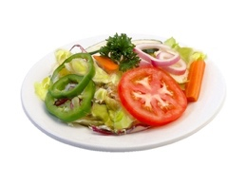 | Pleasure | Fear

S2. The sequence of trial blocks in the Implicit Association Test (IAT (
Block | Number of trials | Function | Items allocated to the left-key response | Items allocated to the right-key response
1 | 20 | Practice | Low-calorie food images | High-calorie food images
2 | 20 | Practice | Unpleasant words | Pleasant words
3 | 20 | Practice | Low-calorie food images  + Unpleasant words | High-calorie food images + Pleasant words
4 | 40 | Test | Low-calorie food images  + Unpleasant words | High-calorie food images + Pleasant words
5 | 20 | Practice | High-calorie food images | Low-calorie food images
6 | 20 | Practice | High-calorie food images + Unpleasant words | Low-calorie food images + Pleasant words
7 | 40 | Test | High-calorie food images + Unpleasant words | Low-calorie food images + Pleasant words
Note. For half of the participants blocks 1,3 and 4 were switched with blocks 5, 6, and 7, respectively.

