Supplemental materials
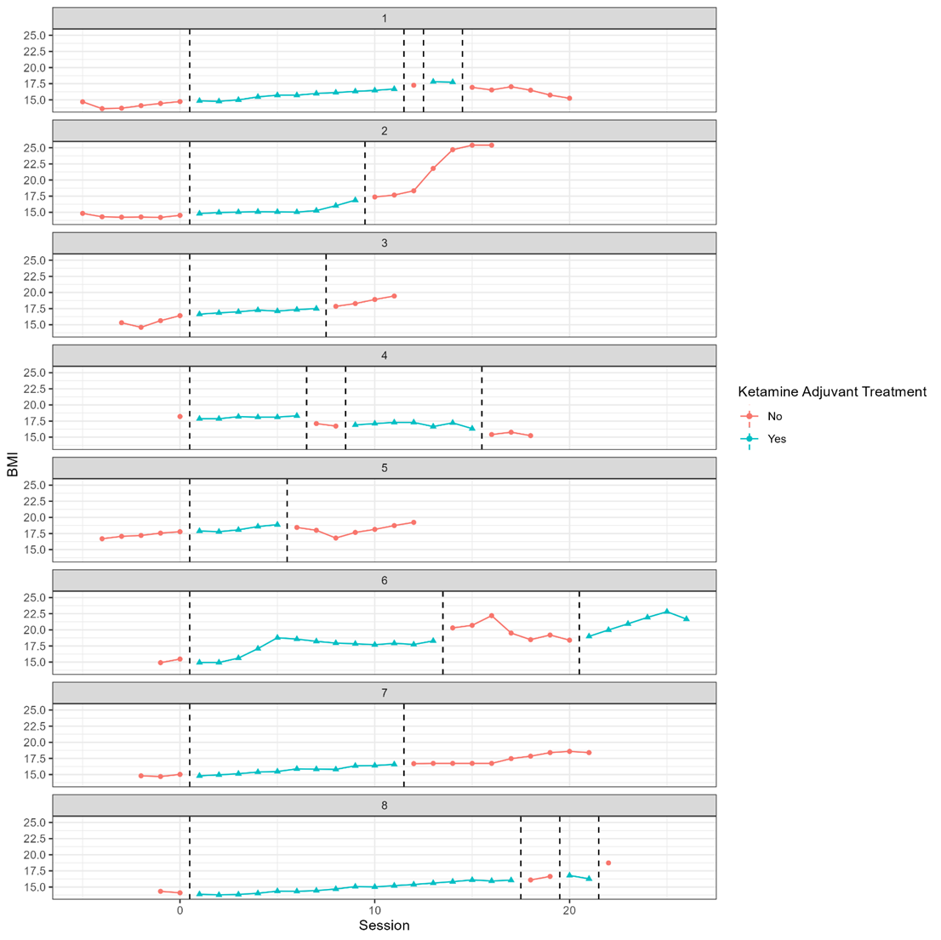Supplemental material 1. Change in BMI over time per patient according to KAT. BMI = Body Mass Index; KAT = Ketamine Adjuvant Treatment.
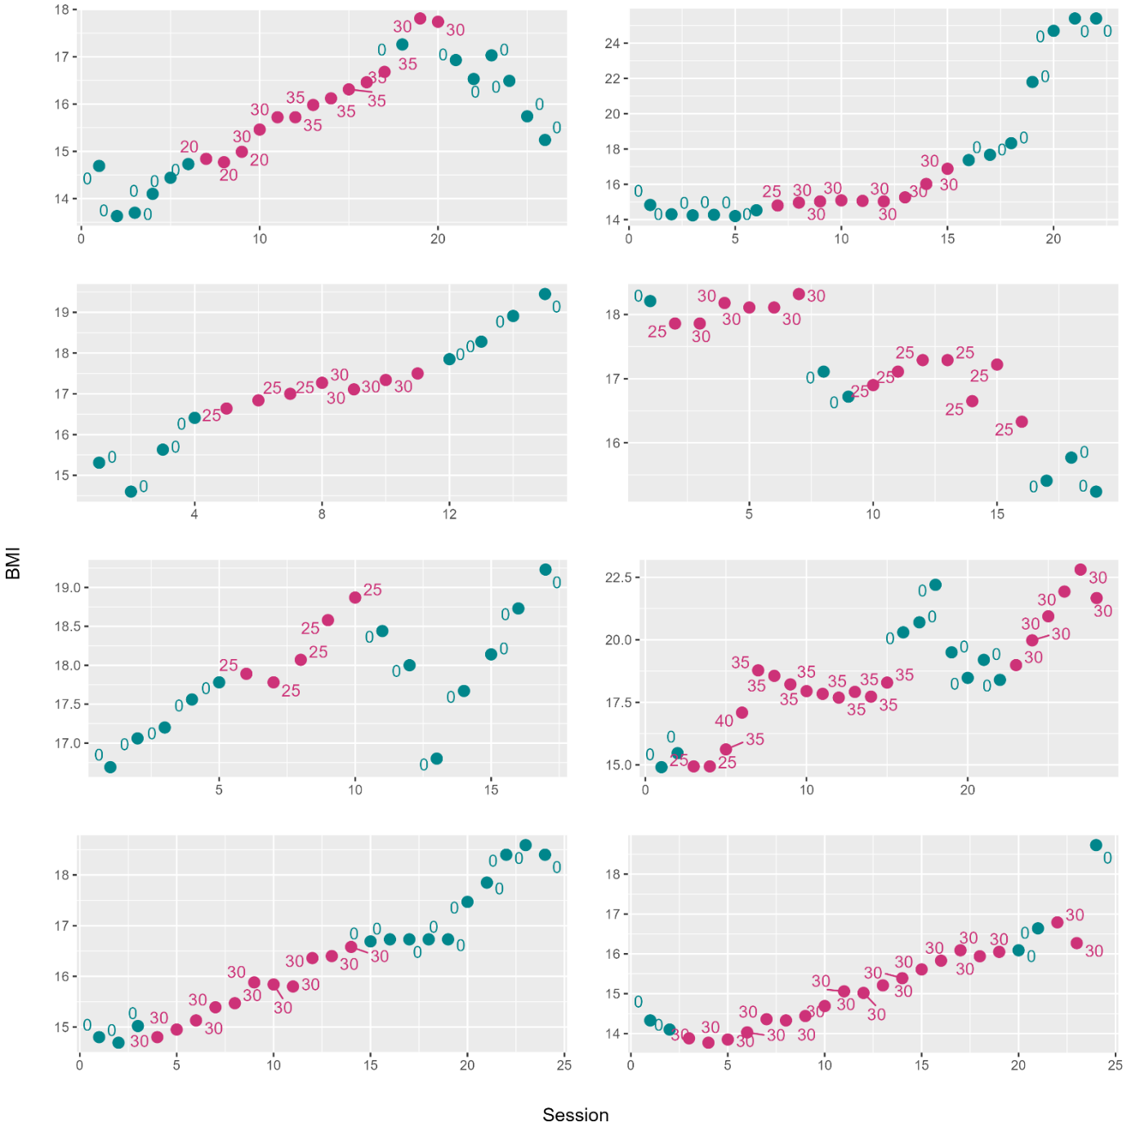
Supplemental material 2. Change in BMI per patient according to weight monitoring and ketamine dose. KAT sessions are denoted in pink, with dose in mg. Weight monitoring outside the KAT sessions is represented in green. BMI = Body Mass Index; KAT = Ketamine Adjuvant Treatment.

