Supplementary Material

Supplementary Table 1. Comparison of accumulated food intake between donor groups after FMT1 and FMT2. Overall, the AN cages after FMT1 and ANAN cages after FMT2 had lower food intake between 1.9% and 6.9% accumulated in any comparison with other donor combinations.
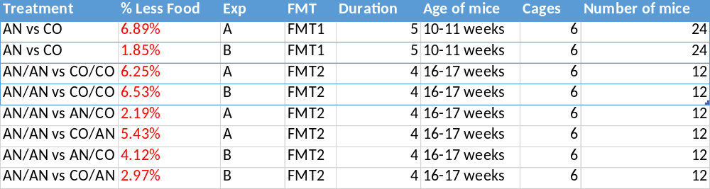
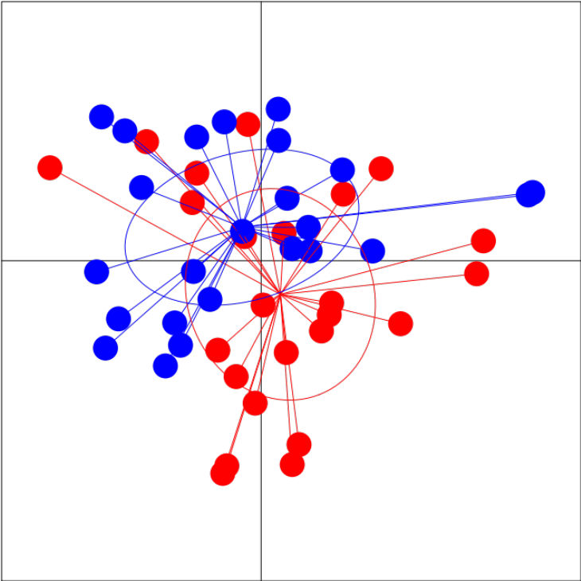
Jaccard
PC1=17%
PC2=14%
p<0.01
R2=0.055
ExpA
ExpB
Supplementary Figure 1. Differences of gut microbiota after FMT1 between the experimental runs ExpA and ExpB shown by the Jaccard index. After FMT1 the two runs were statistically significant different when looking at the presence and absence of ASVs (**p < 0.01).
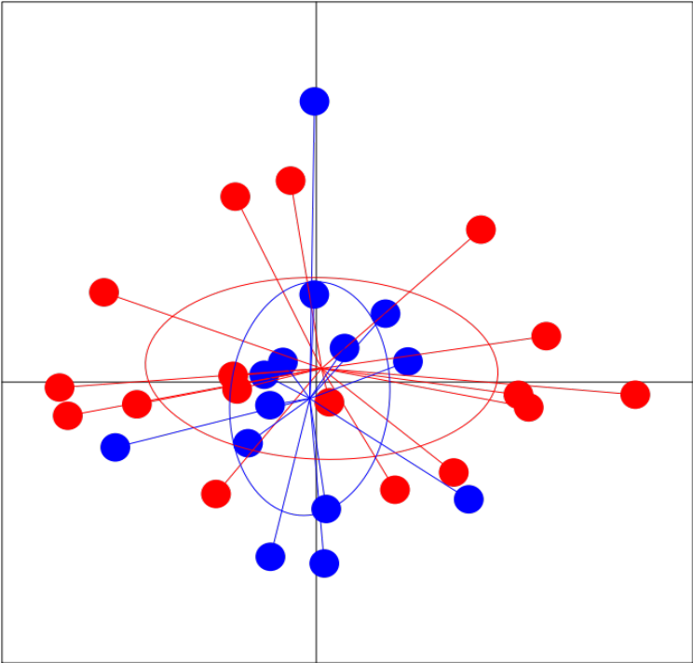
Jaccard
PC1=23%
PC2=14%
p<0.02
R2=0.074
ExpA
ExpB
Supplementary Figure 2. Differences of gut microbiota after FMT2 between the experimental runs ExpA and ExpB shown by the Jaccard index. After FMT2 the two runs were statistically significant different when looking at the presence and absence of ASVs (*p < 0.02).

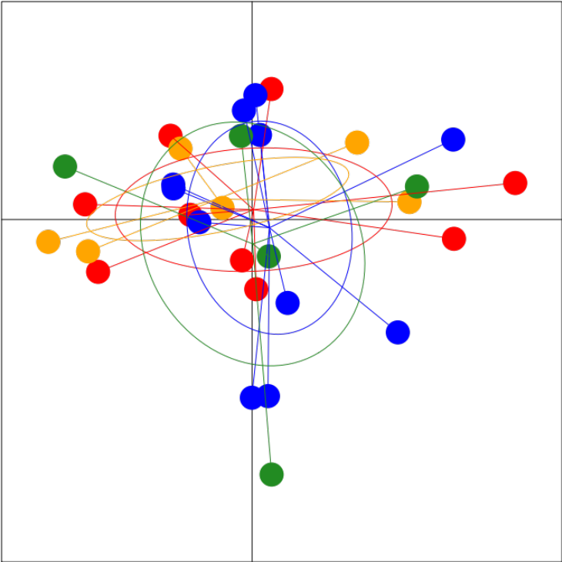
ANAN
ANCO
COAN
COCO
Jaccard
PC1=24%
PC2=14%
p=1
R2=0.047
Supplementary Figure 3. After two weeks of AB treatment and four weeks of FMT2, the combined donor types did not differ significantly from each other (ANAN = red, ANCO = blue, COAN = yellow, COCO = green).

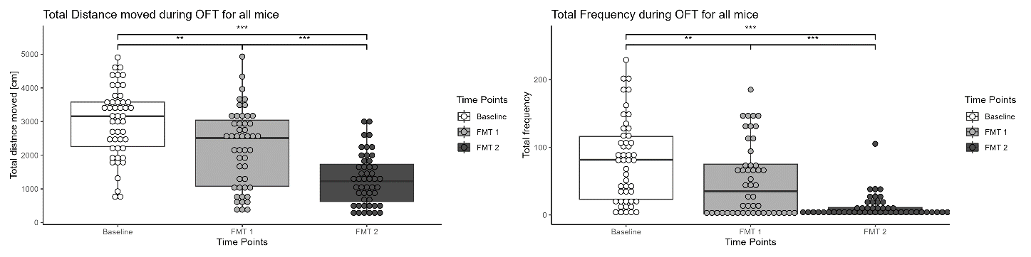
Supplementary figure 4. Effects of time, treatments and repeated measurements on general locomotor activity and total frequency. All mice (n = 48) were subjected to open field test before FMT1 (Baseline), after FMT1 (FMT1), and after FMT2 (FMT2). General locomotor activity and total frequency was evaluated by paired t-test (2-tailed). A) There was significant decrease in general locomotor activity after FMT1 (***p < 0.001) and after FMT2 (***p < 0.0001). B) There was significant difference in total frequency after FMT1 (**p < 0.01) and after FMT2 (***p < 0.0001).

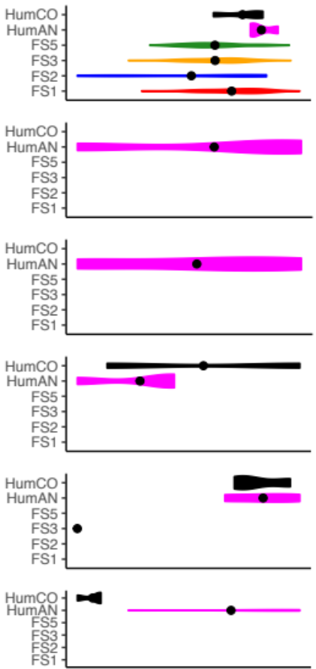
f__Lachnospiraceae
f__Christensenellaceae
s__Coprococcus_eutactus
s__Dorea_formicigenerans
g__Ruminococcus
s__Faecalibacterium_prausnitzii
Supplementary Figure 5. Significant difference in bacterial compositions between the mice fecal samples obtained at various time points and the human donors. Lachnospiraceae fluctuates from different time points and is more abundant in the human AN samples compared to the CO samples (top graph). There is a difference in abundance of Dorea formicigenerans between human AN and CO samples. The abundance of Faecalibacterium prausnitzi is higher in human AN samples compared to CO samples.

Supplementary table 2. Overview of primers used to target the hypervariable region (V1-V8) when sequencing near full-length 16S rRNA gene amplicons using the oxford nanopore technology (ONT).
Name | Sequence
UMI_338Fa | GTCTCGTGGG CTCGGNNNNN NNNNNNNNNN ACWCCTACGG GWGGCAGCAG
UMI_338Fb | GTCTCGTGGG CTCGGNNNNN NNNNNNNNNN GACTCCTACG GGAGGCWGCA G
UMI_1391R | GTCTCGTGGG CTCGGNNNNN NNNNNNNNNN GACGGGCGGT GTGTRCA
UMI_27Fa | GTCTCGTGGG CTCGGNNNNN NNNNNNNNNN AGAGTTTGAT YMTGGCTYAG
UMI_27Fb | GTCTCGTGGG CTCGGNNNNN NNNNNNNNNN AGGGTTCGAT TCTGGCTCAG
UMI_1540_R | GTCTCGTGGG CTCGGNNNNN NNNNNNNNNN TACGGYTACC TTGTTACGAC T

