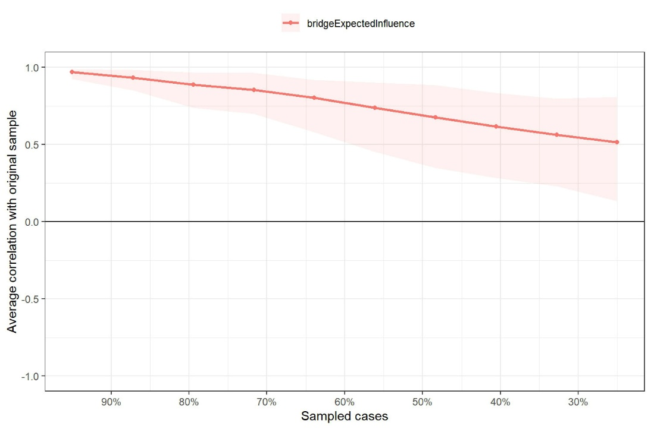
Supplementary Figure. S1 Case-dropping bootstrap plot for the Paternal Rejection–Disordered Eating bridge network.
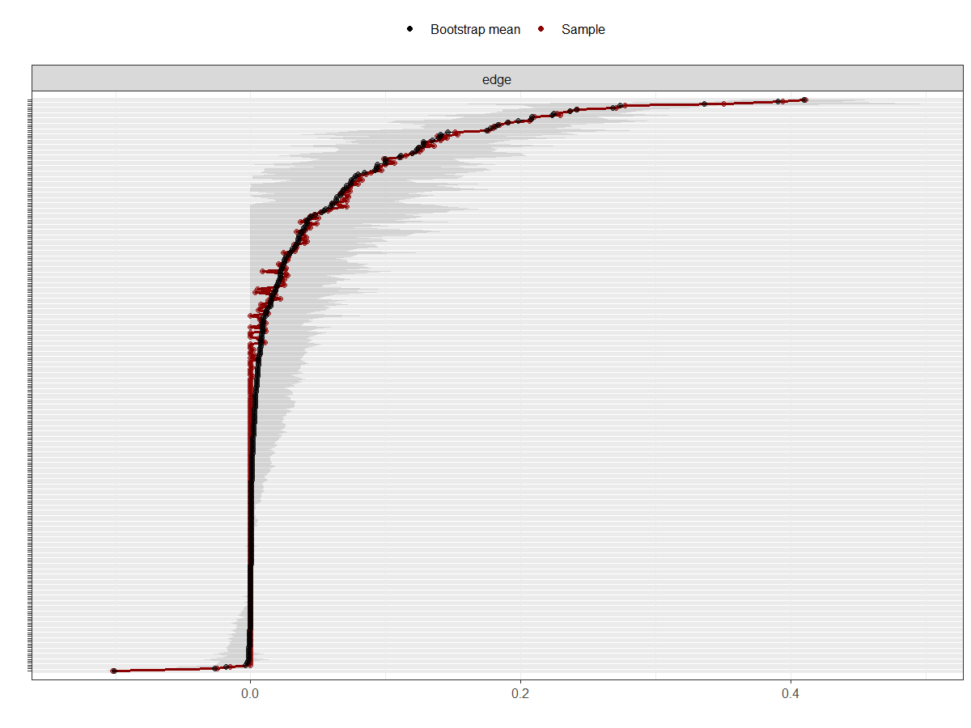
Supplementary Figure. S2 Nonparametric bootstrap confidence intervals for edge weights in the Paternal Rejection–Disordered Eating network.
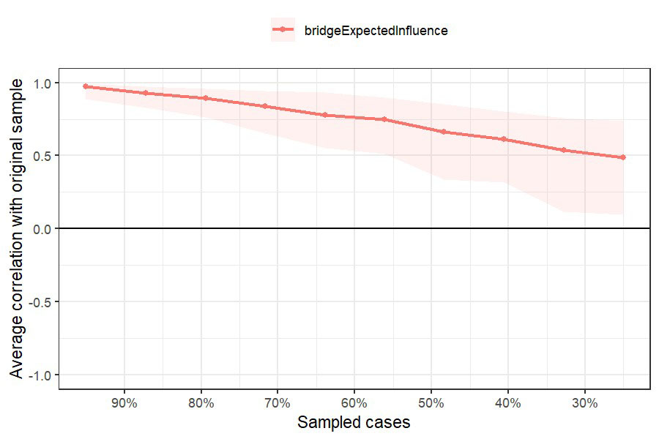
Supplementary Figure. S3 Case-dropping bootstrap plot for the Maternal Rejection–Disordered Eating bridge network.
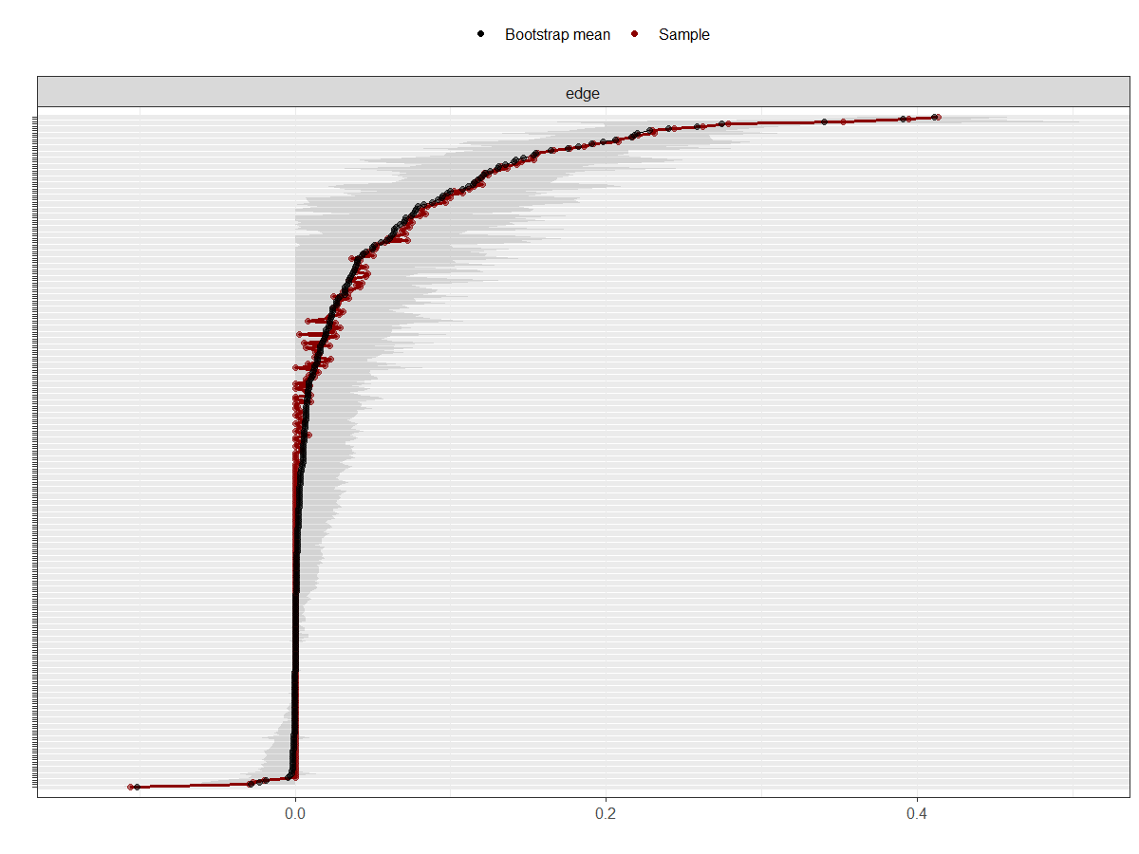
Supplementary Figure. S4 Nonparametric bootstrap confidence intervals for edge weights in the Maternal Rejection–Disordered Eating network.
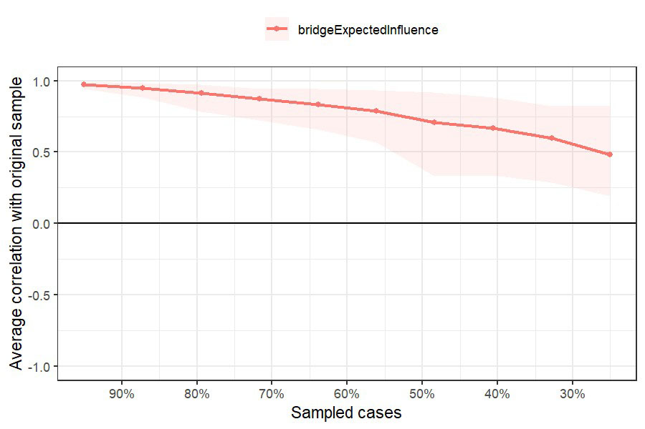
Supplementary Figure. S5 Case-dropping bootstrap plot for the Paternal Overprotection–Disordered Eating bridge network.
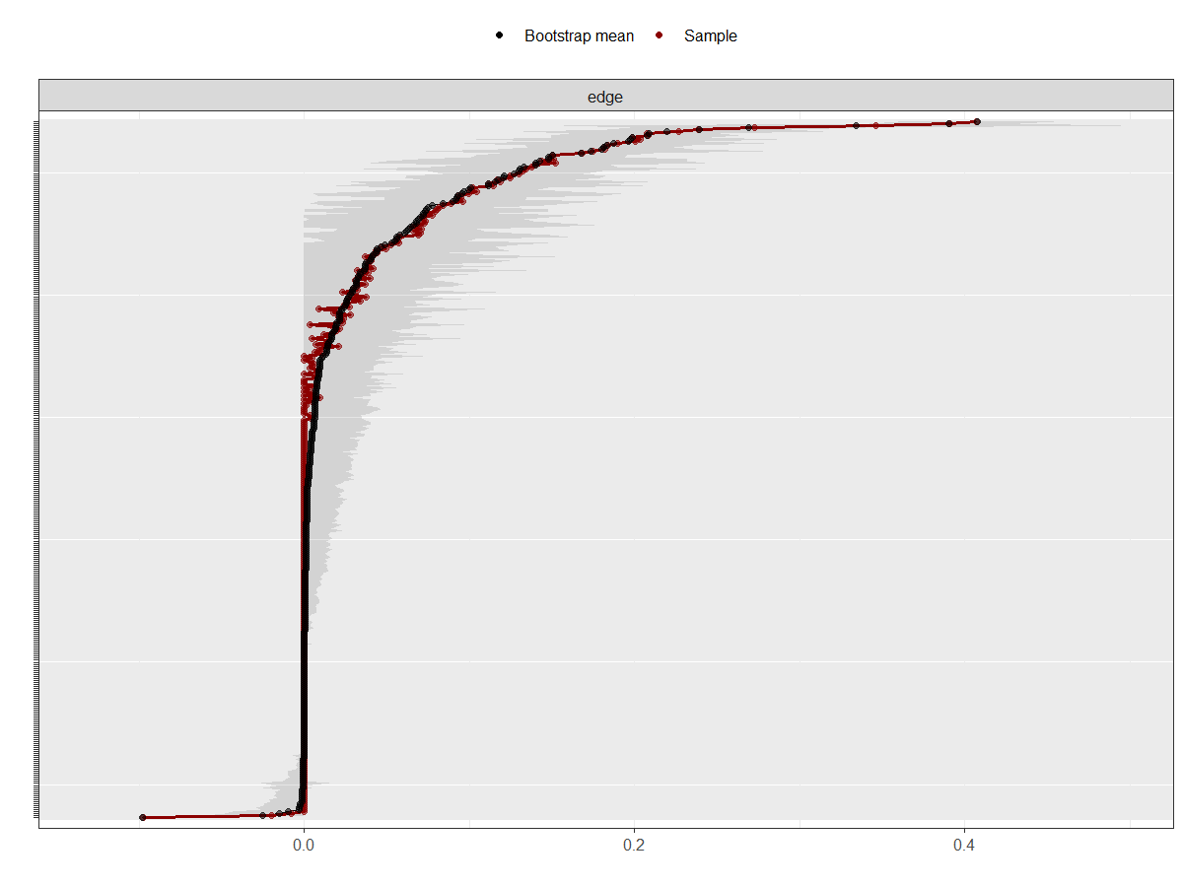
Supplementary Figure. S6 Nonparametric bootstrap confidence intervals for edge weights in the Paternal Overprotection–Disordered Eating network.
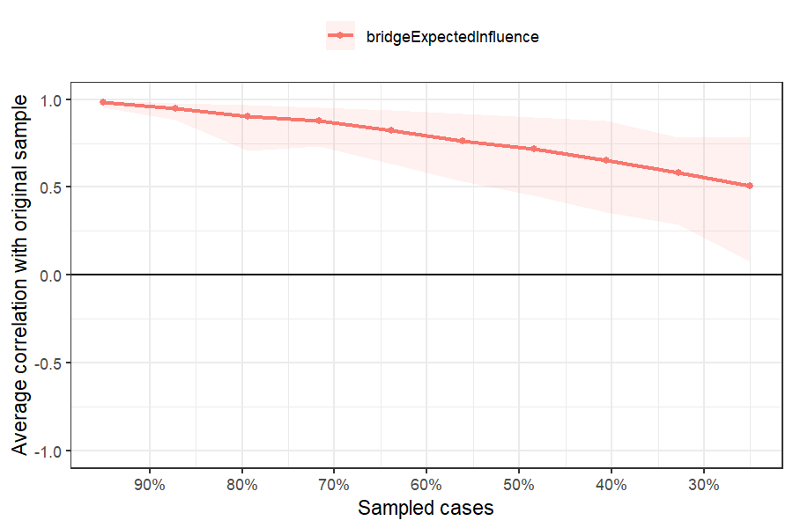
Supplementary Figure. S7 Case-dropping bootstrap plot for the Maternal Overprotection–Disordered Eating bridge network.
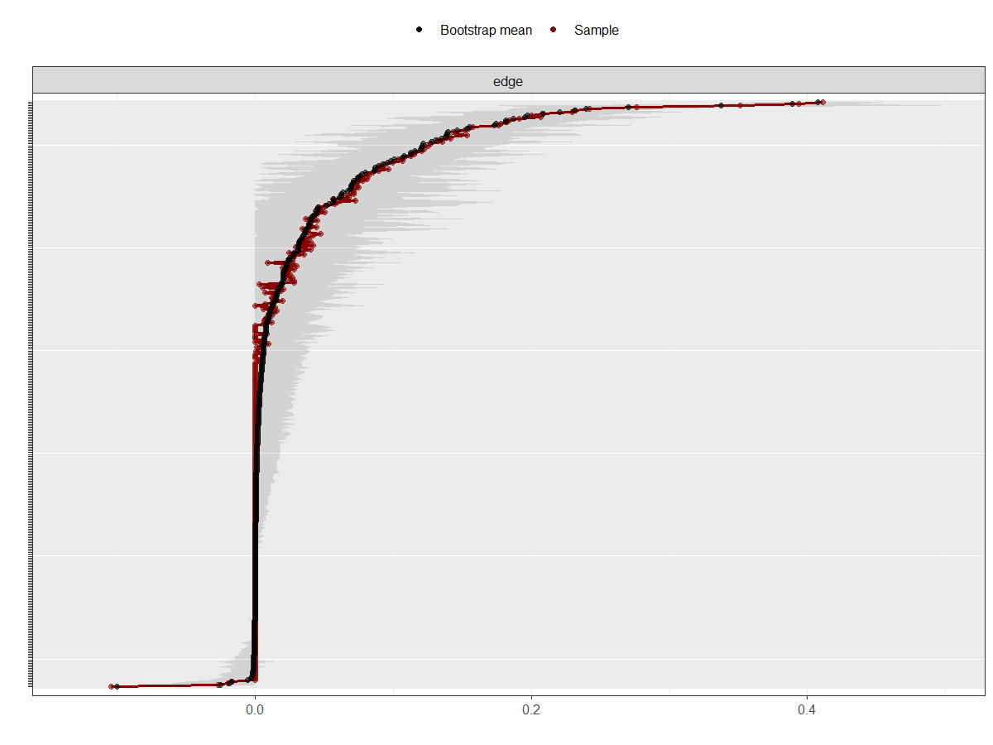
Supplementary Figure. S8 Nonparametric bootstrap confidence intervals for edge weights in the Maternal Overprotection–Disordered Eating network.

