Additional file 2: Overview of the RTA in NVivo 1.7.1
Figure 1: The first five phases of the RTA were conducted using NVivo 1.7.1.
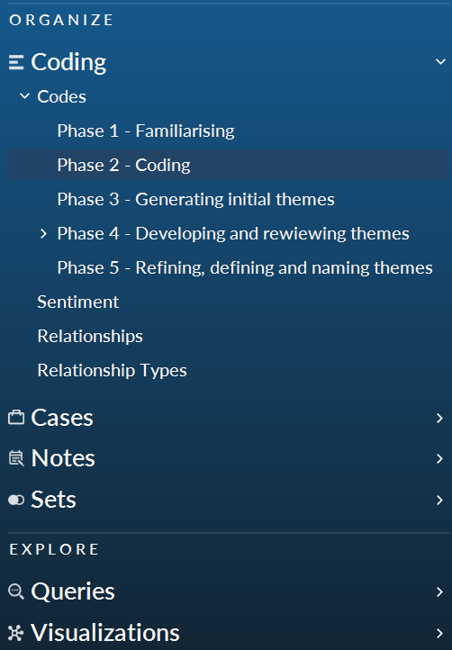
Figure 2: Overview of the coding process in Phase 2 of the RTA. The coding resulted in 89 distinct codes.
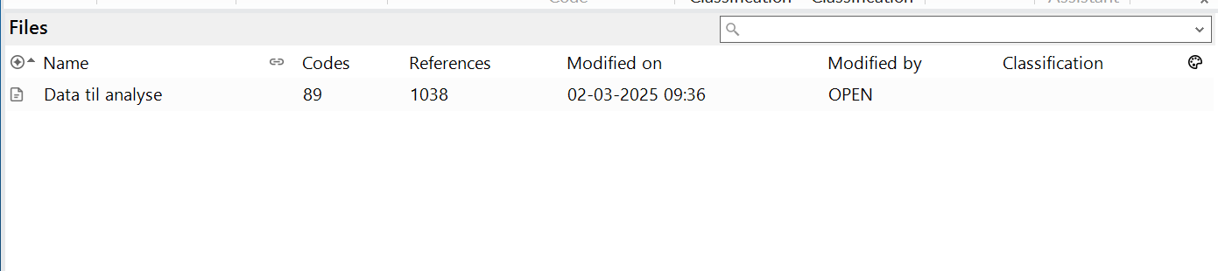

Figure 3: Mind map of themes and subthemes in Phase 4 prior to Workshop 2.
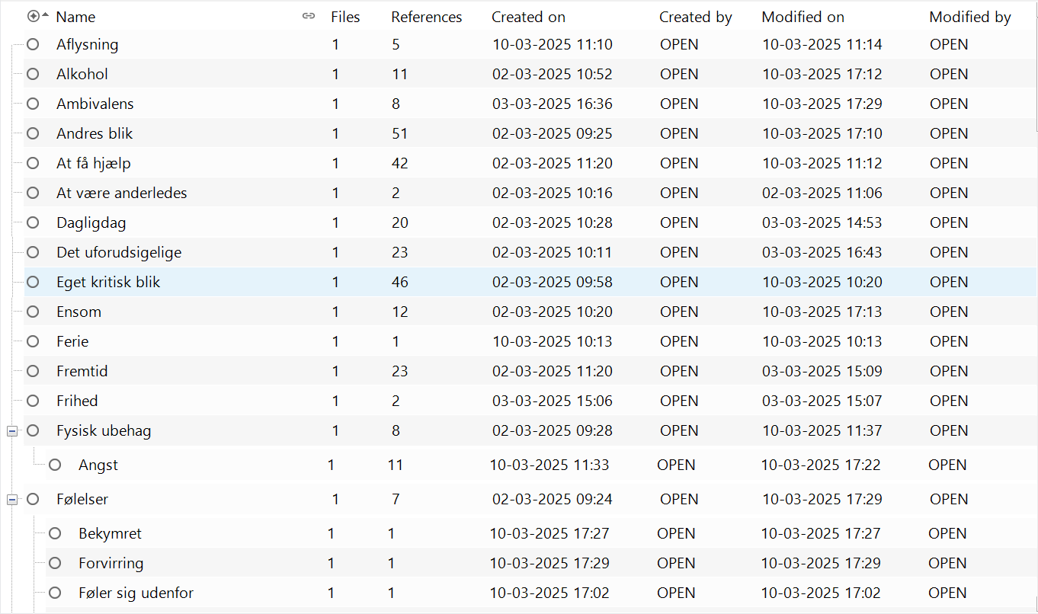
Figure 4: Illustration of the 89 codes prior to Workshop 1 and Phase Three of the RTA
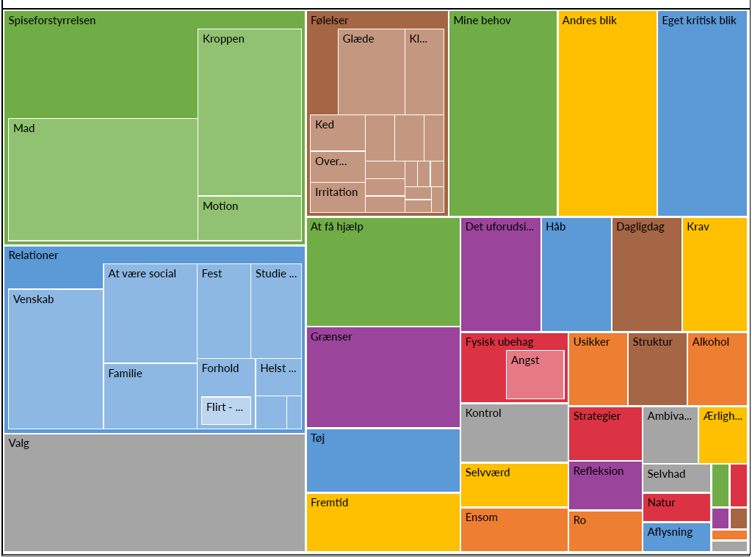

Figure 5: The six themes and subthemes following Workshop 1 and Phase Three of the RTA

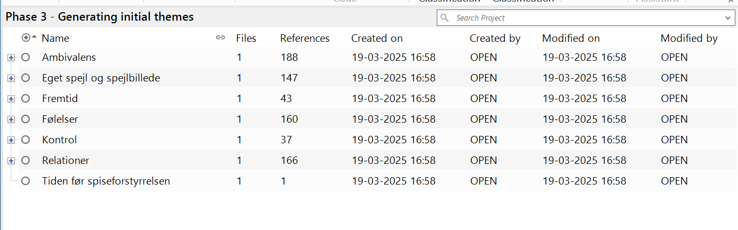
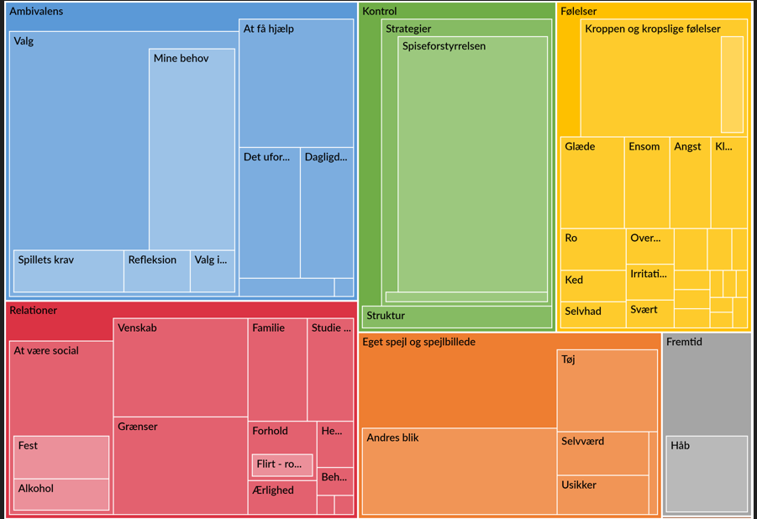

Figure 6: Mind map of themes and subthemes in Phase 4 prior to Workshop 2.
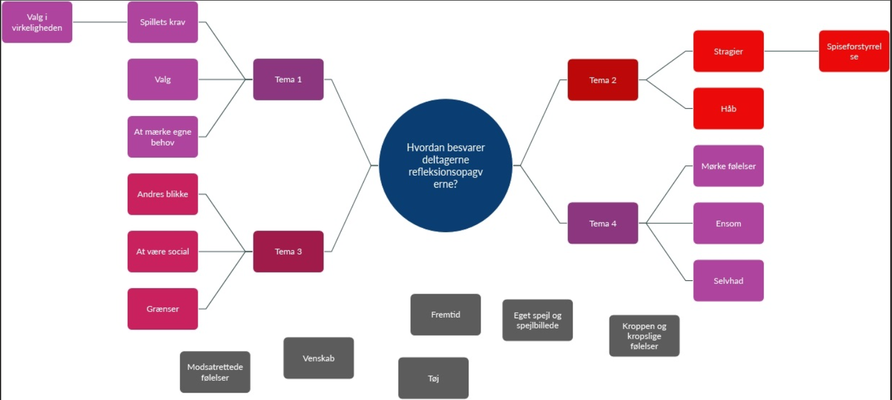

Figure 7: Mind map of themes and subthemes in Phase 4 after Workshop 2
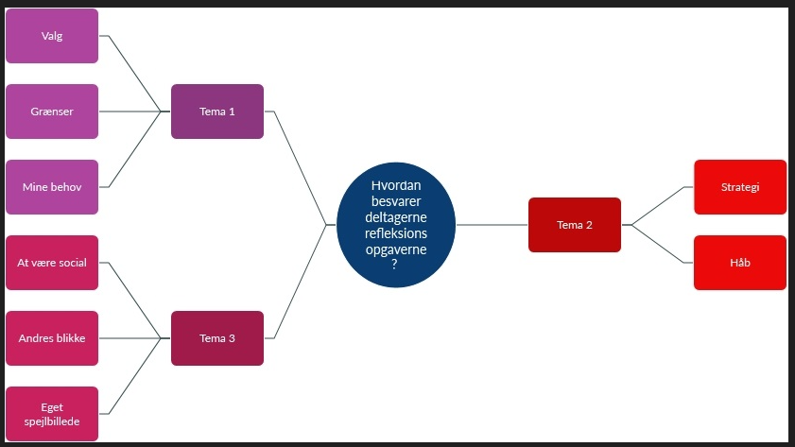

Figure 8: Themes and subthemes at phase 5
