SUPPLEMENTARY MATERIAL
Table S1. Characteristics of the illness severity severity clusters and motivation/personality clusters. Clusters were derived from a Two-Step Cluster Analysis.
Clusters with regard to illness severity
 | Cluster 1 “High severity”  (N = 54) | Cluster 2 “Low severity”  (N = 22) | Difference between clusters
 | Mean (SD) | Mean (SD) | t(df) | p
BMI SDS | -1.88 (0.89) | -1.95 | 0.278(74) | .781
ED age of onset | 14.75 (1.73) | 13.91 (1.77) | 1.912(74) | .060
ED duration | 15.42 (11.07) | 23.00 (24.25) | -1.879(74) | .064
EDE total score | 3.85 (0.83) | 2.37 (0.69) | 7.413(74) | < .001
EDI total score | 101.44 (26.51) | 36.82 (20.46) | 10.246(74) | < .001
BDI total score | 27.69 (9.94) | 8.23 (5.36) | 8.663(74) | < .001
Weight suppression | 15.00 (7.07) | 13.40 (4.96) | 0.967(74) | .337
Clusters with regard to treatment motivation and personality
 | Cluster 1  “Unfavorable profile”  (N = 52) | Cluster 2  “Favorable profile”  (N = 30) | Difference between clusters
 | Mean (SD) | Mean (SD) | t(df) | p
ANSOCQ total score | 2.19 (0.56) | 3.28 (0.85) | -6.986(80) | < .001
Harm avoidance | 63.69 (8.18) | 47.20 (10.22) | 8.016(80) | < .001
Persistence | 54.77 (10.66) | 59.23 (10.58) | -1.832(80) | .071
Self-directedness | 36.27 (7.05) | 52.07 (8.12) | -9.236(80) | < .001
Cooperativeness | 52.56 (8.65) | 58.80 (6.55) | -3.424(80) | < .001

Table S2. Dropout analysis: Baseline differences between patients who were included vs. excluded from the cluster analysis due to missing data
 | Included in cluster analysis (illness severity)  (N = 76) | Excluded from cluster analysis  (illness severity)  (N = 16) | Included in cluster analysis (motivation/ personality)  (N = 82) | Excluded from cluster analysis (motivation/ personality)  (N = 10)
 | Mean (SD) | Mean (SD) | Mean (SD) | Mean (SD)
Age | 16.31 (1.96)^{ⴕ} | 15.49 (2.00)^{ⴕ} | 16.22 (1.96) | 16.51 (2.23)
BMI SDS | -1.46 (1.16) | -1.90 (0.98) | -1.76 (0.94) | -2.37 (1.46)
ED age of onset | 14.11 (1.69) | 14.51 (1.77) | 14.51 (2.76) | 14.10 (1.79)
ED duration | 17.61 (16.23) | 13.13 (7.45) | 16.67 (14.40) | 21.44 (24.38)
EDE total score | 3.42 (1.04) | 3.27 (1.21) | 3.45 (1.04) | 2.96 (1.22)
EDI total score | 82.74 (38.52) | 90.64 (46.54) | 84.09 (40.37) | 78.00 (18.45)
BDI total score | 22.05 (12.52) | 26.78 (14.49) | 22.32 (12.76) | 29.00 (13.11)
Weight suppression | 14.54 (6.54) | 14.42 (7.87) | 14.60 (6.74) | 13.83 (6.62)
ANSOCQ total score | 2.64 (0.88)^{ⴕ} | 2.12 (0.44)^{ⴕ} | 2.58 (0.86) | NA
Harm avoidance | 58.45 (11.78) | 53.90 (11.35) | 57.66 (11.98) | 63.25 (2.50)
Persistence | 56.00 (10.86) | 57.60 (11.75) | 56.40 (10.78) | 51.75 (14.22)
Self-directedness | 41.80 (10.84) | 39.20 (10.72) | 42.05 (10.66)* | 30.25 (6.29)*
Cooperativeness | 55.33 (8.17) | 50.80 (9.17) | 54.84 (8.46) | 54.00 (6.78)
ⴕ p < .10, * p < .05

Figure S1. Differences in EDE total scores at 18-month follow-up between clusters
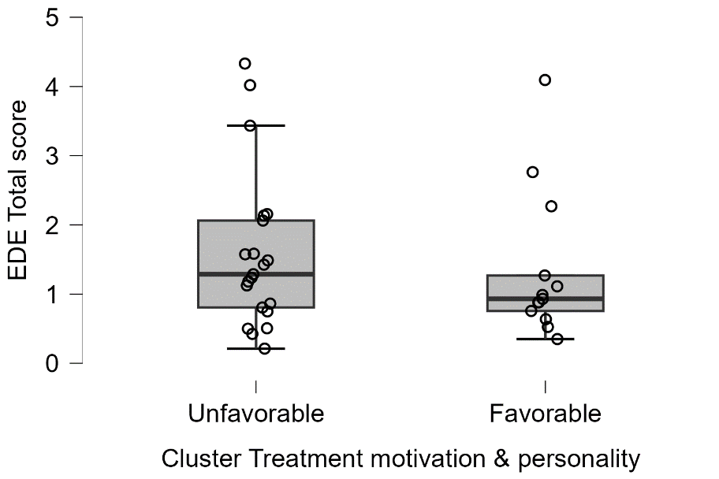
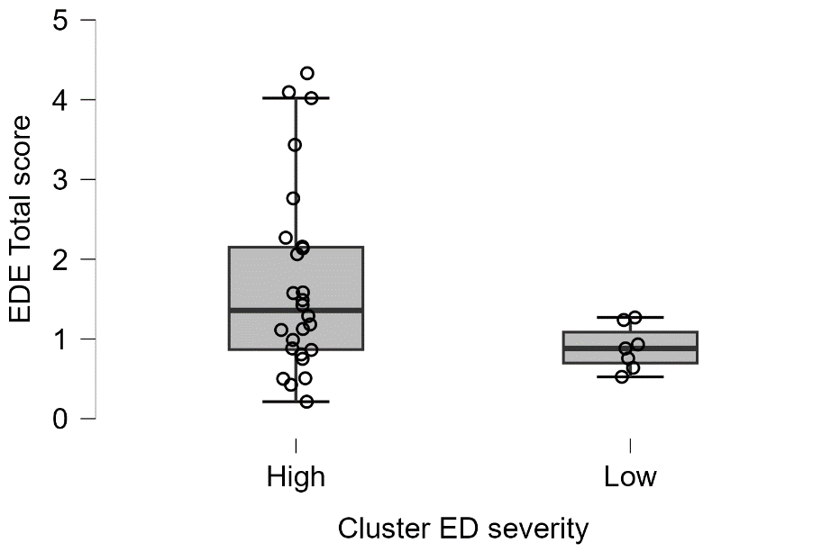
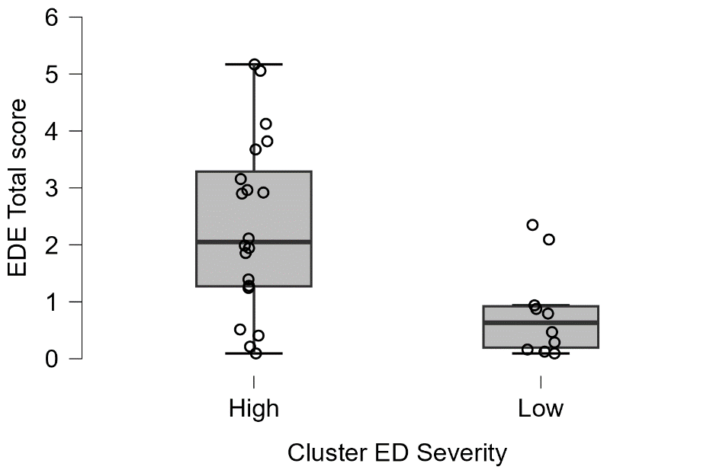
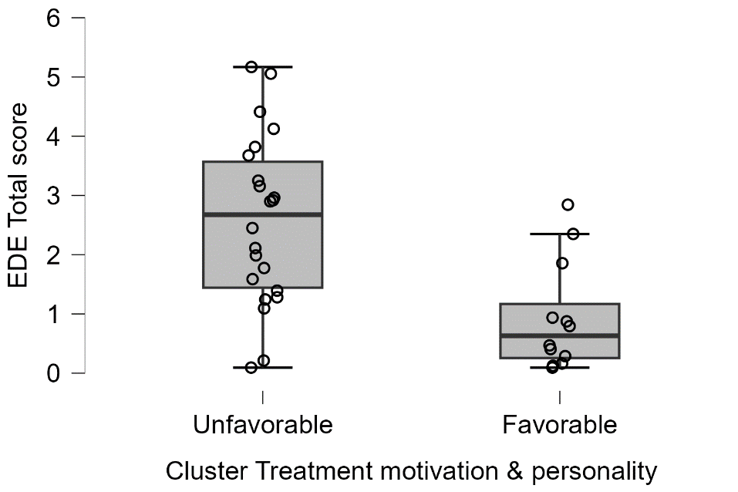
MANTRA
p = .556, d = 0.21
MANTRA
p = .087, d = 0.75
TAU
p = .007, d = 1.13
TAU
p = .001, d = 1.28

