Table S1. Mean differences between phase angle tertiles based on post hoc analysis
Phase angle | Low vs Mid (MD) | p | Low vs High (MD) | p | Mid vs High (MD) | p
Anthropometry
Weight (kg) | -2.14 | 0.397 | -4.12 | 0.054 | -1.98 | 0.451
BMI (kg/m²) | -0.947 | 0.189 | -1.508 | 0.027 | -0.561 | 0.547
AC (cm) | -1.62 | 0.047 | -2.242 | 0.006 | -0.618 | 0.551
CC (cm) | -0.450 | 0.902 | -2.28 | 0.093 | -1.83 | 0.103
TST (mm) | -1.64 | 0.250 | -2.555 | 0.045 | -0.919 | 0.522
BIVA
PhA (°) | -0.759 | <0.001 | -1.538 | <0.001 | -0.779 | <0.001
R (Ω) | -3.53 | 0.994 | -48.4 | 0.381 | -44.9 | 0.400
XC (Ω) | -9.60 | 0.012 | -24.0 | <0.001 | -14.4 | <0.001
BCM (kg) | -2.18 | 0.012 | -4.39 | <0.001 | -2.21 | 0.011
BCMI (kg/m²) | -0.943 | <0.001 | -1.685 | <0.001 | -0.741 | 0.010
FM (kg)* | -1.07 | 0.190 | -1.808 | 0.063 | -0.733 | 0.671
FFM (kg) | -1.06 | 0.739 | -2.31 | 0.284 | -1.25 | 0.660
TMM (kg) | 0.0923 | 0.996 | 0.0000 | 1.000 | -0.0923 | 0.996
ASMM (kg) | -0.332 | 0.861 | -1.080 | 0.249 | -0.748 | 0.492
SMI (kg/m²) | -0.263 | 0.668 | -0.134 | 0.908 | 0.129 | 0.910
Hydration (%)* | 0.140 | 0.979 | 1.80 | 0.160 | 1.66 | 0.127
TBW (%) | 4.02 | 0.130 | 8.79 | <0.001 | 4.78 | 0.060
ECW (%)* | 10.2 | 0.330 | 12.38 | 0.185 | 2.17 | 0.954
ICW (%) | -5.29 | 0.005 | -9.24 | <0.001 | -3.95 | 0.045
BM (kcal/day) | -63.6 | 0.012 | -127.3 | <0.001 | -63.7 | 0.012
Nutrition | -70.1 | 0.005 | -136.4 | <0.001 | -66.4 | 0.009
Functional Measurement
HGS max (kg) | 1.33 | 0.839 | -4.59 | 0.156 | -5.92 | 0.022
Muscle Ultrasound
RF-CSA (cm²) | -1.30 | 0.018 | -1.3535 | 0.007 | -0.0527 | 0.988
RF-X-axis (cm) | -0.393 | 0.306 | -0.685 | 0.030 | -0.292 | 0.471
RF-Y-axis (cm) | -0.519 | 0.003 | -0.351 | 0.013 | 0.168 | 0.294
L-SAT (cm)* | 0.0854 | 0.960 | 0.0322 | 0.991 | -0.0533 | 0.971
Abdominal Ultrasound
T-SAT (cm) | 0.0380 | 0.951 | -0.275 | 0.092 | -0.313 | 0.056
S-SAT (cm) | -0.0510 | 0.900 | -0.04167 | 0.916 | 0.00933 | 0.996
VAT (cm) | -0.0207 | 0.991 | -0.486 | 0.021 | -0.465 | 0.026
Biochemical Analysis
Glucose (mg/dL) | -3.50 | 0.645 | -9.28 | 0.101 | -5.78 | 0.371
Urea (mg/dL) | 12.4 | 0.413 | 13.333 | 0.509 | 0.924 | 0.996
Creatinine (mg/dL) | -0.0345 | 0.826 | -0.02500 | 0.920 | 0.00949 | 0.988
Total Protein (g/dL) | 0.138 | 0.929 | -0.313 | 0.739 | -0.451 | 0.505
Albumin (g/dL) | -0.0452 | 0.978 | -0.339 | 0.382 | -0.294 | 0.461
Prealbumin (mg/dL)* | 7.06 | 0.505 | -8.73 | 0.799 | -15.79 | 0.445
Sodium (mEq/L) | -10.6 | 0.329 | -10.056 | 0.445 | 0.516 | 0.998
Potassium (mEq/L) | -0.0844 | 0.771 | -0.1495 | 0.523 | -0.0651 | 0.871
Na/K (Ratio) | 0.354 | <0.001 | 0.623 | <0.001 | 0.269 | 0.002
Magnesium (mg/dL) | -0.00452 | 0.998 | -0.01111 | 0.992 | -0.00659 | 0.997
Phosphorus (mg/dL) | -0.310 | 0.512 | -0.2542 | 0.712 | 0.0554 | 0.983
Calcium (mg/dL) | 0.201 | 0.678 | -0.258 | 0.602 | -0.460 | 0.193
Iron (µg/dL) | 24.7 | 0.318 | 8.87 | 0.907 | -15.80 | 0.715
C-reactive Protein (mg/L)* | 2.67 | 0.344 | -9.33 | 0.221 | -12.00 | 0.090
Total Cholesterol (mg/dL)* | -6.14 | 0.967 | 81.6 | 0.102 | 87.7 | 0.097
Triglycerides (mg/dL) | 27.1 | 0.363 | -7.72 | 0.934 | -34.82 | 0.246
Folic Acid (ng/mL)* | 9.20 | 0.742 | -27.7 | 0.098 | -36.9 | 0.022
Vitamin B12 (pg/mL)* | -5.90 | 0.999 | 249 | 0.094 | 255 | 0.342
TSH (µU/mL)* | 0.141 | 0.945 | -2.73 | 0.503 | -2.87 | 0.476
Hospitalization Data
Hospital Stay (days) | 14.3 | 0.070 | 17.03 | 0.035 | 2.73 | 0.895
Hospitalization Cost (€) | 8943.26 | 0.085 | 10694.38 | 0.028 | 1751.12 | 0.795
Data are expressed as mean differences between groups. Statistically significant differences between groups were assumed when p < 0.05, based on post hoc ANOVA tests. Parameters marked with an asterisk (*) were analyzed using the Games–Howell post hoc test when the assumption of homogeneity of variances was not met, whereas the remaining comparisons were performed using Tukey’s post hoc test. Abbreviations: AC: Arm circumference; ASMM: Appendicular skeletal muscle mass; BCM: Body cell mass; MB: Basal metabolism; BMI: Body mass index; CC: Calf circumference; CI: Confidence interval; ECW: Extracellular water; FFM: Fat-free mass; FM: Fat mass; HGS max: Maximum handgrip strength; MD: Mean differences; PhA: Phase angle; RF-CSA: Rectus femoris cross-sectional area; RF-X-axis: Rectus femoris X-axis length; RF-Y-axis: Rectus femoris Y-axis length; R: Resistance; SAT: Subcutaneous adipose tissue of leg (L), and superficial (S) and total (T) abdominal regions; TBW: Total body water volume; TMM: Total muscle mass; TST: Triceps skinfold thickness; VAT: Visceral adipose tissue; XC: Reactance.

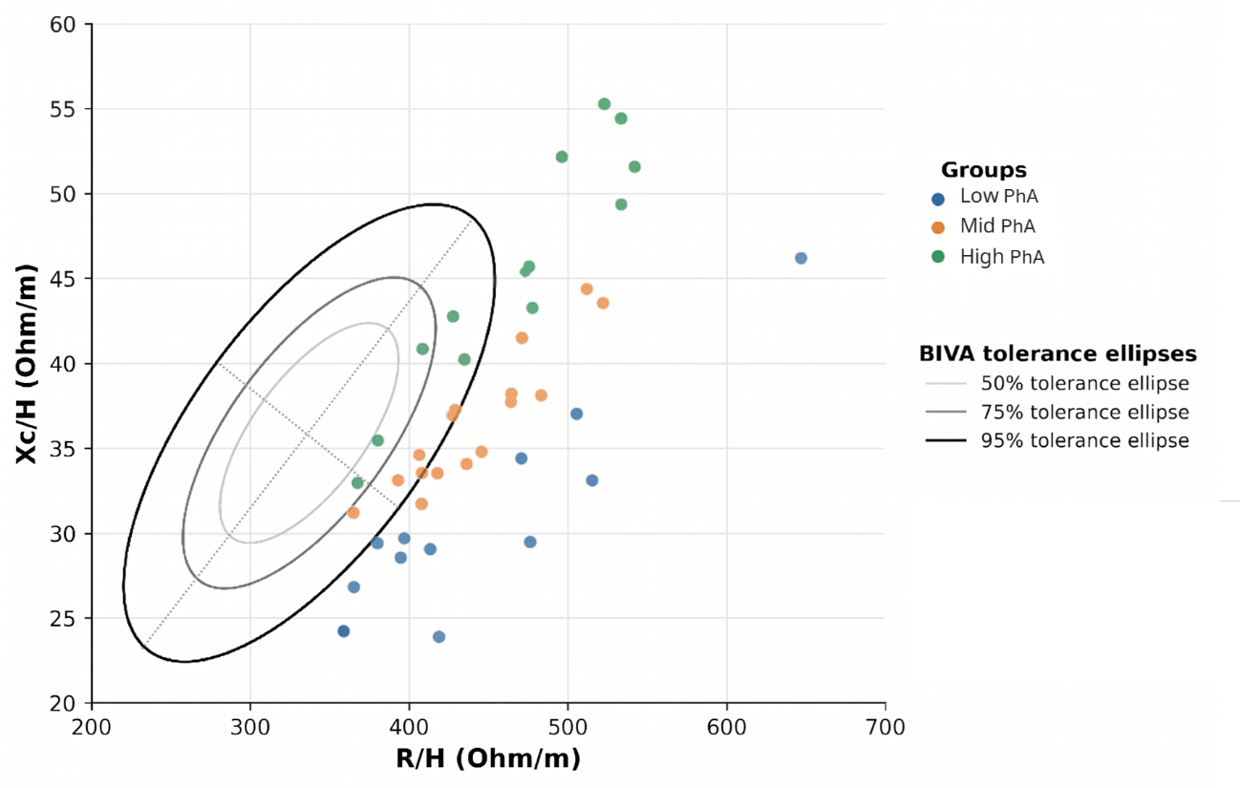
Figure S1. BIVA-derived bioelectrical phenotypes across phase angle tertiles in severe anorexia nervosa

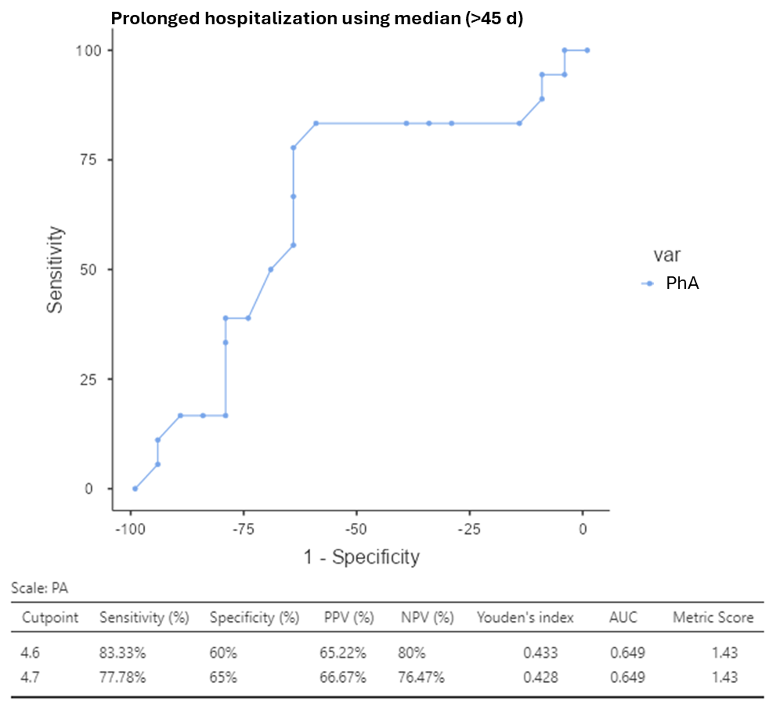
Figure S2. Receiver operating characteristic analysis of PhA for exploratory discrimination between shorter and extended hospital stay using median threshold

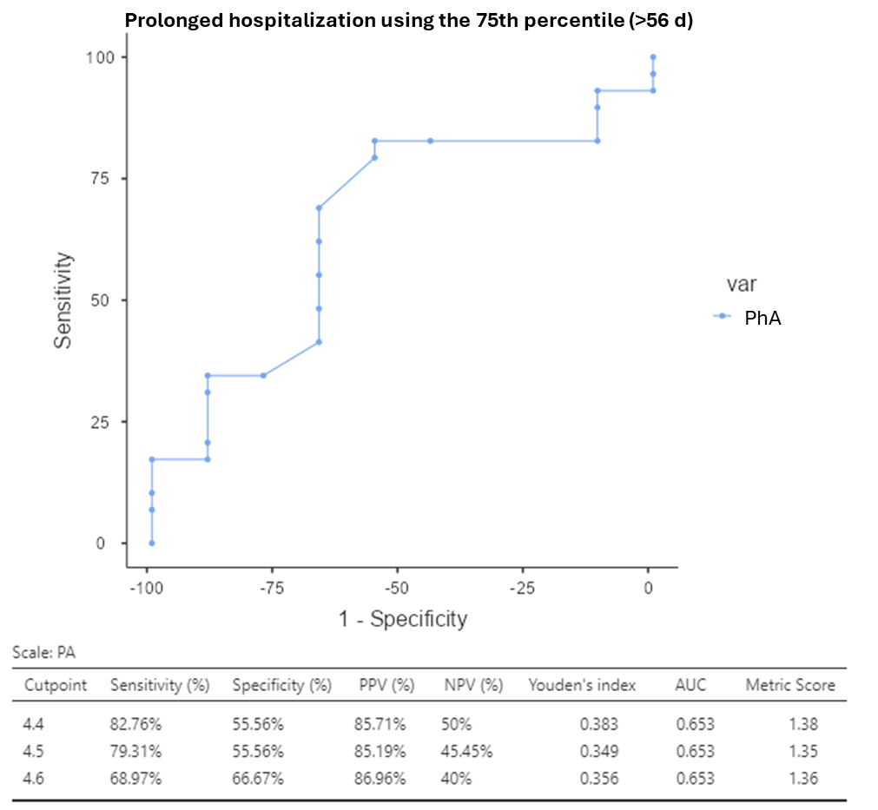
Figure S3. Receiver operating characteristic analysis of PhA for exploratory discrimination between shorter and extended hospital stay using the 75th percentile threshold

