Supplementary Figures S1-2

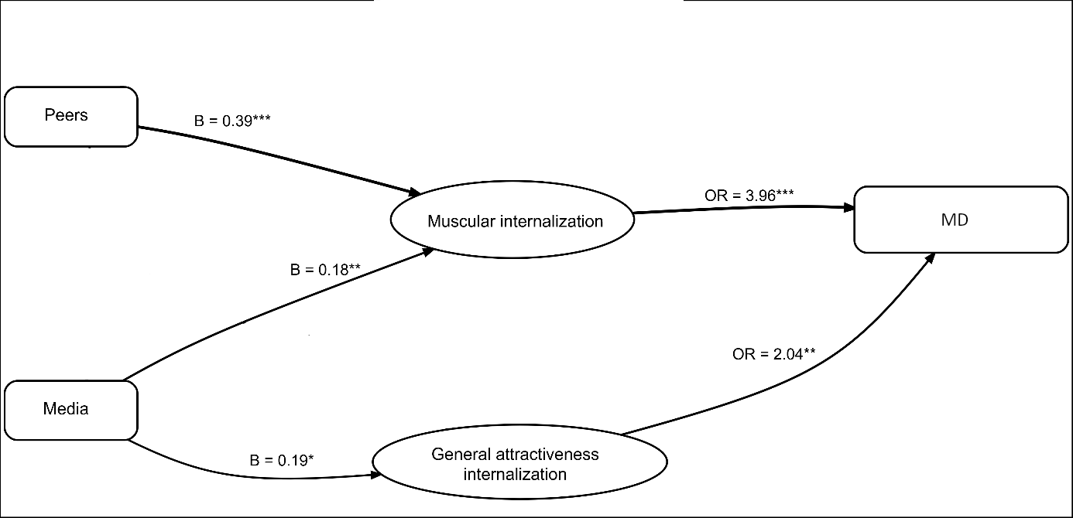
Figure S1. Significant indirect Paths in the Mediation Model for men

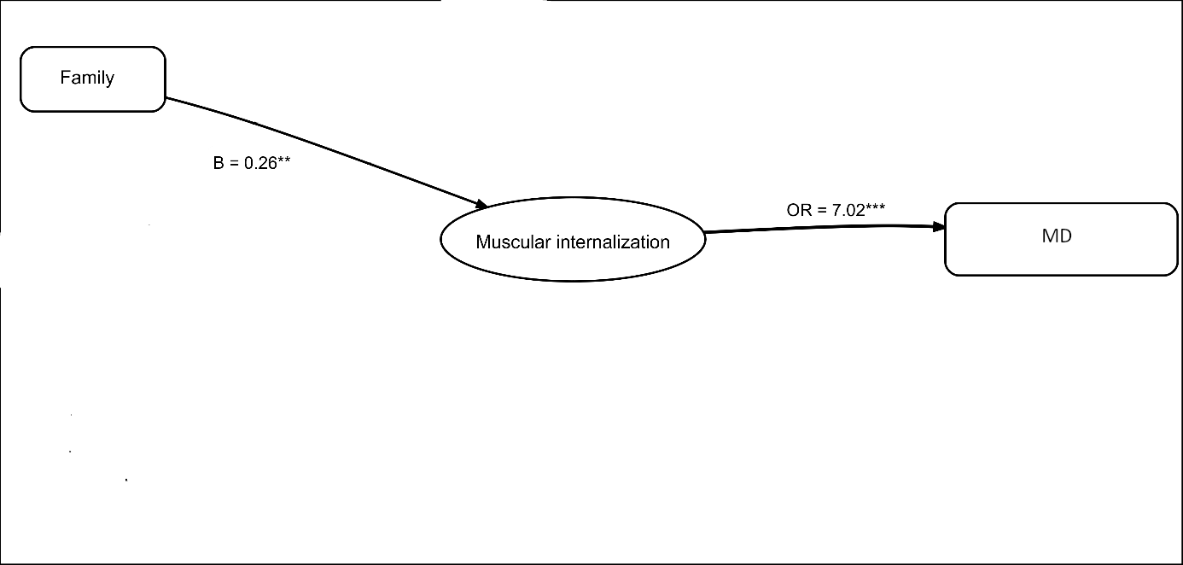
Figure S2. Significant indirect Paths in the Mediation Model for women

