Additional file
Table S1 List of participating hospitals 2014 to 2021
 | years
 | 2014 | 2015 | 2016 | 2017 | 2018 | 2019 | 2020 | 2021
Bezirksklinik Hochstadt | x | x | x | x | x | x | x | x
Bezirksklinikum Ansbach | x | x | x | x | x | x | x | x
Bezirksklinikum Mainkofen | x | x | x | x | x | x | x | x
Bezirksklinikum Obermain | x | x | x | x | x | x | x | x
Bezirksklinikum Regensburg |  |  | x | x | x | x | x | x
Bezirksklinik Rehau | x | x | x | x | x | x | x | x
Bezirkskrankenhaus Augsburg | x | x | x | x | x | x | x | x
Bezirkskrankenhaus Bayreuth | x | x | x | x | x | x | x | x
Bezirkskrankenhaus Günzburg | x | x | x | x | x | x | x | x
Bezirkskrankenhaus Kaufbeuren | x | x | x | x | x | x | x | x
Bezirkskrankenhaus Kempten | x | x | x | x | x | x | x | x
Bezirkskrankenhaus Landshut | x | x | x | x | x | x | x | x
Bezirkskrankenhaus Lohr | x | x
Bezirkskrankenhaus Memmingen | x | x | x | x | x | x | x | x
Frankenalb-Klinik Engelthal | x | x | x | x | x | x | x | x
kbo-Isar-Amper-Klinikum München Ost | x | x | x | x | x | x | x | x
kbo-Inn-Salzach-Klinikum | x | x | x | x | x | x | x | x
kbo-Isar-Amper-Klinikum Taufkirchen (Vils) | x | x | x | x | x | x | x | x
kbo-Lech-Mangfall-Klinik Agatharied | x | x | x | x | x | x | x | x
kbo-Lech-Mangfall-Klinik Garmisch-Partenkirchen | x | x | x | x | x | x | x | x
kbo-Lech-Mangfall-Klinik Landsberg am Lech | x | x | x | x | x | x | x | x
Klinikum am Europakanal | x | x | x | x | x | x | x | x
Krankenhaus für Psychiatrie, Psychotherapie und Psychosomatische Medizin Schloss Werneck | x | x | x | x | x | x | x | x
Tagesklinik Lindau | x | x | x | x | x | x | x | x
Bezirkskrankenhaus Donauwörth |  |  | x | x | x
Hospitals participating in the Pharmako-EpiVig survey by year 2014 to 2021

Table S2 Prescription numbers of lithium by year and diagnosis group
Year | bipolar disorder | unipolar depression | schizophrenia | schizoaffective disorder
2014 | 155/539  28.8% | 206/4166  4.9% | 27/1706  1.6% | 81/595  13.6%
2015 | 175/579  30.2% | 179/4317  4.1% | 28/1722  1.6% | 84/601  14.0%
2016 | 158/529  29.9% | 200/4412  4.5% | 41/1774  2.3% | 89/598  14.9%
2017 | 181/579  31.3% | 202/4347  4.6% | 51/1792  2.8% | 91/541  16.8%
2018 | 197/585  33.7% | 209/4561  4.6% | 58/1758  3.3% | 97/591  16.4%
2019 | 188/547  34.4% | 209/4447  4.7% | 43/1768  2.4% | 109/578  18.9%
2020 | 142/453  31.3% | 175/3518  5.0% | 42/1716  2.4% | 78/536  14.6%
2021 | 148/481  30.8% | 168/3840  4.4% | 46/1679  2.7% | 68/516  13.2%
Total | 1344/4292  31.3% | 1548/33608  4.6% | 336/13915  2.4% | 697/4556  15.3%
Absolute and relative prescription numbers of LI in selected principal diagnosis groups from 2014 to 2021. Diagnosis groups are defined by three-character code of International Classification of Disease in its 10th Version, German Modification (ICD-10-GM): bipolar disorder: F31, unipolar depression: F32+F33, schizophrenia: F20, schizoaffective disorder: F25.

Table S3 Top 20 drugs with intermediate-priority drug-drug interactions with lithium
drug | n | mediQ comments about interaction
Venlafaxine | 799 | increased risk for serotonin toxicity
Olanzapine | 784 | increased risk for neurotoxicity, lowering of seizure threshold, EPS, QT-elongation, potentiation of ADRs like weight gain, hyperglycemia, sleepiness, tremor, slurred speech
Risperidone | 569 | increased risk for neurotoxicity, lowering of seizure threshold, EPS, QT-elongation
Pipamperone | 487 | increased risk for lowering of seizure threshold, EPS, QT-elongation and neurotoxicity rare cases of enzephalopathic syndromes
Sertraline | 478 | increased risk for serotonin toxicity, QT-elongation, influence on sodium balance, bodyweight and glucose-regulation
Ramipril | 475 | increase of lithium blood levels
Duloxetin | 283 | increased risk for serotonin toxicity, potentiation of ADRs like hyponatremia and hypothyroidism
Clozapine | 278 | increased risk for neurotoxicity, weight gain, cardiovascular ADRs i.e., QT-elongation, potential of lithium to increase neutrophil cell count in benign neutropenia
Haloperidol | 263 | increased risk for QT-elongation, neurotoxicity, EPS, rare cases of enzephalopathic syndromes
Prothipendyl | 232 | increased risk for QT-elongation, neurotoxicity, EPS, rare cases of enzephalopathic syndromes
Amitriptyline | 195 | increased risk for QT-elongation, neurotoxicity, lowering of seizure threshold
Chlorprothixene | 161 | increased risk for QT-elongation, EPS, rare cases of enzephalopathic syndromes
Zuclopenthixol | 160 | increased risk for lowering of seizure threshold, QT-elongation and neurotoxicity
Amisulpride | 152 | increase of Amisulpride blood levels, increased risk for QT-elongation, neurotoxicity, EPS
Escitalopram | 147 | increased risk for serotonin toxicity, QT-elongation
Promethazine | 142 | increased risk for QT-elongation, neurotoxicity, EPS, enzephalopathic syndromes, lowering of seizure threshold
Candesartan | 138 | increase of lithium blood levels
Flupentixol | 136 | increased risk for QT-elongation, neurotoxicity, EPS, rare cases of enzephalopathic syndromes
Torasemide | 128 | increase of lithium blood levels
Metamizole | 125 | possible increase of lithium blood levels
20 most commonly prescribed drugs in patients with LI prescription with intermediate-priority drug-drug interactions with LI, along with, prescription numbers and mediQ comments about interaction risk. MediQ-search (https://www.mediq.ch) was last reviewed January 19, 2022

Pharmako-EpiVig survey questionnaire
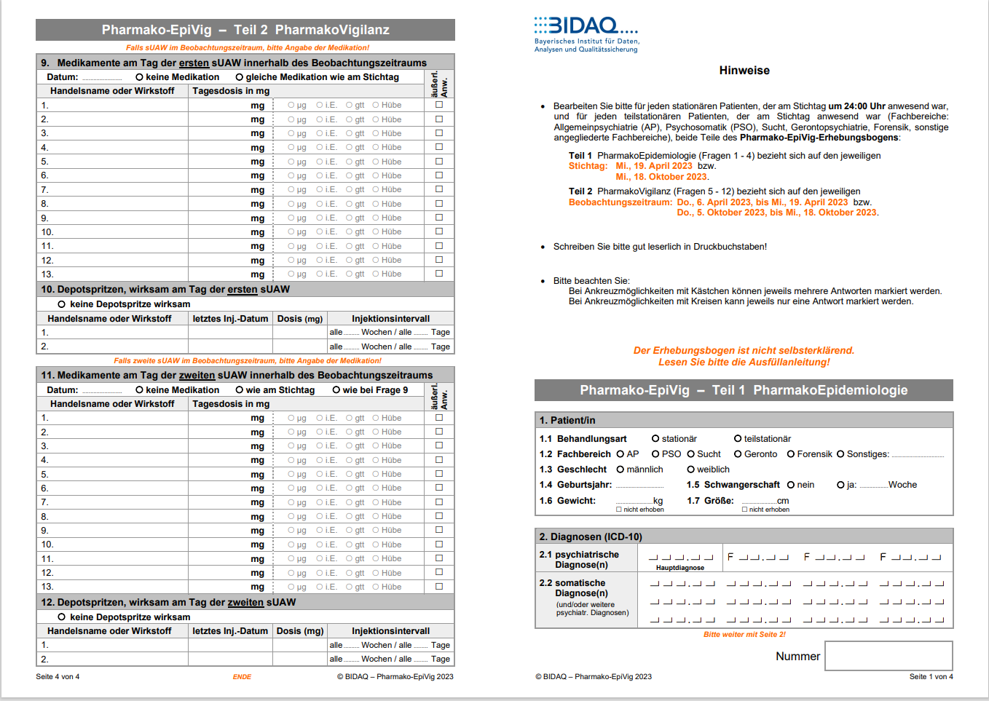
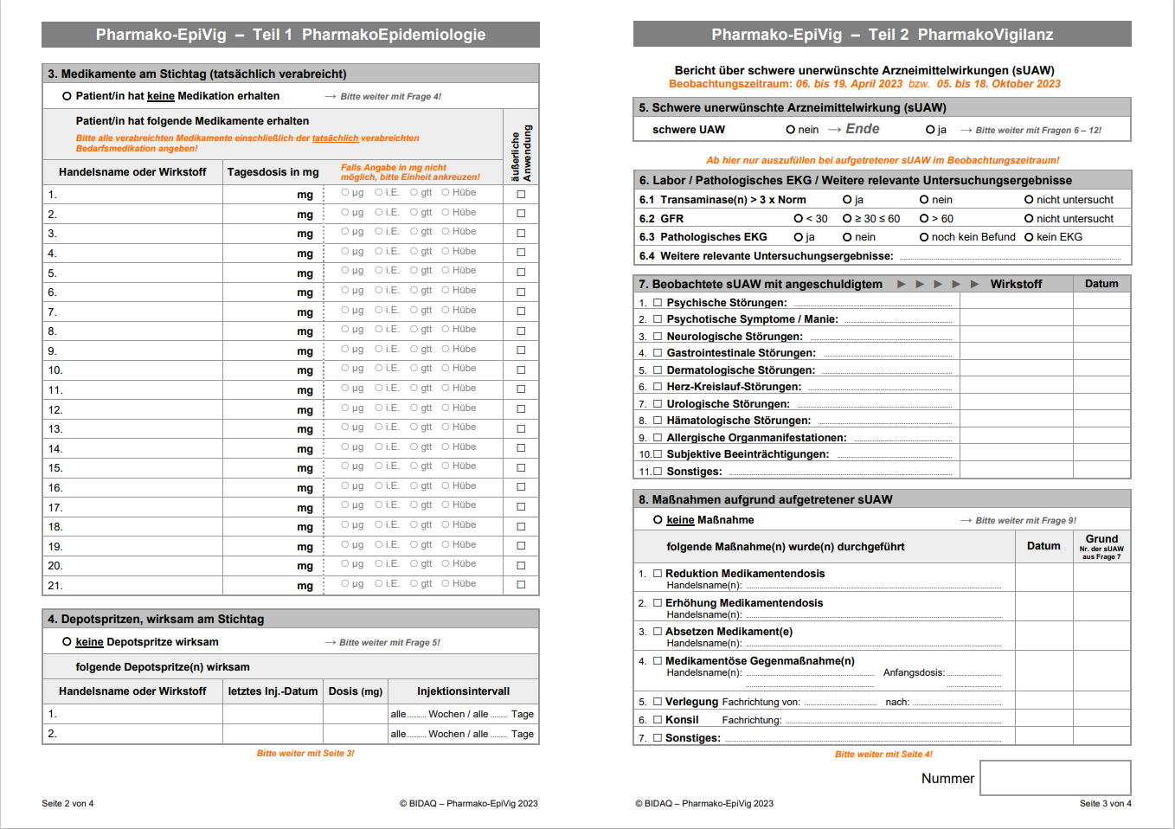
Questionnaire and associated instructions can be found on the BIDAQ-homepage under https://bidaq.de/projekte/epivig/dokumente.

