Table 1. One-way ANOVA across the three groups (p < 0.05)
Metabolite name | f.value | p.value | FDR | Fisher's LSD
Isocitric acid | 577.64 | 2.33E-70 | 2.14E-68 | Control - Moderate; Control - Severe
Uridine | 41.514 | 5.09E-15 | 2.34E-13 | Moderate - Control; Severe - Control
5-Methoxytryptophan | 38.292 | 4.11E-14 | 1.26E-12 | Moderate - Control; Severe - Control
5-Aminolevulinic acid | 35.992 | 1.89E-13 | 4.36E-12 | Moderate - Control; Severe - Control
Acetone | 34.359 | 5.72E-13 | 1.05E-11 | Moderate - Control; Severe - Control
1,3-Dimethyluracil | 32.089 | 2.73E-12 | 4.18E-11 | Moderate - Control; Severe - Control
Benzaldehyde | 28.359 | 3.84E-11 | 5.04E-10 | Moderate - Control; Severe - Control
L-Fucose | 24.784 | 5.30E-10 | 6.10E-09 | Control - Moderate; Control - Severe
L-Arginine | 24.35 | 7.34E-10 | 7.51E-09 | Control - Moderate; Control - Severe
Asymmetric dimethylarginine | 24.163 | 8.45E-10 | 7.77E-09 | Control - Moderate; Control - Severe
L-Aspartyl-L-phenylalanine | 21.698 | 5.53E-09 | 4.63E-08 | Moderate - Control; Severe - Control
Canavanine | 21.475 | 6.57E-09 | 4.99E-08 | Moderate - Control; Severe - Control
L-Acetylcarnitine | 21.384 | 7.05E-09 | 4.99E-08 | Moderate - Control; Severe - Control; Moderate - Severe
Pipecolic acid | 19.52 | 3.03E-08 | 1.99E-07 | Moderate - Control; Severe - Control
Orotic acid | 18.841 | 5.20E-08 | 3.19E-07 | Moderate - Control; Severe - Control
Trimethylamine | 18.669 | 5.96E-08 | 3.43E-07 | Moderate - Control; Severe - Control
Histamine | 17.261 | 1.85E-07 | 9.99E-07 | Moderate - Control; Severe - Control
L-Glutamine | 16.974 | 2.33E-07 | 1.19E-06 | Control - Moderate; Control - Severe
DL-2-aminooctanoic acid | 16.055 | 4.94E-07 | 2.39E-06 | Control - Moderate; Control - Severe
(R)-Lipoic acid | 15.918 | 5.52E-07 | 2.54E-06 | Control - Moderate; Control - Severe
Hypoxanthine | 15.639 | 6.95E-07 | 3.04E-06 | Moderate - Control; Severe - Control
Glycocholic acid | 14.278 | 2.15E-06 | 9.01E-06 | Moderate - Control; Severe - Control
L-Homocysteic acid | 12.905 | 6.86E-06 | 2.74E-05 | Moderate - Control; Severe - Control; Moderate - Severe
2-Phenylbutyric acid | 11.878 | 1.65E-05 | 6.33E-05 | Moderate - Control; Severe - Control
Indole-3-carboxylic acid | 11.288 | 2.75E-05 | 0.000101 | Moderate - Control; Severe - Control; Moderate - Severe
Ethanolamine | 10.823 | 4.12E-05 | 0.000146 | Control - Moderate; Control - Severe
5-Methoxytryptophol | 10.577 | 5.11E-05 | 0.000174 | Control - Moderate; Control - Severe; Moderate - Severe
Fructose 1,6-bisphosphate | 9.9227 | 9.07E-05 | 0.000298 | Moderate - Control; Severe - Control
Thymidine | 9.2797 | 0.00016 | 0.000508 | Control - Moderate; Control - Severe
Pyruvaldehyde | 9.1328 | 0.000183 | 0.00056 | Moderate - Control; Severe - Control
Xanthine | 8.6815 | 0.000273 | 0.00081 | Control - Moderate; Control - Severe
Nutriacholic acid | 8.5609 | 0.000304 | 0.000855 | Moderate - Control; Severe - Control
Urea | 8.552 | 0.000307 | 0.000855 | Moderate - Control; Severe - Control
Uric acid | 8.3217 | 0.000377 | 0.00102 | Control - Severe; Moderate - Severe
Sphingosine | 8.1228 | 0.000451 | 0.001185 | Moderate - Control; Severe - Control
DUMP | 7.9493 | 0.000527 | 0.001347 | Control - Severe; Moderate - Severe
L-Norleucine | 7.6426 | 0.000696 | 0.001729 | Moderate - Control
Benzoic acid | 7.2154 | 0.001025 | 0.002482 | Control - Severe; Moderate - Severe
Creatinine | 7.1364 | 0.001102 | 0.002599 | Control - Moderate
Cis-Aconitic acid | 7.0792 | 0.001161 | 0.00267 | Moderate - Control; Severe - Control
Pantothenic acid | 6.7734 | 0.001535 | 0.003444 | Control - Severe; Moderate - Severe
5-Hydroxy-L-tryptophan | 6.5494 | 0.001885 | 0.004129 | Control - Moderate; Control - Severe
m-Coumaric acid | 6.476 | 0.002016 | 0.004314 | Control - Severe; Moderate - Severe
Homocysteine | 6.4327 | 0.002098 | 0.004388 | Control - Moderate; Severe - Moderate
Cortisol | 6.1496 | 0.002724 | 0.005568 | Control - Severe; Moderate - Severe
6-(Methylamino) purine | 5.5773 | 0.004627 | 0.009254 | Control - Severe
Indoleacetic acid | 5.5 | 0.004972 | 0.0096 | Moderate - Control; Severe - Control
o-Tyrosine | 5.492 | 0.005009 | 0.0096 | Control - Severe; Moderate - Severe
Adenosine | 5.2763 | 0.006124 | 0.011498 | Severe - Control
1-Methyladenosine | 5.2334 | 0.006374 | 0.011728 | Moderate - Control; Severe - Control
Phenylacetaldehyde | 5.0438 | 0.00761 | 0.013728 | Moderate - Control; Moderate - Severe
L-Carnitine | 4.8851 | 0.00883 | 0.015622 | Control - Moderate; Control - Severe
Allantoic acid | 4.7554 | 0.009973 | 0.017311 | Control - Moderate; Control - Severe
Phenol | 4.514 | 0.012515 | 0.021322 | Control - Severe; Moderate - Severe
Levoglucosan | 4.2978 | 0.015347 | 0.025672 | Control - Moderate; Severe - Moderate
Pyrrolidonecarboxylic acid | 4.213 | 0.016628 | 0.027318 | Control - Severe
Alpha-N-phenylacetyl-L-glutamine | 3.962 | 0.021092 | 0.034043 | Moderate - Control
Acetoin | 3.7605 | 0.025541 | 0.040513 | Moderate - Control; Severe - Control
Indoleacrylic acid | 3.5233 | 0.032018 | 0.049926 | Severe - Control

Table2. Venn diagram data comparing metabolites identified in moderate asthma and severe asthma groups compared to healthy group
Names | Total Elements | Metabolites | Pathways
Moderate + SEVERE | 39 | Indole-3-carboxylic acid
 |  | Xanthine | Purine Metabolism
 |  | Thymidine | Pyrimidine Metabolism
 |  | Histamine | Histidine Metabolism
 |  | Indoleacetic acid
 |  | (R)-Lipoic acid | Glycine and Serine Metabolism, and Ammonia Recycling
 |  | Pyruvaldehyde | Glycine and Serine Metabolism, Spermidine and Spermine Biosynthesis
 |  | L-Carnitine | Beta Oxidation of Very Long Chain Fatty Acids, Oxidation of Branched Chain Fatty Acids, Carnitine Synthesis, and Mitochondrial Beta-Oxidation of Long Chain Saturated Fatty Acids
 |  | Orotic acid | Pyrimidine Metabolism
 |  | L-Fucose
 |  | Nutriacholic acid
 |  | L-Arginine | Glycine and Serine Metabolism, Urea Cycle, Aspartate Metabolism, and Arginine and Proline Metabolism
 |  | Trimethylamine
 |  | L-Aspartyl-L-phenylalanine
 |  | Benzaldehyde
 |  | 1,3-Dimethyluracil
 |  | Glycocholic acid
 |  | Adenosine | Purine Metabolism and Methionine Metabolism
 |  | L-Homocysteic acid
 |  | Pipecolic acid
 |  | Canavanine
 |  | Uridine | Pyrimidine Metabolism
 |  | 5-Hydroxy-L-tryptophan
 |  | Hypoxanthine | Purine Metabolism
 |  | Acetone | Purine Metabolism
 |  | L-Acetylcarnitine | Beta Oxidation of Very Long Chain Fatty Acids, and Oxidation of Branched Chain Fatty Acids
 |  | Sphingosine
 |  | Urea | D-Arginine and D-Ornithine Metabolism, Arginine and Proline Metabolism, and Urea Cycle
 |  | Fructose 1,6-bisphosphate | Warburg Effect, Fructose and Mannose Degradation, and Glycolysis
 |  | 5-Methoxytryptophan
 |  | DL-2-aminooctanoic acid
 |  | L-Glutamine | Phenylacetate Metabolism, Urea Cycle, Ammonia Recycling, Pyrimidine Metabolism, Purine Metabolism, Warburg Effect, and Aspartate Metabolism
 |  | 1-Methyladenosine
 |  | Ethanolamine | Phosphatidylethanolamine Biosynthesis, Phosphatidylcholine Biosynthesis, and Phosphatidylcholine Biosynthesis
 |  | Asymmetric dimethylarginine
 |  | 5-Methoxytryptophol
 |  | Isocitric acid | Citric Acid Cycle and Warburg Effect
 |  | 5-Aminolevulinic acid | Glycine and Serine Metabolism
 |  | 2-Phenylbutyric acid
Severe | 18 | Hyodeoxycholic acid
 |  | Creatine | Glycine and Serine Metabolism, Arginine and Proline Metabolism
 |  | Glycerophosphocholine
 |  | Uric acid
 |  | Pantothenic acid | Pantothenate and CoA Biosynthesis
 |  | 6-(Methylamino) purine
 |  | Pyrrolidonecarboxylic acid
 |  | DUMP | Pyrimidine Metabolism
 |  | D-Limonene
 |  | Indoleacrylic acid
 |  | Stearic acid | Mitochondrial Beta-Oxidation of Long Chain Saturated Fatty Acids
 |  | Cortisol
 |  | Benzoic acid
 |  | o-Tyrosine
 |  | Deoxycytidine | Pyrimidine Metabolism
 |  | m-Coumaric acid
 |  | Phenol | Sulfate/Sulfite Metabolism
 |  | N-Methyl-D-aspartic acid
Moderate | 11 | Creatinine
 |  | Acetoin
 |  | Phenylacetaldehyde
 |  | Urocanic acid | Ammonia Recycling, Histidine Metabolism
 |  | Alpha-N-phenylacetyl-L-glutamine
 |  | Levoglucosan
 |  | L-Norleucine
 |  | 5-Phenylvaleric acid
 |  | Allantoic acid
 |  | Homocysteine | Glycine and Serine Metabolism, Betaine Metabolism, Methionine Metabolism, Catecholamine Biosynthesis
 |  | Cis-Aconitic acid | Citric Acid Cycle, Homocysteine Degradation

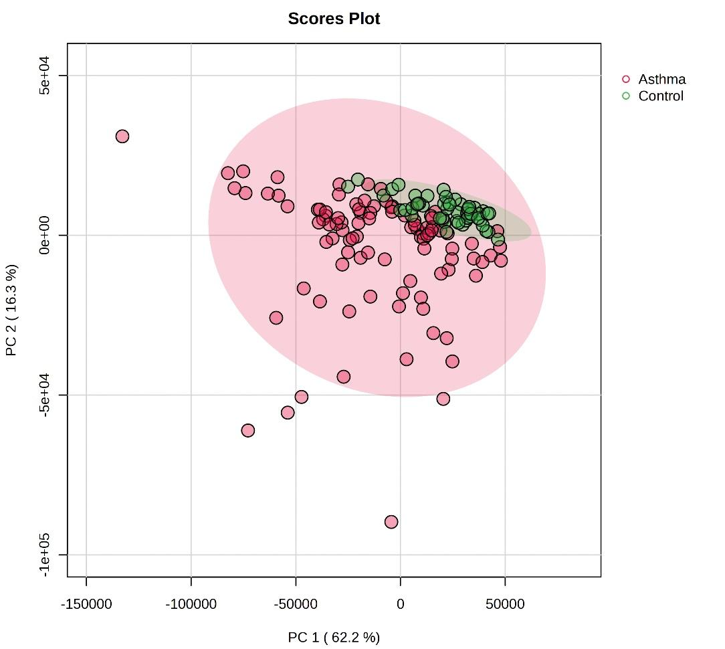

Figure S1. The principal component analysis for asthmatics and healthy controls.

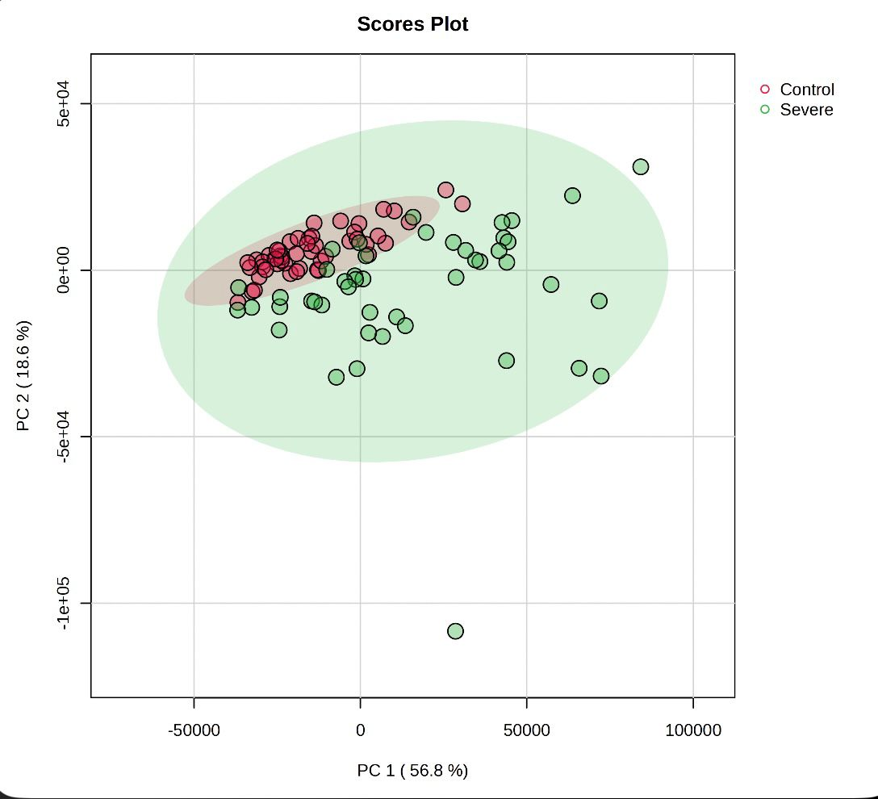

Figure S2. Principal component analysis of severely asthmatic patients and healthy controls.

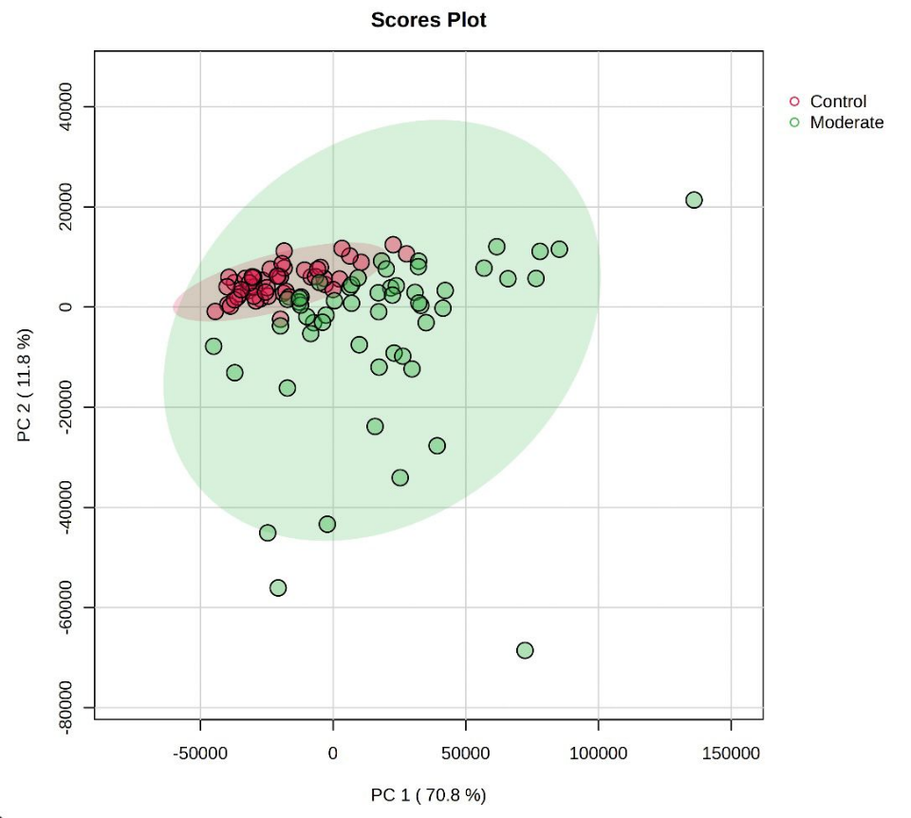

Figure S3. Principal component analysis of moderately asthmatic patients and healthy controls.

