Supplementary figures

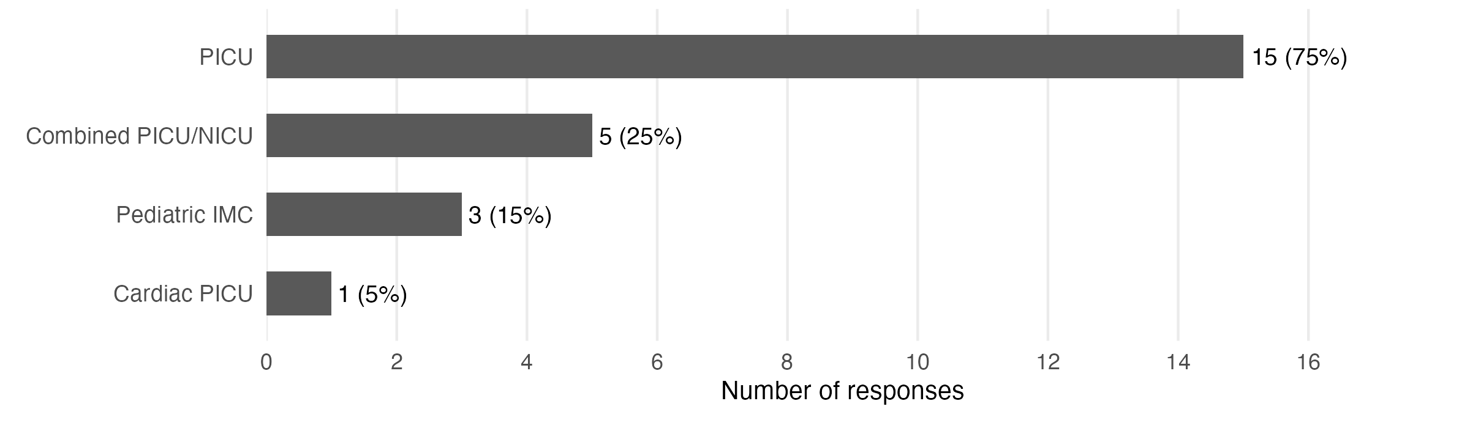
Figure S1: Wards where pediatric intensive care patients are treated. Multiple answers per center were possible, as several centers operate more than one type of unit; the figure is based on responses from all 20 participating centers.

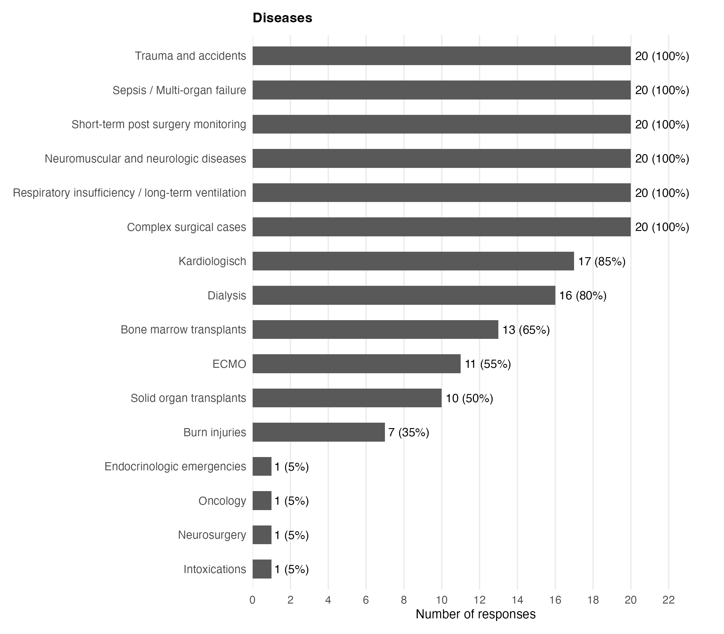
Figure S2: Pediatric intensive care conditions treated at the participating centers. Pediatric intensive care conditions treated at the participating centers. Categories reflect the clinical situations for which pediatric intensive care is provided rather than diagnoses alone. "Post-surgery monitoring" denotes planned postoperative surveillance, most often delayed extubation of an otherwise stable patient, whereas "complex surgical cases" denotes patients who remain critically ill after surgery and require ongoing intensive care beyond planned monitoring. Multiple answers per center were possible.

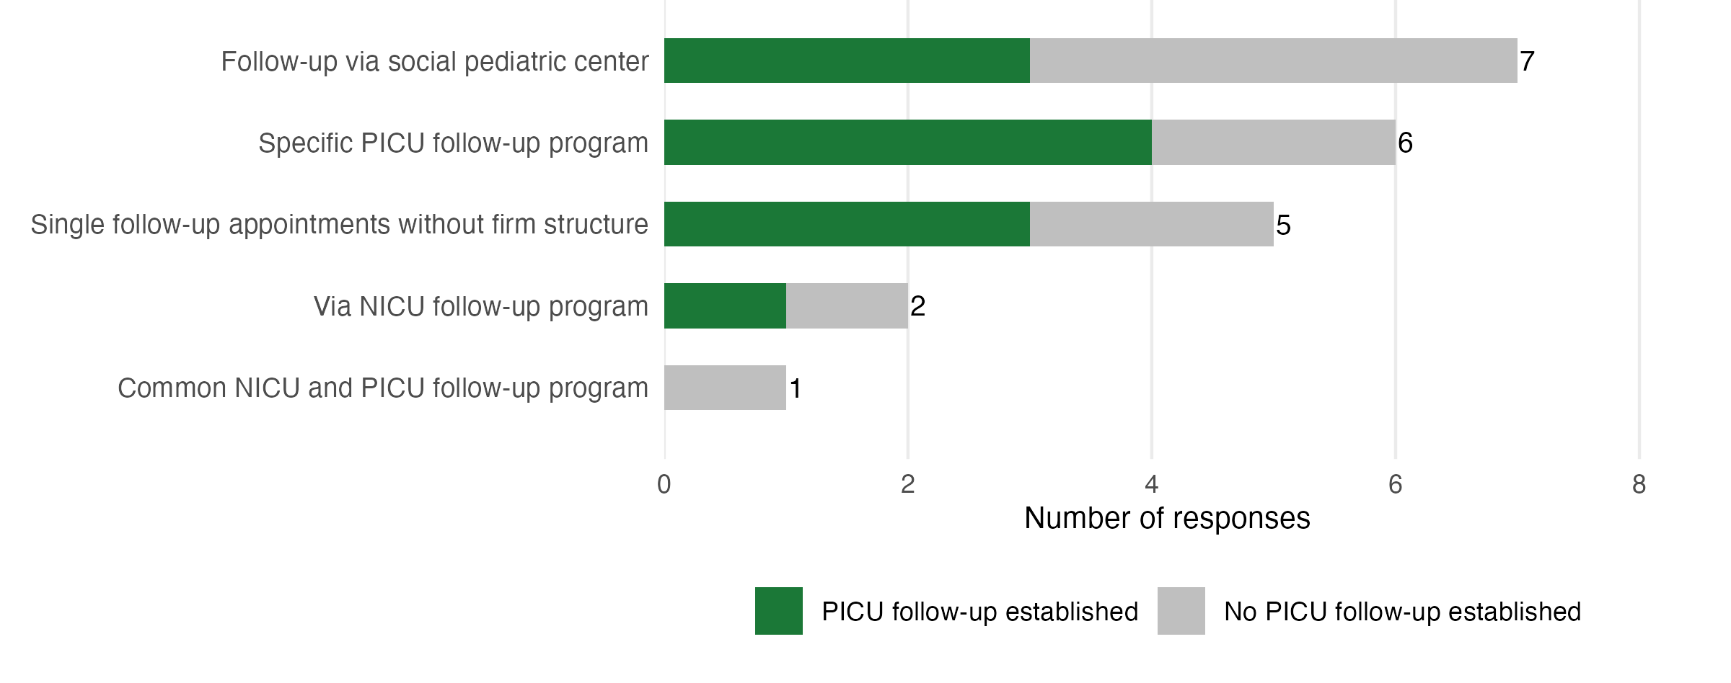
Figure S3: Organizational form of PICU follow-up at the participating centers. Multiple answers per center were possible; the figure is based on responses from the 11 centers with established or planned follow-up programs.

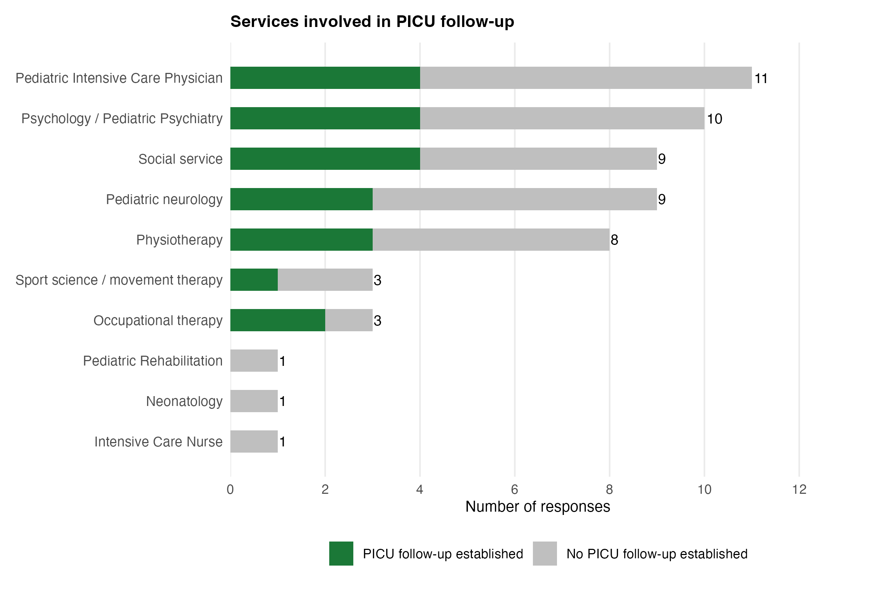
Figure S4: Services involved in PICU follow-up at the participating centers. Centers with an already established follow-up program are marked separately within each category. Multiple answers per center were possible.

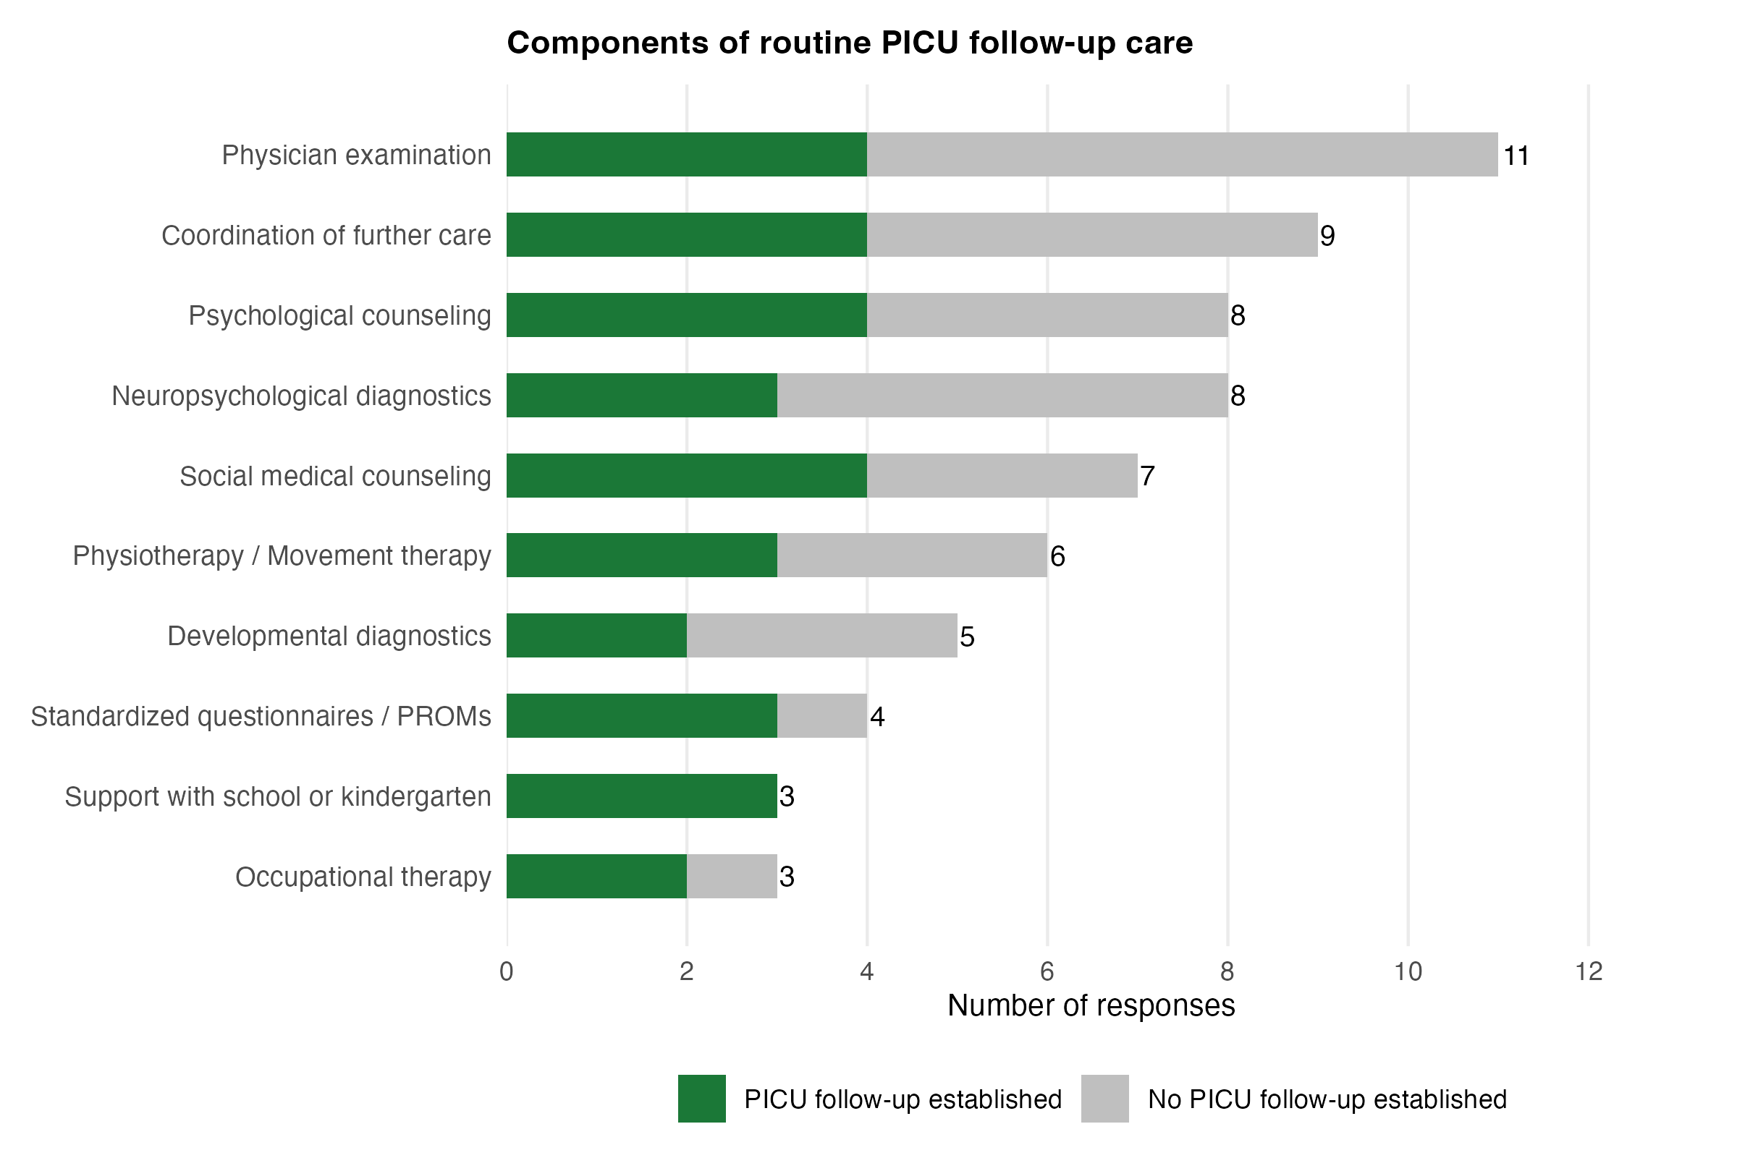
Figure S5: Components of routine PICU follow-up care. Multiple answers per center were possible; the figure is based on responses from the 11 centers with established or planned follow-up programs.

