Appendix 2: Search strategy
EMBASE and Medline
1. Prisons/
2. Prisoners/
3. (Jail* or penitent* or Gaol* or reformatory).tw.
4. ((penal or secure or correctional) adj (institution* or system* or unit* or facilit* or centre* or center*)).tw.
5. (Incarceration or imprisonment or detention).tw.
6. (Inmate* or Offender* or Prison* or Convict* or detainee* or re-offend* or reoffend* or incarcerat* or felon*).tw.
7. or/1-6
8. Evidence-based/ or evidence based/ or evidence-based practice/ or evidence-based medicine/
9. (evidenced-based or evidenced based).tw.
10. EBP*.tw.
11. Evidence-informed.tw.
12. Best practice/
13. Patient-centred care/
14. (Patient adj (centered or centred)).tw.
15. (Patient-centered or patient-centred).tw.
16. (QOF or quality outcomes framework).tw.
17. (guideline adj (adherence or implementation or promotion)).tw.
18. Implementation science/
19. (implementation adj2 (guideline or best practice or evidence-based practice)).tw.
20. Quality improvement/
21. health promotion/
22. or/8-21
23. 7 and 22
CINAHL
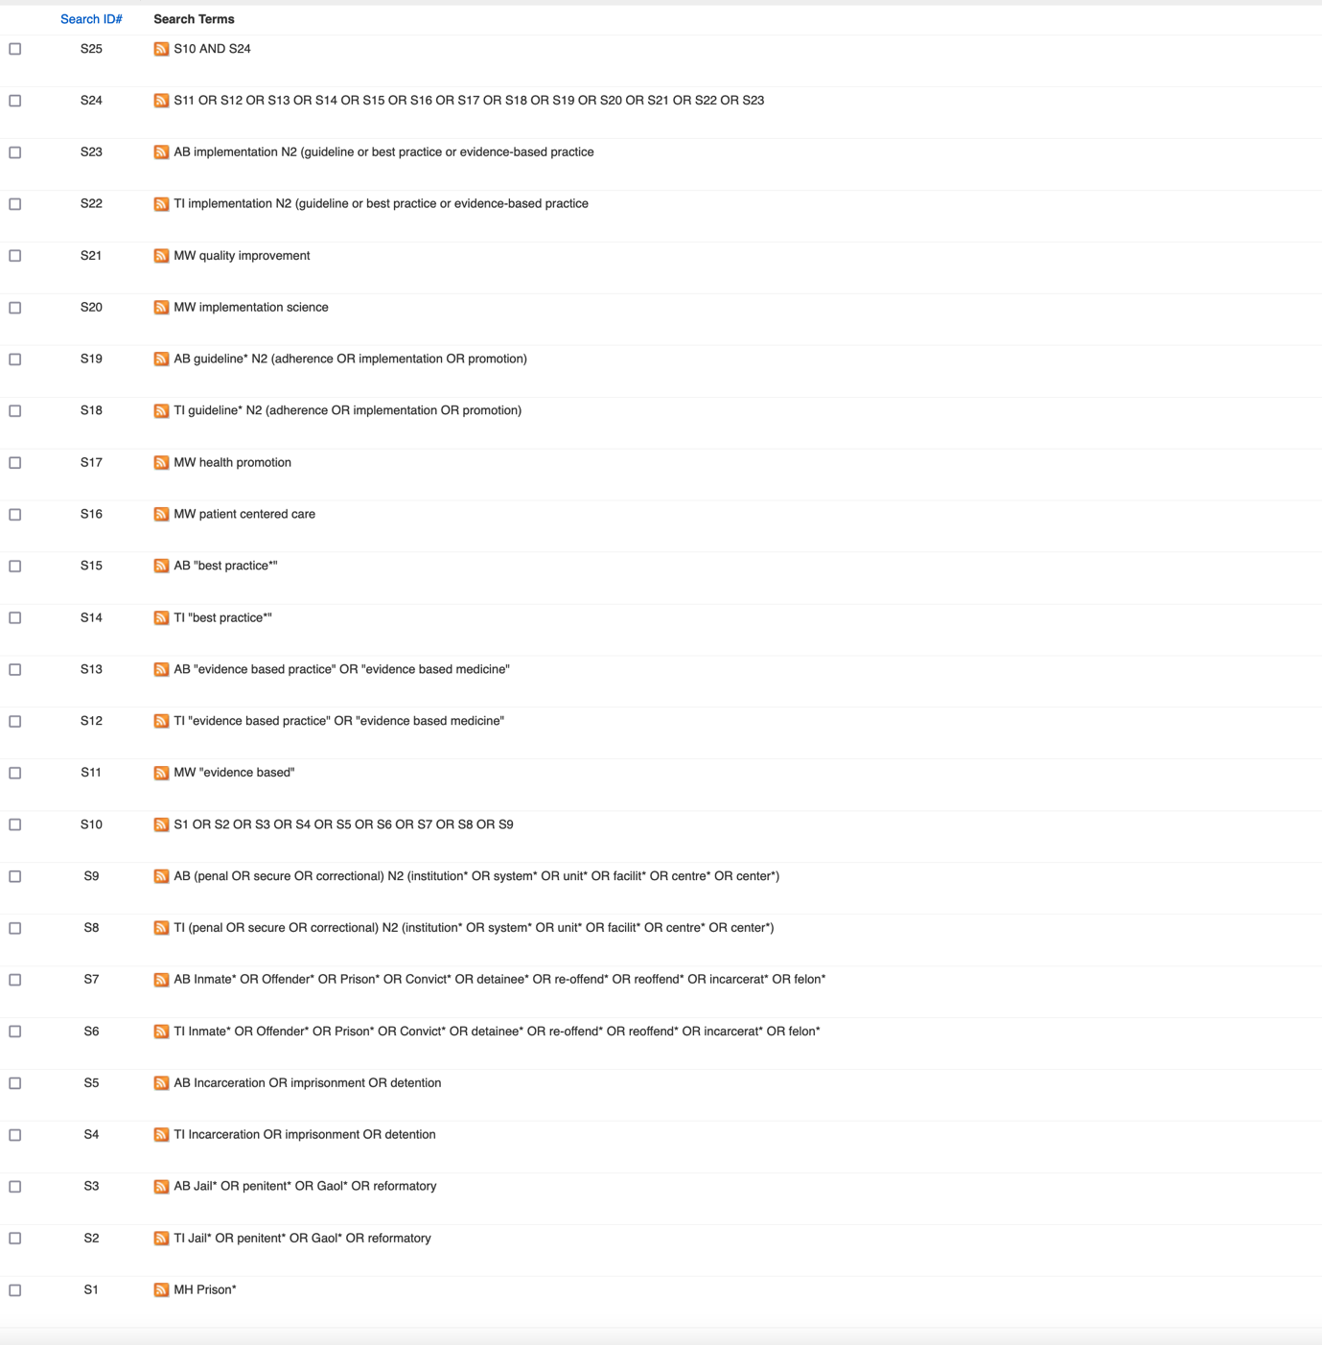
Scopus
( ( TITLE-ABS-KEY ( prison* OR jail* OR penitent* OR gaol* OR reformatory ) OR TITLE-ABS-KEY ( ( penal OR secure OR correctional ) W/1 ( institution* OR system* OR unit* OR facilit* OR centre* OR center* ) ) OR TITLE-ABS-KEY ( incarceration OR imprisonment OR detention ) OR TITLE-ABS-KEY ( inmate* OR offender* OR prisoner* OR convict* OR detainee* OR re-offend* OR reoffend* OR incarcerat* OR felon* ) ) ) AND ( ( TITLE-ABS-KEY ( [evidence-based] ) OR TITLE-ABS-KEY ( [evidence based] ) OR TITLE-ABS-KEY ( [Quality Improvement] ) OR TITLE-ABS-KEY ( [Implementation science] ) OR TITLE-ABS-KEY ( [health promotion] ) OR TITLE-ABS-KEY ( [best practice*] ) ) )

Web of Science
