Risk of bias assessment
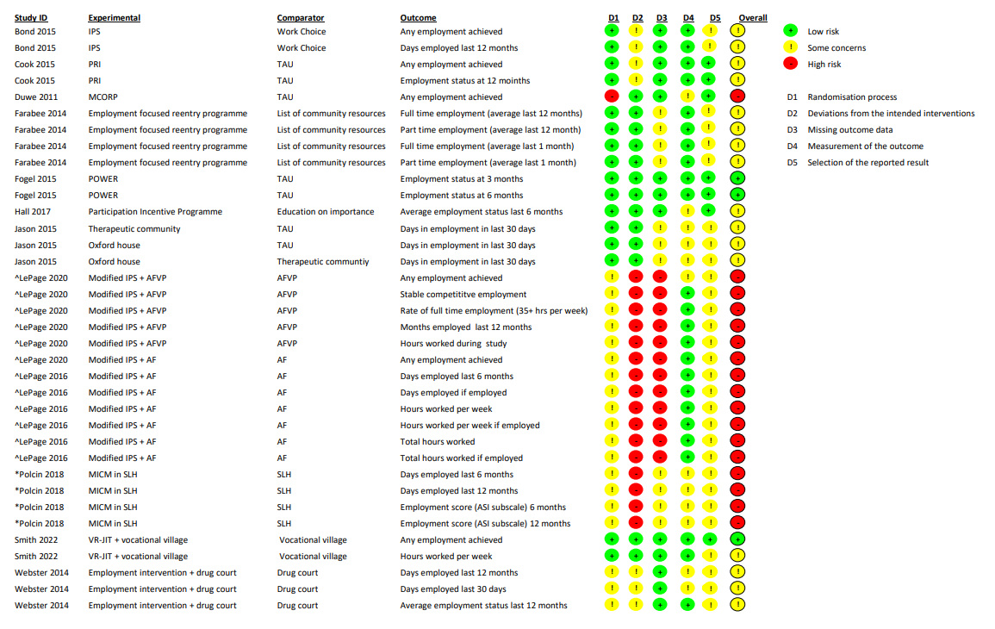
*=cluster RCT
^=per protocol analysis

