Additional file 1.
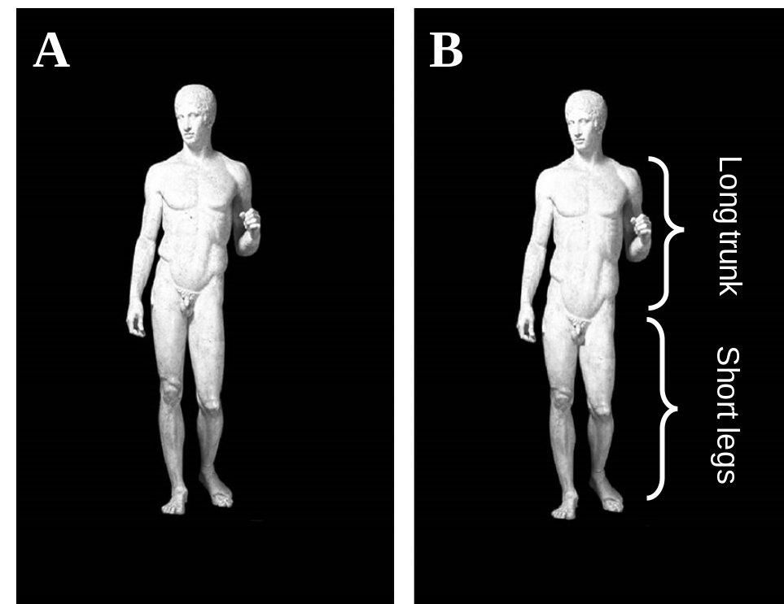
A: represents a sculpture with canonical proportions between body parts
B: represents a sculpture with modified proportions between body parts

