Additional file 2: Supplementary materials

 | Referred for (%) | Diagnosed with (%) | Expected prevalence(%)
ADHD | 2.7 | 1.4 | 2.2
Dyslexia | 3.1 | 2.4 | 3-10
Language disorder | 1.0 | 1.0 | 7.6
ASD | 5.6 | 1.7 | 1.6
Other NDD | 1.0 | 3.1 | --

Table A1. Percentage of parents who reported their child had been referred for or had been diagnosed with a neurodevelopmental disorder (NDD). Expected prevalence rates for the UK are also given, based on best available literature: ADHD¹; ASD²; language disorder³; Dyslexia⁴.

At the moment, do you feel you get enough sleep?
- Phase 1
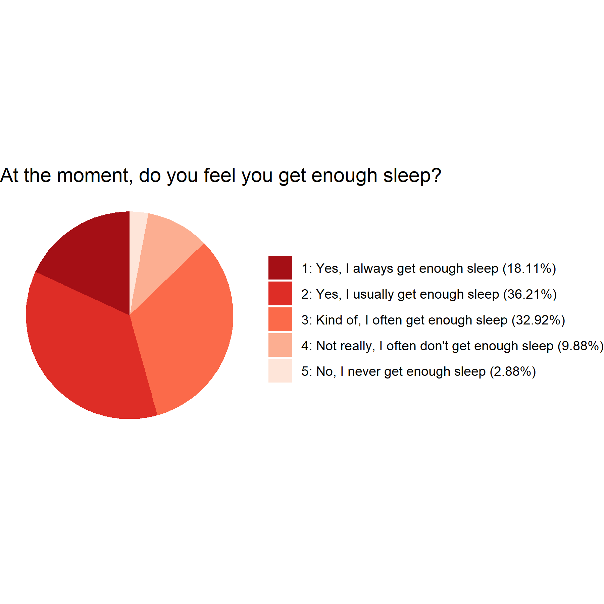
- Phase 2
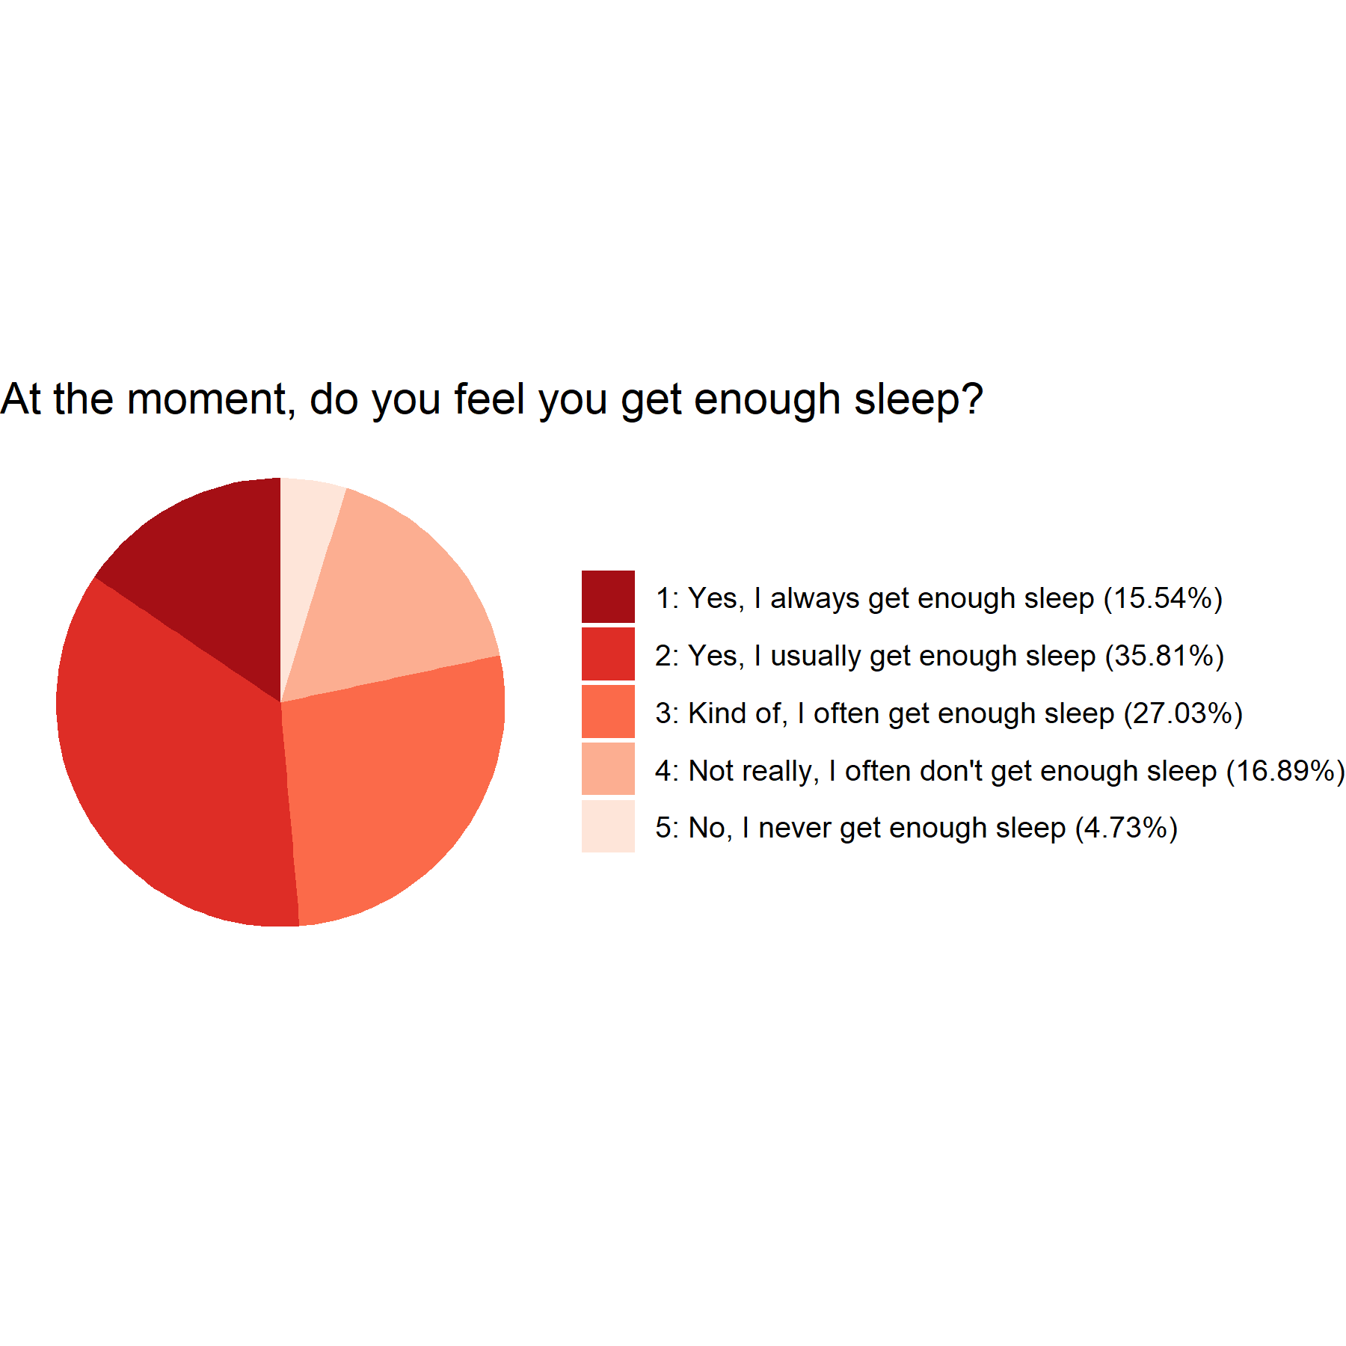

After your lights are turned off, do you spend a long time thinking or worrying about things?
- Phase 2
- Phase 1
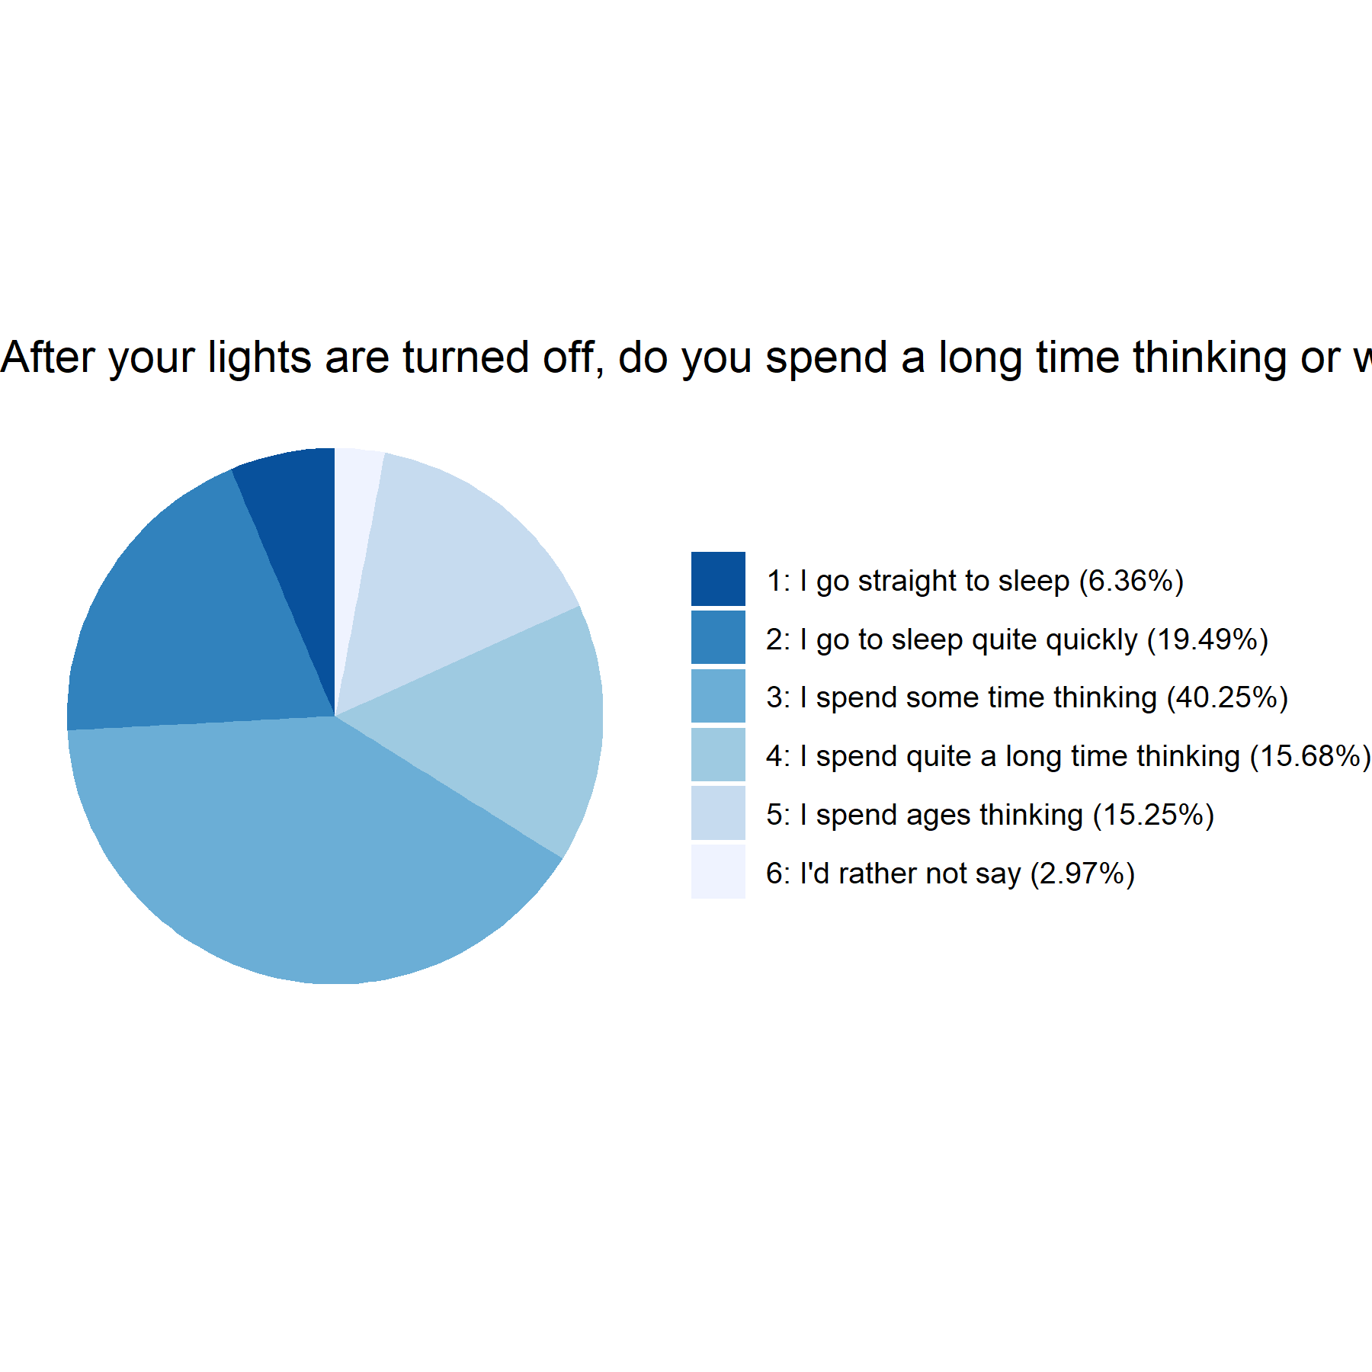
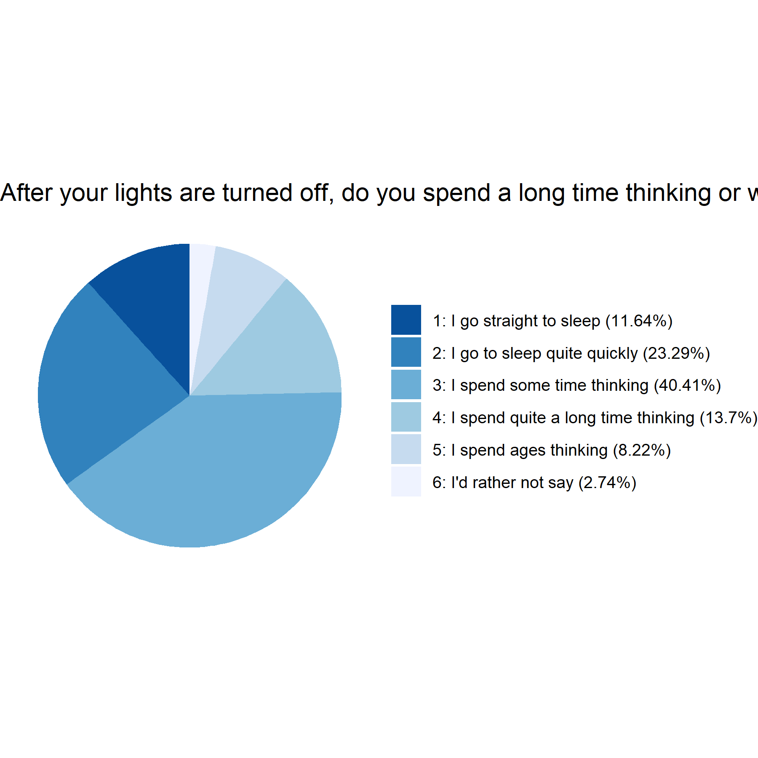

If you wake in the night does it take you a long time to get back to sleep?
- Phase 1
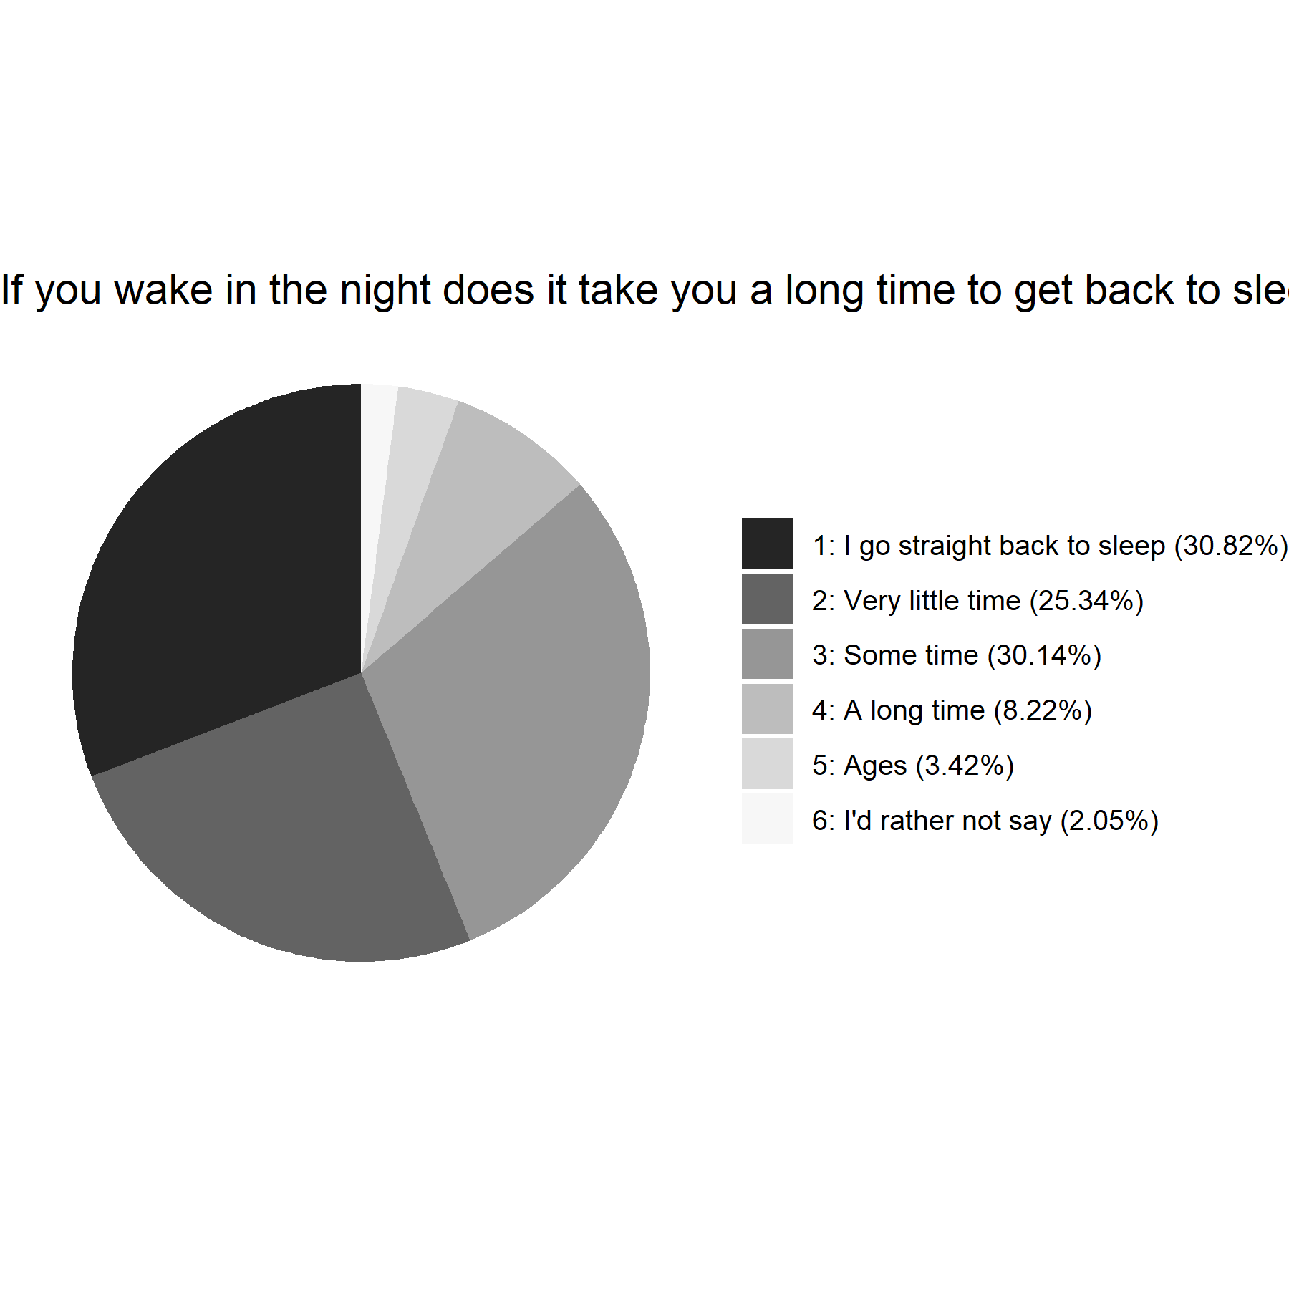
- Phase 2
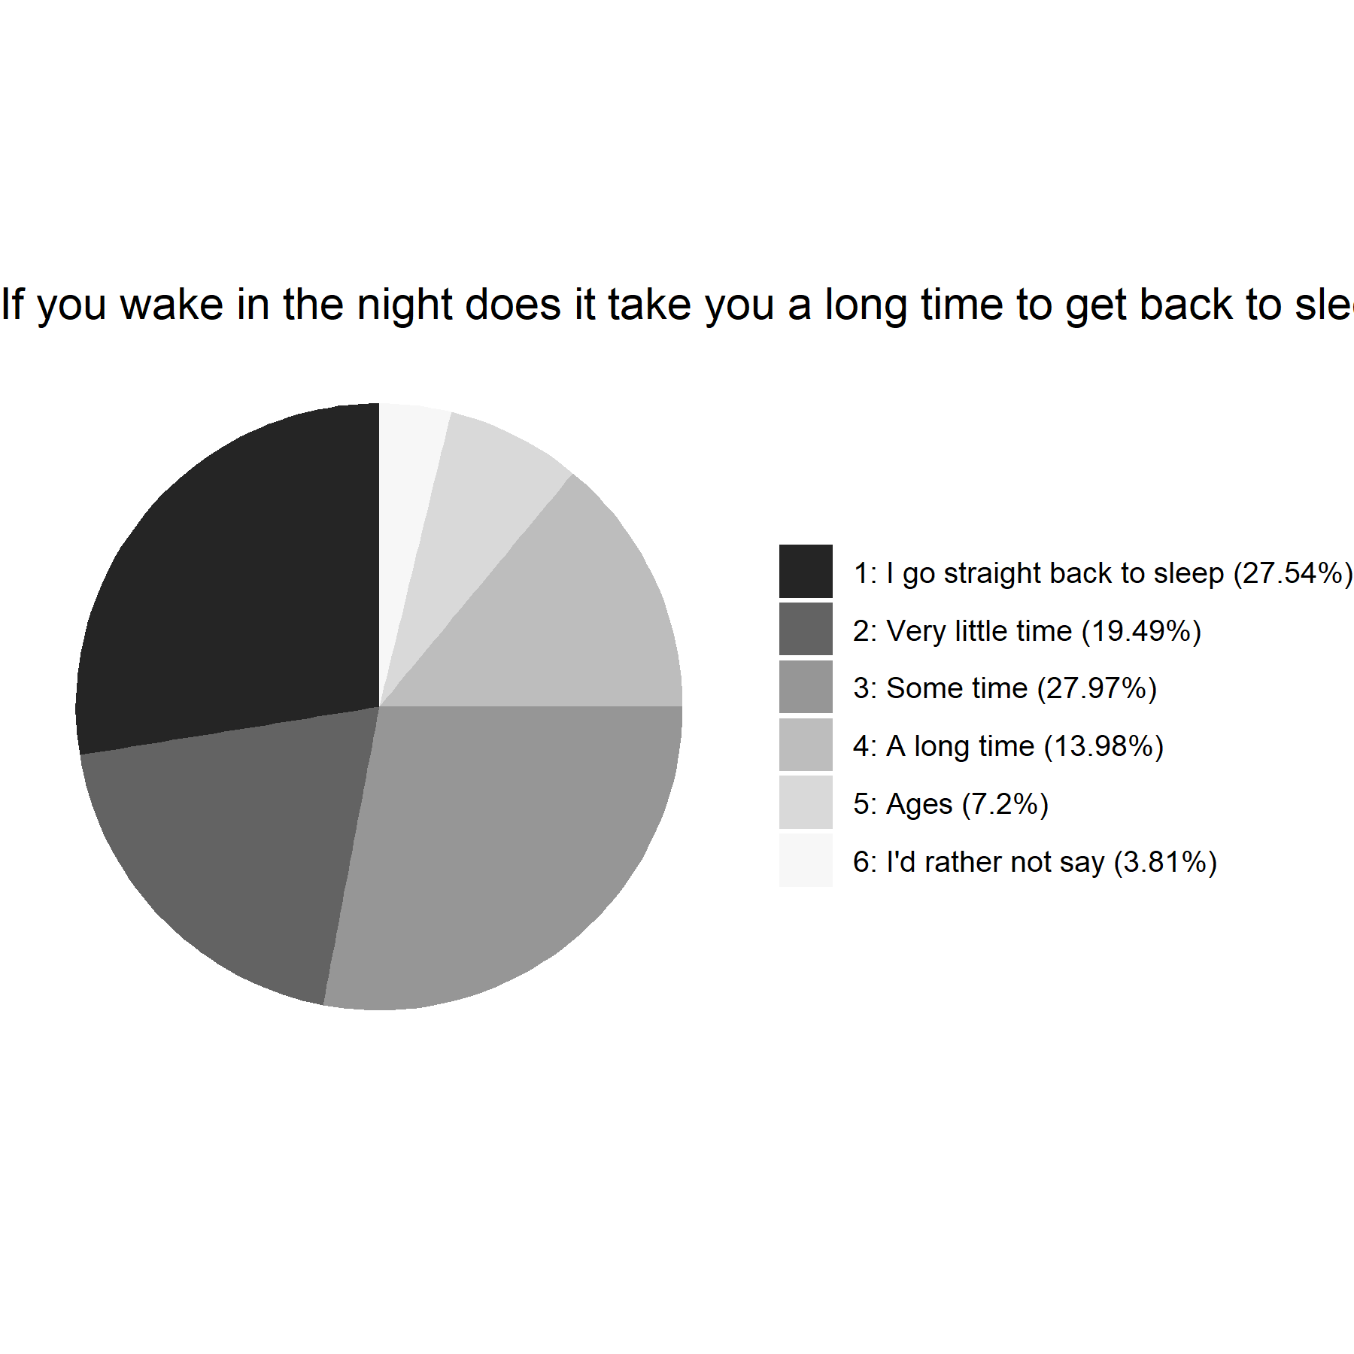

At the moment, how sleepy do you feel during the day?
- Phase 1
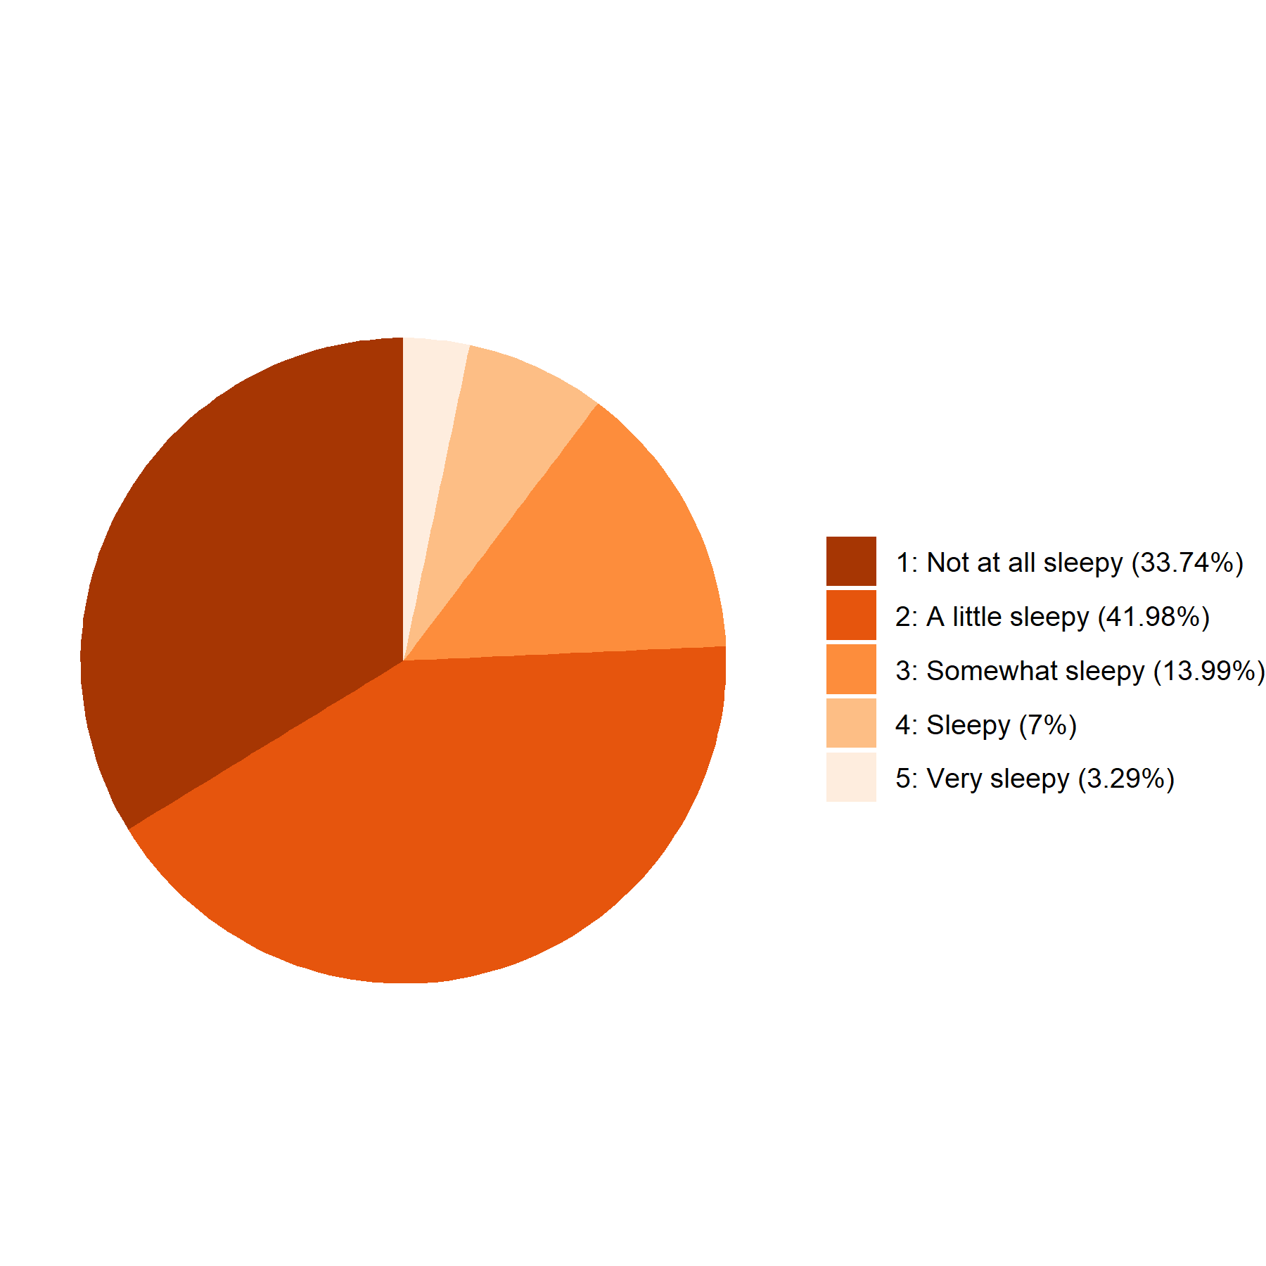
- Phase 2
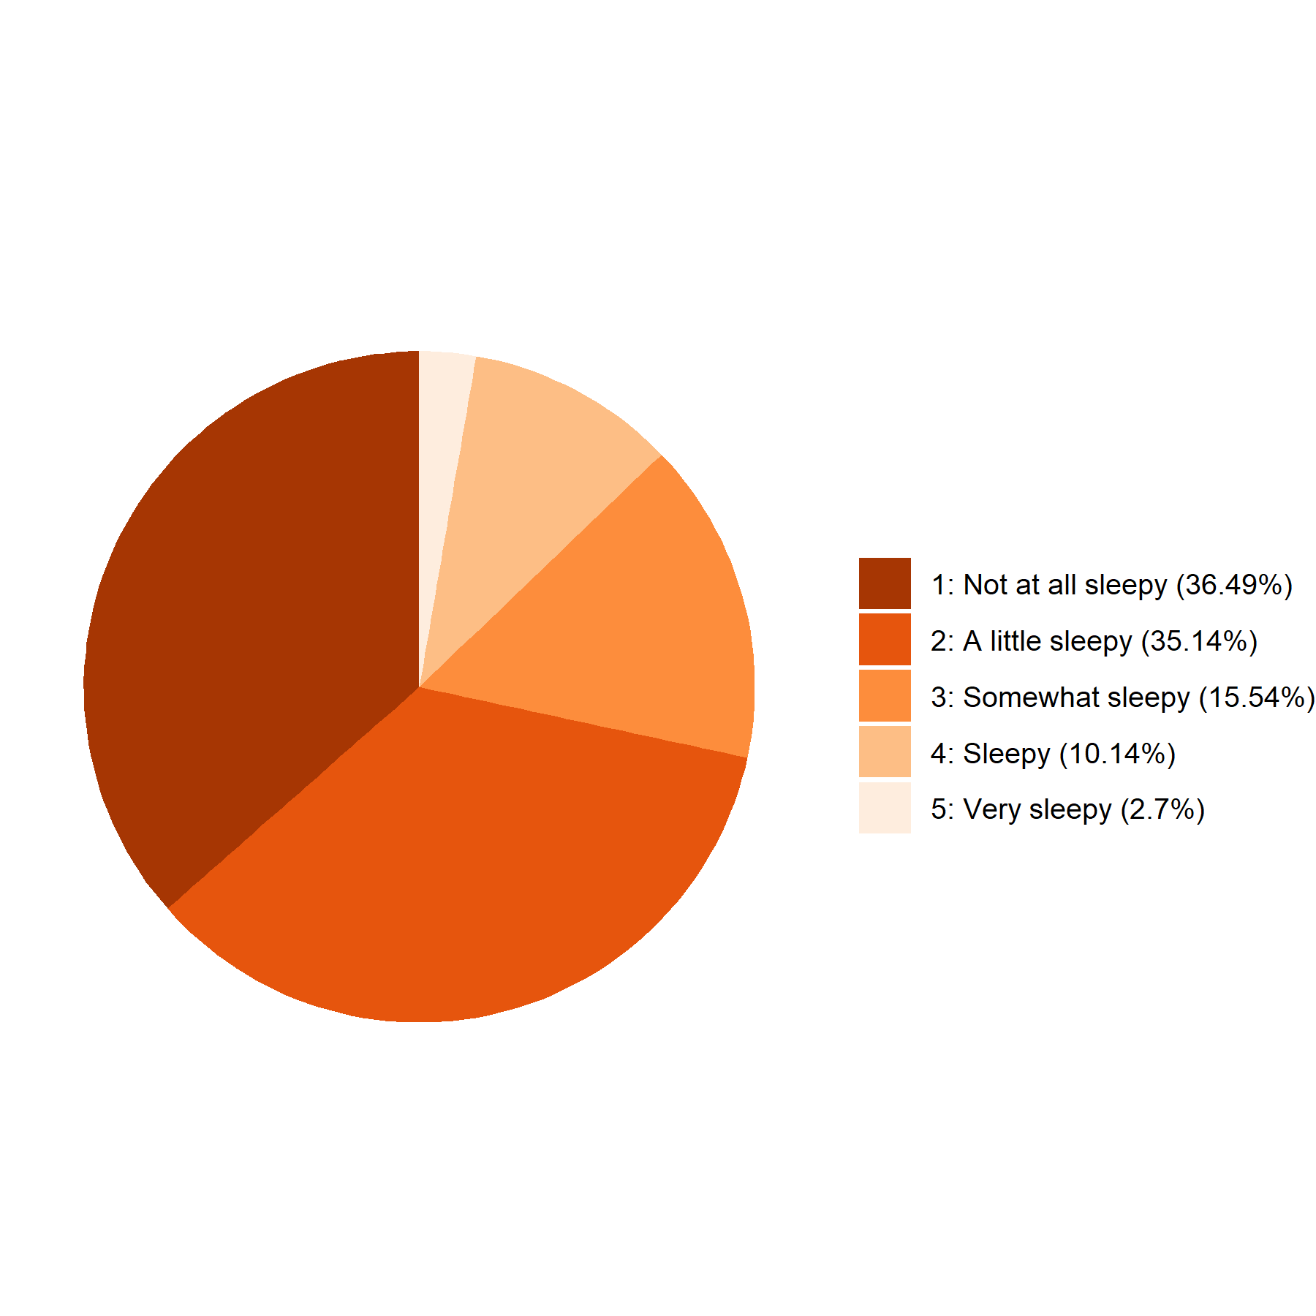

Figure A1. Responses to the questions posed to children at A/C/E/G) Phase 1 (n = 243) and B/D/F/H) Phase 2 (n = 148).

 | During the past week, did you feel scared or worried for no particular reason? |  | During the past week, did you worry about the virus?
 | Phase 1  n = 145 | Phase 2  n = 145 | Phase 1  n = 134 | Phase 2  n = 134
‘Never’ (%) | 37.0 | 39.8 | 28.8 | 42.8
‘Rarely’ (%) | 18.1 | 15.1 | 22.2 | 13.9
‘Sometimes’ (%) | 24.7 | 23.5 | 28.8 | 23.5
‘Quite often’ (%) | 10.3 | 6.0 | 8.6 | 4.8
‘Very often’ (%) | 2.8 | 1.8 | 5.3 | 1.8
‘I’d rather not say’ (%) | 3.7 | 1.2 | 2.9 | 0.6
No response (%) | 3.3 | 1.3 | 3.3 | 1.3

Table A2. Responses to children’s questions about anxiety at Phase 1 & Phase 2.

 |  | Method | r/r_{s} | Lower 95%CI | Upper 95%CI | df | p
Parent reported | Bedtime | Pearson | .74 | .66 | .80 | 177 | <0.001***
Parent reported | Get up time | Pearson | .70 | .62 | .77 | 177 | <0.001***
Parent reported | SOL | Spearman | .56 | .43 | .70 | 177 | <0.001***
Parent reported | Daytime sleepiness | Spearman | .47 | .33 | .60 | 177 | <0.001***
Parent reported | Time spent outside in week | Pearson | .44 | .31 | .55 | 177 | <0.001***
Parent reported | Time spent outside at weekend | Pearson | .48 | .36 | .59 | 177 | <0.001***
Parent reported | Screen hours for education | Pearson | .26 | .12 | .39 | 177 | 0.001**
Parent reported | Screen hours for entertainment | Pearson | .40 | .27 | .52 | 177 | <0.001***
Parent reported | TV before bed | Spearman | .47 | .33 | .60 | 177 | <0.001***
Parent reported | Games before bed | Spearman | .47 | .35 | .60 | 177 | <0.001***
Parent reported | Social media before bed | Spearman | .30 | .12 | .49 | 177 | <0.001***
Parent reported | Bedtime anxiety | Spearman | .50 | .38 | .63 | 177 | <0.001***
Parent reported | Expressed anxiety about COVID-19 | Spearman | .43 | .30 | .56 | 177 | <0.001***
Parent reported | Parental anxiety about COVID-19 | Spearman | .47 | .33 | .60 | 177 | <0.001***
Self-reported | Enough sleep | Spearman | .39 | .24 | .55 | 135 | <0.001***
Self-reported | Daytime sleepiness | Spearman | .39 | .22 | .55 | 135 | <0.001***
Self-reported | SOL | Spearman | .42 | .27 | .56 | 132 | <0.001***
Self-reported | Number of night wakings | Pearson | .62 | .51 | .72 | 132 | <0.001***
Self-reported | Time to sleep after night waking | Spearman | .38 | .23 | .54 | 132 | <0.001**
Self-reported | General worry in surveyed week | Spearman | .36 | .21 | .51 | 132 | <0.001***
Self-reported | COVID-19 worry in surveyed week | Spearman | .43 | .28 | .58 | 132 | <0.001***

Table A3. Correlations between comparable variables at Phase 1 and Phase 2.

References
1. Ford, T., Goodman, R., Meltzer, H. (2003). The British child and adolescent mental health survey 1999: prevalence of the DSM-VI disorders. Journal of the American Academy of Child & Adolescent Psychiatry, 42 (10): 1203-1211. Doi: 10.1097/00004583-200310000-00011
2. Baron-Cohen, S., Scott, F.J., Williams, J., Bolton, P., Matthews, F. E., & Brayne, C. (2009). Prevalence of autism-spectrum conditions: UK school-based population study. The British Journal of Psychiatry, 194: 500–509. doi: 10.1192/bjp.bp.108.059345
3. Norbury, C.F., Gooch, D., Wray, C., Baird, G., Charman, T., Simonoff, E., Vamvakas, G., & Pickles, A. (2016). The impact of nonverbal ability on prevalence and clinical presentation of language disorder: evidence from a population study. The Journal of Child Psychology & Psychiatry, 57 (11): 1247-1257. doi: 10.1111/jcpp.12573
4. Snowling, M. (2000). Dyslexia (2nd Ed.). Blackwell, UK

