Supplementary Figure 1: A graphical illustration of observed vs predicted flanker conflict effects for each individual participant
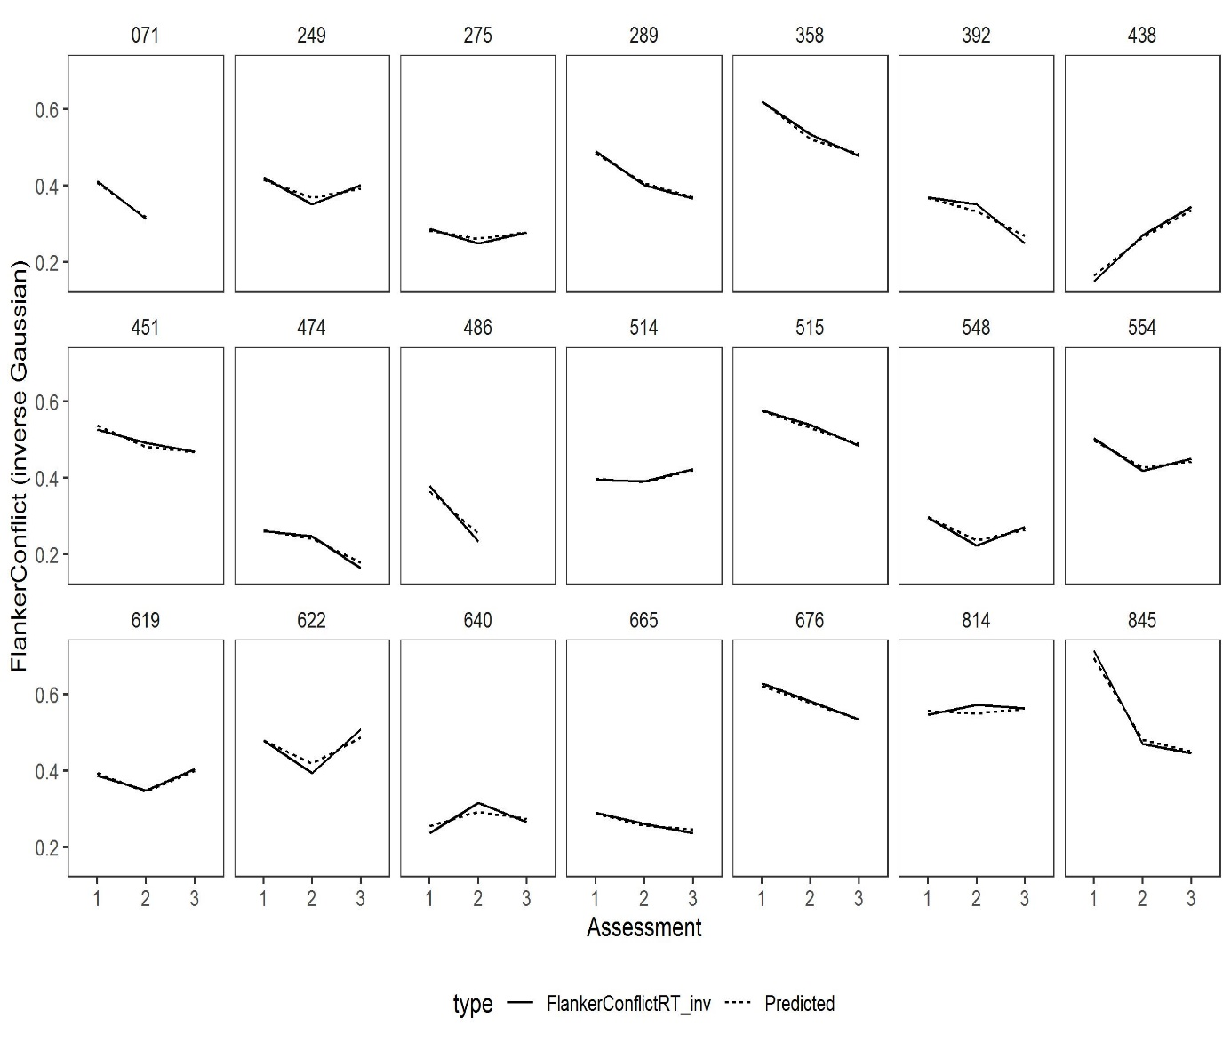
Note: The figure depicts comparisons between observed values (complete lines) and predicted values based on the final model (dashed lines).

