Supplements

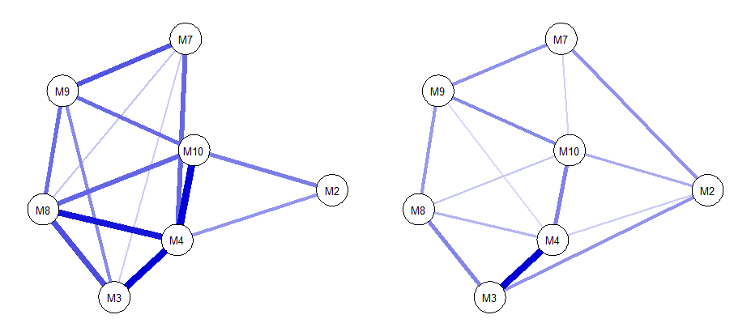
2)
1)

Supplement A
Compared networks of 1) children with silence in specific situation (n = 268) and 2) children without silence in specific situations (n =268). In order to compare networks of identical sample sizes, we drew a random sample of n = 268 of children with silence (n = 631). Included symptoms: M2 = reduced speech; M3 = incapacity of nonverbal communication; M4 = motor inhibition; M7 = avoidance of eye-contact; M8 = suppression of noises; M9 = avoidance of verbal situations; M10 = selectivity of speaking behavior; Symptom M1 (silence) could not be included as we selected groups based on this item.

Supplement B: Node Predicatability of total sample, N = 899
Item | R²
M1 | .573
M2 | .411
M3 | .449
M4 | .520
M7 | .386
M8 | .330
M9 | .439
M10 | .534

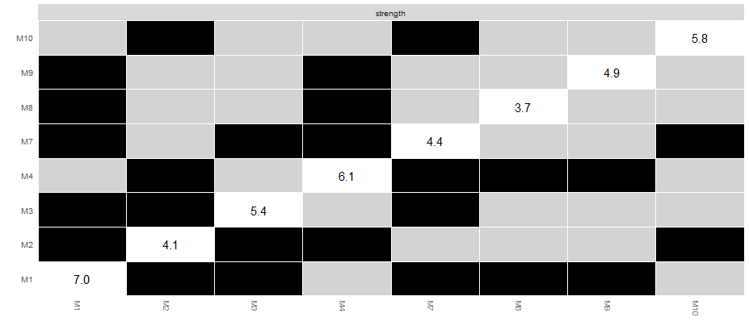
Supplement C: Strength comparison between nodes of total sample N = 899; black box = significant difference; Included symptoms: M1 = silence; M2 = reduced speech; M3 = incapacity of nonverbal communication; M4 = motor inhibition; M7 = avoidance of eye-contact; M8 = suppression of noises; M9 = avoidance of verbal situations; M10 = selectivity of speaking behavior

Supplement D
Strength comparison between nodes of subsample n = 373; black box = significant difference; and bridge strength values of symptoms of symptoms related to selective mutism (M1-M10) and 3 symptoms related to social anxiety disorder (S1-S3). Included symptoms: M1 = silence; M2 = reduced speech; M3 = incapacity of nonverbal communication; M4 = motor inhibition; M7 = avoidance of eye-contact; M8 = suppression of noises; M9 = avoidance of verbal situations; M10 = selectivity of speaking behavior; S1 = fear of performance situations, S2 = fear of interactions with unknown children, S3 = fear of interactions with unknown adults

