Supplementary File

Supplement 1. Original English version of PHQ-9

PATIENT HEALTH QUESTIONNAIRE-9
(PHQ-9)
Over the last 2 weeks, how often have you been bothered by any of the following problems? (Use “✔” to indicate your answer) | Not at all | Several days | More than half the days | Nearly every day
1. Little interest or pleasure in doing things | 0 | 1 | 2 | 3
2. Feeling down, depressed, or hopeless | 0 | 1 | 2 | 3
3. Trouble falling or staying asleep, or sleeping too much | 0 | 1 | 2 | 3
4. Feeling tired or having little energy | 0 | 1 | 2 | 3
5. Poor appetite or overeating | 0 | 1 | 2 | 3
6. Feeling bad about yourself — or that you are a failure or have let yourself or your family down | 0 | 1 | 2 | 3
7. Trouble concentrating on things, such as reading the newspaper or watching television | 0 | 1 | 2 | 3
8. Moving or speaking so slowly that other people could have noticed? Or the opposite — being so fidgety or restless that you have been moving around a lot more than usual | 0 | 1 | 2 | 3
9. Thoughts that you would be better off dead or of hurting yourself in some way | 0 | 1 | 2 | 3
FOR OFFICE CODING 0 + ______ + ______ + ______
=Total Score: ______

Supplement 2. Checklist of the ISPOR principles of translation and cross-cultural adaptation framework in this study

No | Steps | Done | Notes
1 | Preparation
 | Obtain permission to use instrument | Yes | Permitted by Van Rie and team
 | Invite instrument developer to be involved | Yes | A guidance for instrument was sent by Van Rie and team
 | Develop explanation of concepts in instrument | Yes
 | Recruit key in-country persons to the project | Yes | Invited to panel expert
2 | Forward Translation
 | Development of at least two independent forward translations | Yes | With two independent translators
 | Provision of explanation of concepts in the instrument to the key in-country persons and forward translators | Yes | Presented at expert panel meeting
3 | Reconciliation of the forward translations into a single forward translation | Yes | In this study, we used term “Consolidation”
4 | Back translation of the reconciled translation into the source language | Yes
5 | Back translation review: Review of the back translations against the source language | Yes | Done by research team
6 | Harmonization of all new translations with each other and the source version | Yes | Done by research team
7 | Cognitive debriefing of the new translation, usually with patients drawn from the target population | Yes | With 10 people with TB
8 | Review of cognitive debriefing results and finalization | Yes | Done with research team
9 | Proof reading: The finalized translation is proofread | Yes | Research team checked the final translation and corrected any remaining spelling, diacritical, grammatical, or other errors
10 | Final report: is written on the development of the translation | Yes

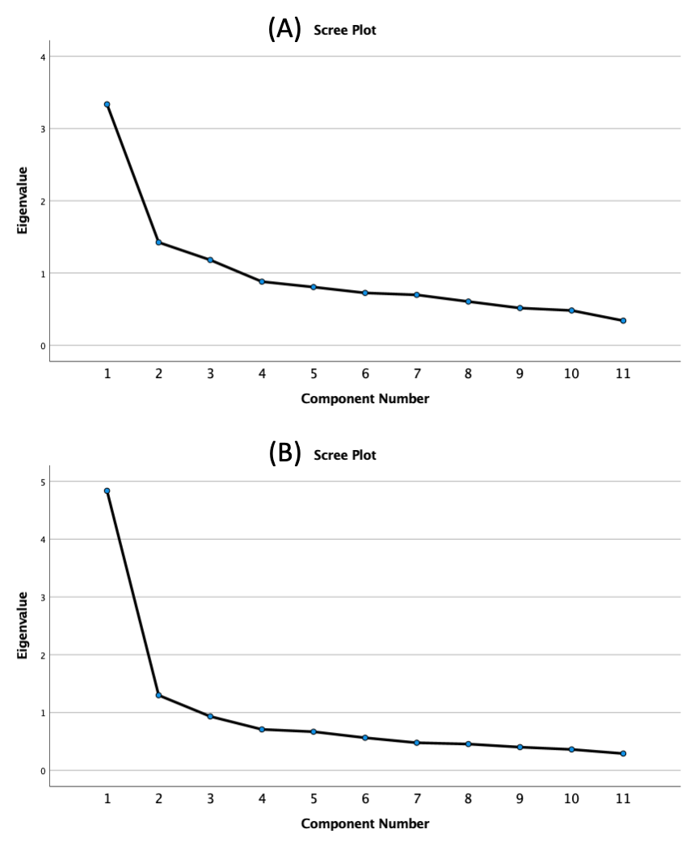
Supplement 3. Scree Plot for (A) Form A: Patient Perspective and (B) Form B: Community Perspective

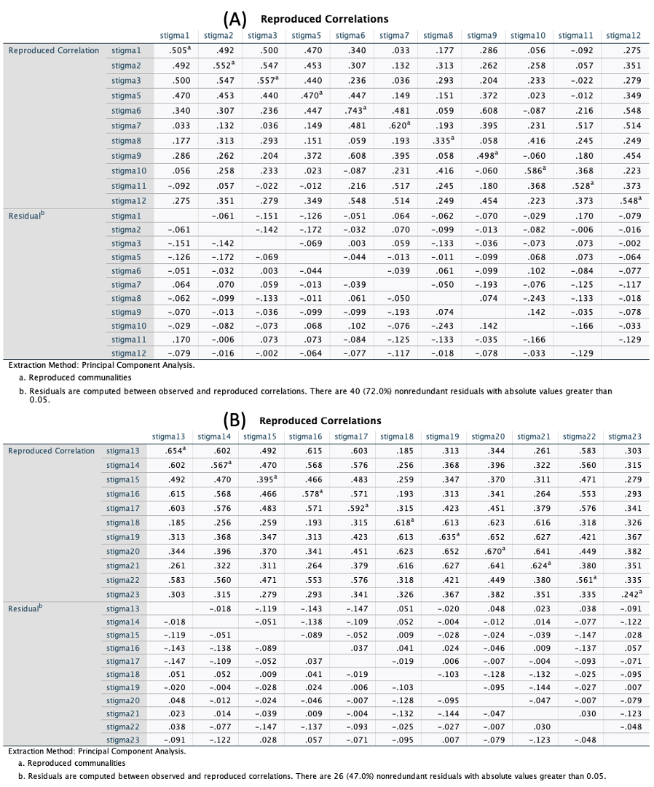

Supplement 4. Reproduced correlations for (A) Form A: Patient Perspective and (B) Form B: Community Perspective

Supplement 5. Horn’s parallel analysis

Component | Principal component analysis |  |  | Parallel analysis
Component | Initial Eigenvalues |  |  | Random Data Eigenvalues
Component | Total | % of Variance | Cumulative % | Root | Means | Percentile
Form A: Patient Perspective
1 | 3.336 | 30.328 | 30.328 | 1 | 1.273775 | 1.35177
2 | 1.425 | 12.957 | 43.285 | 2 | 1.19732 | 1.24339
3 | 1.181 | 10.740 | 54.025 | 3 | 1.133904 | 1.17004
4 | .881 | 8.013 | 62.039 | 4 | 1.084146 | 1.126101
5 | .806 | 7.330 | 69.369 | 5 | 1.038353 | 1.077054
6 | .725 | 6.595 | 75.964 | 6 | 0.993232 | 1.022189
7 | .698 | 6.348 | 82.313 | 7 | 0.947996 | 0.982078
8 | .606 | 5.509 | 87.822 | 8 | 0.905221 | 0.938285
9 | .516 | 4.691 | 92.512 | 9 | 0.859812 | 0.905595
10 | .482 | 4.386 | 96.898 | 10 | 0.809883 | 0.845185
11 | .341 | 3.102 | 100.000 | 11 | 0.756358 | 0.802062
Form B: Community Perspective
1 | 4.468 | 44.679 | 44.679 | 1 | 1.256404 | 1.32113
2 | 1.173 | 11.728 | 56.406 | 2 | 1.179502 | 1.228016
3 | .900 | 9.002 | 65.408 | 3 | 1.116668 | 1.151042
4 | .708 | 7.083 | 72.491 | 4 | 1.065396 | 1.100054
5 | .664 | 6.644 | 79.135 | 5 | 1.016058 | 1.046303
6 | .528 | 5.283 | 84.419 | 6 | 0.97068 | 1.001144
7 | .469 | 4.695 | 89.114 | 7 | 0.921546 | 0.948367
8 | .419 | 4.193 | 93.307 | 8 | 0.877029 | 0.90852
9 | .366 | 3.655 | 96.962 | 9 | 0.82924 | 0.873758
10 | .304 | 3.038 | 100.000 | 10 | 0.767477 | 0.819032
Extraction Method: Principal Component Analysis.

In Form A: Patient Perspective, the random eigen values (see ‘percentile’ column) are lower than initial Eigenvalues (see ‘total’ column) for component 1, 2, 3, then we can conclude that Form A has three loading factors.

In Form B: Community Perspective, the random eigen values (see ‘percentile’ column) are lower than initial Eigenvalues (see ‘total’ column) for component 1, we can conlude that Form B has certainly one loading factor. The second component is at borderline, but we decided to include it as the second loading factor.

Supplement 6. Average variance, composite reliability, and maximum shared variance of TB-Stigma Scale domains.

Domain |  | AVE |  | CR |  | MSV
Form A: Patient Perspective
 | Disclosure |  | 0.479 | 0.78 | 0.608
 | Isolation |  | 0.461 | 0.77 | 0.511
 | Guilt |  | 0.279 | 0.63 | 0.575
Form B: Community Perspective
 | Isolation |  | 0.511 | 0.90 | 0.638
 | Distancing |  | 0.580 | 0.84 | 0.607
AVE, average variance; CR, composite reliability; MSV, maximum shared variance

