SUPPLEMENTARY MATERIAL
Testing the Parallel Mediation Model
Parallel mediation analysis was conducted using Model 4 as provided in the PROCESS macro. The results showed that parental phubbing was related to PIU both directly and indirectly (see S Table 1 & S Figure 1). First, the pathway of “parental phubbing → parent–child relationship → PIU” was significant (indirect effect = .05, 95% CI = .01 to .10). Second, the pathway of “parental phubbing → BPNS → PIU” was significant (indirect effect = .07, 95% CI = .03 to .11).
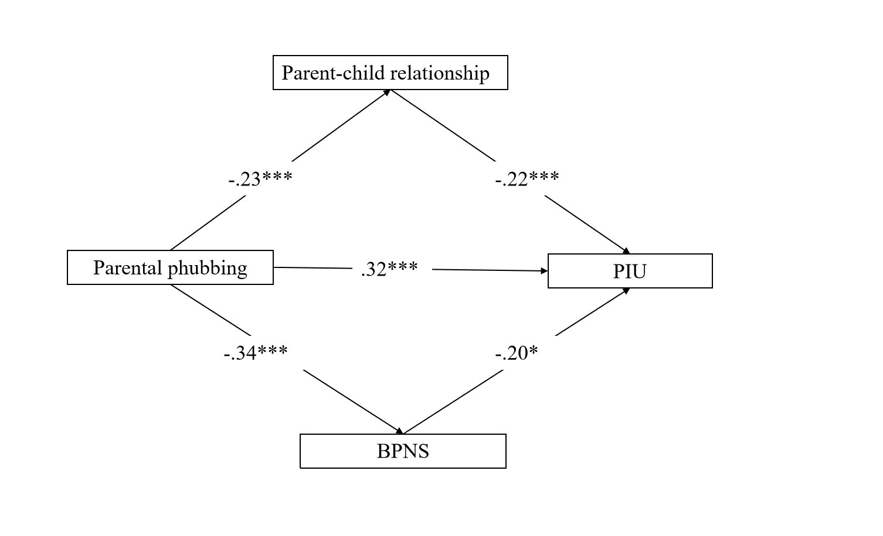
S Figure 1. The parallel mediation model. Path values show path coefficients. ***p < .001, **p < .01.
S Table 2. Testing the Pathways of the Parallel Mediation Model
Path | Point  estimate | 95% CI
Path | Point  estimate | Lower | Upper
Direct effects
Parental phubbing PIU | .32*** | .18 | .46
Parental phubbing Parent–child relationship | -.23*** | -.30 | -.15
Parent–child relationship PIU | -.22*** | -.38 | -.06
Parental phubbing BPNS | -.34*** | -.46 | -.21
BPNS PIU | -.20*** | -.30 | -.11
Indirect effects
Parental phubbing Parent–child relationship PIU | .05 | .01 | .10
Parental phubbing BPNS PIU | .07 | .03 | .11
Note. N = 495. ***p <.001.
Abbreviations. CI: Confidence Interval; PIU: Problematic Internet Use; BPNS: Basic Psychological Needs Satisfaction

