Supplementary Material
An additional repeated-measure 2(type: exact, estimation) x 2(country: China, Italy) x 2(gender: boys, girls) x 2(grade: 3, 4) ANOVA was conducted to investigate whether the patterns of performance on the two types of arithmetic tasks were different between countries, performance was analyzed in a 2(type: exact, estimation) x 2(country: China, Italy) repeated-measure ANOVA. The results for the main and interaction effects are shown in Table S. The four-way interaction effect was not significant. Thus, the two significant three-way interaction effects, as the highest order of significant effects, are interpreted as follows.
For the interaction between Country, Grade and Type, no significant difference was found between grades 3 and 4 for both exact arithmetic (p = .146, η_{p}² = .005) and arithmetic estimation tasks (p = .060, η_{p}² = .009) for Chinese children. In contrast, for Italian children, those in Grade 4 performed significantly better than those in Grade 3 for both exact arithmetic and arithmetic estimation tasks (p < .001, η_{p}² = .040 and p < .001, η_{p}² = .032, respectively). Furthermore, as shown in Figure S1, the differences between grades appeared larger on the arithmetic estimation task than on the exact arithmetic task for Chinese children, whereas Italian children performed similarly across grades on both types of arithmetic tasks.
For the interaction between Country, Gender and Type, no difference was found between boys and girls for exact arithmetic (p = .242, η_{p}² = .003), but boys performed better than girls on the arithmetic estimation (p < .001, η_{p}² = .033) for Chinese children. In contrast, for Italian children, no gender differences were found for both exact arithmetic and arithmetic estimation tasks (p = .105, η_{p}² = .007 and p = .185, η_{p}² = .004, respectively). As shown in Figure S2, gender differences were present only in exact arithmetic for the Chinese children.
Table S
Results for the Repeated Measures ANOVA
Main Effects | F (1, 396) | MSE | p | η_{p}²
Type (Exact vs. Estimation) | 302.67*** | 3.30 | <.001 | .433
Country (China vs. Italy) | 449.82*** | 22.43 | <.001 | .532
Gender (Boys vs. girls) | 0.92 | .05 | .339 | .002
Grade (4 vs. 6) | 8.96** | .45 | .003 | .022
Two-way Interaction Effects
Country x Grade | 6.68* | 0.33 | .010 | .017
Country x Gender | 9.63** | 0.48 | .002 | .024
Grade x Gender | 0.02 | <0.01 | .883 | <.001
Type x Country | 127.14*** | 1.39 | <.001 | .243
Type x Grade | 7.42** | 0.08 | .007 | .018
Type x Gender | 6.21* | 0.07 | .013 | .015
Three-way Interaction Effects
Country x Grade x Gender | 0.07 | <.01 | .799 | <.001
Country x Grade x Type | 10.35** | 0.11 | .001 | .025
Country x Gender x Type | 4.45* | 0.05 | .036 | .011
Grade x Gender x Type | 1.20 | 0.01 | .273 | .003
Four-way Interaction Effect
Country x Grade x Gender x Type | 1.09 | 0.01 | .298 | .003
* p < .05; ** p < .01; *** p < .001

Figure S1
Significant Interaction Between Country, Grade and Type of Arithmetic Tasks
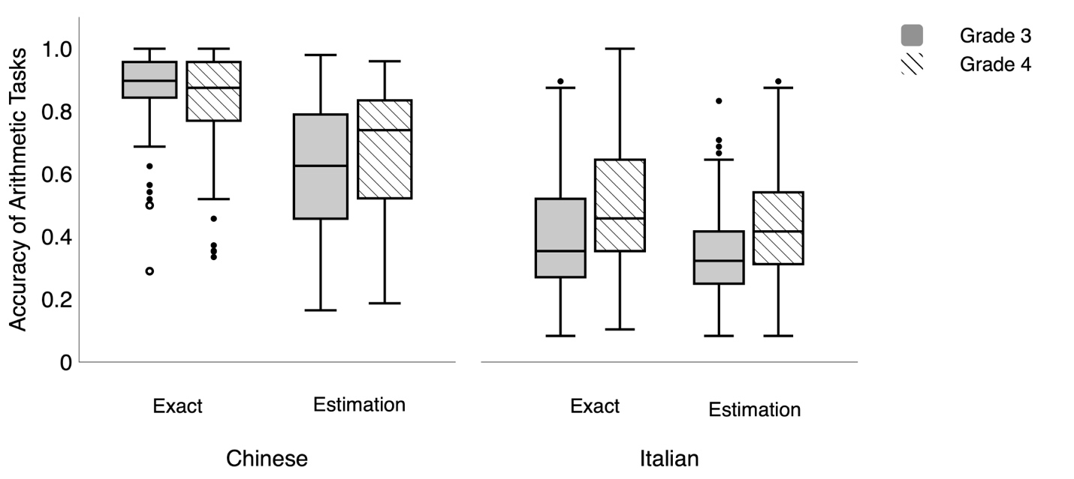
Note. The boxplots represent the quartiles of accuracy for arithmetic tasks. The upper and lower bars of the box represent the 75th and 25th percentiles, respectively. The line within the box indicates the median.

Figure S2
Significant Interaction Between Country, Gender and Type of Arithmetic Tasks
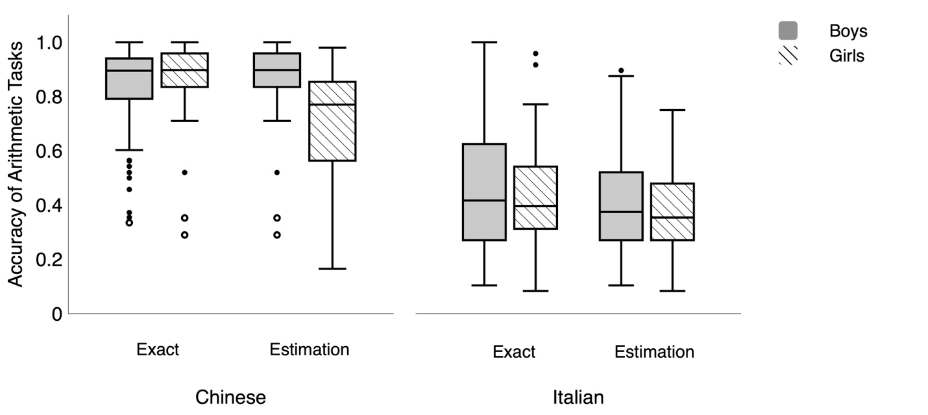
Note. The boxplots represent the quartiles of accuracy for arithmetic tasks. The upper and lower bars of the box represent the 75th and 25th percentiles, respectively. The line within the box indicates the median.

