Supplementary Table 1. COVID-19 and treatment related variables 3
Supplementary Table 2. Fixed effect estimates in the univariate Linear Mixed Model 4
Supplementary Table 3. Fixed effect estimates in the multivariable Linear Mixed Model 5
Supplementary Figure 1. Ridgeline plots depicting the participants‘ coping responses score distribution at baseline and follow-up measurements 6
Multiple Imputation & Sensitivity Analysis Procedure 7
Multiple Imputation & Sensitivity Analysis Results 7
Supplementary Figure 2. Pie chart depicting complete and incomplete data with respect to cases and values 8
Supplementary Table 4. Possible predictors of missing data - results of multivariable logistic regression analysis 9
Supplementary Table 5. Number of missing data regarding Brief COPE and BSCL at baseline (t0) and follow-ups (t1 & t2) 10
Supplementary Figure 3a. Line chart depicting the imputed mean values of BSCL and Brief COPE questionnaires as a function of iteration number and imputation number 11
Supplementary Figure 3b. Line chart depicting the imputed mean values of BSCL and Brief COPE questionnaires as a function of iteration number and imputation number 12
Supplementary Figure 3c. Line chart depicting the imputed mean values of BSCL and Brief COPE questionnaires as a function of iteration number and imputation number 13
Supplementary Figure 3d. Line chart depicting the imputed mean values of BSCL and Brief COPE questionnaires as a function of iteration number and imputation number 14
Supplementary Figure 3e. Line chart depicting the imputed mean values of BSCL and Brief COPE questionnaires as a function of iteration number and imputation number 15
Supplementary Table 6. Pooled estimates of fixed effects in the univariate Linear Mixed Model after multiple imputation procedure 16
Supplementary Table 7. Pooled estimates of fixed effects in the multivariable Linear Mixed Model after multiple imputation procedure 17
Supplementary Table 8. Exposure and propensity to violence separated by men and women 18
Supplementary Table 9. Means, and standard deviations of BSCL scales at baseline (t0) and follow-up (t1 & t2) for men and women 18
Supplementary Table 10. Means, and standard deviations of Brief COPE scales at baseline (t0) and follow-up (t1 & t2) for men and women 18
Supplementary Table 11. Means, and standard deviations of BSCL scales at baseline (t0) and follow-up (t1 & t2) for Tyrol and South-Tyrol 19
Supplementary Table 12. Means, and standard deviations of Brief COPE scales at baseline (t0) and follow-up (t1 & t2) for Tyrol and South-Tyrol 19
References 20

Supplementary Table 1. COVID-19 and treatment related variables
Variable | Measurement | N (%) | Statistics† | Effect size§ | p-value
Exposed to increased violence since the outbreak of the COVID-19 pandemic | t₀  t₁  t₂ | 19/ 598 (3.2%)  24/ 566 (4.2%)  33/ 527 (6.3%) | 9 / (9+12)  10 / (10+20)  9 / (9+20) | 0.07  0.17  0.19 | t₀-t_{1:} 0.6642  t₀-t_{2:} 0.1000  t₁-t_{2:} 0.0631
Propensity for violence has increased since the outbreak of the COVID-19 pandemic | t₀  t₁  t₂ | 73/ 598 (12.2%)  89/ 566 (15.7%)  98/ 527 (18.6%) | χ²(1) = 0.24  χ²(1) = 5.96  χ²(1) = 3.31 | 0.04  0.15  0.12 | t₀-t_{1:} 0.6254  t₀-t_{2:} 0.0152‡  t₁-t_{2:} 0.0690
Severe physical health problems (e.g. diabetes, cancer, etc.) | t₀  t₁  t₂ | 49/ 598 (8.2%)  43/ 566 (7.6%)  49/ 527 (9.3%) | 16 / (16+16)  12 / (12+14)  10 / (10+13) | < 0.01  0.04  0.07 | t₀-t_{1:} >0.9999  t₀-t_{2:} 0.8454  t₁-t_{2:} 0.6783
Current treatment due to mental health disorder | t₀  t₁  t₂ | 44/598 (7.4%)  43/566 (7.6%)  41/527 (7.8%) | 14 / (14+16)  14 / (14+15)  14 / (14+11) | 0.03  0.02  0.06 | t₀-t_{1:} 0.8551  t₀-t_{2:} >0.9999  t₁-t_{2:} 0.6900
Psychological/ psychotherapeutic treatment | t₀  t₁  t₂ | 23/44 (52.3%)  30/43 (69.8%)  31/41 (75.6%) | 1 / (1+1)  3 / (3+1)  2 / (2+1) | < 0.01  0.25  0.17 | t₀-t_{1:} >0.9999  t₀-t_{2:} 0.6254  t₁-t_{2:} >0.9999
Psychiatric treatment (outside a hospital) | t₀  t₁  t₂ | 19/44 (43.2%)  22/43 (51.2%)  18/41 (43.9%) | 1 / (1+2)  1 / (1+2)  1 / (1+3) | 0.17  0.17  0.25 | t₀-t_{1:} >0.9999  t₀-t_{2:} >0.9999  t₁-t_{2:} 0.6254
Psychiatric treatment (outpatient unit of a hospital) | t₀  t₁  t₂ | 3/44 (6.8%)  6/43 (14.0%)  5/41 (12.2%) | 0 / (0+1)  0 / (0+1)  1 / (1+1) | ~ 0.50  ~ 0.50  < 0.01 | t₀-t_{1:} >0.9999  t₀-t_{2:} >0.9999  t₁-t_{2:} >0.9999
General practitioner | t₀  t₁  t₂ | 8/44 (18.2%)  3/43 (7.0%)  7/41 (17.1%) | 0 / (0+3)  4 / (4+1)  5 / (5+0) | ~ 0.50  0.30  ~ 0.50 | t₀-t_{1:} 0.2500  t₀-t_{2:} 0.3753  t₁-t_{2:} 0.0631
Care facility (work) | t₀  t₁  t₂ | 0/44 (-)  2/43 (4.7%)  1/41 (2.4%) | - | - | -
Care facility (living) | t₀  t₁  t₂ | 1/44 (2.3%)  0/43 (-)  0/41 (-) | - | - | -
† For the McNemar test a χ² distribution was used, when the number of observations was at least n=35. Else the binomial distribution was used and the cell counts for the 2x2 table in the form of (b/(b + c)) were reported.
‡ Remains statistically significant (α=0.05) after Benjamini-Hochberg correction
§ Cohen’s g is calculated with |(b/(b + c)) – 0.5|

Supplementary Table 2. Fixed effect estimates in the univariate Linear Mixed Model
Model | Coping response | Estimate | S.E. | df | t | 95% CI (Estimate) |  | p-value
 |  |  |  |  |  | LB | UB | p-value
M1.1 | Acceptance | -5.174 | 0.730 | 871 | -7.084 | -6.608 | -3.741 | <0.0001
M2.1 | Acceptance (t0) | -4.637 | 1.034 | 867 | -4.454 | -6.667 | -2.607 | <0.0001
M2.1 | Acceptance (t1 vs. t0) | -0.818 | 1.262 | 867 | -0.648 | -3.296 | 1.659 | 0.5169
M2.1 | Acceptance (t2 vs. t0) | -0.612 | 1.282 | 867 | -0.477 | -3.128 | 1.904 | 0.6333
M1.2 | Active coping | -3.999 | 0.777 | 871 | -5.147 | -5.524 | -2.474 | <0.0001
M2.2 | Active coping (t0) | -2.970 | 1.091 | 867 | -2.723 | -5.110 | -0.829 | 0.0066
M2.2 | Active coping (t1 vs. t0) | -0.528 | 1.347 | 867 | -0.392 | -3.172 | 2.116 | 0.6952
M2.2 | Active coping (t2 vs. t0) | -2.360 | 1.426 | 867 | -1.655 | -5.158 | 0.438 | 0.0983
M1.3 | Behavioural disengagement | 9.008 | 0.874 | 871 | 10.302 | 7.292 | 10.724 | <0.0001
M2.3 | Behavioural disengagement (t0) | 11.308 | 1.338 | 867 | 8.450 | 8.681 | 13.935 | <0.0001
M2.3 | Behavioural disengagement (t1 vs. t0) | -2.275 | 1.626 | 867 | -1.399 | -5.465 | 0.916 | 0.1621
M2.3 | Behavioural disengagement (t2 vs. t0) | -3.811 | 1.701 | 867 | -2.240 | -7.150 | -0.420 | 0.0253
M1.4 | Denial | 12.647 | 0.902 | 871 | 14.021 | 10.876 | 14.417 | <0.0001
M2.4 | Denial (t0) | 14.031 | 1.281 | 867 | 10.951 | 11.517 | 16.546 | <0.0001
M2.4 | Denial (t1 vs. t0) | -0.191 | 1.618 | 867 | -0.118 | -3.366 | 2.985 | 0.9063
M2.4 | Denial (t2 vs. t0) | -4.166 | 1.637 | 867 | -2.545 | -7.379 | -0.953 | 0.0111
M1.5 | Emotional support | -3.378 | 0.775 | 871 | -4.361 | -4.899 | -1.858 | <0.0001
M2.5 | Emotional support (t0) | -2.899 | 1.048 | 867 | -2.767 | -4.955 | -0.842 | 0.0058
M2.5 | Emotional support (t1 vs. t0) | -0.171 | 1.231 | 867 | -0.139 | -2.586 | 2.245 | 0.8896
M2.5 | Emotional support (t2 vs. t0) | -1.432 | 1.292 | 867 | -1.108 | -3.968 | 1.120 | 0.2680
M1.6 | Humour | -3.217 | 0.782 | 871 | -4.115 | -4.751 | -1.683 | <0.0001
M2.6 | Humour (t0) | -3.861 | 1.024 | 867 | -3.771 | -5.871 | -1.851 | 0.0002
M2.6 | Humour (t1 vs. t0) | 2.074 | 1.221 | 867 | 1.698 | -0.323 | 4.472 | 0.0898
M2.6 | Humour (t2 vs. t0) | 0.650 | 1.224 | 867 | 0.531 | -1.753 | 3.053 | 0.5957
M1.7 | Informational support | -1.104 | 0.745 | 871 | -1.482 | -2.566 | 0.358 | 0.1386
M2.7 | Informational support (t0) | -0.030 | 1.009 | 867 | -0.030 | -2.011 | 1.951 | 0.9762
M2.7 | Informational support (t1 vs. t0) | -0.902 | 1.204 | 867 | -0.750 | -3.266 | 1.460 | 0.4536
M2.7 | Informational support (t2 vs. t0) | -2.365 | 1.279 | 867 | -1.849 | -4.875 | 0.144 | 0.0647
M1.8 | Planning | 0.113 | 0.786 | 871 | 0.144 | -1.429 | 1.655 | 0.8856
M2.8 | Planning (t0) | 0.775 | 1.102 | 867 | 0.703 | -1.388 | 2.938 | 0.4821
M2.8 | Planning (t1 vs. t0) | 0.709 | 1.381 | 867 | 0.513 | -2.001 | 3.419 | 0.6079
M2.8 | Planning (t2 vs. t0) | -2.922 | 1.400 | 867 | -2.086 | -5.670 | -0.1733 | 0.0372
M1.9 | Positive reframing | -6.692 | 0.759 | 871 | -8.816 | -8.181 | -5.202 | <0.0001
M2.9 | Positive reframing (t0) | -6.673 | 1.021 | 867 | -6.539 | -8.676 | -4.670 | <0.0001
M2.9 | Positive reframing (t1 vs. t0) | 0.608 | 1.259 | 867 | 0.483 | -1.863 | 3.079 | 0.6293
M2.9 | Positive reframing (t2 vs. t0) | -1.060 | 1.301 | 867 | -0.815 | -3.613 | 1.494 | 0.4155
M1.10 | Religion | -0.136 | 0.910 | 871 | -0.149 | -1.921 | 1.650 | 0.8816
M2.10 | Religion (t0) | -0.921 | 1.091 | 867 | -0.844 | -3.061 | 1.220 | 0.3988
M2.10 | Religion (t1 vs. t0) | 1.247 | 1.129 | 867 | 1.105 | -0.968 | 3.462 | 0.2695
M2.10 | Religion (t2 vs. t0) | 1.455 | 1.205 | 867 | 1.208 | -0.909 | 3.819 | 0.2274
M1.11 | Self-blame | 12.185 | 0.747 | 871 | 16.304 | 10.718 | 13.652 | <0.0001
M2.11 | Self-blame (t0) | 13.302 | 1.028 | 867 | 12.946 | 11.286 | 15.319 | <0.0001
M2.11 | Self-blame (t1 vs. t0) | -1.448 | 1.242 | 867 | -1.166 | -3.885 | 0.989 | 0.2438
M2.11 | Self-blame (t2 vs. t0) | -1.909 | 1.259 | 867 | -1.516 | -4.381 | 0.562 | 0.1299
M1.12 | Self-distraction | 2.059 | 0.784 | 871 | 2.625 | 0.520 | 3.599 | 0.0088
M2.12 | Self-distraction (t0) | 2.139 | 1.060 | 867 | 2.019 | 0.059 | 4.219 | 0.0438
M2.12 | Self-distraction (t1 vs. t0) | 0.964 | 1.368 | 867 | 0.705 | -1.721 | 3.649 | 0.4812
M2.12 | Self-distraction (t2 vs. t0) | -1.895 | 1.431 | 867 | -1.325 | -4.704 | 0.913 | 0.1857
M1.13 | Substance use | 15.221 | 0.990 | 871 | 15.376 | 13.278 | 17.164 | <0.0001
M2.13 | Substance use (t0) | 14.588 | 1.239 | 867 | 11.770 | 12.155 | 17.021 | <0.0001
M2.13 | Substance use (t1 vs. t0) | 1.907 | 1.319 | 867 | 1.446 | -0.681 | 4.495 | 0.1485
M2.13 | Substance use (t2 vs. t0) | -0.380 | 1.378 | 867 | -0.276 | -3.084 | 2.324 | 0.7828
M1.14 | Venting | 1.433 | 0.823 | 871 | 1.741 | -0.182 | 3.047 | 0.0820
M2.14 | Venting (t0) | 3.157 | 1.118 | 867 | 2.823 | 0.962 | 5.352 | 0.0049
M2.14 | Venting (t1 vs. t0) | -1.649 | 1.343 | 867 | -1.227 | -4.285 | 0.988 | 0.2200
M2.14 | Venting (t2 vs. t0) | -4.050 | 1.411 | 867 | -2.872 | -6.819 | -1.282 | 0.0042
Abbreviations. CI=confidence interval; S.E.=standard error; df=degree of freedom; LB=lower bound; UB=upper bound; M1=univariate model, including each coping response separately; M2=univariate model, including the interaction with time and each coping response separately
Linear mixed model specifications: Independent variable = coping response; dependent variable = psychological distress; covariates = age, gender, residence;
Participants were considered subjects, time of assessment as factor. Parameter estimates are based on the restricted maximum likelihood (REML) method. The variance-covariance structure of the random effects was specified as unstructured (UN), the variance-covariance structure of the within-group residuals (time) was specified as first-order autoregressive (AR1)

Supplementary Table 3. Fixed effect estimates in the multivariable Linear Mixed Model
Model | Coping response | Estimate | S.E. | df | t | 95% CI (Estimate) |  | p-value
 |  |  |  |  |  | LB | UB | p-value
M3 | Acceptance | -2.636 | 0.680 | 862 | -3.875 | -3.972 | -1.301 | 0.0001
M4 | Acceptance (t0) | -2.126 | 1.020 | 840 | -2.084 | -4.129 | -0.124 | 0.0374
M4 | Acceptance (t1 vs. t0) | 1.172 | 1.305 | 840 | 0.898 | -1.386 | 3.730 | 0.3696
M4 | Acceptance (t2 vs. t0) | 0.252 | 1.350 | 840 | 0.187 | -2.398 | 2.902 | 0.8520
M3 | Active coping | -3.650 | 0.755 | 862 | -4.834 | -5.132 | -2.168 | <0.0001
M4 | Active coping (t0) | -3.465 | 1.172 | 840 | -2.955 | -5.766 | -1.164 | 0.0032
M4 | Active coping (t1 vs. t0) | 1.162 | 1.561 | 840 | 0.745 | -1.901 | 4.225 | 0.4566
M4 | Active coping (t2 vs. t0) | -0.826 | 1.603 | 840 | -0.515 | -3.972 | 2.320 | 0.6064
M3 | Behavioural disengagement | 4.715 | 0.804 | 862 | 5.863 | 3.137 | 6.294 | <0.0001
M4 | Behavioural disengagement (t0) | 5.963 | 1.310 | 840 | 4.55 | 3.392 | 8.535 | <0.0001
M4 | Behavioural disengagement (t1 vs. t0) | 2.066 | 1.663 | 840 | 1.242 | -1.193 | 5.325 | 0.2145
M4 | Behavioural disengagement (t2 vs. t0) | -0.922 | 1.710 | 840 | -0.539 | -4.278 | 2.434 | 0.5898
M3 | Denial | 6.577 | 0.877 | 862 | 7.503 | 4.857 | 8.297 | <0.0001
M4 | Denial (t0) | 7.291 | 1.365 | 840 | 5.339 | 4.611 | 9.971 | 0.0001
M4 | Denial (t1 vs. t0) | 1.203 | 1.779 | 840 | 0.676 | -2.289 | 4.696 | 0.4991
M4 | Denial (t2 vs. t0) | -3.533 | 1.829 | 840 | -1.932 | -7.123 | 0.056 | 0.0537
M3 | Emotional support | -3.106 | 0.717 | 862 | -4.329 | -4.514 | -1.698 | <0.0001
M4 | Emotional support (t0) | -3.413 | 1.020 | 840 | 3.346 | -5.415 | -1.411 | 0.0009
M4 | Emotional support (t1 vs. t0) | 0.481 | 1.236 | 840 | 0.390 | -1.944 | 2.907 | 0.6969
M4 | Emotional support (t2 vs. t0) | -0.178 | 1.318 | 840 | -0.135 | -2.765 | 2.409 | 0.8925
M3 | Humour | -1.105 | 0.710 | 862 | -1.557 | -2.499 | 0.288 | 0.1199
M4 | Humour (t0) | -1.338 | 0.967 | 840 | -1.383 | -3.237 | 0.561 | 0.1671
M4 | Humour (t1 vs. t0) | 0.965 | 1.196 | 840 | 0.806 | -1.383 | 3.313 | 0.4203
M4 | Humour (t2 vs. t0) | 0.305 | 1.244 | 840 | 0.245 | -2.137 | 2.747 | 0.8063
M3 | Positive reframing | -3.008 | 0.765 | 862 | -3.932 | -4.509 | -1.507 | 0.0001
M4 | Positive reframing (t0) | -3.008 | 1.112 | 840 | 2.704 | -5.191 | -0.825 | 0.0070
M4 | Positive reframing (t1 vs. t0) | -0.004 | 1.506 | 840 | -0.002 | -2.959 | 2.952 | 0.9980
M4 | Positive reframing (t2 vs. t0) | -1.042 | 1.557 | 840 | -0.670 | -4.098 | 2.010 | 0.5033
M3 | Self-blame | 8.987 | 0.715 | 862 | 12.569 | 7.583 | 10.390 | <0.0001
M4 | Self-blame (t0) | 9.317 | 1.044 | 840 | 8.921 | 7.267 | 11.367 | <0.0001
M4 | Self-blame (t1 vs. t0) | -1.021 | 1.325 | 840 | -0.771 | -3.623 | 1.580 | 0.4410
M4 | Self-blame (t2 vs. t0) | 0.416 | 1.326 | 840 | 0.314 | -2.186 | 3.019 | 0.7536
M3 | Self-distraction | 3.487 | 0.688 | 862 | 5.068 | 2.139 | 4.835 | <0.0001
M4 | Self-distraction (t0) | 4.399 | 1.082 | 840 | 4.065 | 2.275 | 6.523 | 0.0001
M4 | Self-distraction (t1 vs. t0) | -1.389 | 1.402 | 840 | 0.990 | -4.142 | 1.364 | 0.3222
M4 | Self-distraction (t2 vs. t0) | -2.133 | 1.484 | 840 | 1.437 | -5.047 | 0.780 | 0.1510
M3 | Substance use | 10.239 | 0.810 | 862 | 12.641 | 8.651 | 11.827 | <0.0001
M4 | Substance use (t0) | 9.745 | 1.203 | 840 | 8.101 | 7.384 | 12.107 | <0.0001
M4 | Substance use (t1 vs. t0) | 1.156 | 1.391 | 840 | 0.832 | -1.573 | 3.886 | 0.4059
M4 | Substance use (t2 vs. t0) | 0.191 | 1.424 | 840 | 0.134 | -2.600 | 2.982 | 0.8932
Abbreviations. CI=confidence interval; S.E.=standard error; df=degree of freedom; LB=lower bound; UB=upper bound; M3=multivariable model, including the combined effect of coping responses; M4=multivariable model, including the interaction with time and coping responses
Linear mixed model specifications: independent variable = coping responses; dependent variable = psychological distress; covariates: age, gender, residence;
Participants were considered subjects, time of assessment as factor. Parameter estimates are based on the restricted maximum likelihood (REML) method. The variance-covariance structure of the random effects was specified as unstructured (UN), the variance-covariance structure of the within-group residuals (time) was specified as first-order autoregressive (AR1)
Note. In both models the following independent variables were excluded due to non-significant results in the univariate analysis: Informational support, planning, religion, and venting

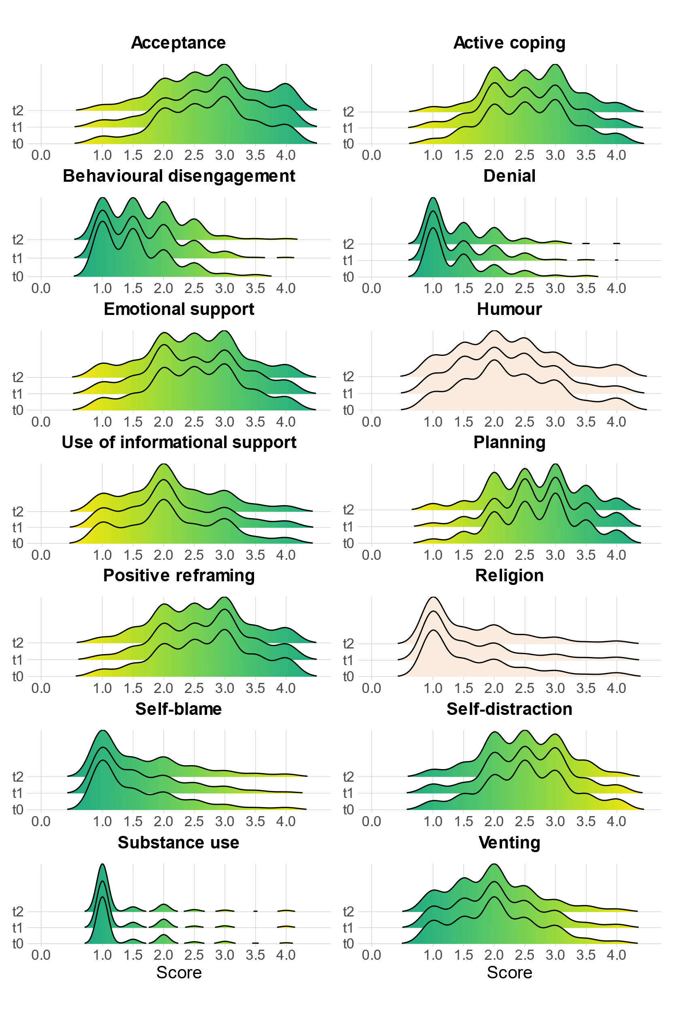
Supplementary Figure 1. Ridgeline plots depicting the participants‘ coping responses score distribution at baseline and follow-up measurements
Abbreviations. t0 = Baseline measurement; t1, t2 = Follow-up measurement
Note. The colour gradient indicates in which direction (higher or lower scores) the coping response must be pronounced to be considered favourable or unfavourable. Green colour represents favourable coping, whereas yellow colour can be considered as rather unfavourable coping. Humour and religion are considered neutral coping styles.

Multiple Imputation & Sensitivity Analysis Procedure
To evaluate the robustness of the main analysis’ results, we compared the primary sample (n=1691) with the sample that underwent multiple imputation for missing data (n=2472). Initially, a multivariable logistic regression has been conducted, including age, gender, residence, relationship status, severe physical illness and treatment due to mental health disorder as independent variables and information about missing / non-missing data as dependent variable. Next, Little’s MCAR test (Little, 1988) was used to analyse if the data is missing completely at random.
Thereafter, the fully conditional specification (FCS) technique has been employed. This iterative Markov chain Monte Carlo (MCMC) method uses a series of conditional imputation models to specify the multivariate model. The advantage of this approach is that no joint distributional assumptions have to be made (van Buuren, 2007, 2018). For metric variables, predictive mean matching (PMM) was selected as the imputation model type, ensuring that missing values are imputed reasonably. This is done by using complete cases whose predicted mean values are closest to the predicted value for the incomplete case. Thus, if the normality assumption is violated, as in the case of skewed data, PMM might be more suitable than the standard linear regression approach (Horton & Lipsitz, 2001).
The predictor variables incorporated in the analysis encompassed age, gender, relationship status, residence, severe physical illness, treatment due to mental health disorder, and available Brief COPE and BSCL questionnaire scores. Missing values were imputed into the latter both. The minimum and maximum value for the imputed numbers was specified according to the potential scale range of the respective variable. The number of maximum parameters and case draws was set to 10,000. For practical model building purposes the initial number of imputations was established at m = 5, hereafter incrementally increasing to m = 30, which approximately represented the average percentage of missing values in our dataset (von Hippel, 2009). The maximum number of iterations per imputation was capped at 100.
To ascertain successful convergence of the imputation model, a visual inspection was performed. This involved plotting (line chart) the number of iterations against means of the imputed data. Convergence was evidenced by the absence of distinct trends or divergent streams. Imputed data validity was evaluated through graphical presentations and descriptive statistics. Following Rubin's rules (Rubin, 1987), the data underwent separate analyses and was subsequently pooled to generate final estimates.

Multiple Imputation & Sensitivity Analysis Results
Initially, variables that had undergone the multiple imputation procedure, were analyzed for missingness. Supplementary Figure 2 shows the incomplete data when split according to cases and values. The number of missing data within the coping responses and psychological distress variables is depicted in the Supplementary Table 5. Across all measurements, on average 30% of the values within the Brief COPE and BSCL questionnaire are missing. In total, 61% of all cases had missing data.
According to the results of the multivariable logistic regression, none of the included variables predicted missingness (Supplementary Table 4). Results of the conducted Little’s MCAR was not statistically significant (χ²=1328.2, df= 1399, p=0.9110).
Starting with converging five imputations, the multiple imputation procedure could steadily be expanded up to the planned 30 imputations. Successful convergence of the imputation models was checked by line charts, plotting the number of iterations against the mean values of the imputed data (Supplementary Figure 3a-e). Regarding psychological distress, convergence was obtained after 5-10 iterations, meaning there was no separation of streams or definite trend. Similar results could be observed concerning the imputation models for the coping responses.
Based on the data sets generated by multiple imputation (data entries: n=2472), pooled estimates for the linear mixed models could then be derived (Supplementary Table 6 and 7) and compared to the models with complete data (data entries: n=1691).

Supplementary Figure 2. Pie chart depicting complete and incomplete data with respect to cases and values
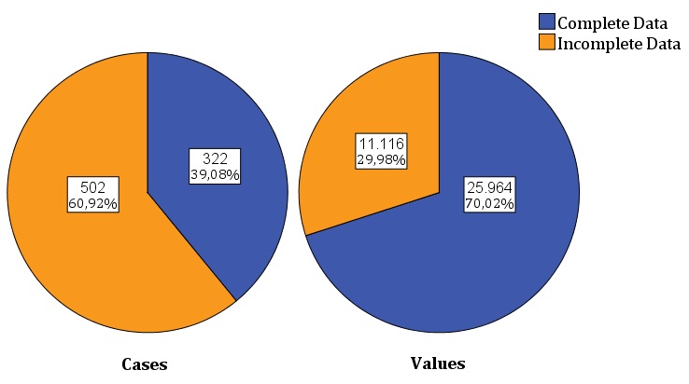

Supplementary Table 4. Possible predictors of missing data - results of multivariable logistic regression analysis
Abbreviations. df= degree of freedom; S.E. = standard error; OR = odds ratio

Supplementary Table 5. Number of missing data regarding Brief COPE and BSCL at baseline (t0) and follow-ups (t1 & t2)
Variable | Measurement | Missing  N (%)
COPE - Acceptance | t₀  t₁  t₂ | 208/824 (25.2%)  244/824 (29.6%)  288/824 (35.0%)
COPE - Active coping | t₀  t₁  t₂ | 206/824 (25.0%)  242/824 (29.4%)  289/824 (35.1%)
COPE - Behavioural disengagement | t₀  t₁  t₂ | 210/824 (25.5%)  243/824 (29.5%)  289/824 (35.1%)
COPE - Denial | t₀  t₁  t₂ | 210/824 (25.5%)  245/824 (29.7%)  287/824 (34.8%)
COPE - Emotional support | t₀  t₁  t₂ | 209/824 (25.4%)  244/824 (29.6%)  288/824 (35.0%)
COPE - Humour | t₀  t₁  t₂ | 208/824 (25.2%)  244/824 (29.6%)  288/824 (35.0%)
COPE - Informational support | t₀  t₁  t₂ | 208/824 (25.2%)  244/824 (29.6%)  288/824 (35.0%)
COPE - Planning | t₀  t₁  t₂ | 210/824 (25.5%)  245/824 (29.7%)  288/824 (35.0%)
COPE - Positive reframing | t₀  t₁  t₂ | 210/824 (25.5%)  245/824 (29.7%)  287/824 (34.8%)
COPE - Religion | t₀  t₁  t₂ | 209/824 (25.4%)  244/824 (29.6%)  289/824 (35.1%)
COPE - Self-blame | t₀  t₁  t₂ | 209/824 (25.4%)  243/824 (29.5%)  288/824 (35.0%)
COPE - Self-distraction | t₀  t₁  t₂ | 207/824 (25.1%)  243/824 (29.5%)  289/824 (35.1%)
COPE - Substance use | t₀  t₁  t₂ | 206/824 (25.0%)  242/824 (29.4%)  285/824 (34.6%)
COPE - Venting | t₀  t₁  t₂ | 212/824 (25.7%)  246/824 (29.9%)  289/824 (35.1%)
BSCL - Global Severity Index | t₀  t₁  t₂ | 213/824 (25.8%)  247/824 (30.0%)  288/824 (35.0%)

Supplementary Figure 3a. Line chart depicting the imputed mean values of BSCL and Brief COPE questionnaires as a function of iteration number and imputation number
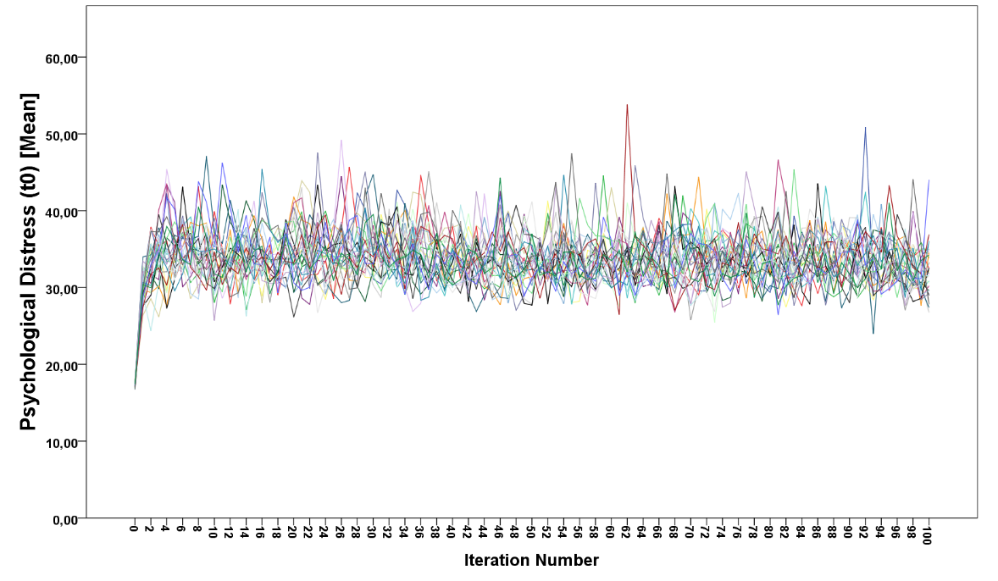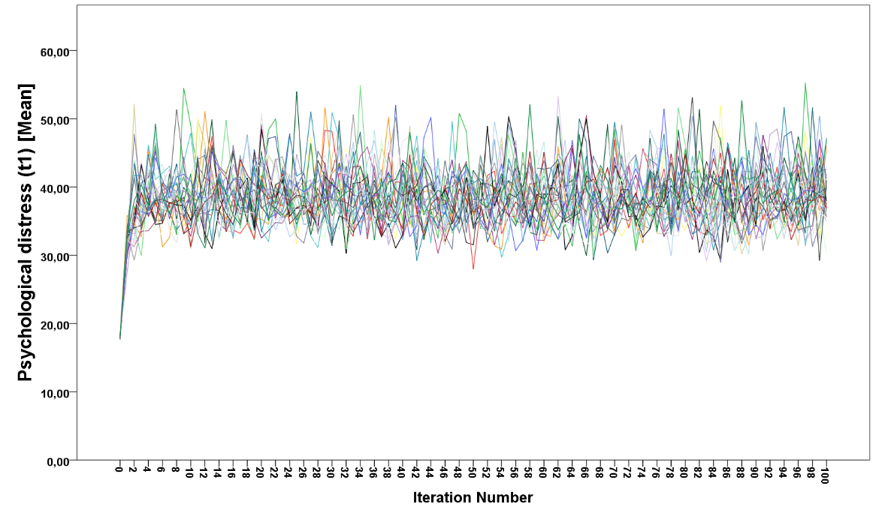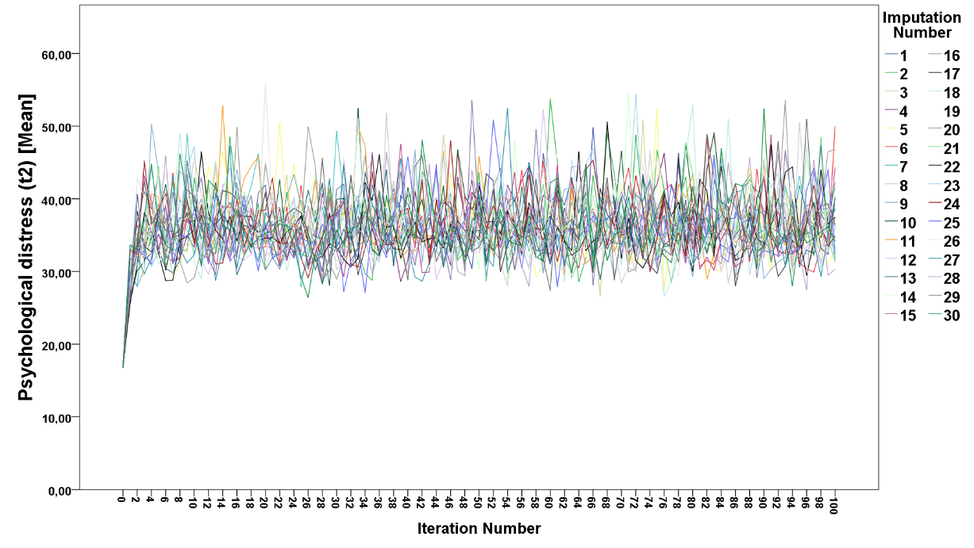
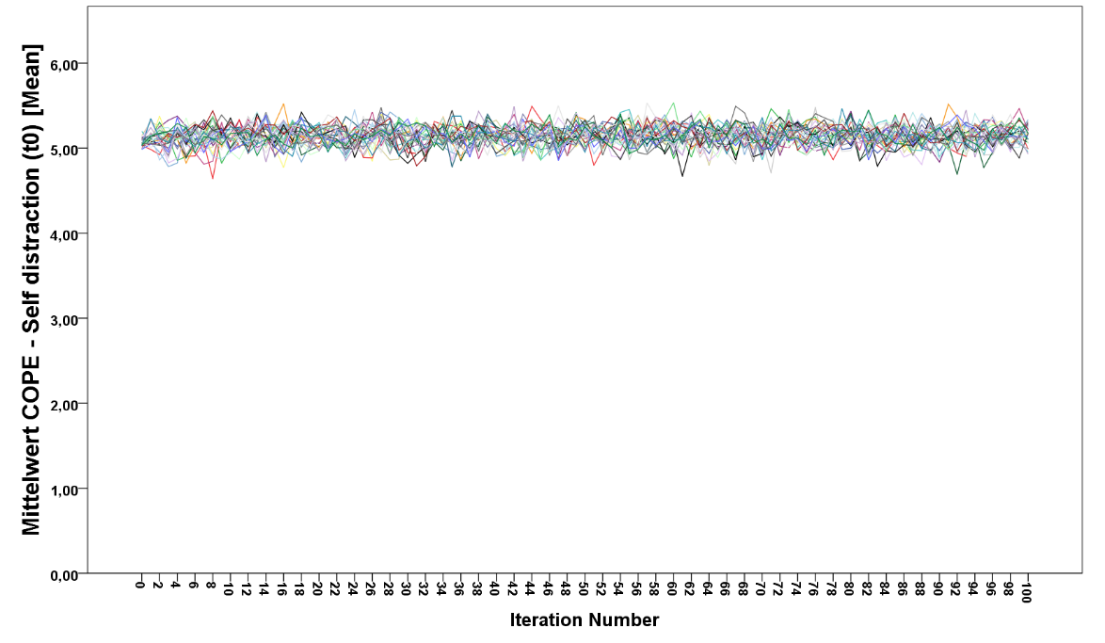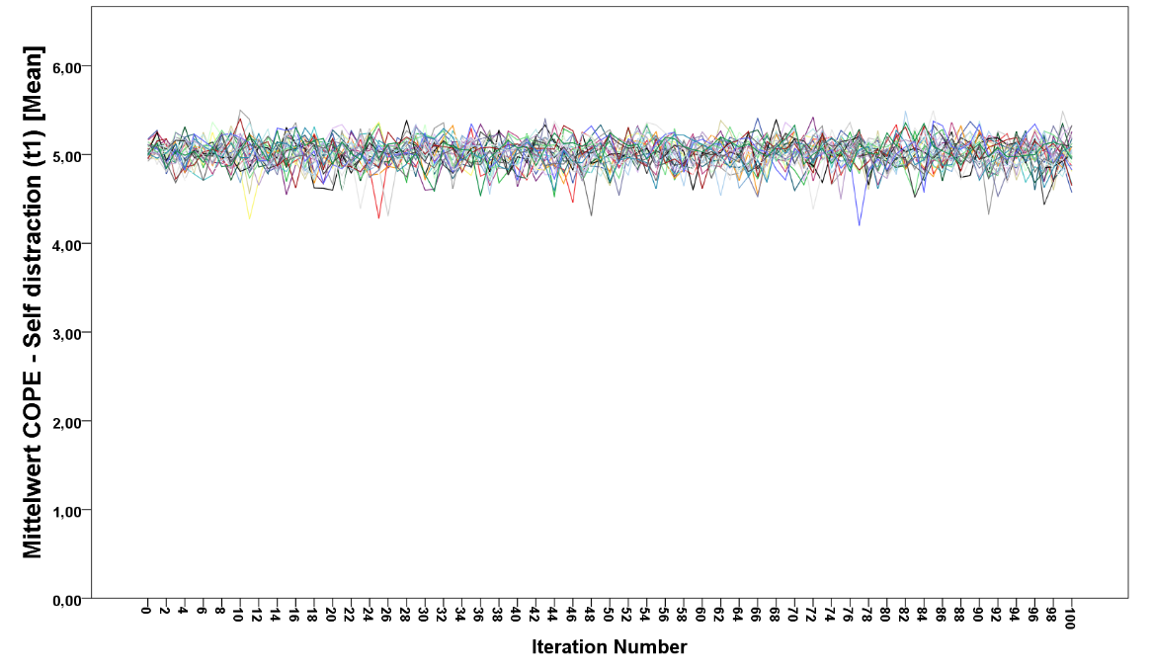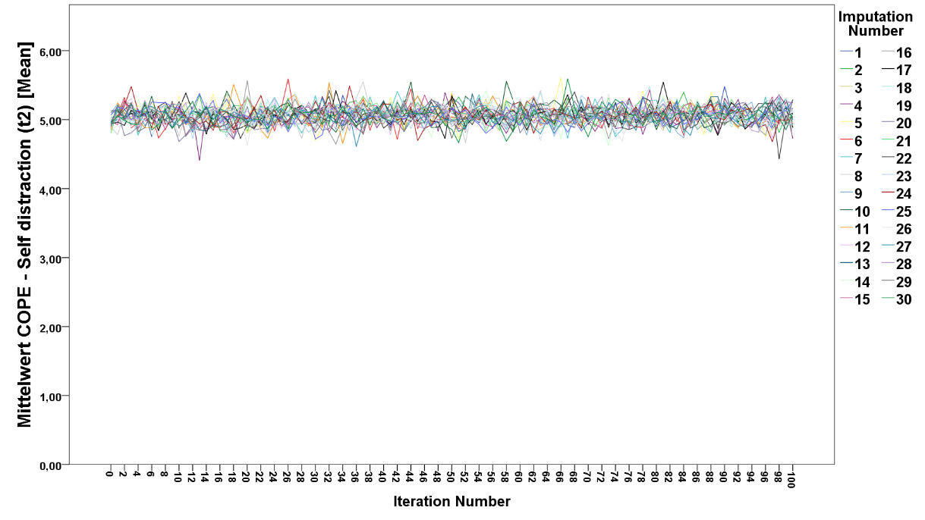
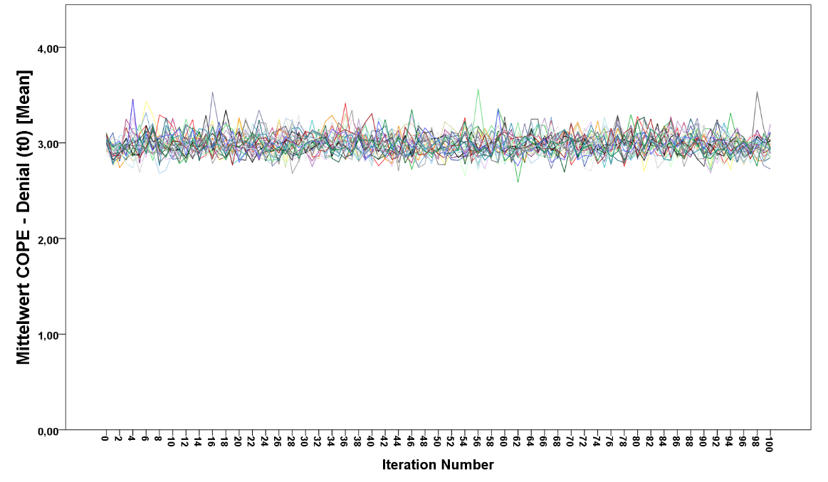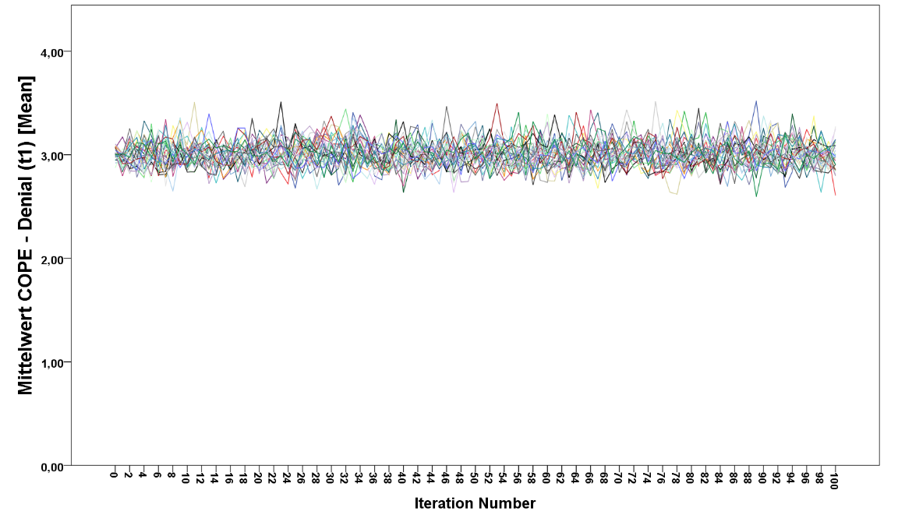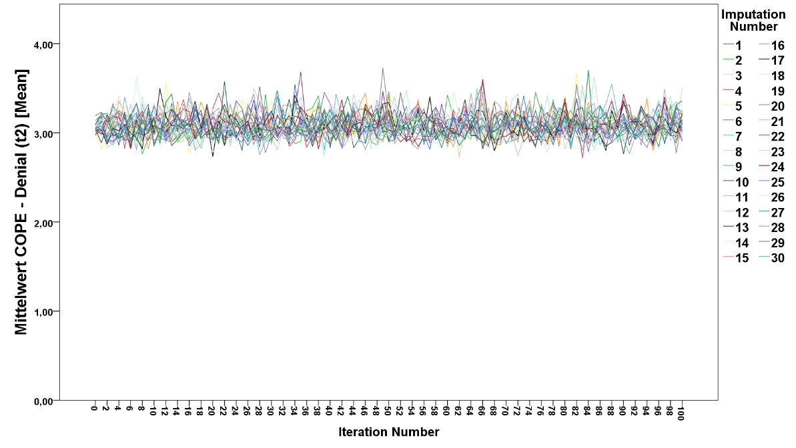

Supplementary Figure 3b. Line chart depicting the imputed mean values of BSCL and Brief COPE questionnaires as a function of iteration number and imputation number
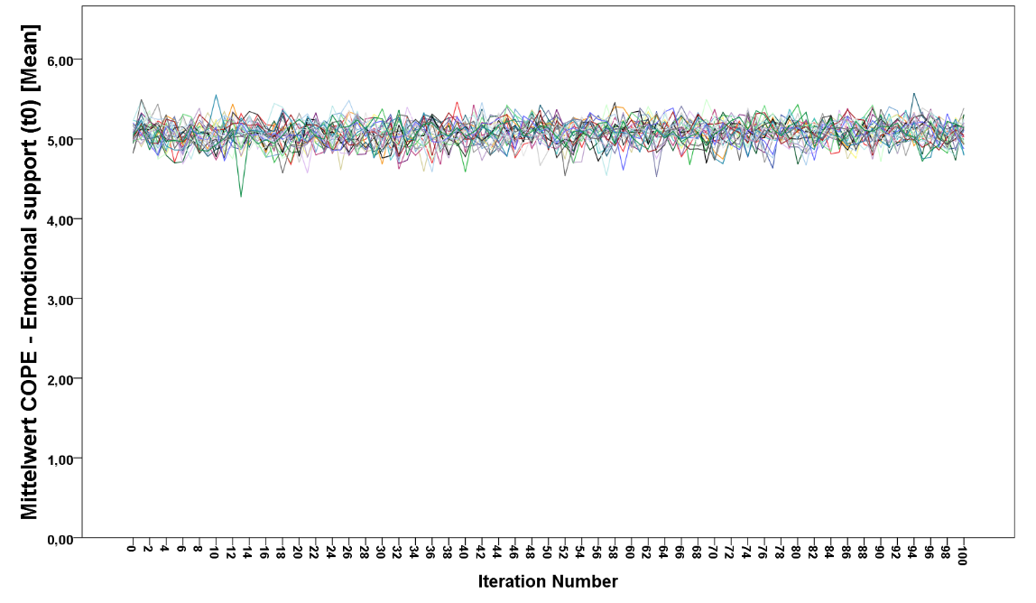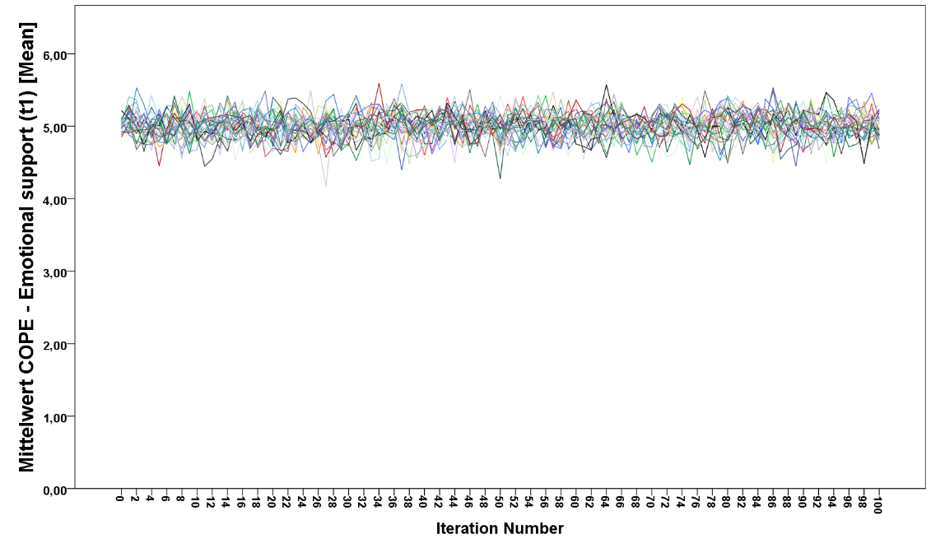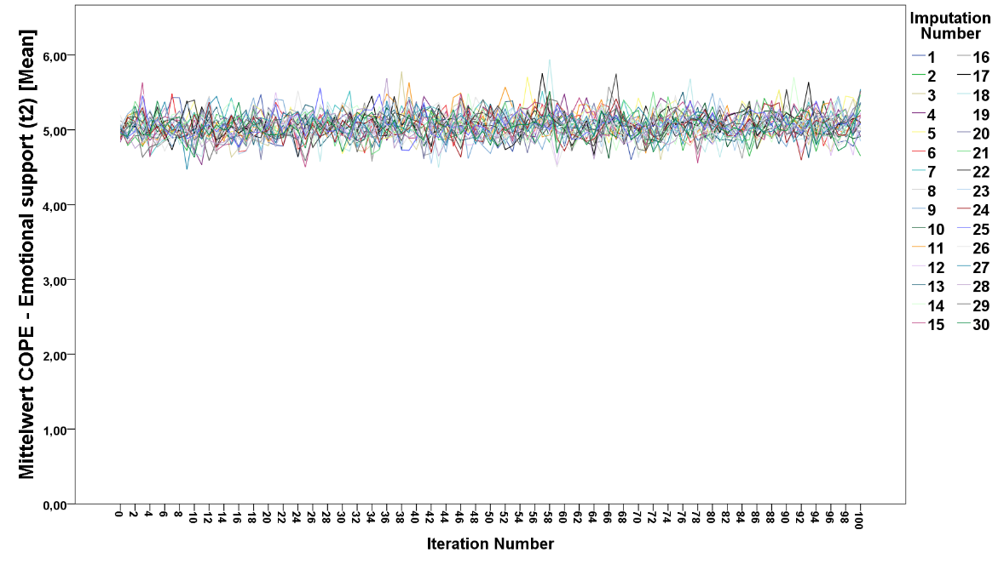
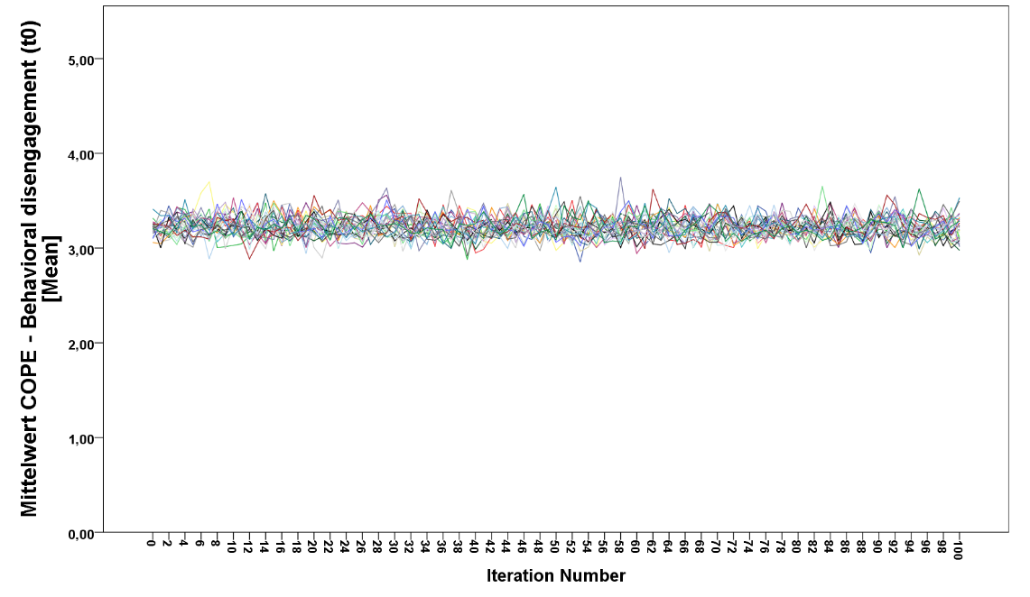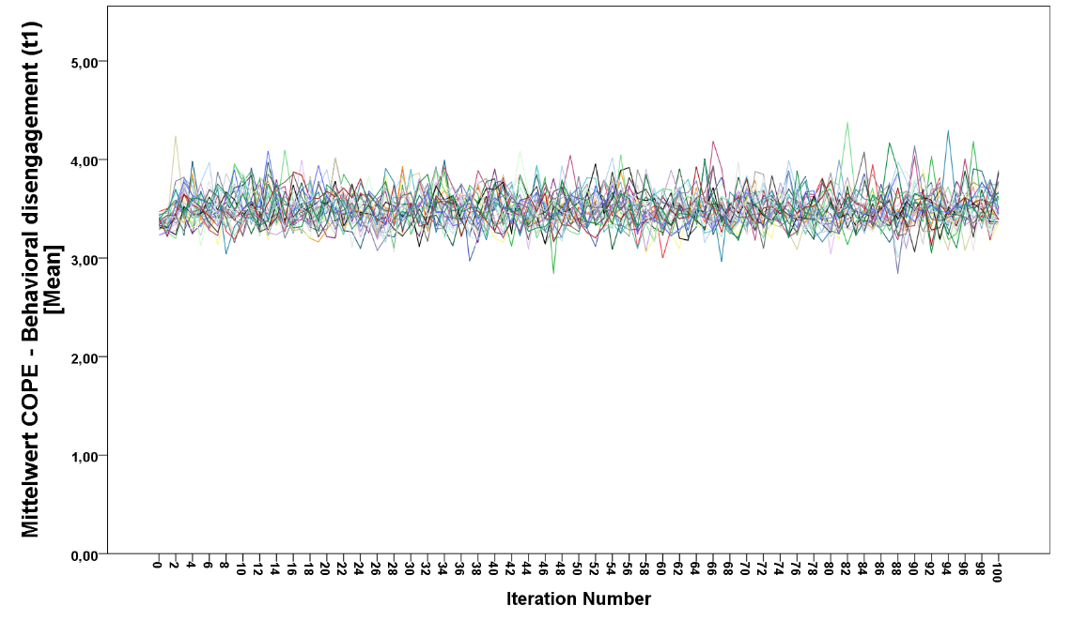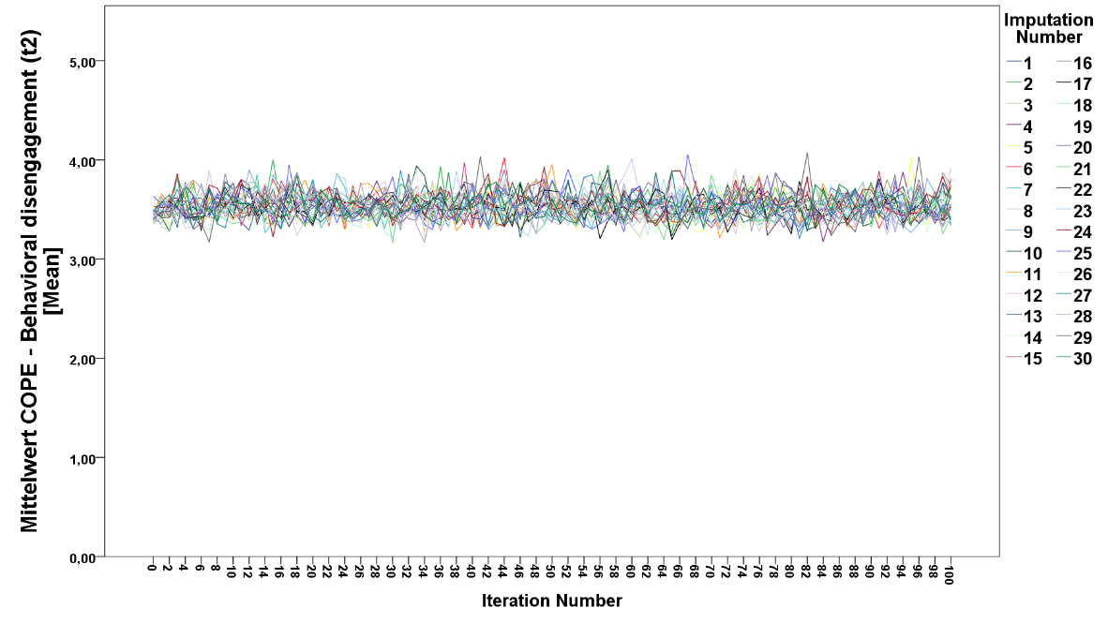
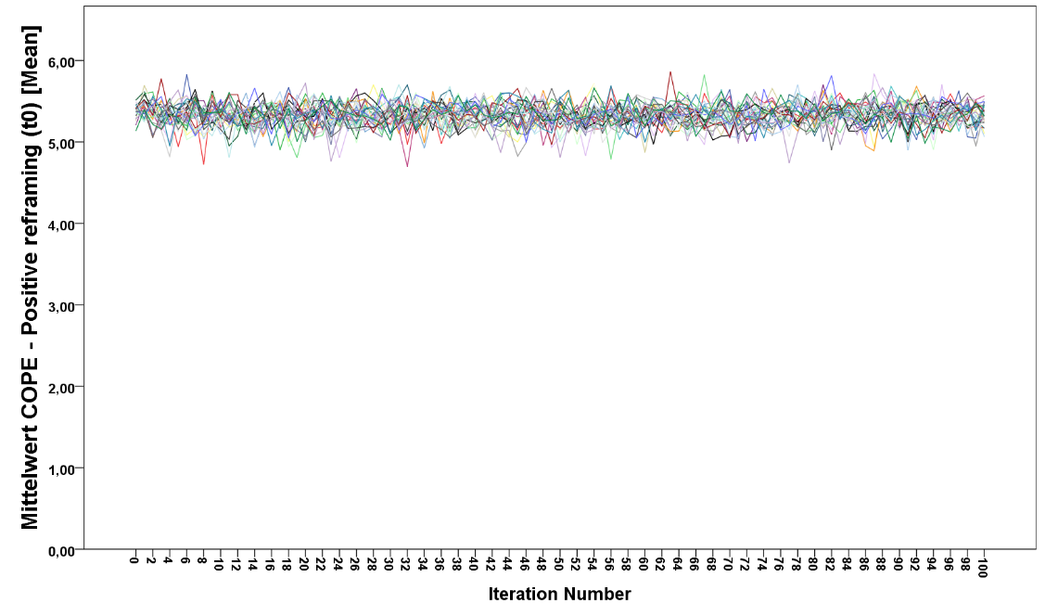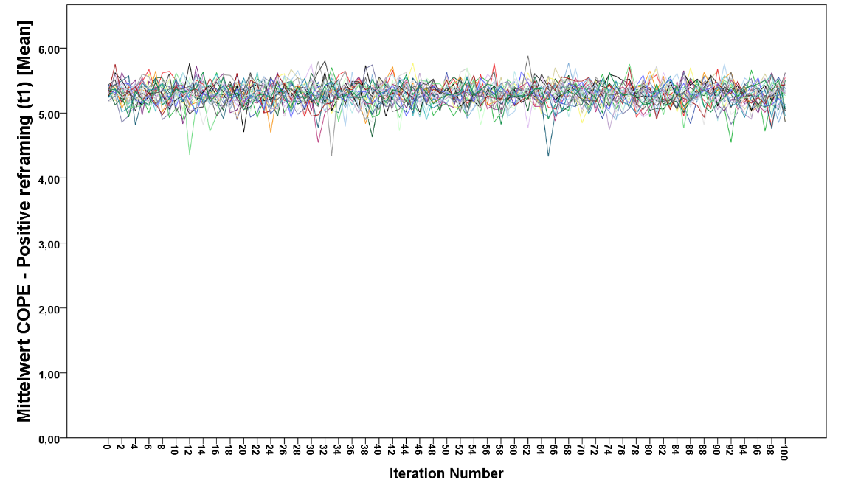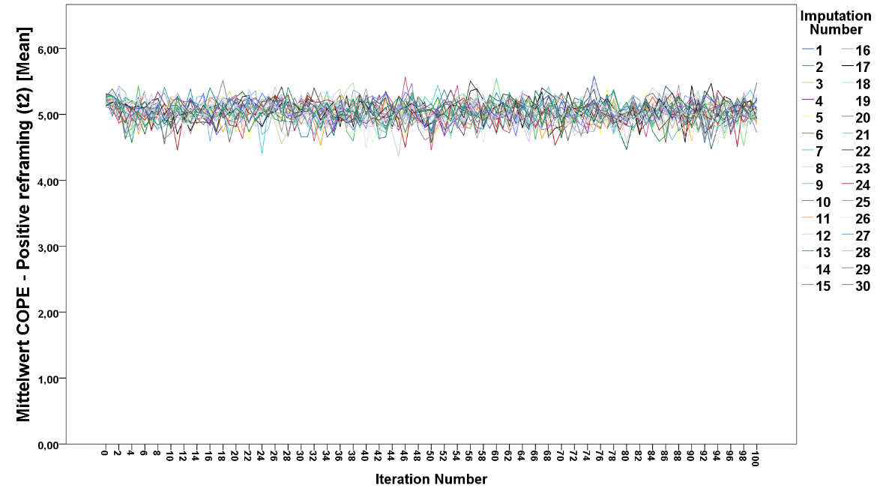

Supplementary Figure 3c. Line chart depicting the imputed mean values of BSCL and Brief COPE questionnaires as a function of iteration number and imputation number
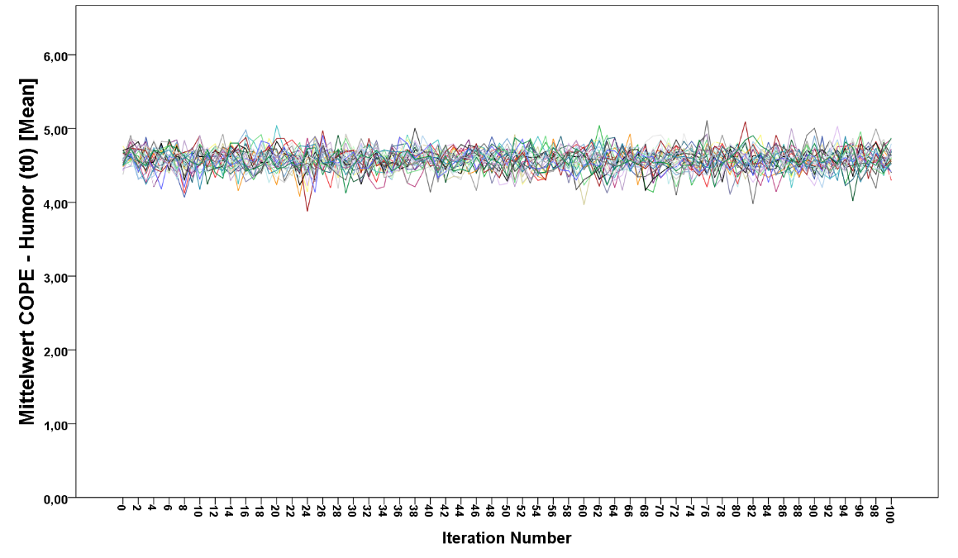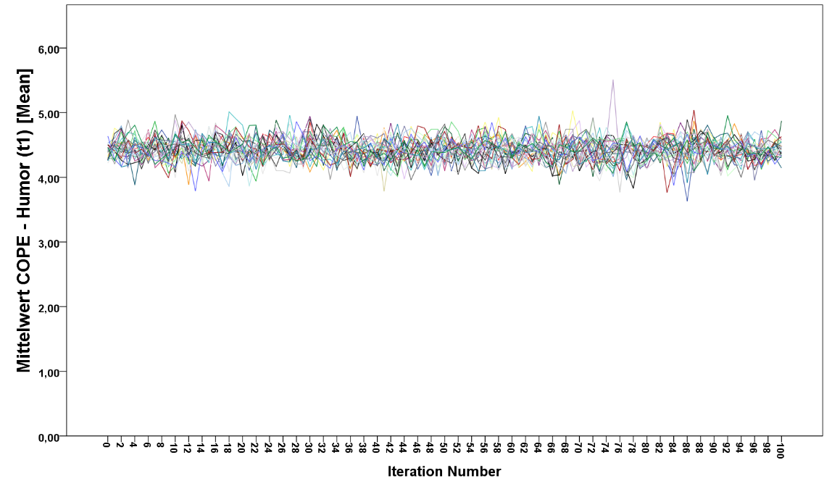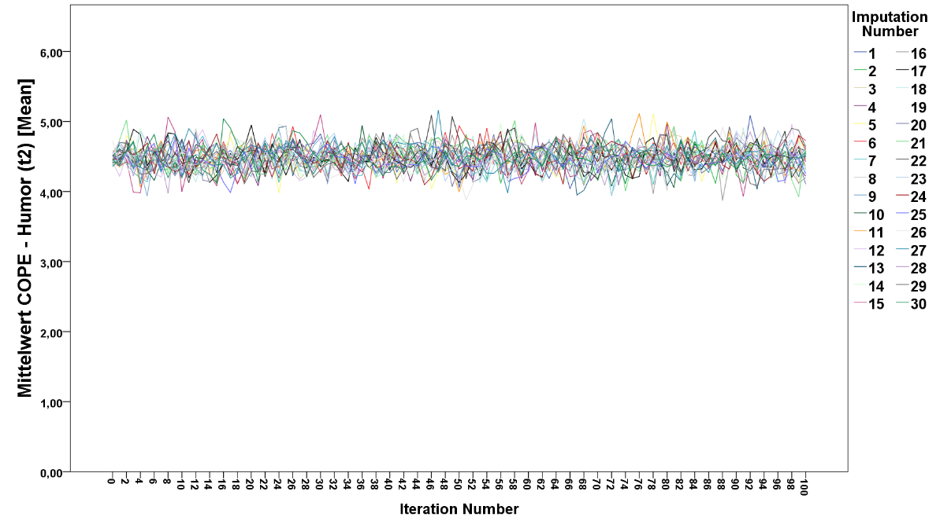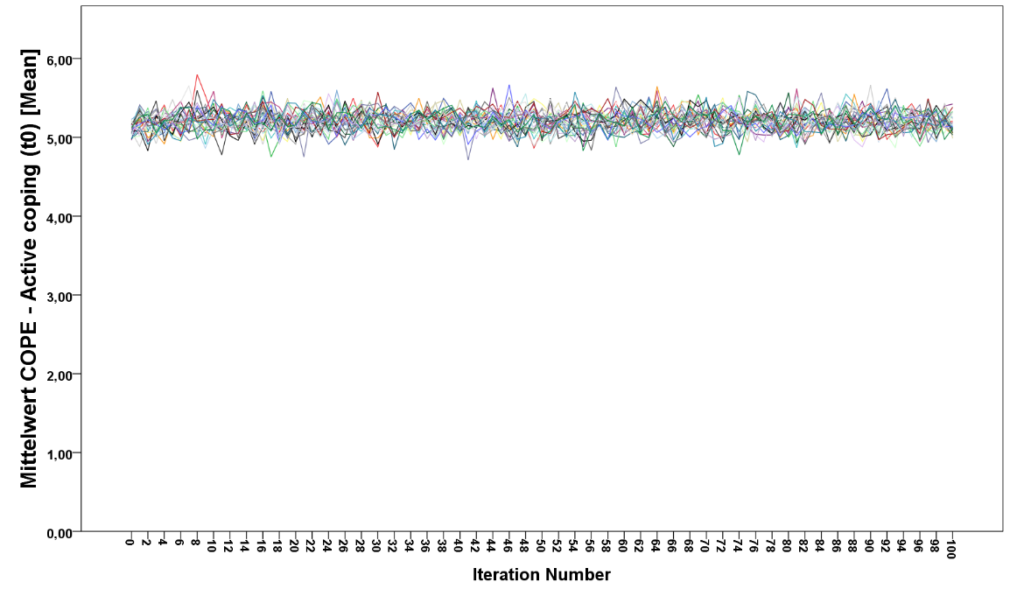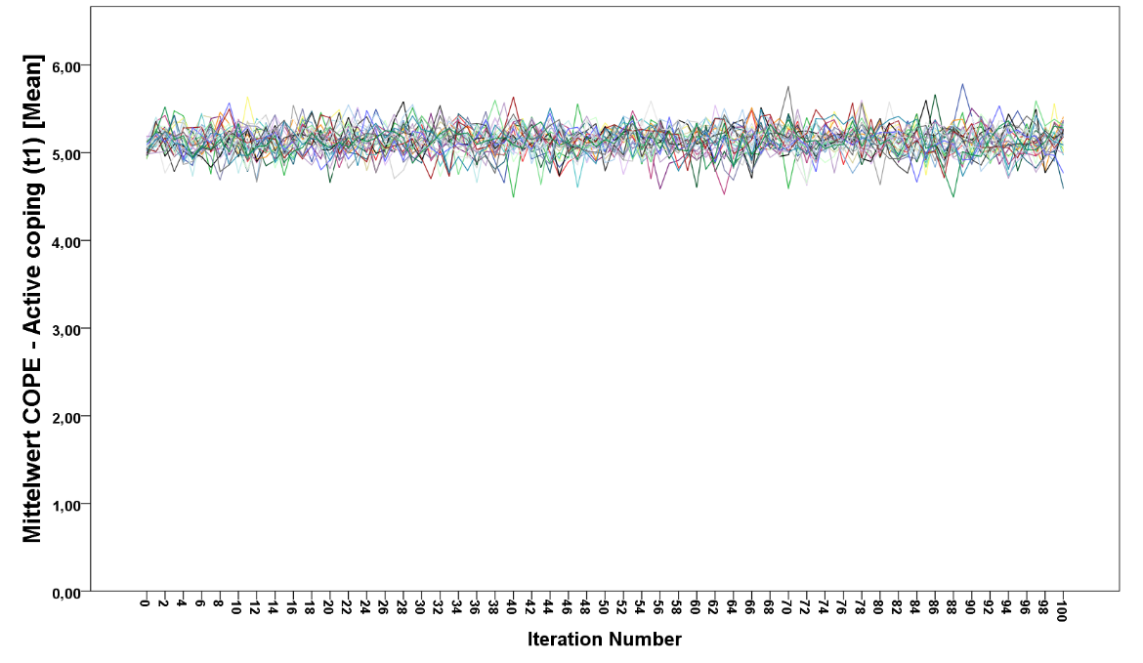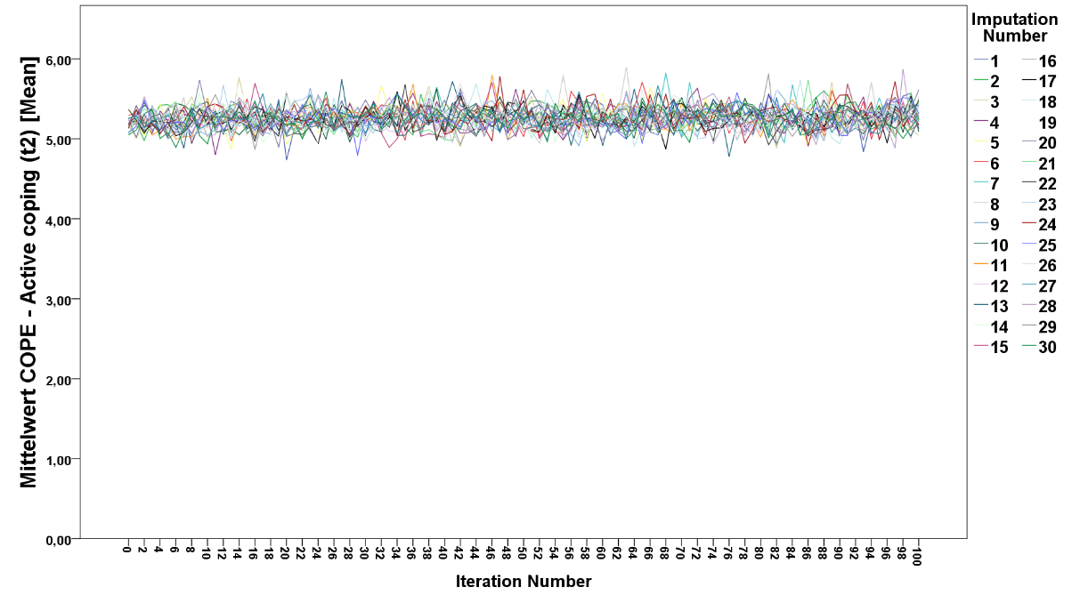
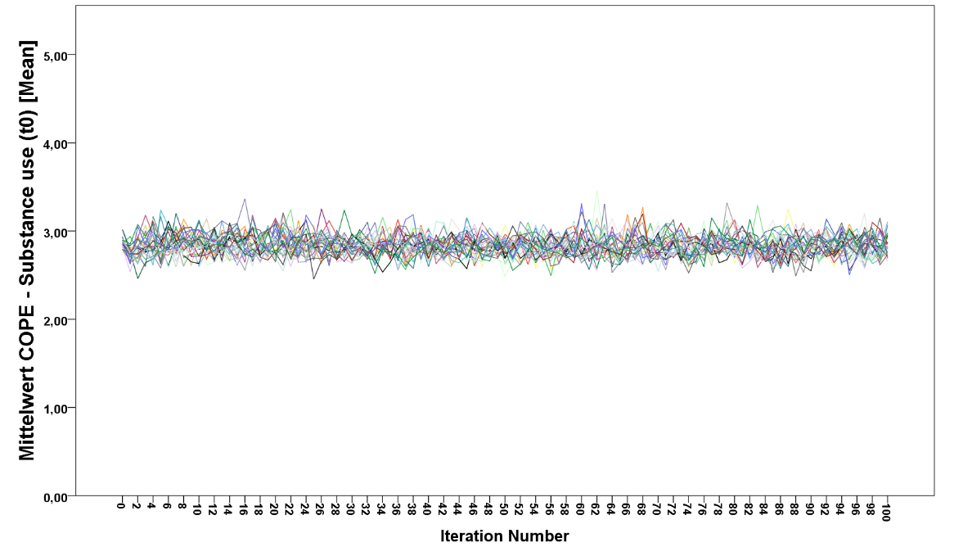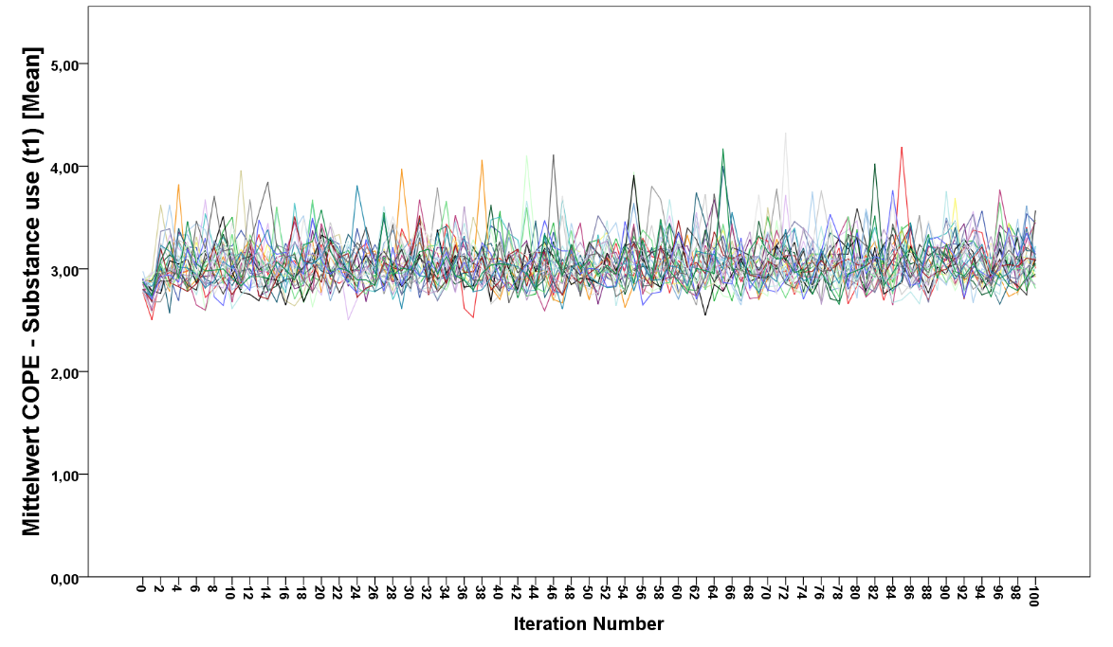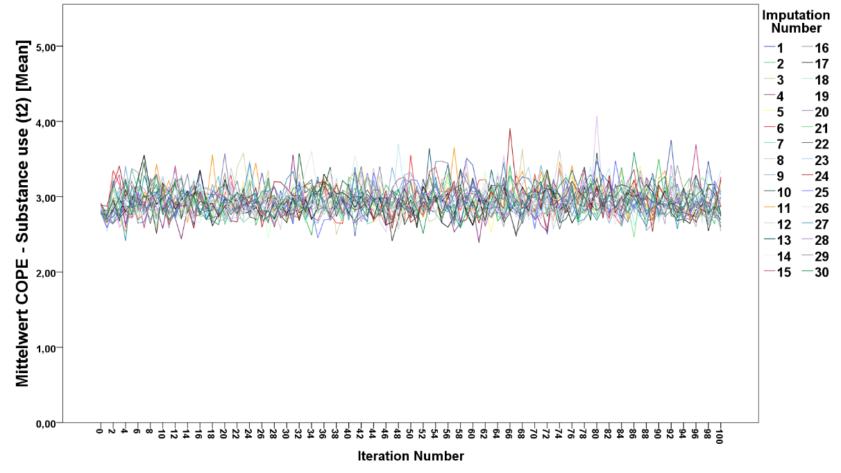

Supplementary Figure 3d. Line chart depicting the imputed mean values of BSCL and Brief COPE questionnaires as a function of iteration number and imputation number
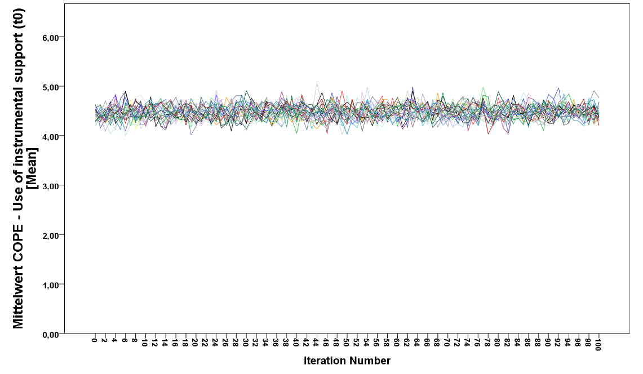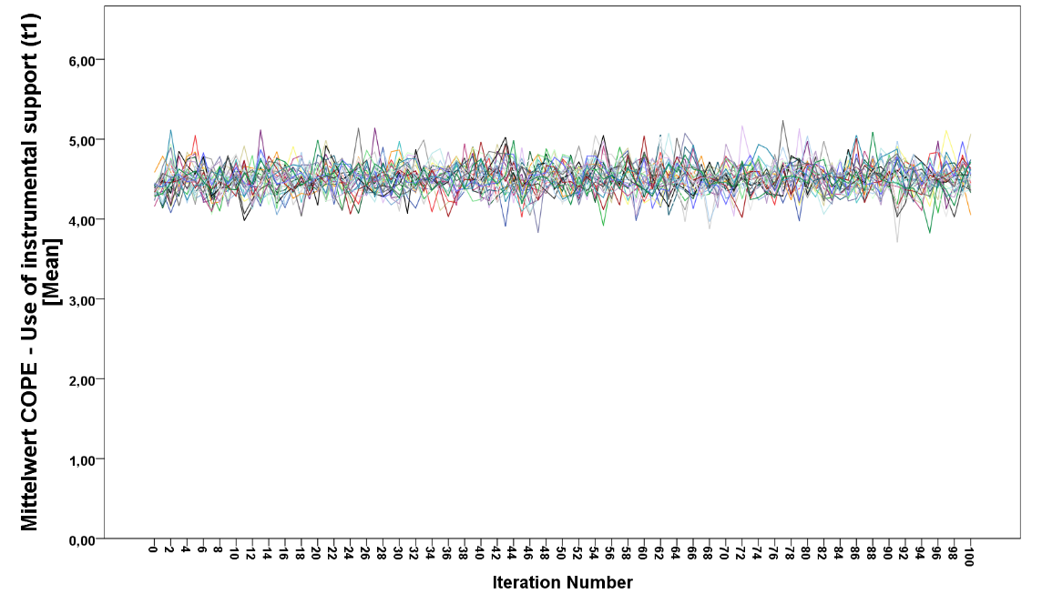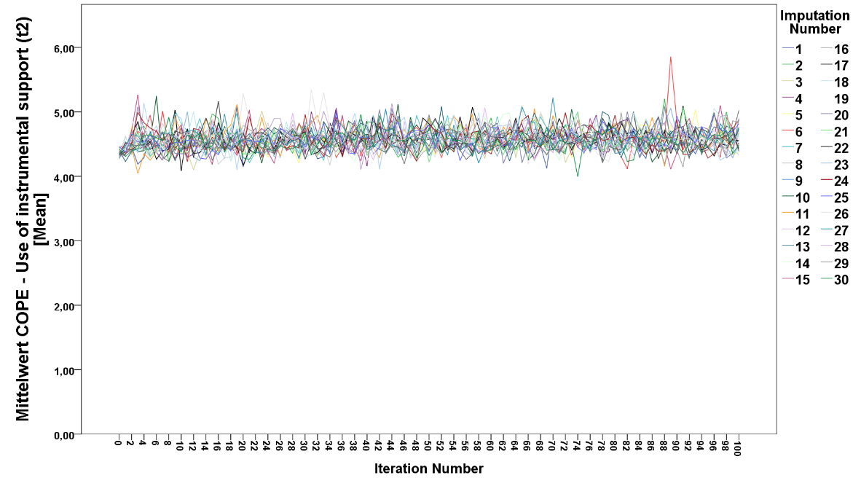
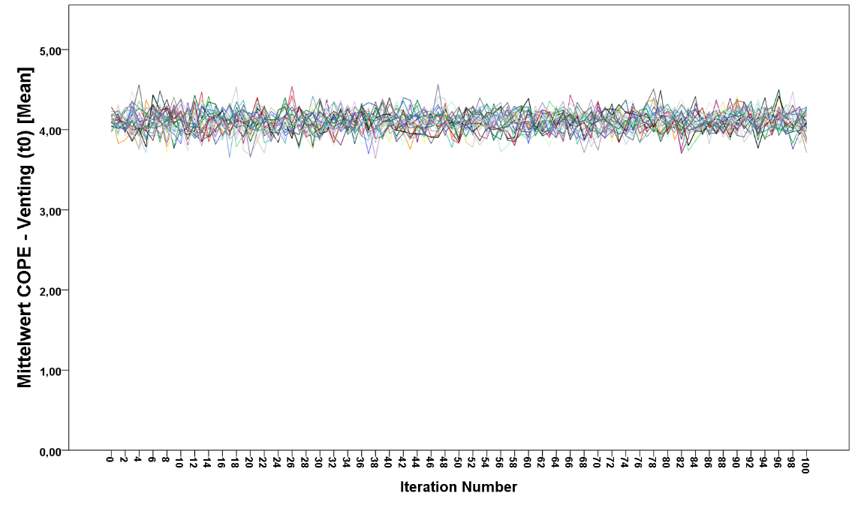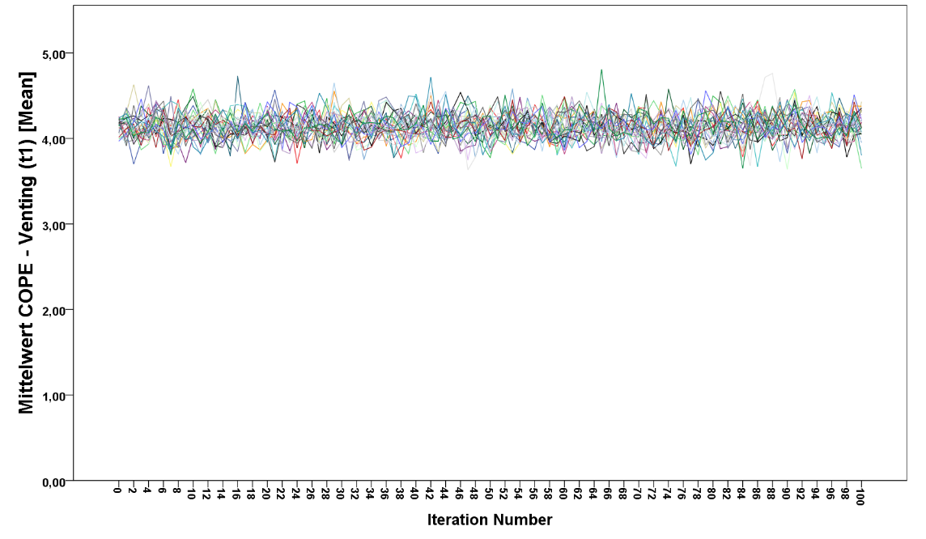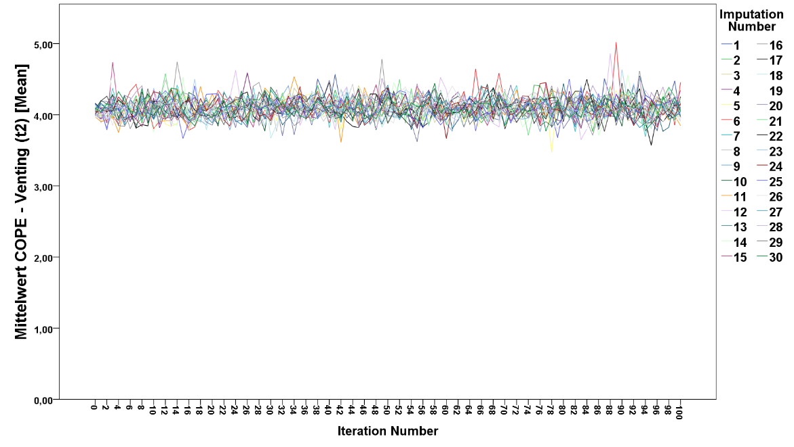
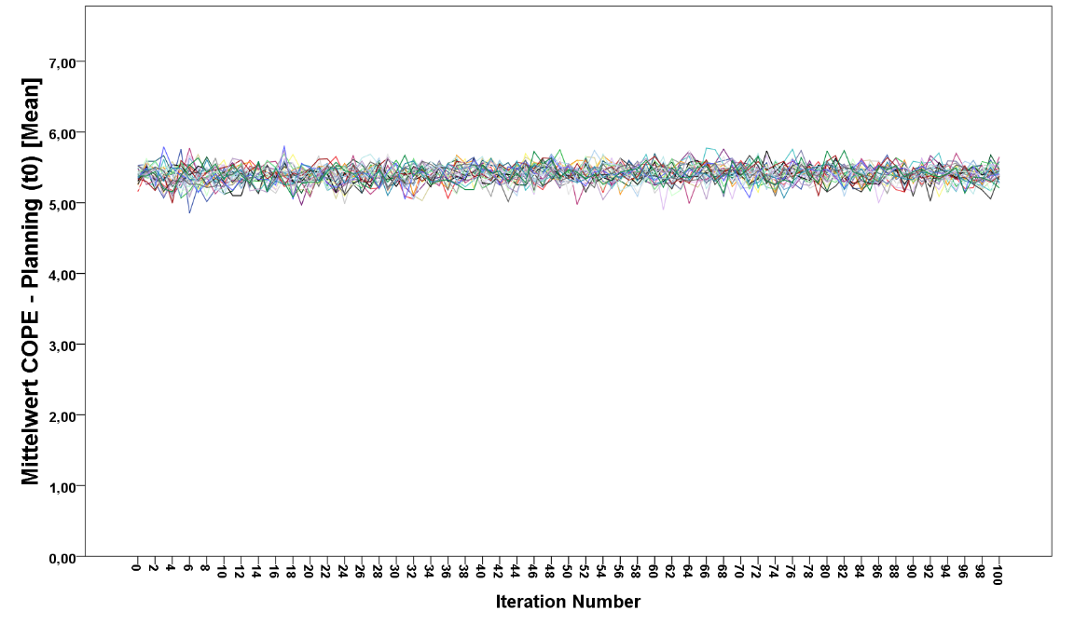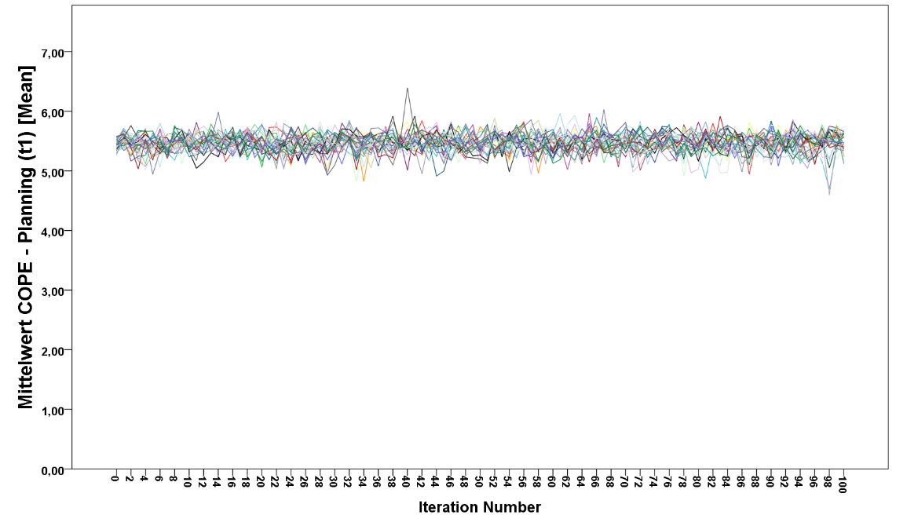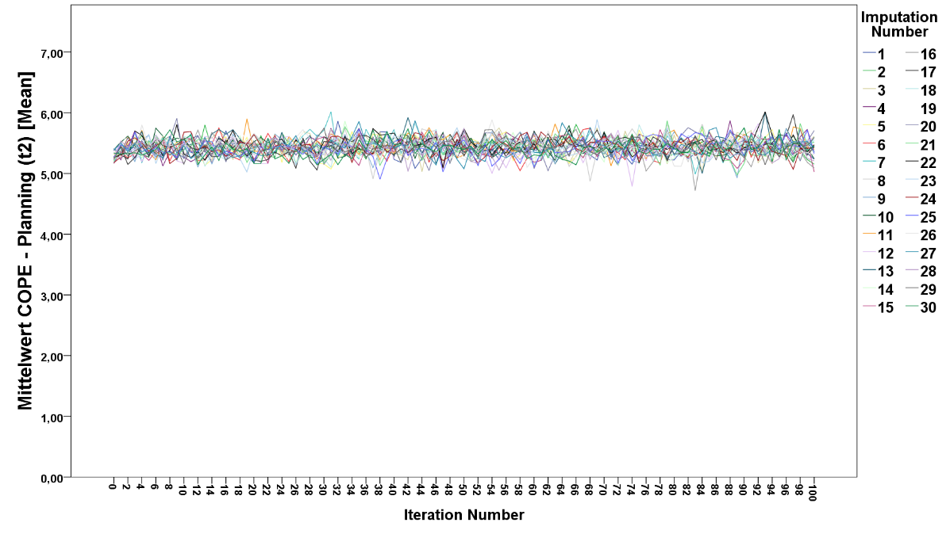

Supplementary Figure 3e. Line chart depicting the imputed mean values of BSCL and Brief COPE questionnaires as a function of iteration number and imputation number
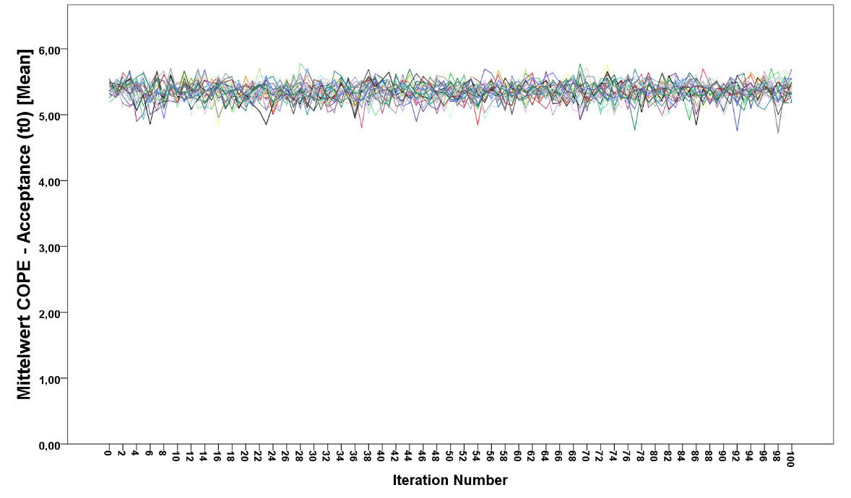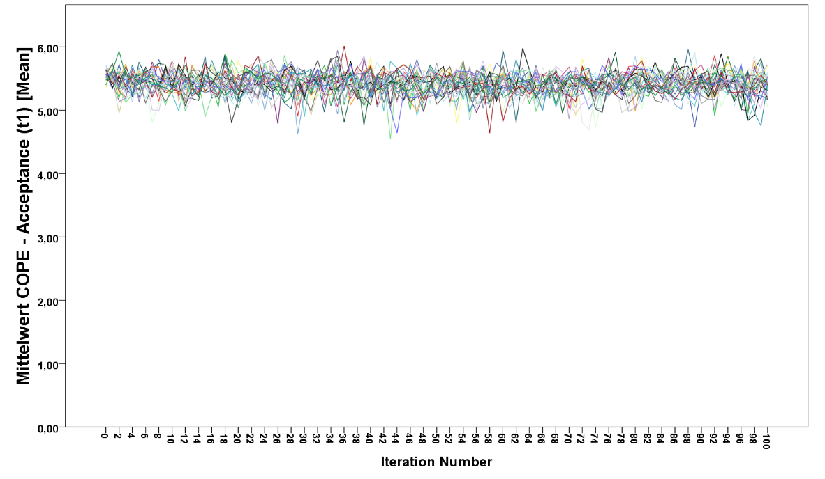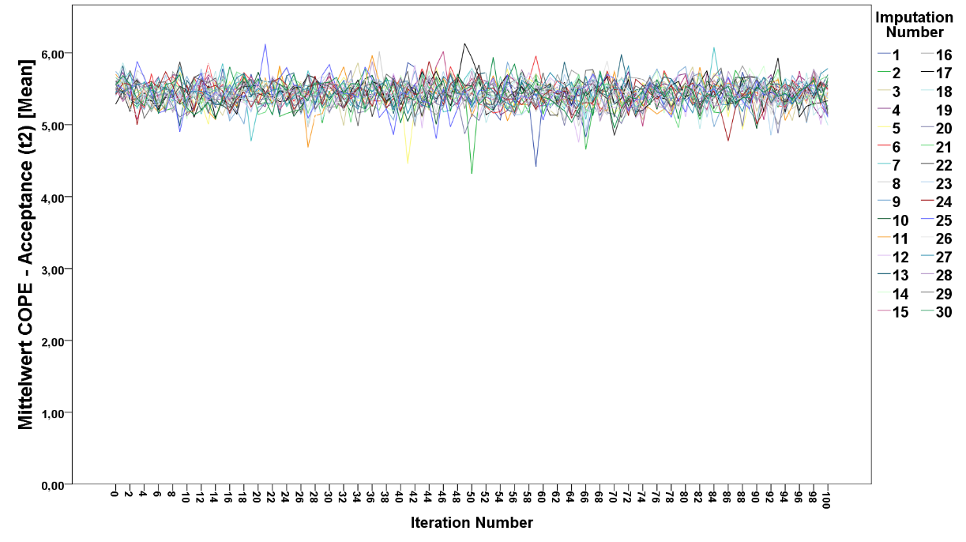
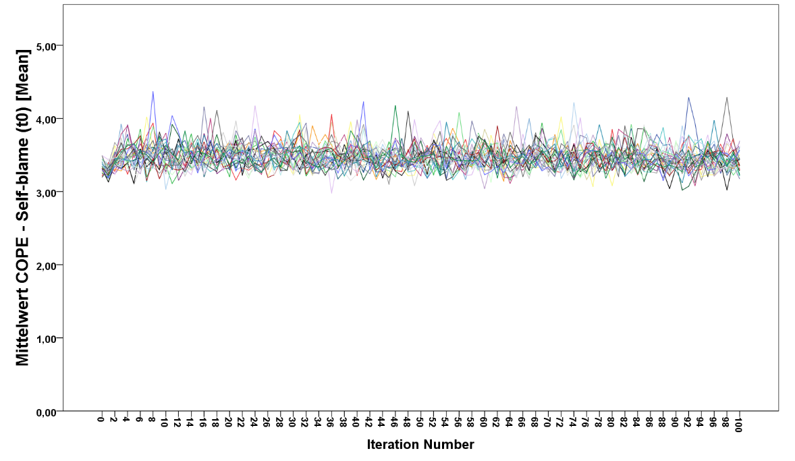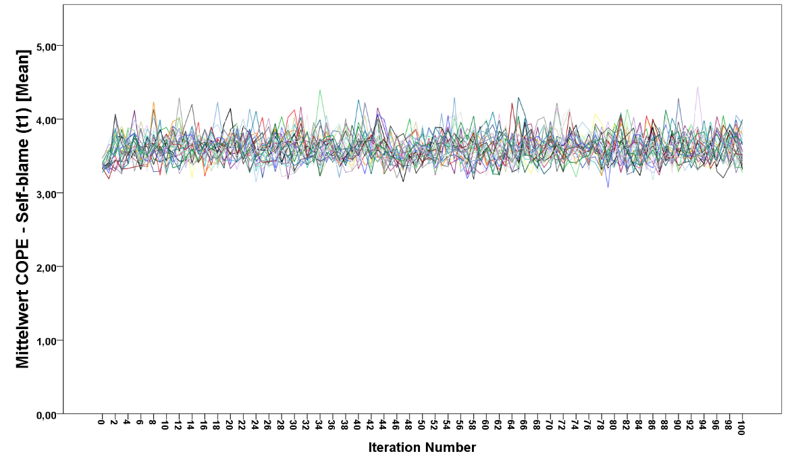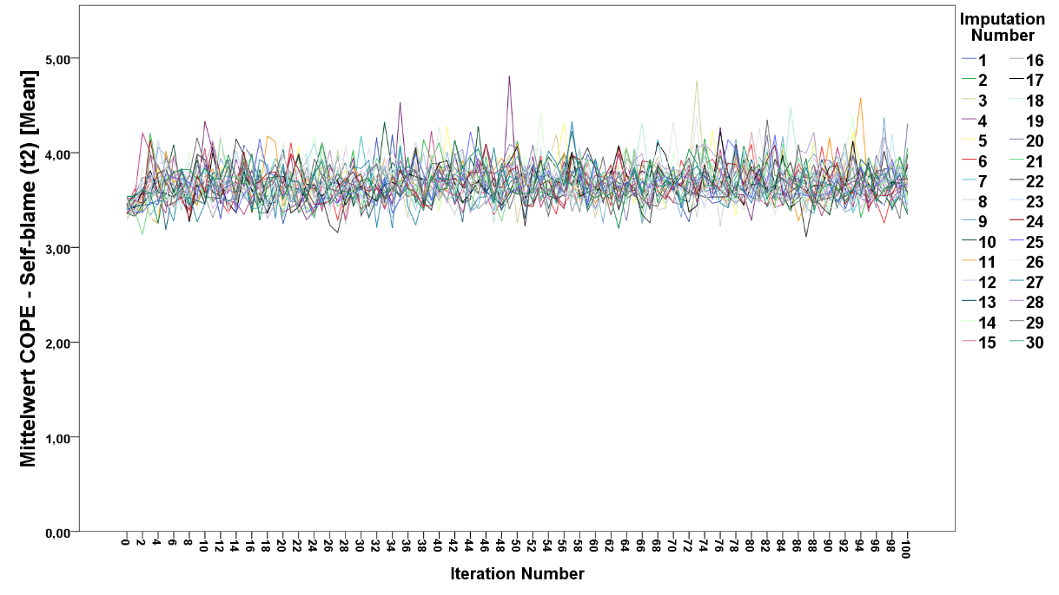
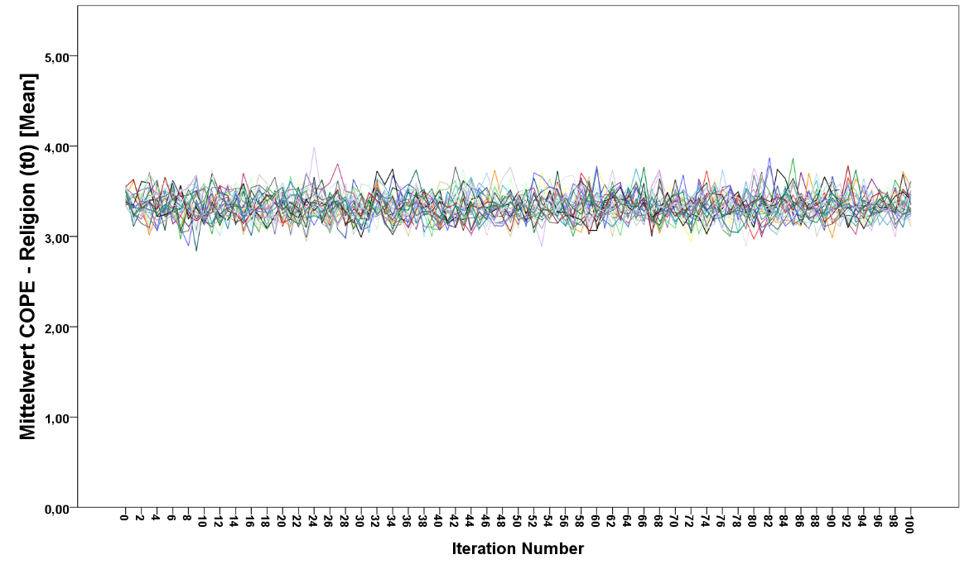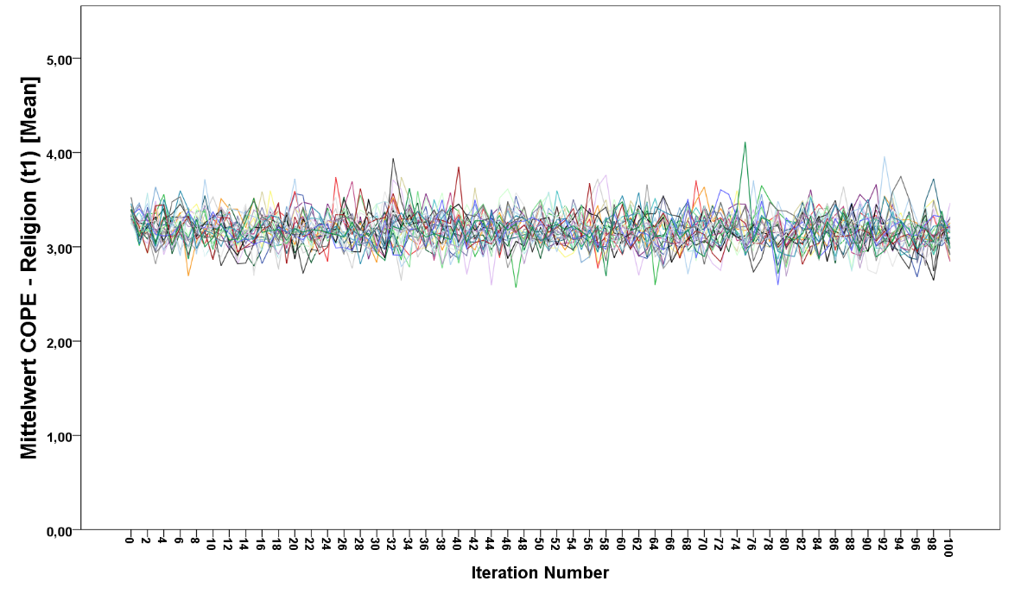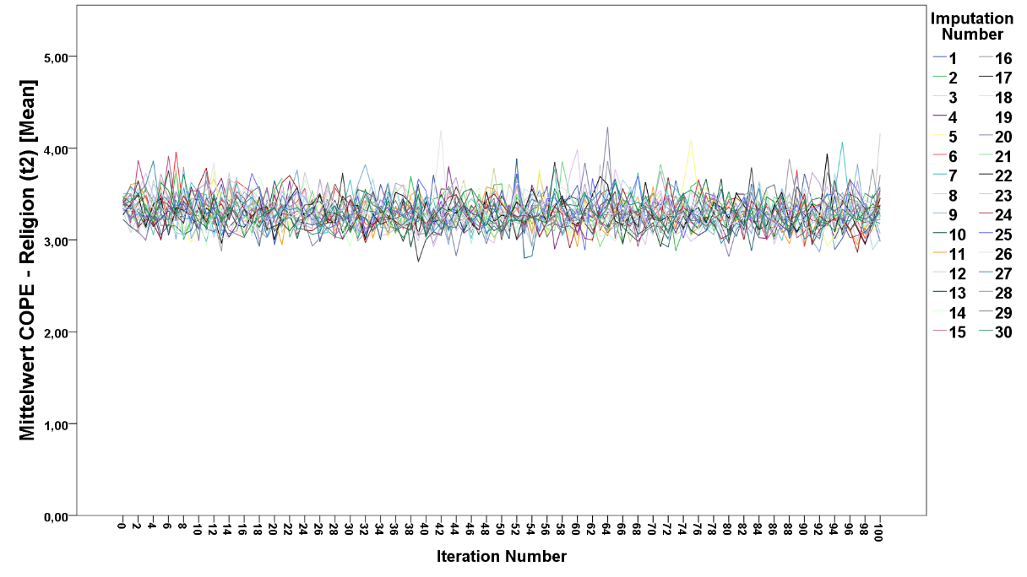

Supplementary Table 6. Pooled estimates of fixed effects in the univariate Linear Mixed Model after multiple imputation procedure
Model | Coping response | Estimate | S.E. | t | 95% CI (Estimate) |  | p-value
 |  |  |  |  | LB | UB | p-value
M1.1 Pooled | Acceptance | -5.022 | 0.667 | -7.529 | -6.329 | -3.715 | <0.0001
M2.1 Pooled | Acceptance (t0) | -4.598 | 1.014 | -4.535 | -6.585 | -2.611 | <0.0001
M2.1 Pooled | Acceptance (t1 vs. t0) | -0.436 | 1.199 | -0.364 | -2.786 | 1.914 | 0.4441
M2.1 Pooled | Acceptance (t2 vs. t0) | -0.574 | 1.135 | -0.506 | -2.799 | 1.651 | 0.5890
M1.2 Pooled | Active coping | -3.543 | 0.678 | -5.226 | -4.872 | -2.214 | <0.0001
M2.2 Pooled | Active coping (t0) | -3.226 | 1.08 | -2.987 | -5.343 | -1.109 | 0.0044
M2.2 Pooled | Active coping (t1 vs. t0) | 0.446 | 1.246 | 0.358 | -1.996 | 2.888 | 0.5773
M2.2 Pooled | Active coping (t2 vs. t0) | -1.192 | 1.378 | -0.865 | -3.893 | 1.509 | 0.0781
M1.3 Pooled | Behavioural disengagement | 9.314 | 0.776 | 12.003 | 7.793 | 10.835 | <0.0001
M2.3 Pooled | Behavioural disengagement (t0) | 12.397 | 1.321 | 9.385 | 9.808 | 14.986 | <0.0001
M2.3 Pooled | Behavioural disengagement (t1 vs. t0) | -2.384 | 1.54 | -1.548 | -5.402 | 0.634 | 0.2954
M2.3 Pooled | Behavioural disengagement (t2 vs. t0) | -4.297 | 1.576 | -2.727 | -7.386 | -1.208 | 0.0161
M1.4 Pooled | Denial | 12.519 | 0.822 | 15.230 | 10.908 | 14.130 | <0.0001
M2.4 Pooled | Denial (t0) | 13.679 | 1.185 | 11.543 | 11.356 | 16.002 | <0.0001
M2.4 Pooled | Denial (t1 vs. t0) | -0.201 | 1.547 | -0.130 | -3.233 | 2.831 | 0.8420
M2.4 Pooled | Denial (t2 vs. t0) | -3.388 | 1.475 | -2.297 | -6.279 | -0.497 | 0.0104
M1.5 Pooled | Emotional support | -3.025 | 0.624 | -4.848 | -4.248 | -1.802 | <0.0001
M2.5Pooled | Emotional support (t0) | -2.891 | 0.939 | -3.079 | -4.731 | -1.051 | 0.0014
M2.5Pooled | Emotional support (t1 vs. t0) | 0.295 | 1.012 | 0.292 | -1.689 | 2.279 | 0.7074
M2.5Pooled | Emotional support (t2 vs. t0) | -1.207 | 1.123 | -1.075 | -3.408 | 0.994 | 0.1733
M1.6 Pooled | Humour | -3.811 | 0.703 | -5.421 | -5.189 | -2.433 | <0.0001
M2.6 Pooled | Humour (t0) | -3.518 | 1.018 | -3.456 | -5.513 | -1.523 | 0.0001
M2.6 Pooled | Humour (t1 vs. t0) | 2.177 | 1.175 | 1.853 | -0.126 | 4.480 | 0.0601
M2.6 Pooled | Humour (t2 vs. t0) | 0.374 | 1.203 | 0.311 | -1.984 | 2.732 | 0.4411
M1.7 Pooled | Informational support | -0.863 | 0.632 | -1.366 | -2.102 | 0.376 | 0.0813
M2.7 Pooled | Informational support (t0) | -0.158 | 0.977 | -0.162 | -2.073 | 1.757 | 0.9302
M2.7 Pooled | Informational support (t1 vs. t0) | -0.873 | 1.131 | -0.772 | -3.090 | 1.344 | 0.3523
M2.7 Pooled | Informational support (t2 vs. t0) | -1.395 | 1.228 | -1.136 | -3.802 | 1.012 | 0.2344
M1.8 Pooled | Planning | 0.212 | 0.623 | 0.340 | -1.009 | 1.433 | 0.5131
M2.8 Pooled | Planning (t0) | 0.283 | 1.039 | 0.272 | -1.753 | 2.319 | 0.3562
M2.8 Pooled | Planning (t1 vs. t0) | 0.322 | 1.352 | 0.238 | -2.328 | 2.972 | 0.4822
M2.8 Pooled | Planning (t2 vs. t0) | -3.176 | 1.283 | -2.475 | -5.691 | -0.661 | 0.0080
M1.9 Pooled | Positive reframing | -6.874 | 0.736 | -9.340 | -8.317 | -5.431 | <0.0001
M2.9 Pooled | Positive reframing (t0) | -7.084 | 0.842 | -8.413 | -8.734 | -5.434 | <0.0001
M2.9 Pooled | Positive reframing (t1 vs. t0) | 0.831 | 1.065 | 0.780 | -1.256 | 2.918 | 0.5211
M2.9 Pooled | Positive reframing (t2 vs. t0) | -0.923 | 1.252 | -0.737 | -3.377 | 1.531 | 0.6393
M1.10 Pooled | Religion | 0.015 | 0.852 | 0.018 | -1.655 | 1.685 | 0.8772
M2.10 Pooled | Religion (t0) | -0.699 | 0.975 | -0.717 | -2.610 | 1.212 | 0.3672
M2.10 Pooled | Religion (t1 vs. t0) | 1.212 | 1.037 | 1.169 | -0.821 | 3.245 | 0.2214
M2.10 Pooled | Religion (t2 vs. t0) | 1.395 | 1.225 | 1.139 | -1.006 | 3.796 | 0.2430
M1.11 Pooled | Self-blame | 11.463 | 0.665 | 17.238 | 10.160 | 12.766 | <0.0001
M2.11 Pooled | Self-blame (t0) | 13.324 | 1.017 | 13.101 | 11.331 | 15.317 | <0.0001
M2.11 Pooled | Self-blame (t1 vs. t0) | -1.224 | 1.224 | -1.000 | -3.623 | 1.175 | 0.3454
M2.11 Pooled | Self-blame (t2 vs. t0) | -2.283 | 1.231 | -2.019 | -4.500 | 0.130 | 0.0883
M1.12 Pooled | Self-distraction | 2.708 | 0.693 | 3.908 | 1.350 | 4.066 | 0.0003
M2.12 Pooled | Self-distraction (t0) | 2.145 | 0.935 | 2.294 | 0.312 | 3.978 | 0.0293
M2.12 Pooled | Self-distraction (t1 vs. t0) | 0.318 | 1.316 | 0.242 | -2.261 | 2.897 | 0.6114
M2.12 Pooled | Self-distraction (t2 vs. t0) | -1.110 | 1.074 | -1.034 | -3.215 | 0.995 | 0.3032
M1.13 Pooled | Substance use | 12.440 | 0.942 | 13.206 | 10.594 | 14.286 | <0.0001
M2.13 Pooled | Substance use (t0) | 12.249 | 1.075 | 11.394 | 10.142 | 14.356 | <0.0001
M2.13 Pooled | Substance use (t1 vs. t0) | 1.542 | 1.218 | 1.266 | -0.845 | 3.929 | 0.4752
M2.13 Pooled | Substance use (t2 vs. t0) | -0.912 | 1.251 | -0.729 | -3.364 | 1.540 | 0.1964
M1.14 Pooled | Venting | 1.153 | 0.723 | 1.595 | -0.264 | 2.570 | 0.1921
M2.14 Pooled | Venting (t0) | 2.487 | 1.007 | 2.470 | 0.513 | 4.461 | 0.0027
M2.14 Pooled | Venting (t1 vs. t0) | -1.404 | 1.133 | -1.239 | -3.625 | 0.817 | 0.1830
M2.14 Pooled | Venting (t2 vs. t0) | -2.822 | 1.311 | -2.153 | -5.392 | -0.252 | 0.0035
Abbreviations. CI=confidence interval; S.E.=standard error; df=degree of freedom; LB=lower bound; UB=upper bound; M1= Univariate model, including each coping response separately; M2=Univariate model, including the interaction with time and each coping response separately
Linear mixed model specifications: independent variable = coping response; dependent variable = psychological distress; covariates: age, gender, residence; Participants were considered subjects, time of assessment as factor. Parameter estimates are based on the restricted maximum likelihood (REML) method. The variance-covariance structure of the random effects was specified as unstructured (UN), the variance-covariance structure of the within-group residuals (time) was specified as first-order autoregressive (AR1)

Supplementary Table 7. Pooled estimates of fixed effects in the multivariable Linear Mixed Model after multiple imputation procedure
Model | Coping response | Estimate | S.E. | t | 95% CI (Estimate) |  | p-value
 |  |  |  |  | LB | UB | p-value
M3 Pooled | Acceptance | -2.722 | 0.608 | -4.477 | -3.914 | -1.530 | <0.0001
M4 Pooled | Acceptance (t0) | -2.174 | 1.045 | -2.080 | -4.222 | -0.126 | 0.0221
M4 Pooled | Acceptance (t1 vs. t0) | 1.413 | 1.141 | 1.238 | -0.823 | 3.649 | 0.2122
M4 Pooled | Acceptance (t2 vs. t0) | 0.002 | 1.378 | 0.001 | -2.699 | 2.703 | 0.9994
M3 Pooled | Active coping | -3.488 | 0.671 | -5.198 | -4.803 | -2.173 | <0.0001
M4 Pooled | Active coping (t0) | -2.747 | 1.115 | -2.464 | -4.932 | -0.562 | 0.0122
M4 Pooled | Active coping (t1 vs. t0) | 1.237 | 1.295 | 0.955 | -1.301 | 3.775 | 0.7021
M4 Pooled | Active coping (t2 vs. t0) | -0.039 | 2.370 | -0.016 | -4.684 | 4.606 | 0.9870
M3 Pooled | Behavioural disengagement | 5.196 | 0.764 | 6.801 | 3.699 | 6.693 | <0.0001
M4 Pooled | Behavioural disengagement (t0) | 6.171 | 1.255 | 4.917 | 3.711 | 8.631 | <0.0001
M4 Pooled | Behavioural disengagement (t1 vs. t0) | 1.978 | 1.279 | 1.547 | -0.529 | 4.485 | 0.1872
M4 Pooled | Behavioural disengagement (t2 vs. t0) | -1.755 | 2.155 | -0.814 | -5.979 | 2.469 | 0.5823
M3 Pooled | Denial | 7.354 | 0.792 | 9.285 | 5.802 | 8.906 | <0.0001
M4 Pooled | Denial (t0) | 6.642 | 1.389 | 4.782 | 3.920 | 9.364 | 0.0002
M4 Pooled | Denial (t1 vs. t0) | 1.363 | 1.894 | 0.720 | -2.349 | 5.075 | 0.4183
M4 Pooled | Denial (t2 vs. t0) | -2.756 | 1.903 | -1.448 | -6.486 | 0.974 | 0.1084
M3 Pooled | Emotional support | -2.948 | 0.609 | -4.841 | -4.142 | -1.754 | <0.0001
M4 Pooled | Emotional support (t0) | -3.213 | 1.085 | -2.961 | -5.340 | -1.086 | 0.0031
M4 Pooled | Emotional support (t1 vs. t0) | 0.596 | 1.563 | 0.381 | -2.467 | 3.659 | 0.5182
M4 Pooled | Emotional support (t2 vs. t0) | -0.037 | 1.607 | -0.023 | -3.187 | 3.113 | 0.9891
M3 Pooled | Humour | -1.201 | 0.657 | -1.828 | -2.489 | 0.087 | 0.0641
M4 Pooled | Humour (t0) | -1.587 | 0.859 | -1.847 | -3.271 | 0.097 | 0.0563
M4 Pooled | Humour (t1 vs. t0) | 1.245 | 1.283 | 0.970 | -1.270 | 3.760 | 0.5894
M4 Pooled | Humour (t2 vs. t0) | 0.319 | 1.727 | 0.185 | -3.066 | 3.704 | 0.9082
M3 Pooled | Positive reframing | -3.336 | 0.706 | -4.725 | -4.720 | -1.952 | <0.0001
M4 Pooled | Positive reframing (t0) | -3.717 | 0.981 | -3.789 | -5.640 | -1.794 | 0.0002
M4 Pooled | Positive reframing (t1 vs. t0) | 0.386 | 1.337 | 0.289 | -2.235 | 3.007 | 0.8693
M4 Pooled | Positive reframing (t2 vs. t0) | -1.521 | 2.189 | -0.695 | -5.811 | 2.769 | 0.6381
M3 Pooled | Self-blame | 8.498 | 0.626 | 13.575 | 7.271 | 9.725 | <0.0001
M4 Pooled | Self-blame (t0) | 9.282 | 1.270 | 7.309 | 6.793 | 11.771 | <0.0001
M4 Pooled | Self-blame (t1 vs. t0) | -1.445 | 1.547 | -0.934 | -4.477 | 1.587 | 0.5890
M4 Pooled | Self-blame (t2 vs. t0) | 0.872 | 1.685 | 0.518 | -2.431 | 4.175 | 0.7050
M3 Pooled | Self-distraction | 2.038 | 0.660 | 3.088 | 0.744 | 3.332 | 0.0038
M4 Pooled | Self-distraction (t0) | 3.875 | 0.973 | 3.983 | 1.968 | 5.782 | 0.0031
M4 Pooled | Self-distraction (t1 vs. t0) | -0.998 | 1.145 | -0.872 | -3.242 | 1.246 | 0.4643
M4 Pooled | Self-distraction (t2 vs. t0) | -2.297 | 1.379 | -1.666 | -5.000 | 0.406 | 0.0614
M3 Pooled | Substance use | 8.829 | 0.802 | 11.009 | 7.257 | 10.401 | <0.0001
M4 Pooled | Substance use (t0) | 8.146 | 1.013 | 8.041 | 6.161 | 10.131 | <0.0001
M4 Pooled | Substance use (t1 vs. t0) | 1.872 | 1.206 | 1.552 | -0.492 | 4.236 | 0.0742
M4 Pooled | Substance use (t2 vs. t0) | 0.453 | 1.472 | 0.308 | -2.432 | 3.338 | 0.4011
Abbreviations. CI=confidence interval; S.E.=standard error; df=degree of freedom; LB=lower bound; UB=upper bound; M3= Multivariable model, including the combined effect of coping responses; M4= Multivariable model, including the interaction with time and coping responses
Linear mixed model specifications: independent variable = coping responses; dependent variable = psychological distress; covariates: age, gender, residence; Participants were considered subjects, time of assessment as factor. Parameter estimates are based on the restricted maximum likelihood (REML) method. The variance-covariance structure of the random effects was specified as unstructured (UN), the variance-covariance structure of the within-group residuals (time) was specified as first-order autoregressive (AR1)
Note. In both models the following independent variables were excluded due to non-significant results in the univariate analysis: Informational support, planning, religion, and venting

Supplementary Table 8. Exposure and propensity to violence separated by men and women
Gender | Variable | Measurement | N (%) | Statistics† | Effect size§ | p-value
Men | Exposed to increased violence since the outbreak of the COVID-19 pandemic | t₀  t₁  t₂ | 3/ 169 (1.8%)  7/ 158 (4.4%)  9/ 144 (6.3%) | 0 / (0+1)  0 / (0+0)  0 / (0+0) | ~0.00  ~0.00  ~0.00 | t₀-t_{1:} ~1.000  t₀-t_{2:} ~1.000  t₁-t_{2:} ~1.000
Women | Exposed to increased violence since the outbreak of the COVID-19 pandemic | t₀  t₁  t₂ | 16/ 429 (3.7%)  17/ 408 (4.2%)  24/ 383 (6.3%) | 0 / (0+2)  2 / (2+1)  2 / (2+1) | ~0.00  0.17  0.17 | t₀-t_{1:} 0.500  t₀-t_{2:} ~1.000  t₁-t_{2:} ~1.000
Men | Propensity for violence has increased since the outbreak of the COVID-19 pandemic | t₀  t₁  t₂ | 17/ 169 (10.1%)  28/ 158 (17.7%)  31/ 144 (21.5%) | 9 / (9+11)  7 / (7+15)  7 / (7+13) | 0.05  0.18  0.15 | t₀-t_{1:} 0.824  t₀-t_{2:} 0.134  t₁-t_{2:} 0.263
Women | Propensity for violence has increased since the outbreak of the COVID-19 pandemic | t₀  t₁  t₂ | 56/ 429 (13.1%)  61/ 408 (15.0%)  67/ 383 (17.5%) | χ²(1) = 0.09  χ²(1) = 3.25  χ²(1) = 1.69 | 0.03  0.13  0.10 | t₀-t_{1:} 0.770  t₀-t_{2:} 0.071  t₁-t_{2:} 0.194

† For the McNemar test a χ² distribution was used, when the number of observations was at least n=35. Else the binomial distribution was used and the cell counts for the 2x2 table in the form of (b/(b + c)) were reported.
§ Cohen’s g is calculated with |(b/(b + c)) – 0.5|

Supplementary Table 9. Means, and standard deviations of BSCL scales at baseline (t0) and follow-up (t1 & t2) for men and women
Scales | Measurement | Number of items | Men  Mean (SD) | Women  Mean (SD) | p_{BH}-value†
Anger-hostility | t₀  t₁  t₂ | 5 | 2.05 (2.58)  2.65 (3.12)  2.22 (2.87) | 3.07 (3.23)  2.91 (3.00)  2.57 (2.96) | 0.0009
 |  |  |  |  | 0.3699
 |  |  |  |  | 0.3330
Anxiety | t₀  t₁  t₂ | 6 | 2.42 (3.39)  2.74 (3.65)  2.53 (3.57) | 3.37 (4.14)  3.45 (4.12)  3.13 (3.87) | 0.0246
 |  |  |  |  | 0.0884
 |  |  |  |  | 0.1102
Depression | t₀  t₁  t₂ | 6 | 3.34 (4.67)  3.74 (4.75)  3.47 (4.32) | 4.05 (4.78)  4.02 (4.80)  3.71 (4.78) | 0.3039
 |  |  |  |  | 0.5869
 |  |  |  |  | 0.5869
Paranoid ideation | t₀  t₁  t₂ | 5 | 2.83 (3.39)  3.35 (3.62)  3.00 (3.32) | 3.33 (3.72)  3.39 (3.66)  3.44 (3.68) | 0.3176
 |  |  |  |  | 0.9121
 |  |  |  |  | 0.3176
Phobic anxiety | t₀  t₁  t₂ | 5 | 2.24 (3.14)  2.39 (3.31)  1.77 (2.91) | 2.63 (3.18)  2.67 (3.38)  2.09 (3.19) | 0.3800
 |  |  |  |  | 0.3800
 |  |  |  |  | 0.3800
Psychoticism | t₀  t₁  t₂ | 5 | 1.59 (2.37)  1.92 (2.87)  1.74 (2.33) | 1.96 (2.93)  1.96 (3.05)  1.90 (3.03) | 0.4431
 |  |  |  |  | 0.8892
 |  |  |  |  | 0.8435
Somatization | t₀  t₁  t₂ | 7 | 1.69 (3.21)  2.63 (3.87)  2.62 (3.75) | 3.14 (4.38)  3.35 (4.43)  3.07 (4.06) | 0.0003
 |  |  |  |  | 0.1109
 |  |  |  |  | 0.2452
Interpersonal sensitivity | t₀  t₁  t₂ | 4 | 2.11 (2.64)  2.61 (2.92)  2.21 (2.68) | 2.97 (3.19)  3.18 (3.09)  3.01 (3.19) | 0.0060
 |  |  |  |  | 0.0464
 |  |  |  |  | 0.0113
Obsessive-compulsiveness | t₀  t₁  t₂ | 6 | 3.64 (4.31)  4.66 (4.76)  4.40 (4.18) | 4.47 (4.44)  4.71 (4.41)  4.58 (4.46) | 0.1197
 |  |  |  |  | 0.9084
 |  |  |  |  | 0.9084
Global severity | t₀  t₁  t₂ | 53 | 23.82 (27.70)  28.85 (30.34)  25.88 (27.46) | 31.15 (31.11)  31.85 (31.10)  29.77 (31.06) | 0.0231
 |  |  |  |  | 0.3011
 |  |  |  |  | 0.2819
Abbreviations: SD = standard deviation, p_{BH} = Benjamini-Hochberg corrected p-value
† Linear mixed model specifications: Independent variable = Gender; dependent variable = BSCL responses; Participants were considered subjects. Parameter estimates are based on the restricted maximum likelihood (REML) method. The variance-covariance structure of the random effects was specified as unstructured (UN), the variance-covariance structure of the within-group residuals (time) was specified as first-order autoregressive (AR1).

Supplementary Table 10. Means, and standard deviations of Brief COPE scales at baseline (t0) and follow-up (t1 & t2) for men and women
Scales | Measurement | Men  Mean (SD) | Women  Mean (SD) | p_{BH}-value†
Acceptance | t₀  t₁  t₂ | 2.75 (0.76)  2.78 (0.80)  2.78 (0.79) | 2.69 (0.76)  2.76 (0.77)  2.77 (0.79) | 0.8689
 |  |  |  | 0.8689
 |  |  |  | 0.8689
Active coping | t₀  t₁  t₂ | 2.51 (0.74)  2.44 (0.71)  2.48 (0.68) | 2.58 (0.71)  2.58 (0.70)  2.65 (0.68) | 0.2692
 |  |  |  | 0.0507
 |  |  |  | 0.0306
Behavioural disengagement | t₀  t₁  t₂ | 1.55 (0.62)  1.63 (0.63)  1.65 (0.60) | 1.56 (0.57)  1.68 (0.62)  1.72 (0.61) | 0.7516
 |  |  |  | 0.5886
 |  |  |  | 0.5886
Denial | t₀  t₁  t₂ | 1.38 (0.57)  1.41 (0.54)  1.40 (0.53) | 1.46 (0.59)  1.46 (0.60)  1.50 (0.62) | 0.1880
 |  |  |  | 0.3699
 |  |  |  | 0.1880
Emotional support | t₀  t₁  t₂ | 2.27 (0.78)  2.29 (0.80)  2.34 (0.72) | 2.64 (0.75)  2.61 (0.77)  2.55 (0.79) | <0.0001
 |  |  |  | <0.0001
 |  |  |  | 0.0045
Humour | t₀  t₁  t₂ | 2.41 (0.80)  2.36 (0.77)  2.35 (0.83) | 2.23 (0.80)  2.14 (0.75)  2.19 (0.81) | 0.0182
 |  |  |  | 0.0060
 |  |  |  | 0.0540
Informational support | t₀  t₁  t₂ | 2.01 (0.77)  2.01 (0.81)  2.01 (0.74) | 2.25 (0.80)  2.24 (0.79)  2.25 (0.78) | 0.0021
 |  |  |  | 0.0026
 |  |  |  | 0.0026
Planning | t₀  t₁  t₂ | 2.64 (0.75)  2.63 (0.73)  2.56 (0.76) | 2.71 (0.69)  2.76 (0.67)  2.70 (0.70) | 0.2981
 |  |  |  | 0.0716
 |  |  |  | 0.0716
Positive reframing | t₀  t₁  t₂ | 2.55 (0.76)  2.64 (0.73)  2.50 (0.73) | 2.74 (0.78)  2.69 (0.74)  2.65 (0.75) | 0.0204
 |  |  |  | 0.4693
 |  |  |  | 0.0459
Religion | t₀  t₁  t₂ | 1.62 (0.81)  1.45 (0.76)  1.52 (0.76) | 1.68 (0.83)  1.67 (0.80)  1.70 (0.80) | 0.3575
 |  |  |  | 0.0078
 |  |  |  | 0.0398
Self-blame | t₀  t₁  t₂ | 1.55 (0.73)  1.61 (0.78)  1.60 (0.78) | 1.62 (0.76)  1.65 (0.73)  1.70 (0.79) | 0.4545
 |  |  |  | 0.6223
 |  |  |  | 0.4545
Self-distraction | t₀  t₁  t₂ | 2.45 (0.76)  2.48 (0.71)  2.41 (0.71) | 2.56 (0.73)  2.55 (0.70)  2.51 (0.65) | 0.1866
 |  |  |  | 0.3331
 |  |  |  | 0.1866
Substance use | t₀  t₁  t₂ | 1.38 (0.60)  1.52 (0.77)  1.46 (0.77) | 1.33 (0.66)  1.28 (0.60)  1.28 (0.60) | 0.4142
 |  |  |  | 0.0003
 |  |  |  | 0.0071
Venting | t₀  t₁  t₂ | 1.87 (0.71)  1.87 (0.71)  1.81 (0.68) | 2.12 (0.71)  2.13 (0.71)  2.08 (0.69) | 0.0001
 |  |  |  | 0.0001
 |  |  |  | 0.0001
Abbreviations: SD = standard deviation. p_{BH} = Benjamini-Hochberg corrected p-value
† Linear mixed model specifications: Independent variable = Gender; dependent variable = Brief COPE responses; Participants were considered subjects. Parameter estimates are based on the restricted maximum likelihood (REML) method. The variance-covariance structure of the random effects was specified as un-structured (UN), the variance-covariance structure of the within-group residuals (time) was specified as first-order autoregressive (AR1).

Supplementary Table 11. Means, and standard deviations of BSCL scales at baseline (t0) and follow-up (t1 & t2) for Tyrol and South-Tyrol
Scales | Measurement | Number of items | Tyrol  Mean (SD) | South-Tyrol  Mean (SD) | p_{BH}-value†
Anger-hostility | t₀  t₁  t₂ | 5 | 2.69 (3.13)  2.91 (3.20)  2.54 (3.03) | 2.90 (3.05)  2.71 (2.72)  2.34 (2.78) | 0.4725
 |  |  |  |  | 0.4725
 |  |  |  |  | 0.4725
Anxiety | t₀  t₁  t₂ | 6 | 3.01 (4.11)  3.37 (4.34)  2.93 (3.90) | 3.23 (3.75)  3.04 (3.33)  3.02 (3.62) | 0.7589
 |  |  |  |  | 0.7589
 |  |  |  |  | 0.8024
Depression | t₀  t₁  t₂ | 6 | 3.72 (4.88)  4.12 (4.99)  3.78 (4.77) | 4.03 (4.57)  3.64 (4.40)  3.41 (4.45) | 0.4350
 |  |  |  |  | 0.4350
 |  |  |  |  | 0.4350
Paranoid ideation | t₀  t₁  t₂ | 5 | 3.28 (3.71)  3.62 (3.76)  3.58 (3.63) | 3.06 (3.52)  2.97 (3.39)  2.86 (3.49) | 0.4579
 |  |  |  |  | 0.0588
 |  |  |  |  | 0.0588
Phobic anxiety | t₀  t₁  t₂ | 5 | 2.55 (3.16)  2.81 (3.65)  2.14 (3.24) | 2.49 (3.19)  2.21 (2.77)  1.76 (2.87) | 0.8285
 |  |  |  |  | 0.1164
 |  |  |  |  | 0.2801
Psychoticism | t₀  t₁  t₂ | 5 | 1.92 (2.97)  2.08 (3.30)  1.91 (2.92) | 1.76 (2.50)  1.72 (2.37)  1.75 (2.75) | 0.5211
 |  |  |  |  | 0.5112
 |  |  |  |  | 0.5211
Somatization | t₀  t₁  t₂ | 7 | 2.76 (4.40)  3.40 (4.56)  3.06 (4.01) | 2.70 (3.72)  2.70 (3.76)  2.75 (3.93) | 0.8581
 |  |  |  |  | 0.1842
 |  |  |  |  | 0.5822
Interpersonal sensitivity | t₀  t₁  t₂ | 4 | 2.79 (3.15)  3.19 (3.15)  2.97 (3.14) | 2.64 (2.94)  2.71 (2.85)  2.47 2.93) | 0.5757
 |  |  |  |  | 0.1122
 |  |  |  |  | 0.1122
Obsessive-compulsiveness | t₀  t₁  t₂ | 6 | 4.29 (4.42)  5.04 (4.85)  4.77 (4.47) | 4.16 (4.42)  4.11 (3.79)  4.10 (4.20) | 0.7178
 |  |  |  |  | 0.0519
 |  |  |  |  | 0.1346
Global severity | t₀  t₁  t₂ | 53 | 29.18 (31.62)  32.91 (33.12)  29.97 (30.94) | 28.93 (28.50)  27.72 (26.34)  26.46 (28.62) | 0.9225
 |  |  |  |  | 0.1620
 |  |  |  |  | 0.3006
Abbreviations: SD = standard deviation, p_{BH} = Benjamini-Hochberg corrected p-value
† Linear mixed model specifications: Independent variable = Residence; dependent variable = BSCL responses; Participants were considered subjects. Parameter estimates are based on the restricted maximum likelihood (REML) method. The variance-covariance structure of the random effects was specified as unstructured (UN), the variance-covariance structure of the within-group residuals (time) was specified as first-order autoregressive (AR1).

Supplementary Table 12. Means, and standard deviations of Brief COPE scales at baseline (t0) and follow-up (t1 & t2) for Tyrol and South-Tyrol
Scales | Measurement | Tyrol  Mean (SD) | South-Tyrol  Mean (SD) | p_{BH}-value†
Acceptance | t₀  t₁  t₂ | 2.72 (0.78)  2.79 (0.77)  2.82 (0.77) | 2.69 (0.73)  2.73 (0.79)  2.68 (0.81) | 0.5709
 |  |  |  | 0.5609
 |  |  |  | 0.1518
Active coping | t₀  t₁  t₂ | 2.54 (0.72)  2.51 (0.71)  2.59 (0.69) | 2.60 (0.71)  2.59 (0.71)  2.61 (0.67) | 0.4631
 |  |  |  | 0.4631
 |  |  |  | 0.8342
Behavioural disengagement | t₀  t₁  t₂ | 1.54 (0.59)  1.64 (0.63)  1.65 (0.60) | 1.58 (0.58)  1.69 (0.60)  1.77 (0.62) | 0.4058
 |  |  |  | 0.4058
 |  |  |  | 0.0930
Denial | t₀  t₁  t₂ | 1.40 (0.55)  1.46 (0.59)  1.49 (0.59) | 1.49 (0.63)  1.43 (0.59)  1.44 (0.60) | 0.1683
 |  |  |  | 0.6531
 |  |  |  | 0.5309
Emotional support | t₀  t₁  t₂ | 2.57 (0.81)  2.62 (0.81)  2.57 (0.77) | 2.49 (0.73)  2.36 (0.72)  2.36 (0.76) | 0.1965
 |  |  |  | 0.0003
 |  |  |  | 0.0048
Humour | t₀  t₁  t₂ | 2.34 (0.79)  2.27 (0.76)  2.31 (0.84) | 2.20 (0.81)  2.08 (0.76)  2.11 (0.76) | 0.0323
 |  |  |  | 0.0090
 |  |  |  | 0.0090
Informational support | t₀  t₁  t₂ | 2.21 (0.83)  2.20 (0.83)  2.23 (0.79) | 2.14 (0.76)  2.12 (0.75)  2.11 (0.73) | 0.3143
 |  |  |  | 0.3143
 |  |  |  | 0.2778
Planning | t₀  t₁  t₂ | 2.70 (0.70)  2.74 (0.69)  2.68 (0.71) | 2.69 (0.73)  2.71 (0.69)  2.62 (0.73) | 0.8420
 |  |  |  | 0.8420
 |  |  |  | 0.8420
Positive reframing | t₀  t₁  t₂ | 2.64 (0.79)  2.65 (0.75)  2.61 (0.75) | 2.75 (0.76)  2.72 (0.71)  2.62 (0.74) | 0.3126
 |  |  |  | 0.4250
 |  |  |  | 0.9121
Religion | t₀  t₁  t₂ | 1.58 (0.79)  1.55 (0.74)  1.60 (0.76) | 1.78 (0.86)  1.72 (0.87)  1.74 (0.84) | 0.0105
 |  |  |  | 0.0222
 |  |  |  | 0.0424
Self-blame | t₀  t₁  t₂ | 1.58 (0.74)  1.63 (0.73)  1.64 (0.78) | 1.63 (0.77)  1.65 (0.76)  1.73 (0.81) | 0.6212
 |  |  |  | 0.6997
 |  |  |  | 0.5754
Self-distraction | t₀  t₁  t₂ | 2.52 (0.77)  2.56 (0.69)  2.52 (0.66) | 2.54 (0.68)  2.47 (0.71)  2.41 (0.68) | 0.8056
 |  |  |  | 0.2171
 |  |  |  | 0.2171
Substance use | t₀  t₁  t₂ | 1.39 (0.68)  1.41 (0.72)  1.38 (0.70) | 1.28 (0.57)  1.23 (0.53)  1.25 (0.56) | 0.0375
 |  |  |  | 0.0036
 |  |  |  | 0.0375
Venting | t₀  t₁  t₂ | 2.05 (0.75)  2.04 (0.71)  2.00 (0.73) | 2.06 (0.68)  2.09 (0.73)  2.02 (0.65) | 0.8716
 |  |  |  | 0.8716
 |  |  |  | 0.8716
Abbreviations: SD = standard deviation. p_{BH} = Benjamini-Hochberg corrected p-value
† Linear mixed model specifications: Independent variable = Residence; dependent variable = Brief COPE responses; Participants were considered subjects. Parameter estimates are based on the restricted maximum likelihood (REML) method. The variance-covariance structure of the random effects was specified as un-structured (UN), the variance-covariance structure of the within-group residuals (time) was specified as first-order autoregressive (AR1).

References
Horton. N. J. & Lipsitz. S. R. (2001). Multiple Imputation in Practice. The American Statistician. 55(3). 244–254. https://doi.org/10.1198/000313001317098266
Little. R. J. A. (1988). A Test of Missing Completely at Random for Multivariate Data with Missing Values. Journal of the American Statistical Association. 83(404). 1198–1202. https://doi.org/10.1080/01621459.1988.10478722
Rubin. D. B. (1987). Multiple Imputation for Nonresponse in Surveys. Wiley. https://doi.org/10.1002/9780470316696
Van Buuren. S. (2007). Multiple imputation of discrete and continuous data by fully conditional specification. Statistical Methods in Medical Research. 16(3). 219–242. https://doi.org/10.1177/0962280206074463
Van Buuren. S. (2018). Flexible Imputation of Missing Data. Second Edition (second edition). Boca Raton. Florida: Chapman and Hall/CRC. https://doi.org/10.1201/9780429492259
Von Hippel. P. T. (2009). How to Impute Interactions. Squares. and other Transformed Variables. Sociological Methodology. 39(1). 265–291. https://doi.org/10.1111/j.1467-9531.2009.01215.x

