Supplementary material
S-Table 1. Direct and indirect effects of conscientiousness on life satisfaction.
 | β | SE | LCI | UCI
Total effect | .271 | .056 | .160 | .381
Direct effect | .222 | .054 | .116 | .328
Indirect effects
Total indirect effects | .048 | .022 | .006 | .096
Conscientiousness -> Offline bridging -> Life satisfaction | .024 | .015 | .001 | .059
Conscientiousness -> Offline bonding -> Life satisfaction | .008 | .011 | -.013 | .031
Conscientiousness -> Offline bridging -> Offline bonding -> Life satisfaction | .016 | .009 | .001 | .036
Notes. LCI = lower confidence interval; UCI = upper confidence interval. 95% confidence intervals were used. Gender and age were controlled for in the mediation analysis.

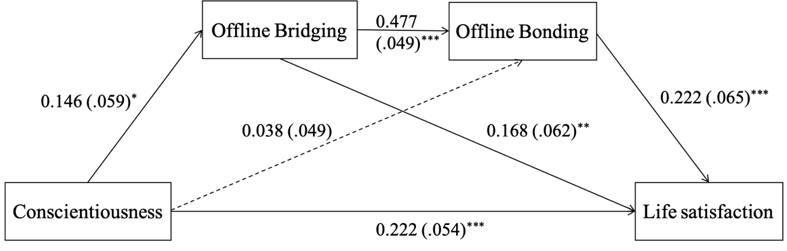
S-Figure 1. Path model of conscientiousness on life satisfaction
The numbers reflect standardized path coefficients.
S-Table 2. Direct and indirect effects of neuroticism on life satisfaction.
 | β | SE | LCI | UCI
Total effect | -.522 | .051 | -.622 | -.422
Direct effect | -.472 | .050 | -.570 | -.375
Indirect effects
Total indirect effects | -.050 | .020 | -.092 | -.012
Neuroticism -> Offline bridging -> Life satisfaction | -.022 | .015 | -.057 | .004
Neuroticism -> Offline bonding -> Life satisfaction | -.004 | .011 | -.027 | .019
Neuroticism -> Offline bridging -> Offline bonding -> Life satisfaction | -.023 | .001 | -.045 | -.007
Notes. LCI = lower confidence interval; UCI = upper confidence interval. 95% confidence intervals were used. Gender and age were controlled for in the mediation analysis.
﻿

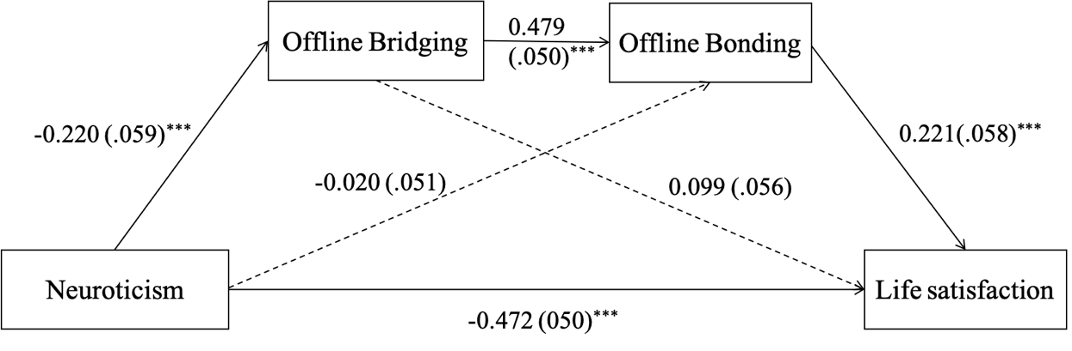
S-Figure 2. Path model of neuroticism on life satisfaction
The numbers reflect standardized path coefficients.
S-Table 3. Direct and indirect effects of openness on life satisfaction.
 | β | SE | LCI | UCI
Total effect | .117 | .058 | .003 | .230
Direct effect | .050 | .055 | -.059 | .160
Indirect effects
Total indirect effects | .066 | .025 | .022 | .119
Openness -> Offline bridging -> Life satisfaction | .038 | .018 | .008 | .079
Openness -> Offline bonding -> Life satisfaction | .006 | .011 | -.015 | .030
Openness -> Offline bridging -> Offline bonding -> Life satisfaction | .023 | .011 | .005 | .046
Notes. LCI = lower confidence interval; UCI = upper confidence interval. 95% confidence intervals were used. Gender and age were controlled for in the mediation analysis.

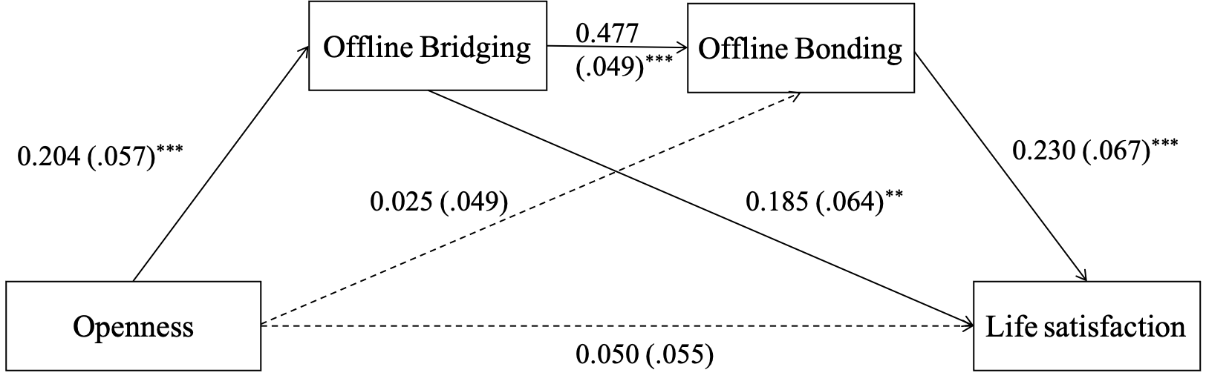
S-Figure 3. Path model of openness on life satisfaction
The numbers reflect standardized path coefficients.

