Supplementary Material
Fig. S1. Nonparametric bootstrapped difference test between total sample dimension network and items network (N=9282).
Fig. S2. The Bootstrapped confidence intervals of edge weights of the total sample dimension network and items network (N=9282).
Fig. S3. Stability estimation of centrality indicators for the total sample dimension network and items network (N=9282).
Table S1. Detailed description of the Psychological Safety Scale (PSS).
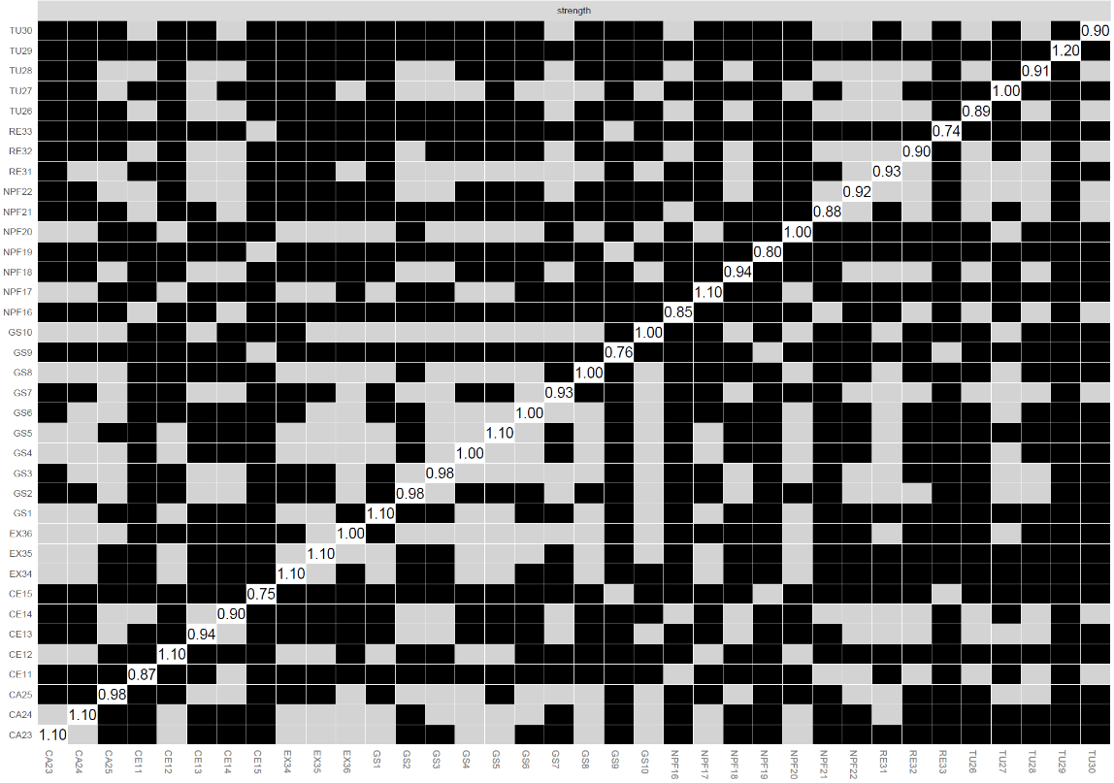
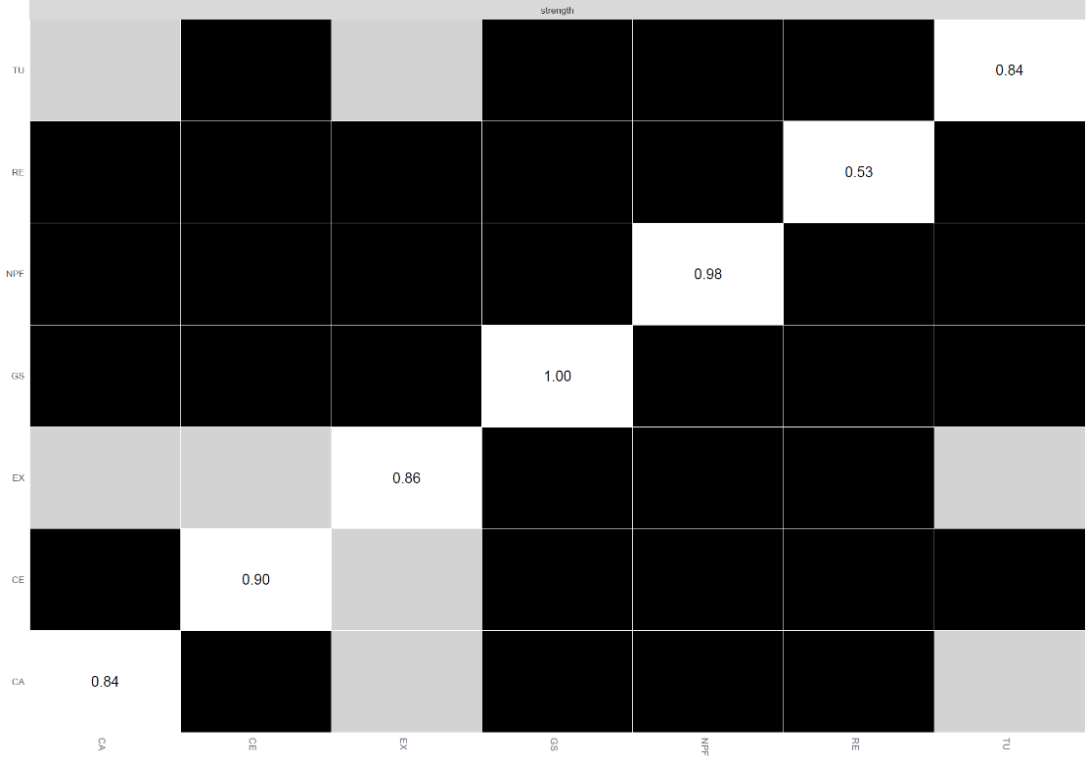
(a) Dimension network (b) Items network
Fig. S1. Nonparametric bootstrapped difference test between total sample dimension network and items network (N=9282).
Note: GS=General sense of safety; CE=Certainty; NPF=Normal physiological function; CA=Calmness; TU=Trust; RE=Relaxation; EX=Excitement Same below. The black box represents significant differences between two nodes, while the gray box represents no significant differences between two nodes.

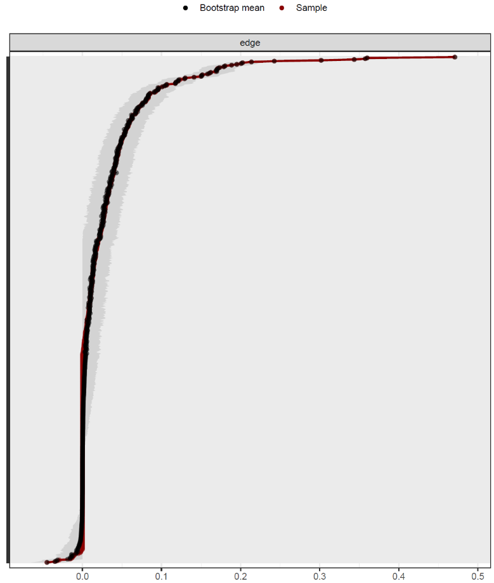
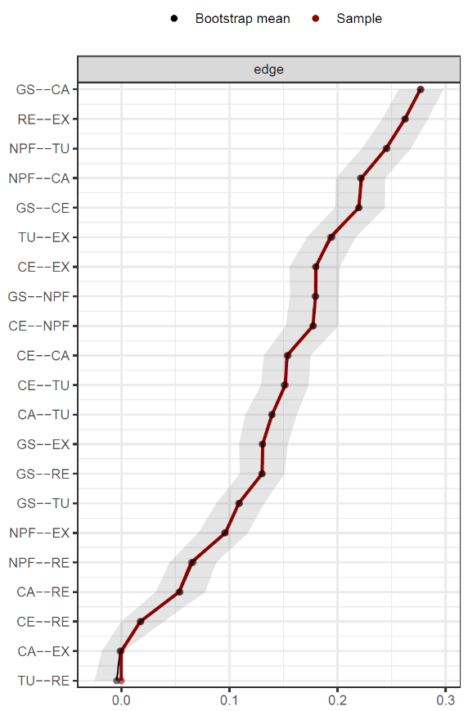

(a) Dimension network (b) Items network
Fig. S2. The Bootstrapped confidence intervals of edge weights of the total sample dimension network and items network (N=9282).
Note: The red line represents the sample value, and the gray area represents the 95% confidence interval. Due to the excessive number of y-axis labels in the items network, the y-axis labels were removed to avoid confusion. Same below.
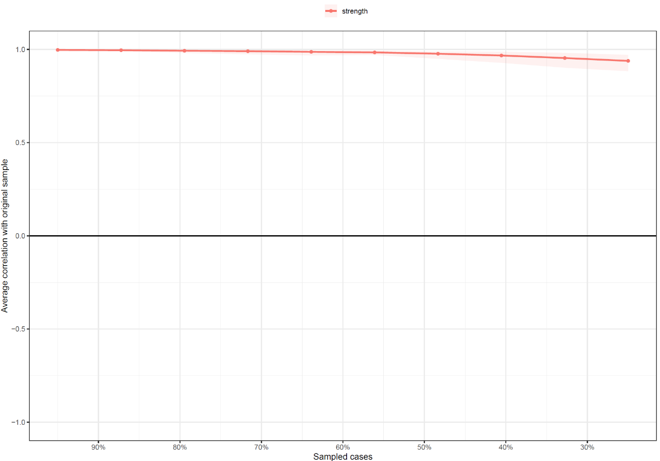
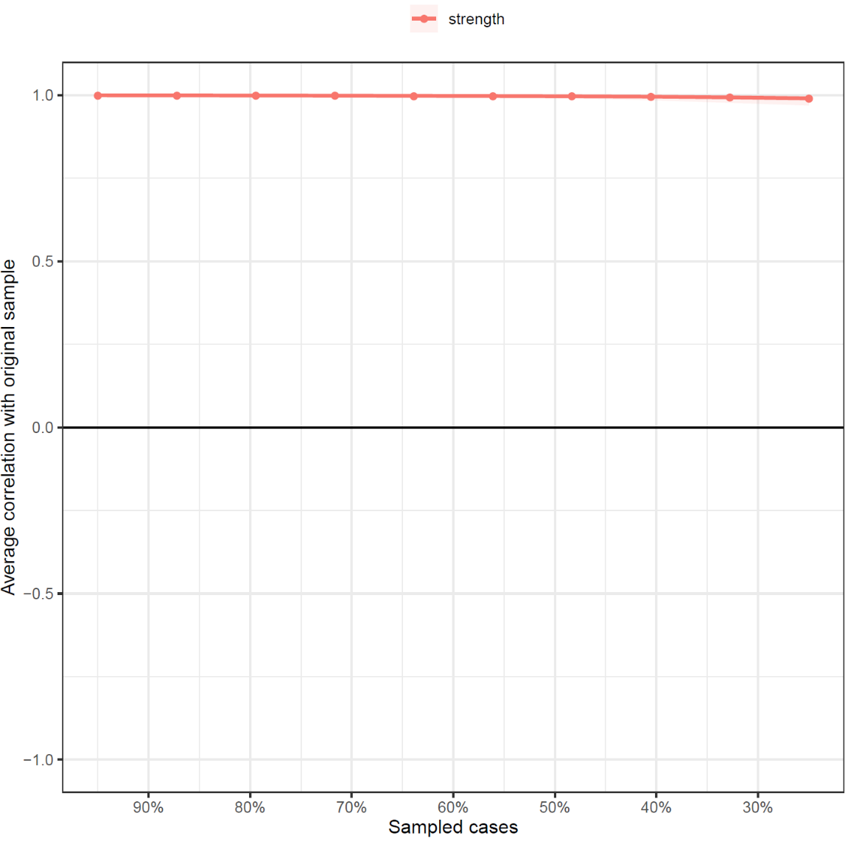

(a) Dimension network (b) Items network
Fig. S3. Stability estimation of centrality indicators for the total sample dimension network and items network (N=9282).
Table S1. Detailed description of the Psychological Safety Scale (PSS)
Abbreviation of items | Items | Detailed description of the question items
GS1 | Happiness | I often feel happiness in my daily life.
GS2 | Warmth | Family, friends, colleagues, and others have brought me warmth.
GS3 | Satisfaction | I am satisfied with my current state of life.
GS4 | Pleasure | I am satisfied with my current life or work.
GS5 | Enjoyment | I often experience happy emotions in my daily life.
GS6 | Entirely free from worry | I feel very relaxed both physically and mentally.
GS7 | Positive and optimistic | When facing difficulties, I maintain a positive and optimistic attitude.
GS8 | Comfortable | The environment around me makes me feel comfortable.
GS9 | Stability | I believe that I am currently stable in terms of finances, emotions, and social interactions.
GS10 | De-stress | I feel particularly relaxed.
CE11 | Active thinking | I feel that my thinking can operate quickly when solving problems or learning new knowledge.
CE12 | Self-confident | I feel confident when I speak in public.
CE13 | Unflappable | I will remain calm in the face of emergency situations.
CE14 | Dedicated to doing things | I will be fully focused on completing tasks or projects.
CE15 | Has a sense of control | I have a strong sense of control over my daily life arrangements, such as time management and task allocation.
NPF16 | Steady heartbeat | My heart rate usually remains stable.
NPF17 | Energetic | I always start a new day full of energy and vitality.
NPF18 | In good condition | I believe that my current body is healthy.
NPF19 | Good appetite | I maintain a good appetite.
NPF20 | Smooth breathing | I can feel my breathing going smoothly.
NPF21 | Good skin | I am very satisfied with my skin condition.
NPF22 | Sleep well | My sleep quality is good.
CA23 | Soothingly | After experiencing anxiety, I will be comforted by some good news.
CA24 | Peaceful | The environment or atmosphere around me helps to relax both body and mind.
CA25 | Calm | I rarely experience drastic emotional changes due to external factors.
TU26 | Be ready to help others | I am willing to help others.
TU27 | Trust others | I can trust strangers.
TU28 | Love to laugh | I love to laugh in life.
TU29 | Be friendly to others | I am able to treat others kindly.
TU30 | Share | I am willing to share my emotions with others.
RE31 | Shopping | I like to go shopping to relax.
RE32 | Traveling outside | I often go on trips to relax my body and mind.
RE33 | Sing | I can express my emotions through singing.
EX34 | Exciting | I often feel excited.
EX35 | Talkative | I am able to converse with others easily and without awkward silence.
EX36 | Like communicating | I am willing to communicate with others, share my thoughts and feelings, and also listen to their opinions.

