Supplementary file II

Supplementary figure 1: Assumptions of PTSD model:
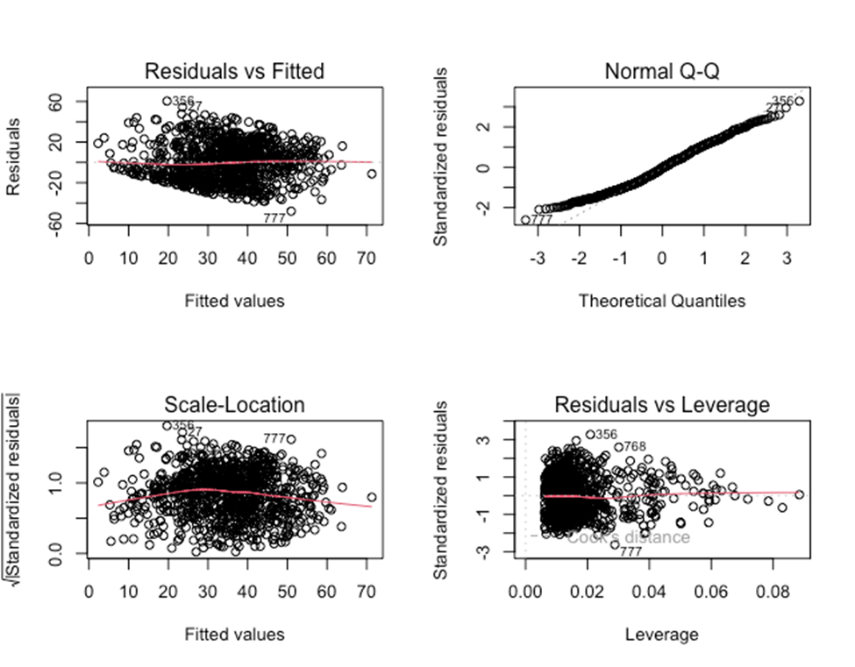

Supplementary figure 2: Assumptions of Wellbeing model
