Supplement materials
Supplement Figures
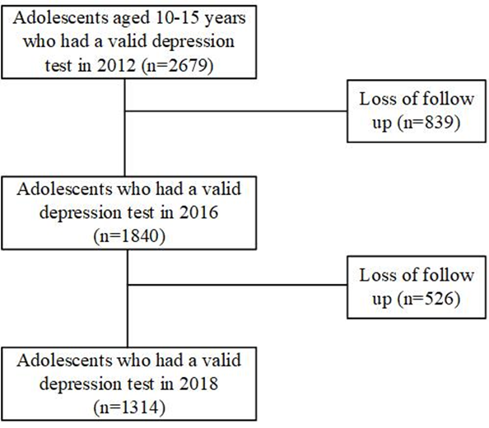
Figure S1. Flowchart of the sample selection. Of all the adolescents included in the CFPS data, 2679 adolescents between the ages of 10 to 15 completed the depressive symptoms survey. In the subsequent surveys conducted in 2016 and 2018, some adolescents were not available for follow-up, resulting in missing data for those individuals. In our analysis, we were able to retain a total of 1314 individuals who participated in all three investigations conducted in 2012, 2016, and 2018.
Table S1. The distribution of characteristics of children excluded and involved in this study
Characteristics | Excluded participants (n=1365) | Involved participants (n=1314) | P value
Adolescents’ characteristics
Age in 2012 | 12.77±1.64 | 12.42±1.70 | <0.05
Gender (female) | 657 (48.1) | 625 (47.6) | 0.77
Parent’s characteristics
Father’s age in 2012 |  |  | 0.23
≤35 | 123 (11.1) | 154 (13.2)
36 - 40 | 459 (41.2) | 473 (40.5)
41 - 45 | 332 (29.8) | 359 (30.8)
≥46 | 199 (17.9) | 181 (15.5)
Occupational status of the father |  |  | <0.05
Yes | 797 (58.4) | 887 (67.5%)
No | 316 (23.2) | 280 (21.3%)
Years of schooling of father |  |  | 0.05
≤6 years | 556 (50.0) | 536 (45.9)
7-9 years | 373 (33.5) | 396 (33.9)
≥10 years | 184 (16.5) | 235 (20.1)
Mother’s age in 2012 |  |  | 0.39
≤35 | 273 (23.5) | 277 (23.1)
36 - 40 | 497 (42.7) | 507 (42.2)
41 - 45 | 277 (23.8) | 315 (26.2)
≥46 | 117 (10.1) | 102 (8.5)
Occupational status of the mother |  |  | <0.05
Yes | 695 (50.9) | 774 (58.9%)
No | 469 (34.4) | 424 (32.3%)
Years of schooling of mother |  |  | <0.05
≤6 years | 739 (63.5) | 708 (59.0)
7-9 years | 253 (21.8) | 339 (28.2)
≥10 years | 171 (14.7) | 154 (12.8)
The father lived together with the children for more than 8 months in the last year, 2012 | 678 (52.0) | 782 (59.5%) | <0.05
The mother lived together with the children for more than 8 months in the last year, 2012 | 834 (63.9) | 922 (73.5) | <0.05
Living place |  |  | 0.06
City | 506 (37.2) | 534 (40.8)
Rural | 854 (62.8) | 775 (59.2)
Net household income in the last year, 2012 |  |  | 0.67
< 15000 RMB | 322 (24.4) | 305 (23.2%)
15000-30000 RMB (not contain 30000) | 306 (23.2) | 312 (23.7%)
30000-45000 RMB (not contain 45000) | 230 (17.5) | 240 (18.3%)
≥45000 RMB | 459 (34.9) | 426 (32.4%)
Depressive symptom scores | 13.85±6.01 | 13.72±5.97 | 0.69

Table S2. Parameters of latent class mixed model
Class | AIC | BIC | Entropy | Class count (%) | posterior probabilities
2 | 25159.83 | 25232.37 | 0.845 | 92.85/7.15 | 0.834/0.967
3 | 25067.05 | 25160.30 | 0.855 | 5.86/88.51/5.63 | 0.789/0.959/0.799
4 | 25075.05 | 25189.02 | 0.453 | 7.00/0.00/86.15/6.85 | 0.725/0.000/0.511/0.732
5 | 25183.83 | 25318.54 | 0.325 | 8.83/0.000/0.00/91.17/0.00 | 0.766/0.000/0.000/0.596/0.000
Note: The contents bolded in the table represent the best fit model.

Table S3. Depression scores of different depression class trajectories in 2012, 2016 and 2018
 | Remitting symptoms | Low symptoms | Decreasing symptoms
2012 (M ± SD) | 15.39±5.23ª | 12.68±4.71^{b} | 28.32±4.68^{c} | P<0.001
2016 (M ± SD) | 25.32±4.64ª | 9.42±4.70^{b} | 13.81±5.98^{c} | P<0.001
2018 (M ± SD) | 16.84±7.33ª | 10.86±6.07^{b} | 12.92±6.36^{c} | P<0.001
If the superscripts a, b, c are the same, it means that there is no difference between the two comparisons.

Table S4. Depression scores of different depression class trajectories in 2012, 2016 and 2018
 | Remitting symptoms | Low symptoms | Decreasing symptoms
2012 (M ± SD) | 15.39±5.23ª | 12.68±4.71ª | 28.32±4.68ª
2016 (M ± SD) | 25.32±4.64^{b} | 9.42±4.70^{b} | 13.81±5.98^{b}
2018 (M ± SD) | 16.84±7.33ª | 10.86±6.07^{c} | 12.92±6.36^{b}
 | P<0.001 | P<0.001 | P<0.001
If the superscripts a, b, c are the same, it means that there is no difference between the two comparisons.

Table S5. The GEE models showing the association between depression class and adolescent’s immediate word recall, delayed word recall and number series test in 2012 and 2016
 | Low symptoms (95% CI) | Remitting symptoms (95% CI) | Decreasing symptoms (95% CI)
Adjusted for adolescents’ cognitive ability during toddlerhood
Immediate word recall coefficient | Ref. | -0.29(-0.65, 0.07) | -0.58(-0.97, -0.19)**
Delayed word recall coefficient | Ref. | -0.37(-0.79, 0.05) | -0.32(-0.78, 0.14)
Number series test coefficient | Ref. | -2.62(-9.67, 4.42) | -3.97(-10.98, 3.04)
Vocabulary test coefficient | Ref. | 0.98(-0.09, 2.05) | -2.22(-3.97, -0.47)*
Mathematics test coefficient | Ref. | -0.11(-1.28, 1.06) | -1.62(-3.02, -0.23)*
Adjusted for parents’ cognitive ability in 2012
Immediate word recall coefficient | Ref. | -0.21(-0.57, 0.15) | -0.48(-0.86, -0.10)*
Delayed word recall coefficient | Ref. | -0.25(-0.67, 0.18) | -0.24(-0.72, 0.24)
Number series test coefficient | Ref. | -2.81(-9.79, 4.16) | -4.45(-12.10, 3.21)
Vocabulary test coefficient | Ref. | 0.60(-0.47, 1.68) | -1.51(-3.22, 0.21)
Mathematics test coefficient | Ref. | -0.14(-1.25, 0.98) | -0.96(-2.50, 0.58)
Adjusted for parents’ depression in 2012
Immediate word recall coefficient | Ref. | -0.17(-0.51, 0.18) | -0.53(-0.93, -0.13)*
Delayed word recall coefficient | Ref. | 0.27(-0.70, 0.15) | -0.31(-0.80, 0.18)
Number series test coefficient | Ref. | -2.35(-9.13, 4.43) | -2.46(-9.72, 4.79)
Vocabulary test coefficient | Ref. | 0.70(-0.40, 1.80) | -1.78(-3.41, -0.14)*
Mathematics test coefficient | Ref. | -0.28(-1.40, 0.84) | -1.13(-2.58, 0.32)
Adjusted for all covariates
Immediate word recall coefficient | Ref. | -0.30(-0.69, 0.10) | -0.60(-1.00, -0.20)*
Delayed word recall coefficient | Ref. | -0.38(-0.82, 0.06) | -0.30(-0.79, 0.20)
Number series test coefficient | Ref. | -2.90(-10.22, 4.43) | -3.36(-11.35, 4.64)
Vocabulary test coefficient | Ref. | 0.70(-0.46, 1.87) | -1.75(-3.57, 0.06)
Mathematics test coefficient | Ref. | 0.04(-1.20, 1.27) | -1.39(-3.00 0.18)

