Association Between Parents’ Value of Children and Adolescent Depression in China: A Multi-informant Study

Supplementary materials
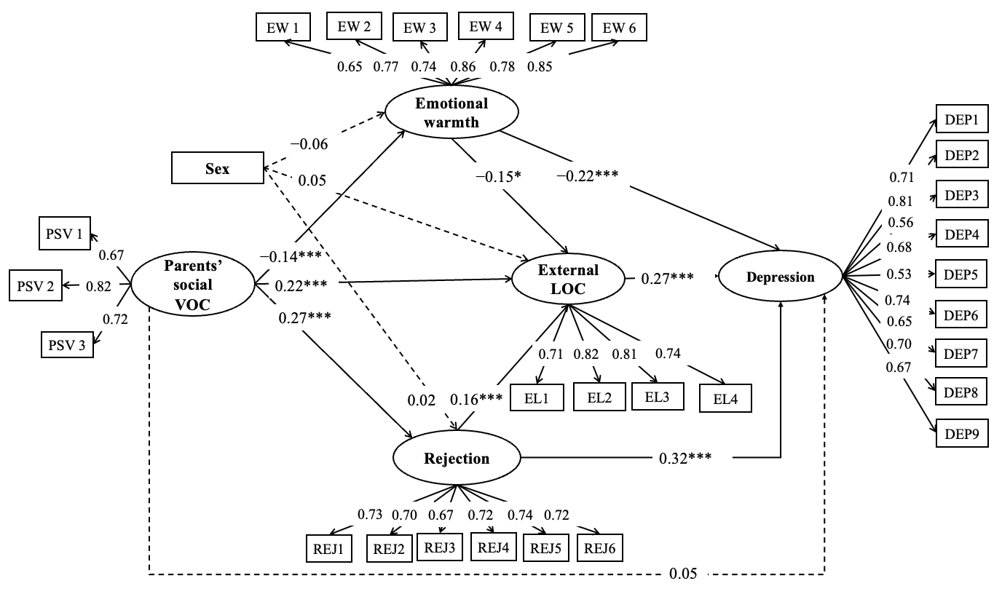
Figure S1. Null model without the latent interaction.
Note: PSV1 - PSV3 are parents’ social VOC scale items; EW1 – EW6 are emotional warmth subscale items; REJ1 – REJ6 are rejection subscale items; EL1 – EL4 are external LOC scale items; DEP1 – DEP9 are depression scale items. Adolescent sex, age, location, school type, parents’ age, and parents’ years of education were controlled as covariates. All values in the figure represent standardized estimates, including path coefficients and factor loadings. ***p < .001. *p < .05.

