Supplementary Material for

Cognitive-behavioral therapy to normalize social learning for patients with major depressive disorders: study protocol for a single-arm clinical trial

Yuening Jin^{a,b}, Si Zu^{c}, Pengchong Wang^{d,e}, Fangrui Sheng^{d,f}, Xue Wang^{d,e}, Yun Wang^{d}, Qun Chen^{d}, Jie Zhong^{d}, Fang Yan^{d,e}, Jia Zhou^{d}, Zhanjiang Li^{d}, Yuan Zhou^{a,b,d#}

ª CAS Key Laboratory of Behavioral Science, Institute of Psychology, Chinese Academy of Sciences, Beijing 100101, China.
^{b} Department of Psychology, University of Chinese Academy of Sciences, Beijing 100049, China.
^{c} Department of Psychiatry, Beijing Chaoyang Hospital, Capital Medical University, Beijing 100020, China
^{d} The National Clinical Research Center for Mental Disorders & Beijing Key Laboratory of Mental Disorders, Beijing Anding Hospital, Capital Medical University, Beijing, China.
^{e} Advanced Innovation Center for Human Brain Protection, Capital Medical University, Beijing, China.
^{f} The Affiliated Brain Hospital, Guangzhou Medical University, Guangzhou, China, 510370.

#Corresponding author:
Yuan Zhou, Ph.D., Institute of Psychology, Chinese Academy of Sciences, 16 Lincui Road, Chaoyang District, Beijing 100101, P.R. China; Email: zhouyuan@psych.ac.cn

Table of Contents
S1 Independent peer-review comments from the National Natural Science Foundation of China
S2 English translation of independent peer-review comments from the National Natural Science Foundation of China
S1 Independent peer-review comments from the National Natural Science Foundation of China
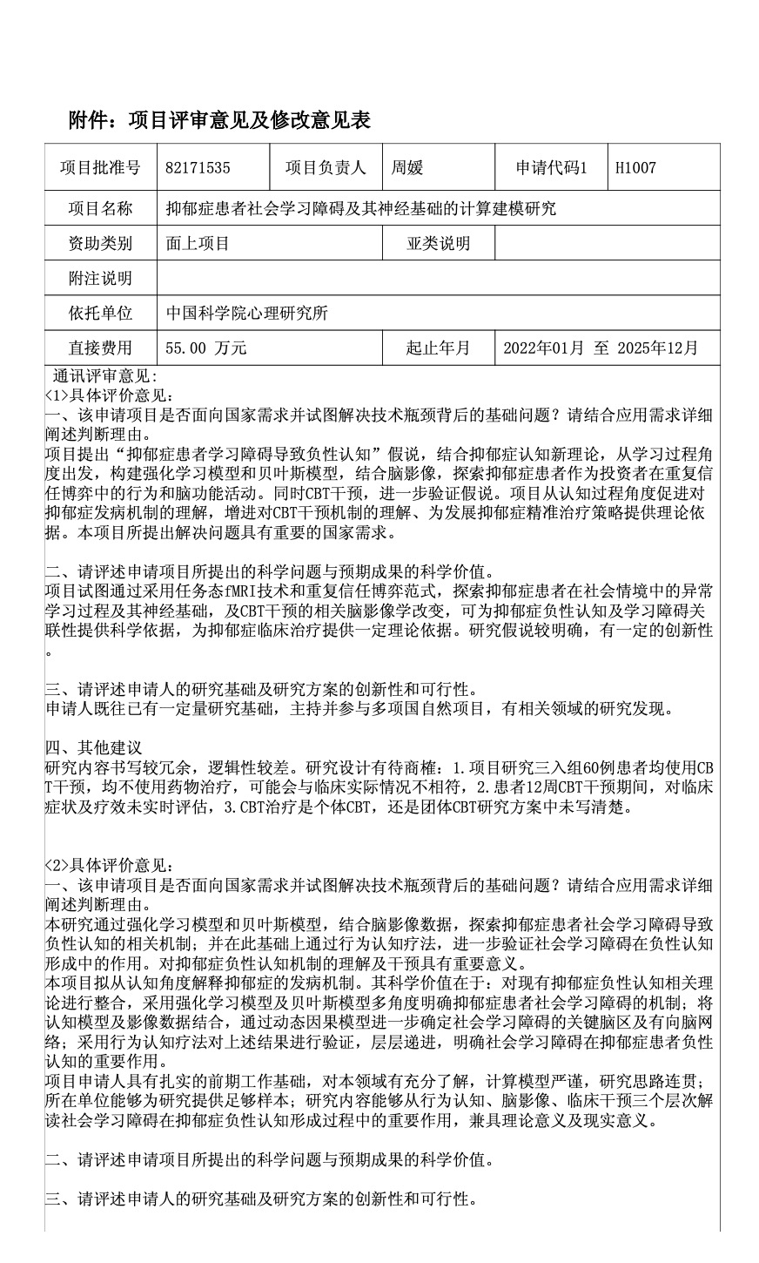


S2 English translation of independent peer-review comments from the National Natural Science Foundation of China
Reviewer 1
1. Do the proposed project address national needs and attempt to solve fundamental problems behind the technological bottlenecks? Please elaborate on your rationale in conjunction with application demands.
The project proposes the hypothesis that “learning impairments in patients with depression leads to negative cognition”. It integrates new cognitive theories of depression. It aims to construct reinforcement learning models and Bayesian models based on the learning process, merging these with neuroimaging to explore the behaviors and brain function of depressed patients as investors in repeated trust games. Additionally, through cognitive behavioral therapy (CBT) interventions, the project seeks to further validate the hypothesis. By focusing on the cognitive processes, this project promotes a deeper understanding of the pathological mechanisms of depression and enhances understanding of CBT mechanisms, thereby providing a theoretical foundation for developing precise treatment strategies for depression. The issues addressed by this project have significant national relevance.

2. Please evaluate the scientific value of the scientific questions proposed in the application and the expected outcomes.
The project aims to explore the abnormal learning processes and neural bases of depression patients within social contexts using task-based fMRI technology and repeated trust game paradigms. The associated neuroimaging changes due to CBT interventions will provide scientific evidence for the relationship between negative cognition and learning disorders in depression, ultimately offering theoretical support for clinical treatment. The research hypothesis is clearly defined and possesses a degree of innovation.

3. Please evaluate the research foundation of the applicant and the innovation and feasibility of the research plan.
The applicant has a considerable amount of previous research experience, having led and participated in multiple National Natural Science Foundation of China projects, along with relevant discoveries in the field.

4. Other Suggestions
The research content is somewhat redundant and lacks logical clarity. The research design warrants reconsideration: (1) The project proposes that all 60 patients in the study will use CBT interventions without pharmacological treatment, which may not align with actual clinical practices. (2) There is no real-time assessment of clinical symptoms and treatment efficacy during the 12-week CBT intervention. (3) The proposal does not clearly specify whether the CBT is individual or group based.

Reviewer 2
1. Do the proposed project address national needs and attempt to solve fundamental problems behind the technological bottlenecks? Please elaborate on your rationale in conjunction with application demands.
This study explores the mechanisms leading to negative cognition in depressed patients with social learning disabilities through reinforcement learning models and Bayesian models, combined with neuroimaging data. Furthermore, it seeks to verify the role of social learning disabilities in the formation of negative cognition through cognitive behavioral therapy (CBT). Understanding the mechanisms of negative cognition and intervention in depression is significant. This project aims to explain the pathological mechanisms of depression from a cognitive perspective. Its scientific value lies in the integration of existing theories related to negative cognition in depression, clarifying the mechanisms of social learning disabilities in depressed patients using multiple angles through reinforcement learning and Bayesian models. By combining cognitive models with imaging data, the study will further identify key brain regions and directed brain networks associated with social learning disabilities using DCM (Dynamic Causal Modeling). The behavioral cognitive therapy will be employed to validate the results, step by step elucidating the significant role of social learning disabilities in negative cognition among depression patients. The applicant has a solid foundation of prior work, demonstrating a comprehensive understanding of the field, with rigorous computational models and coherent research ideas. The applicant’s institution can provide sufficient samples for the study; furthermore, the research content can interpret the significant role of social learning disabilities in the formation of negative cognition in depression from the perspectives of behavioral cognition, neuroimaging, and clinical intervention, which has both theoretical and practical significance.
2. Please evaluate the scientific value of the scientific questions proposed in the application and the expected outcomes.
3. Please evaluate the research foundation of the applicant and the innovation and feasibility of the research plan.
4. Other Suggestions

Reviewer 3
1. Do the proposed project address national needs and attempt to solve fundamental problems behind the technological bottlenecks? Please elaborate on your rationale in conjunction with application demands.
The project targets the bottleneck issue of unclear pathogenic mechanisms of depression, focusing on a new cognitive theory of depression centered on the learning process. It explores how social learning disabilities contribute to the formation of negative cognition in depression. The study combines computational modeling, brain functional imaging data analysis, and clinical validation to investigate the underlying mechanisms, demonstrating an effort to address the fundamental issues behind this bottleneck.

2. Please evaluate the scientific value of the scientific questions proposed in the application and the expected outcomes.
The project revolves around the critical question of “how negative cognition in depression is formed,” proposing several sub-questions for exploration. These include the characterization of patients’ learning processes in social interactions, the potential neural basis of abnormal social learning processes in patients, and the impact of social learning disabilities on negative cognition in depression. The expected outcomes are anticipated to provide evidence concerning the role of social learning disabilities in negative cognition at behavioral, neuroimaging, and clinical validation levels, thereby enhancing the theoretical understanding of the pathogenic mechanisms of depression from a cognitive perspective.

3. Please evaluate the research foundation of the applicant and the innovation and feasibility of the research plan.
The applicant has conducted preliminary research relevant to the project, involving key technologies utilized in the study. They have a solid research foundation particularly in the neural mechanisms of patients’ social decision-making behavior, normal decision-making behavior, brain functional networks in mental disorders, and treatment of depression. The project demonstrates a degree of innovation, as the research content is based on a new cognitive theory of depression, analyzing the mechanisms of negative cognition formation from the learning process perspective. Using computational modeling, the project seeks to investigate the learning processes and neural foundations behind cognitive phenomena and behavior, with the application of computational modeling in this field being relatively novel.

4. Other Suggestions

