Figure 1
Standardized factor loadings of the items for non-clinical sample
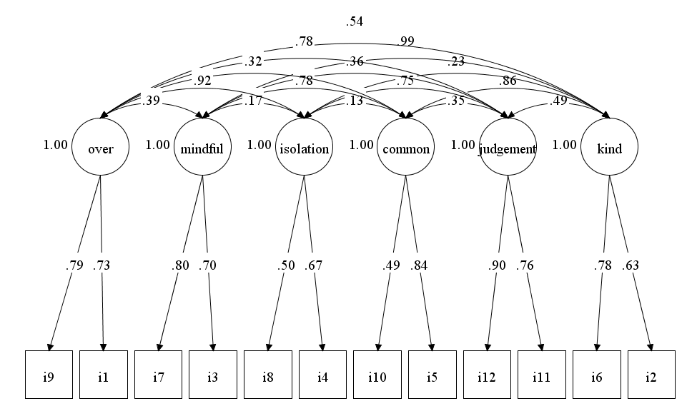

Figure 2
Standardized factor loadings of the items for clinical sample
