Table S1. Normality testing for the study variables (N = 301)
Variables | Shapiro-Wilk |  |  | D’Agostino-Pearson K²
Variables | Statistic | df | P-value | Statistic | P-value
Work experience (Years) | 0.950 | 301 | <0.001 | 83.943 | <0.001
Total knowledge score | 0.868 | 301 | <0.001 | 119.052 | <0.001

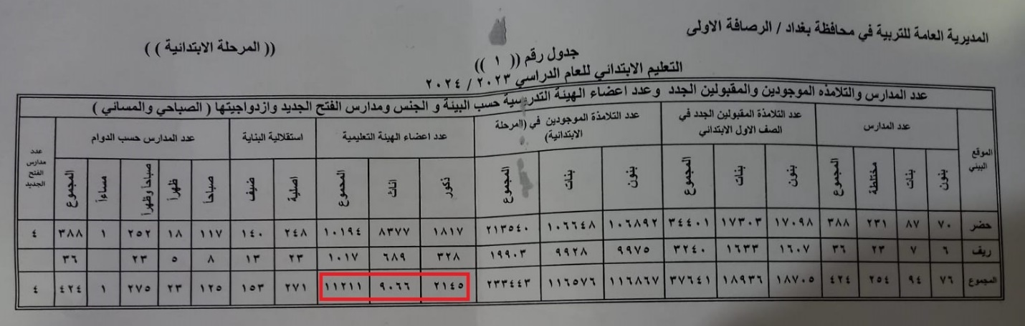
Figure S1. Official records for the number of primary school teachers affiliated with Rusafa 1 Educational Directorate

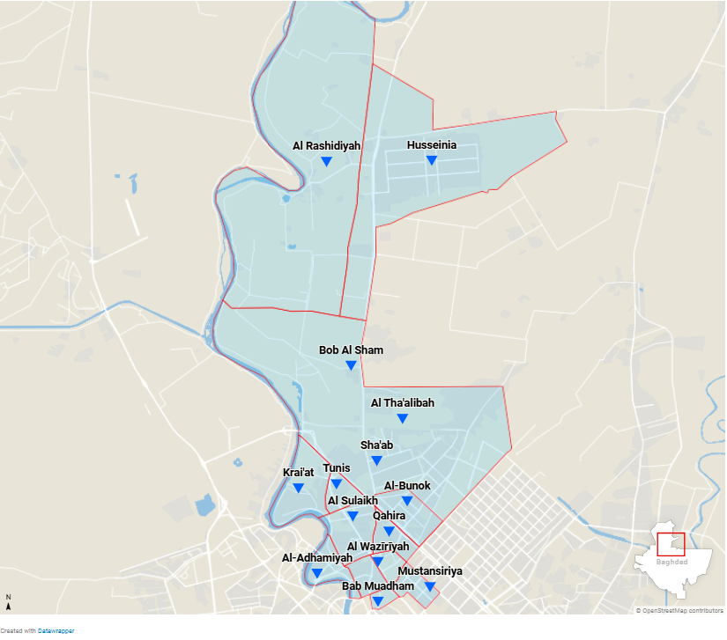Figure S2. Map showing the areas under the supervision of Rusafa 1 Educational directorate with the capital city of Baghdad.

Table S2. Gender distribution of the study sample and the target population
Gender | Study sample  N (%) | Target populations  N (%) | P-valueª
Male | 33 (11.0) | 2145 (19.1) | 0.001
Female | 268 (89.0) | 9066 (80.9) | 0.001
ªOne-sample Chi-square was used for statistical analysis with
0.05 as a cut-off point for statistical significance

Table S3. Performance on awareness items according to previous contact with autistic children among primary school teachers in Baghdad, Iraq. (N = 301)
Category | Previous contact with autistic children
Category | Yes  66 (%)ª | No  235 (%)ª | Odds ratio  (95% CI) | ꭓ² | P-value^{b} | Adj. P-value^{c}
Prevalence
autism occurs more in males | 111 (48.7) | 27 (37.0) | 1.62 (0.94 – 2.78) | 3.05 | 0.081 | 0.242
Autism occurs more in poor families | 159 (69.7) | 47 (64.4) | 1.27 (0.73 – 2.22) | 0.73 | 0.392 | 0.522
Risk factors
Genetic | 89 (39.0) | 36 (49.3) | 0.66 (0.39 – 1.12) | 2.41 | 0.121 | 0.246
Neurological | 66 (28.9) | 19 (26.0) | 1.16 (0.64 – 2.10) | 0.23 | 0.630 | 0.716
Vaccines | 217 (95.2) | 65 (89.0) | 2.43 (0.94 – 6.29) | 3.52 | 0.061 | 0.200
Diet | 206 (90.4) | 60 (82.2) | 2.03 (0.97 – 4.27) | 3.58 | 0.058 | 0.200
Excessive use of electronics | 98 (43.0) | 29 (39.7) | 1.14 (0.69 – 1.96) | 0.24 | 0.624 | 0.717
Maltreatment by parents | 75 (32.9) | 18 (24.7) | 1.50 (0.82 – 2.73) | 1.76 | 0.185 | 0.290
Maternal conditions | 59 (25.9) | 13 (17.8) | 1.61 (0.83 – 3.15) | 1.98 | 0.160 | 0.288
Unknown | 49 (21.5) | 11 (15.1) | 1.54 (0.76 – 3.15) | 1.43 | 0.232 | 0.321
Signs and symptoms
Onset during first few years | 186 (81.6) | 53 (72.6) | 1.67 (0.91 – 3.09) | 2.72 | 0.099 | 0.242
Good eye contact | 122 (53.5) | 24 (32.9) | 2.35 (1.35 – 4.09) | 9.42 | 0.002 | 0.024
No response to name | 151 (66.2) | 42 (57.5) | 1.45 (0.84 – 2.48) | 1.82 | 0.178 | 0.290
Appropriate use of gestures | 43 (18.9) | 8 (11.0) | 1.89 (0.84 – 4.23) | 2.45 | 0.117 | 0.246
Emotional reciprocity | 85 (37.3) | 20 (27.4) | 1.58 (0.88 – 2.81) | 2.38 | 0.123 | 0.246
Good verbal communication | 145 (63.6) | 36 (49.3) | 1.80 (1.05 – 3.06) | 4.70 | 0.030 | 0.135
Does not play with other children | 144 (63.2) | 46 (63.0) | 1.01 (0.58 – 1.74) | 0.0005 | 0.982 | 0.982
Able to develop friendships | 163 (71.5) | 46 (63.0) | 1.47 (0.85 – 2.56) | 1.87 | 0.171 | 0.290
Repetitive behaviors | 191 (83.8) | 47 (64.4) | 2.86 (1.58 – 5.17) | 12.6 | 0.0004 | 0.007
Inappropriate attachment to toys | 180 (78.9) | 38 (52.1) | 3.45 (1.98 – 6.04) | 20.0 | 8*10⁻⁶ | 0.0003
Obsession with the same routine | 154 (67.5) | 48 (65.8) | 1.08 (0.62 – 1.89) | 0.08 | 0.777 | 0.823
Hyper- or hyposensitivity to input | 146 (64.0) | 34 (46.6) | 2.04 (1.20 – 3.48) | 7.01 | 0.008 | 0.048
Comorbidities of autistic children
All have intellectual disability | 176 (77.2) | 44 (60.3) | 2.23 (1.27 – 3.91) | 8.05 | 0.005 | 0.043
The majority have special talents | 44 (19.3) | 8 (11.0) | 1.94 (0.87 – 4.34) | 2.69 | 0.101 | 0.242
Hyperactivity is a feature of ASD itself | 31 (13.6) | 8 (11.0) | 1.28 (0.56 – 2.92) | 0.34 | 0.559 | 0.694
Modes of treatment
Behavioural interventions | 164 (71.9) | 40 (54.8) | 2.11 (1.23 – 3.64) | 7.43 | 0.006 | 0.043
Speech therapy | 109 (47.8) | 28 (38.4) | 1.47 (0.86 – 2.52) | 1.99 | 0.158 | 0.288
Medications | 108 (47.4) | 36 (49.3) | 0.93 (0.55 – 1.57) | 0.08 | 0.772 | 0.823
Dietary restrictions | 171 (75.0) | 54 (74.0) | 1.06 (0.58 – 1.93) | 0.03 | 0.860 | 0.884
Chelation and detoxification | 195 (85.5) | 58 (79.5) | 1.53 (0.78 – 3.01) | 1.52 | 0.217 | 0.321
Outcome
A complete cure is possible | 72 (31.6) | 14 (19.2) | 1.95 (1.02 – 3.71) | 4.17 | 0.041 | 0.164
Early diagnosis improves the outcome | 185 (81.1) | 56 (76.7) | 1.31 (0.69 – 2.47) | 0.68 | 0.410 | 0.527
Educational needs
Need special education | 200 (87.7) | 60 (82.2) | 1.55 (0.76 – 3.17) | 1.44 | 0.231 | 0.321
Better incorporated in normal classes | 101 (44.3) | 20 (27.4) | 2.11 (1.18 – 3.75) | 6.57 | 0.010 | 0.051
Community role in autism
Autistic children face social stigma | 129 (56.6) | 39 (53.4) | 1.14 (0.67 – 1.93) | 0.22 | 0.637 | 0.716
Local resources are adequate | 178 (78.1) | 50 (68.5) | 1.64 (0.91 – 2.94) | 2.76 | 0.097 | 0.242
ª Counts and column percent are described as individuals who have answered correctly on the indicated items
^{b} Chi-square test was used for analysis with a cut-off point of 0.05 for statistical significance
^{c} Benjamin-Hochberg procedure at a false discovery rate (FDR) of 0.05 was used to adjust the P-value for multiple testing

